Table Outline Editor (TOE)

Priyank Porwal
porwal@cs.unc.edu

TOE is a new outline editor that displays outlines in tabular format. Users modify an outline by editing the cells of the table in which it is displayed. TOE allows users to insert new rows of outline headers, above or below a selected row. TOE numbers the new headings automatically depending on their position in the outline. It also allows users to move headings left and right. The movement of headings left or right changes their positions in the overall outline hierarchy.

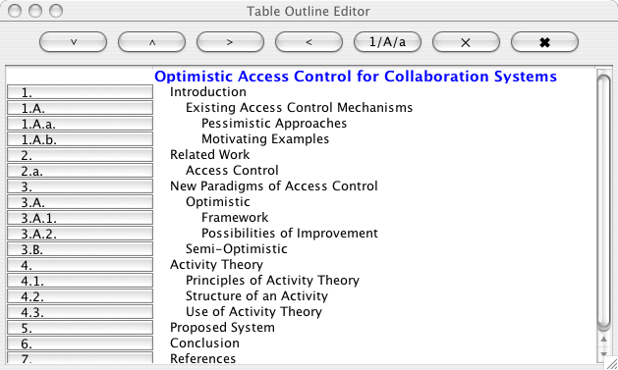
Figure 1: Screenshot of a sample outline

Features of TOE

- More intuitive user interface than existing Outline editor
- Allows users to see the entire outline in a single window and edit any outline heading
- Provides control to add outline headings below or above the selected heading
- Provides control to move headings left and right from their current positions
- Does automatic numbering of the headings
- Allows users to select numbering format (numbers, letters) at different levels
- Allows deletion of selected heading
- Allows clearing the entire outline

User Interface Description

When a new outline is created the outline editor window opens up and copies the object name to the title of the new outline. This title is displayed in the first row of the outline. (e.g. blue text in Figure 1).

Editing Text
Users can double click on any row, including the outline title, and edit the text as with any plain text editor. While in edit phase the editor removes all formatting and displays plain text of the row. Once the user completes editing the new text in the row is updated in the outline and displayed as per structure of the outline.

Adding new rows
Users can use the down and up buttons (first two buttons on the top) to add a single row at a time below or above a selected row. The new row gets added to the outline once one of these buttons is pressed. Users can then edit the text for that row.
The new row is added to the outline hierarchy depending on the level of the selected row, i.e. the new row becomes a sibling of the selected row if the outline is considered as a tree. Whether it becomes an after-sibling or before-sibling depends on whether the down or up button was used to add the new row.

Shifting rows
Users can shift any row or left or right using the left and right buttons (3rd and 4th buttons on the top), within the constraints of the structure of the outline.
TOE takes the following steps during the shift operations:

Right
- First row (title row) cannot be right shifted.
- First row at any particular level (first child in tree terminology) cannot be right shifted.
- If right shift is allowed the selected row becomes the first child of earlier before-sibling. Also, entire sub-tree gets right shifted.

Left
- First row (title row) cannot be left shifted.
- Children of the first row cannot be left shifted.
- If left shift is allowed then the selected row becomes the immediate after-sibling of its earlier parent. Also, entire sub-tree gets left shifted.

Numbering
Users can change the numbering style of a particular level of outline headings by using the 1/A/a button (5th button on the top) after selecting a row. All its siblings get renumbered with the same style, but it does not affect the numbering style of any ancestor or descendent. As of the now, the numbering button toggles between numbers, upper-case letters and lower-case letters in the same cyclic order. Figure 1 shows use of all these numbering styles.
Deleting rows
Users can delete one row at a time using the X button (6th button on the top). In the deleted row has any children then the children are added to its parent’s children starting at the original position of the deleted row.

Clearing outline
Users can clear the entire outline using the clear button (last button on the top).

Possible Enhancements

- Currently the selection model of the outline editor does not work as expected. After inserting, deleting or shifting a row, the cursor goes back to the first row. Users need to select a row before every use of the buttons on the top panel.
- Buttons were used to the numbering column of the outline so that they could be used to expand/collapse sub-trees. This functionality hasn’t been implemented yet. If time permits, this functionality will be added before the demo. Since this is a view-only issue, it will not affect the underlying data model. Users will be able to independently expand/collapse sub-trees.
- APPENDIX

This section describes the Sync objects implementing the replicated model of TOE.

Package: toutline

Classes
NO | Model
NOChildren | Sub-object used by NO model
NOEditor | Editor for NO model

Class NO

Extends: Object
Implements: Serializable
Constructor: NO()

Method Summary
void | addPropertyChangeListener(java.beans.PropertyChangeListener)
String | getBullet()
NOChildren | getChildren()
NO | getParentOf(NO)
String | getTitle()
void | removePropertyChangeListener(java.beans.PropertyChangeListener)
void | reset()
void | setBullet(String)
void | setChildren(NOChildren)
void | setTitle(String)

Method Descriptions

public void reset()

This method resets the object to its original state, as after the Constructor call.

public NO getParentOf(NO child)

This recursive method returns the parent of the child NO node in the tree subtree at this node. If the child NO node does not have a parent in the subtree rooted at this node, this method returns null.

Class NOChildren

Extends: AListenableVector
Constructor: NOChildren()
Method Summary
boolean | contains(Object)

Method Descriptions

public boolean contains(Object obj)

This method returns true or false depending on whether the Vector contains object or not.

Class NOEditor

Extends: Objects
Implements: SyncApplication, RT_SyncApplication
Constructor: NOEditor()

Method Summary
void | addObject(edu.unc.sync.Replicated o, String)
void | doRefresh()
void | init(Object)
edu.unc.sync.Replicated | newObject(String, String)

