Henry McEuen
Collaborative Calendar manual with appendix

This collaborative calendar is based on an existing freeware Java calendar widget. This calendar provides very simple appointment scheduling functionality. Appointments are kept at the granularity of days; multiple appointments scheduled for the same day must be entered together. The calendar also keeps track of appointments for various users. In this application the user is simply a tag; there is no authentication that prevents users from tagging appointments as belonging to other users. A default owner for the calendar can be set so that new appointments will have this owner selected by default.

Clicking on a date in the calendar automatically shows all appointments scheduled for that date. New appointments can be entered by selecting a user and entering the appointment information in the text field. Each user can have at most one appointment on a given date. The text of existing appointments can be modified, but the user an appointment belongs to cannot be changed. To do this it is necessary to delete the appointment and create a new one.

Adding users:

At present the application does not have the functionality to add users from the user interface. Instead the names of users are given in the file users.txt, which should contain the name of one user per line. The users will be displayed in the selection boxes in this order.

Entering appointments:

The first step in entering an appointment is choosing the appropriate day. If the chosen day has no other appointments, a screen like the following will be displayed:

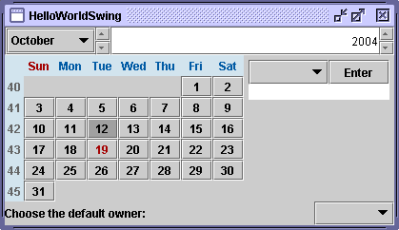

Once the day has been selected, the owner of the appointment (the person it applies to) must be entered. This is done by selecting the name from the drop-down combo box.
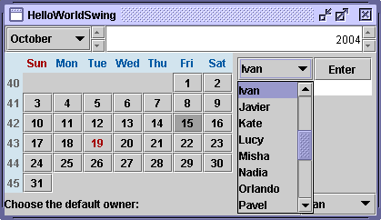

Once the name has been selected the text of the appointment can be entered in the text box. The appointment will not be committed until the enter button is pressed.

Modifying appointments:

Existing appointments can be modified by choosing the appropriate day and changing the text in the appropriate text box. All such changes have immediate effect. The owner of an entered appointment cannot be changed.

Deleting appointments:

An appointment can be deleted by pressing the delete button. Each owner can have exactly one appointment per day. If an owner who already has an appointment on that day is selected, pressing the Enter button to commit the second appointment will have no effect. Below is a sample of a screen with multiple appointments on the same day.

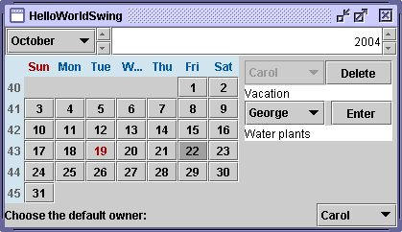

Default owners:

There is also a default owner field at the bottom of the calendar. This field contains a selection list with the same names as the owner field for appointments. When a person is selected as the default owner, all new appointments default to the name of this person. This allows for convenience in the case when users primarily enter their own appointments. An example of this is shown below.

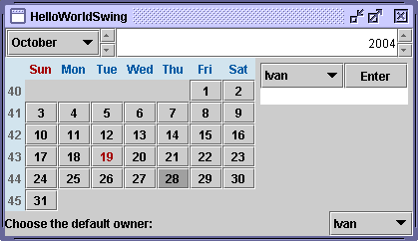

The appointment calendar can be merged by using sync. A user can share a calendar with appointments; some other user can then modify the appointments on this calendar and add new appointments. However, at this point the replication has not been fully implemented.

Appendix I: Synchronization

Synchronization semantics

The calendar supports collaborative work using the sync framework. Not all parts of the calendar are replicated; rather, only those that make sense to replicate are replicated. Users share data but have their own customizable view of the common data. In this version it is not possible to see what other users are viewing, but this enhancement may be added in future versions.

The default owner and current date are not shared. This is because the default owner (the owner of an appointment selected by default for new appointments) is likely to be different for each user. Thus it makes no sense to couple this to input from other users. Similarly, it is only possible for users to have divergent views if the selection of the current date displayed is not coupled. For instance, suppose Alice wants to enter an appointment on November 5 at the same time that Bob wants to enter an appointment on November 8. They can do this simultaneously; the underlying model will be updated and replicated, and they can subsequently click on the other date to look at the appointment the other user entered.

Programming interface

The calendar is implemented as a nested hash table. Each day in the calendar that has appointments is its own hash table, hashing the text of appointments to the owner of the appointment, and is keyed on the owner of the appointment. This is why appointment owners cannot be changed once created and why each person can only have one appointment per calendar day. These hash tables are in turn hashed in a global hash table that is keyed on the date. To find an appointment for a specific person on a specific date, it is first necessary to look in the global hash table and find the table of appointments for that date. Once this nested table is found the appointment can be retrieved by getting the appointment text in the nested table that is keyed to the person. Whenever an appointment is created or updated, the nested table is modified and the sync interface is notified. This nested table modification requires the change to be propagated to the global table. However, only the relevant entry of the global table is modified, by replacing the old nested table with the updated nested table.

Possible collaboration uses

Suppose that Alice and Bob are jointly responsible for scheduling a series of lectures from visiting professors. The lectures will take place over a period of three weeks, and there can be at most three lectures given per day. In addition, each professor will give no more than one lecture per day. We assume that Alice and Bob have an additional method of communication such as phone or instant messaging. With the calendar tool, Alice and Bob can simultaneously schedule professors to speak on various days. The changes they make to the shared calendar will be instantly replicated, and they can look at appointments for different days as necessary. They can specify the professor as the owner of the appointment and give the lecture title as the text of the appointment.

Alice's calendar:
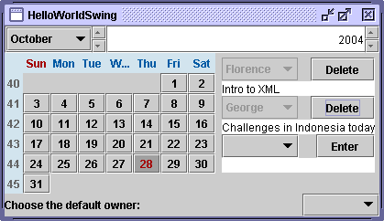

Bob's calendar:
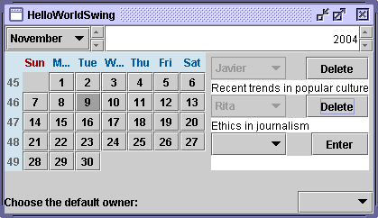

Other uses

This calendar could also be used as a lightweight information manager for a team of employees. The simple interface means that it is perhaps easier to quickly enter information than it would be on a more robust system. Employees can select themselves as the default owner of appointments and use the allotted space for each day to describe what they’re doing on that day. The activities of other employees on various days are automatically replicated, and any employee can see what any other employee has decided to share for a given day.

