Collaborative Spreadsheet User Manual

William Luebke

Introduction

Spreadsheet applications have been around for decades and have remained largely unchanged in terms of basic functionality. Spreadsheets are useful for simple to moderately advanced computational numerical tasks. They are also useful mechanism for creating and editing a tabular data in general.

A collaborative spreadsheet offers the same benefits to users as other collaborative applications. Often, collaborative editing of digital artifacts is more efficient than a non-collaborative approach.

The Collaborative Spreadsheet utilizes the functionality of the Sync framework to implement its shared objects.

User Interface Features

Like many spreadsheet applications before it, the Collaborative Spreadsheet does not depart from the typical spreadsheet user interface. The spreadsheet consists of a two-dimensional grid of “cells,” with each cell containing a value or formula. Rows are numbered starting a 1, while columns are labeled with letters, starting with the letter ‘A’. Below is the user interface of the Collaborative Spreadsheet.

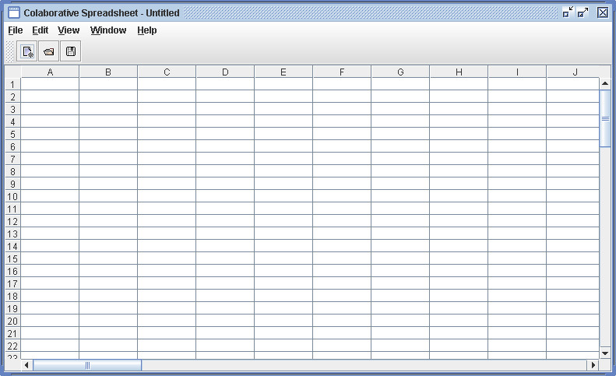

Values are entered by double-clicking on a cell, typing the value, and pressing the ENTER key. For example, in the below screenshot of the Collaborative Spreadsheet, the user has entered the word “hello” into cell B5.

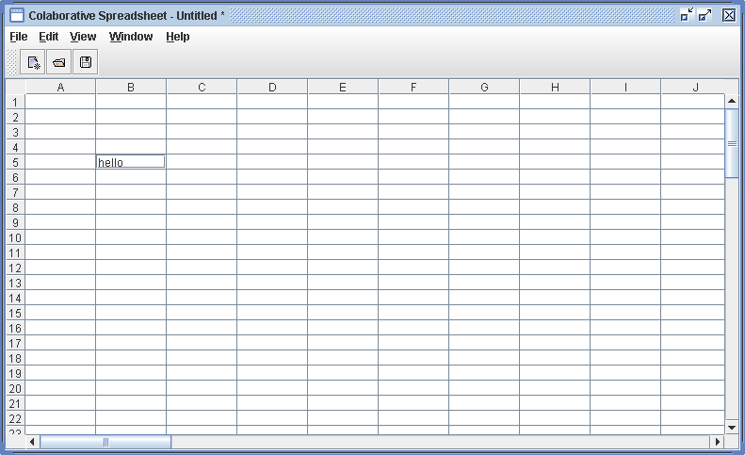

Spreadsheets also support calculation of values, and the Collaborative Spreadsheet is no different in this respect. By starting a value with the equals (“=”) sign, that signals the interface that the value of the cell being edited is a formula that can be computed. For example, in the below screenshot, the user entered “=21*2” into cell B10.

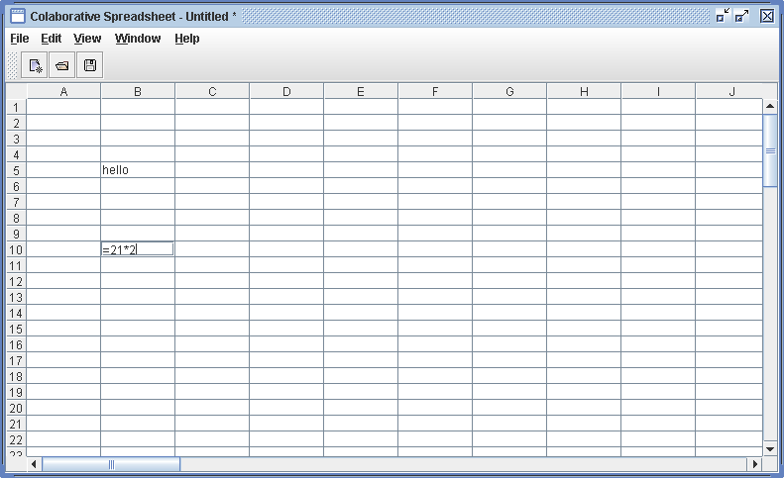

Upon pressing the ENTER key, the formula of the cell is computed, and the spreadsheet shows the answer as the value of the cell. Double clicking the cell again will show the original formula.

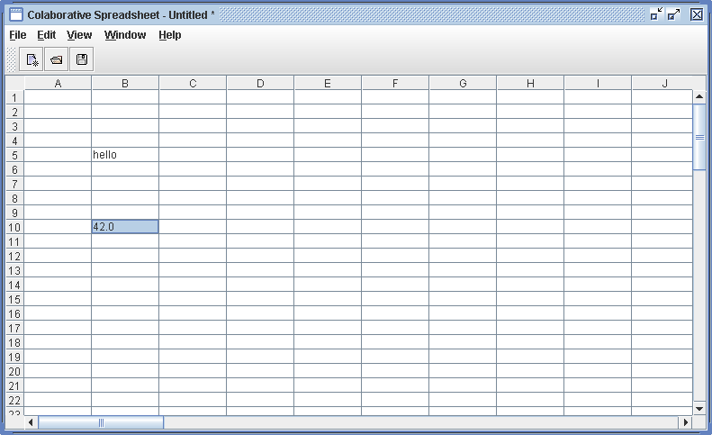

Formulas can also reference other cells in their computations. For example, in the screenshot below, the formula for cell E6 is typed as “=B10+5”.
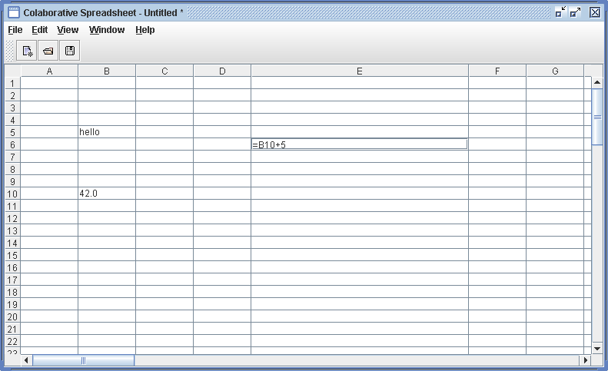

Upon pressing ENTER, the cell is computed, and the value 49.0 is shown in cell E6.

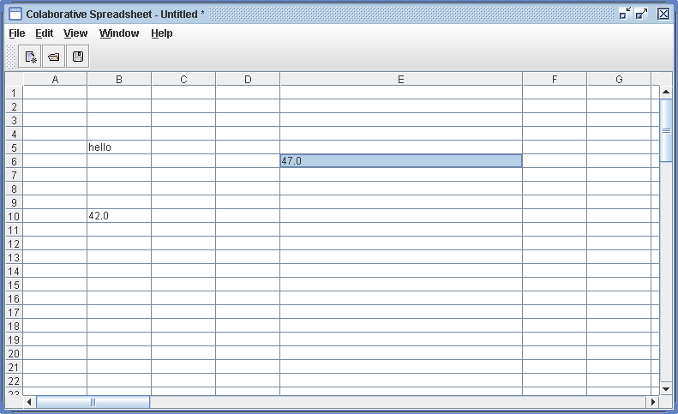

However, the user should be careful not to enter circular references!

The interface of the spreadsheet supports column resizing. Note that in the above two screenshots, the width of the E column was increased. This is done by clicking and dragging on the line between the E and F column headers and sliding the divider to the desired location.

The Collaborative Spreadsheet also supports a few basic file operations through its File menu:

- New
- Open
- Save
- Save As…
- Close
- Exit

These commands are described in more detail below. The other menus (Edit, View, Window, and Help) are placeholders for future enhancements to the Collaborative Spreadsheet.

New

Activating this command first executes the Close command to close the current spreadsheet. If this completes successfully, a new, blank, untitled spreadsheet is created and displayed to the user.

Open

Activating this command first executes the Close command to close the current spreadsheet. If this completes successfully, a dialog is displayed to the user allowing them to select a file to open. The Collaborative Spreadsheet is able to load files in the Comma-Separated-Value (CSV) format. Microsoft Excel is also able to save and load this format. For example, in Microsoft Excel, the spreadsheet “example.csv” was created:

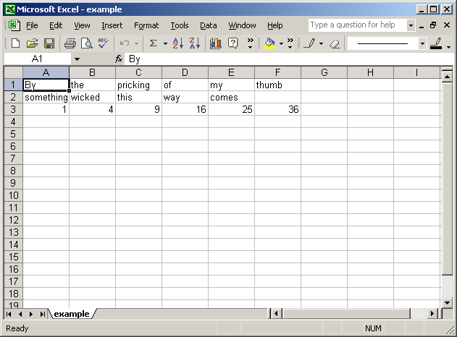

When opened in the Collaborative Spreadsheet, it looks like this:

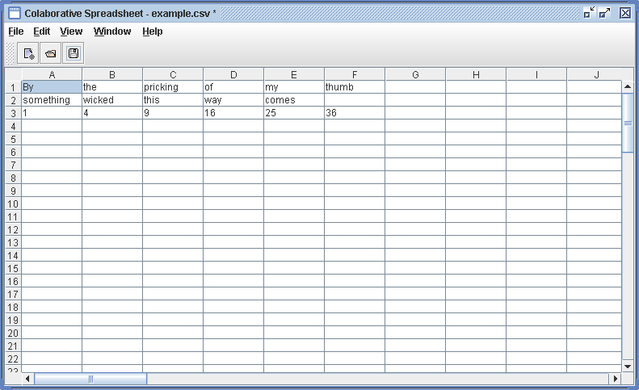

Save

If the current spreadsheet is associated with a filename, activating the Save command writes the current spreadsheet to that file in the CSV format. If the current spreadsheet is not associated with a filename, it delegates to the Save As… command.

Save As…

This command allows the user to associate the current spreadsheet with a filename (if it is not associated with a filename already) or a different filename (if it is associated with a filename already.) This association is made by displaying a file-selection dialog to the user. Once the user selects or enters a file to save, this command activates the Save command.

Close

The Close command closes the current spreadsheet. Before doing so, it checks to see if the spreadsheet has been modified. If so, the user is asked if they would like to save their current spreadsheet before creating a new one, and is presented with a dialog with three options: “Yes”, “No”, and “Cancel”. If the user selects “Yes” then this command activates the Save command before closing. If the user selects “No” then this command proceeds with closing the current spreadsheet. If the user selects “Cancel” then this command aborts, and the current spreadsheet is not closed.

Exit

This command first activates the Close command. Upon successful completion of the Close command, this command gracefully shuts down the Collaborative Spreadsheet.

Demonstration of Collaboration Using the Sync Framework

The Collaborative Spreadsheet is launched through the Sync framework. The easiest way to demonstrate the Collaborative Spreadsheet is to run the “run.bat” batch file in the dist/ directory. This file will:

- Launch the RMI Registry, and wait for the user to press a key.
- Launch the Sync server application, and wait for the user to press a key.
- Launch two Sync clients.

In the first client, open the “Local” folder under the “Sync objects” folder, and select the tree-node of the hostname of the server. Then, select Object -> New -> Spreadsheet in the menu-bar at the top of the window. At this point, the Collaborative Spreadsheet window should pop up.

In the spreadsheet window, add “=A1+A2+A3” into cell A4, and “=4” into cell A1. The value “4.0” should be displayed in both the A1 and the A4 cells. Then, in the Sync Client window, select the entry in the table on the right side of the window, and choose Object -> Synchronize from the menu-bar at the top of the window. At this point, the contents of the spreadsheet have been sent to the server.

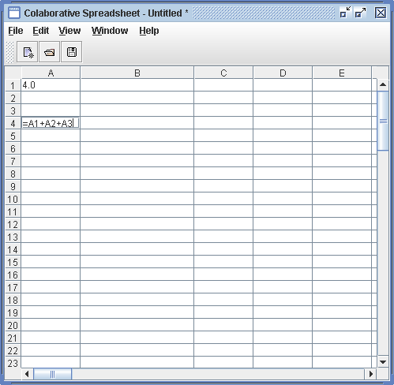

Then, select the second Sync Client window. Open the “Local” folder under the “Sync objects” folder, and select the tree-node of the hostname of the server. Then, choose Object -> Synchronize from the menu-bar at the top of the window. After this, an entry should appear in the table towards the right side of the window. Double click this entry (under any column except the “Name” column), and a Collaborative Spreadsheet window will open. This window should also display the value “4.0” in the A1 and A4 cells.

In the second spreadsheet window, enter the value “2.0” in the A2 cell, the value “=foo” in the B1 cell, and the value “=C2” in the C1 cell. As expected, the A1 cell displays 4.0, the A2 cell displays 2.0, the A4 cell displays 6.0, the B1 cell displays “INVALID FORMULA!”, and the C1 cell displays 0.0.

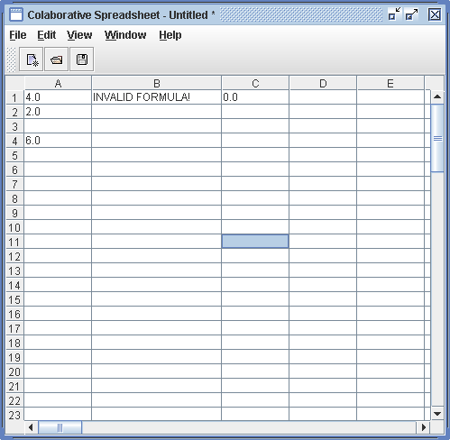

In the first spreadsheet window, enter the value “3.0” in the A3 cell, and the value “=C1” in the C2 cell. As expected, the A1 cell displays 4.0, the A3 cell displays 3.0, the A4 cell displays 7.0, and the C2 cell displays 0.0.

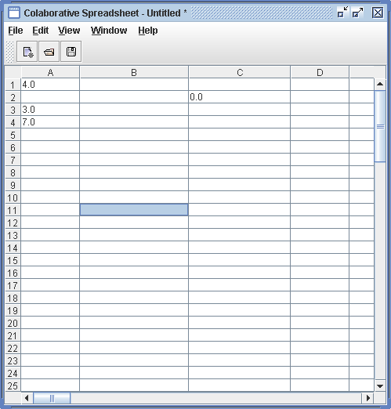

Now, in the first Sync Client window, select Object -> Synchronize in the menu-bar. Then, in the second Sync Client window, select Object -> Synchronize in the menu-bar. At this point, the additions to the first Collaborative Spreadsheet window appear in the second Collaborative Spreadsheet window. Finally, in the first Sync Client window, select Object -> Synchronize one more time.

At this point, both spreadsheets show the same contents. Of particular note, the A4 cell displays 9.0, the sum of the A1, A2, and A3 cells, now complete from the merge. The C1 and C2 cells now form a circular cell reference, and both cells display the “CYCLIC FORMULA!” message:

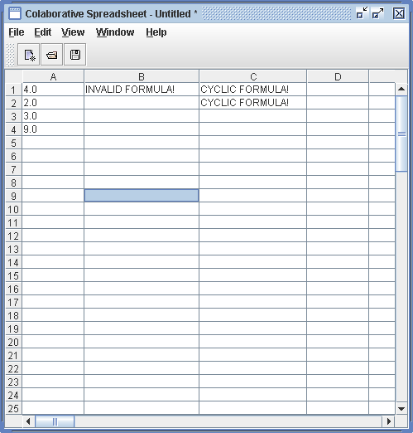

Appendix – Interfaces to Sync Objects

The SyncSpreadSheetTableModel subclasses SpreadSheetTableModel to adapt the interface for use with Sync.

public class SyncSpreadSheetTableModel extends SpreadSheetTableModel implements Serializable, HashtableListenable, HashtableInterface
{
public int size();
public Enumeration keys();
public Enumeration elements();
public Object put(Object key,Object value);
public Object remove(Object key);
public Object get(Object key);
public void addHashtableListener(HashtableListener hashtableListener);
public void removeHashtableListener(HashtableListener hashtableListener);

// Overloaded from SpreadSheetTableModel to notify hashtable listeners as well as table model listeners…
public void setValueAt(Object value,int rowIndex,int columnIndex);
}

The SpreadSheetTableModel maintains a Map from Strings to Cells.

public class Cell implements Serializable
{
public Cell(String value,String cellname);
public String getDisplay();
public String getValue();
public void setValue(String value);
public String toString();
protected String computeDisplay(String value);
}

