Supporting Information for: Hourly Satellite Formaldehyde Columns and Routine Surface Air Toxics Monitoring: Day-to-Day Agreement at 123 United States Sites
[Author list to match the main text.]
Contents: Supporting text S1-S8; Figures S1-S12; Tables S1-S6. 20 pages.

S1. The Colorado sites
CDPHE operates the Colorado Air Toxics Trends (COATTS) network, whose first phase became fully operational on 1 January 2024 and second phase on 1 July 2025²⁵. Surface formaldehyde for all seven sites comes from AQS, the same source as the national comparison (Table S1, Figure S1). CDPHE's 2024 and 2025 annual data packets supply the method detection limit and a sampling temperature and pressure that AQS does not publish, recorded for 118 of the 326 matched days with a defined H_{eff}. The effective mixing height itself is computed from the HRRR meteorology used at every monitor in this study; the packet values are the only independent check on that meteorology available anywhere in the network. The packet temperature agrees with HRRR to +0.5 °C (r = 0.94), whereas the packet pressure is 57 hPa lower (r = 0.56) and about 6 % below the ambient pressure expected at these elevations — what a pressure measured inside the sampling train rather than in open air would look like — and it is therefore not used. Commerce City (Adams County), La Salle (Weld County) and Grand Junction (Mesa County) sampled throughout both years; Colorado Springs (El Paso County), Pueblo (Pueblo County) and Cañon City (Fremont County) began in July 2025; and Wheat Ridge (Jefferson County) began in October 2025. Samples are 24 h integrated collections on a 1-in-6 day schedule, identified by AQS parameter code 43502. AQS reports them in parts per billion carbon, which for a one-carbon molecule equals parts per billion by volume; we converted to mass concentration at 25 °C and 1 atm, exactly as for the rest of the network.
AQS¹⁴ records the time each sample began. For all seven sites this is 00:00 local standard time with a 24 h duration, confirming midnight-to-midnight sampling on the stamped date. AQS gives the method as DNPH-coated silica cartridges with a potassium iodide ozone scrubber, analysed by HPLC with ultraviolet detection, following Compendium Method TO-11A¹⁵; the same method is used at every site. AQS identifies Grand Junction (08-077-0018) as a National Air Toxics Trends Station²⁶.
Two ozone-precursor sites, Chatfield State Park in Douglas County (CHCO) and Platteville in Weld County (PVCO), belong to CDPHE's COOPs network [expand acronym], discontinued at the end of June 2026; its historical data remain available. Both report formaldehyde to AQS as 3 h samples beginning at 06:00 MST, so the sampling window is 06:00-09:00 MST; CDPHE's own packets stamp these samples 09:00, the end of sampling, and confirm the 3 h duration [decide how to cite CDPHE's answers]. Platteville also reported formaldehyde to AQS through 2023 on the same start time and duration, so its record extends back to August 2023; Chatfield reported no 2023 formaldehyde to AQS. The window does not move with daylight saving: AQS records sample times in local standard time, and for every Colorado sample in this study the recorded start is seven hours behind the corresponding GMT stamp in all twelve months, so the 06:00-09:00 window is the same clock interval in summer as in winter. This matters for the lag analysis of S8, which would otherwise compare a summer window with a winter one displaced by an hour.

S2. Quality control
Concentrations come from AQS, and the screen is the one applied throughout the study: records carrying an AQS null data qualifier, which marks a value as invalid or as a quality-control or quality-assurance measurement, are excluded; quality-assurance and informational qualifiers are retained; and duplicate records of the same sampling window are averaged. AQS publishes ambient samples only, so the quality-control samples that CDPHE's own packets list alongside them do not arise. The resulting Colorado record contains 453 site-days with valid concentrations.
The 3 h sites are screened identically. Every AQS sample begins at 06:00 MST, so no sampling window is ambiguous. The resulting record contains 115 samples at Chatfield State Park (8 February 2024-27 December 2025) and 119 at Platteville (4 August 2023-18 July 2025; later 2025 samples were not collected because of sampling problems), all of which enter the analysis.

S3. TEMPO extraction and the national comparison
TEMPO is an ultraviolet-visible grating spectrometer in geostationary orbit that scans North America from east to west approximately hourly during daylight⁵. Level 3 files grid Level 2 retrievals from each scan to a regular 0.02° × 0.02° grid using area weighting. Each file provides the HCHO vertical column and its uncertainty, a main data quality flag, effective cloud fraction, snow and ice fraction, solar zenith angle and, new in version 4, a planetary boundary layer height as support data¹⁷. That height is taken from the GEOS-CF version 2 model, is not used in the retrieval itself, and is supplied for interpretation; it is a modelled quantity, and the comparisons with H_{eff} below should be read with that in mind. At the hours TEMPO observes it runs deeper than the HRRR analysis, as set out in the next paragraph.
Near-surface meteorology. Temperature and pressure for the number density come from the NOAA High-Resolution Rapid Refresh (HRRR) analysis, averaged over the UTC hours each sample spans; the same field is used at every monitor and in every arm. Only three fields are read from each hourly file — 2 m temperature, surface pressure and boundary-layer height — retrieved by byte range from the file’s index, so the archive is not downloaded in full. Figure S4 and Table S3 compare that field with the meteorology supplied with the TEMPO retrieval and with the CDPHE sampler sensors. Surface pressure agrees closely: a median difference of −0.6 hPa over 10,465 matched samples, with r = 0.9995. The boundary-layer heights do not. Averaged over the same scan hours, the GEOS-CF height supplied with the retrieval is a median 155 m deeper than HRRR (r = 0.83), a gap that widens nationally from +99 m in winter to +178 m in autumn and reaches +326 m at the Colorado 24 h sites. Comparing TEMPO’s daylight-only scan mean with an HRRR mean over the whole sampling window would put that difference at +371 m, but half of a 24 h window is night, when the boundary layer is shallow; the scan-hour comparison is the like-for-like one and is what Table S3 reports. The CDPHE packet temperature agrees with HRRR to +0.5 °C (r = 0.94), whereas the packet pressure is 57 hPa lower (r = 0.56), which is why the packet temperature is used as a check on the meteorology and the packet pressure is not used at all.
For the Colorado sites, granules were identified with NASA's Common Metadata Repository and assigned to a sampling period when the midpoint of the scan's time coverage fell within it. For the 24 h samples this gave 1582 granules on 146 of the 151 sampling dates; no TEMPO observations were available on the other 5 dates. For the 3 h samples, scans between 03:00 and 19:00 MST were retrieved (988 granules on 146 of the 153 sampling dates).
The national arm repeats the analysis at every AQS site with three differences forced by its scale. First, extraction: requesting a separate OPeNDAP subset for each of 123 sites would multiply the number of requests by the number of sites, so sites were grouped into 58 clusters of at most 1.25° latitude by 2.5° longitude, one subset was requested per cluster and scan, and the 5 × 5 cell block around each site was cut from it afterwards. Only scans a cluster's samples actually require were retrieved: the days a site sampled, and for sub-daily samples the sampling window padded by 3 h on each side. The extraction holds 79 493 cluster-scans with retrievable cells and 3.97 million cell records. Second, matching is by UTC hour set as described in the main text; nearly every AQS sampling window begins on the hour, and the one exception in this record, an 8 h sample at Los Angeles-North Main Street beginning at 08:15, is assigned to the hour its window begins in and named in the run log. Lags are applied only to sub-daily samples, since a 24 h window shifted by a few hours is almost the same window, and only to ±3 h, the padding the extraction retrieved; the +6 and +9 h windows are evaluated only for the Colorado 3 h sites, whose extraction covers 03:00-19:00 MST. Third, the pooled regression uses ordinary least squares with fixed effects for site and calendar month rather than a mixed model, because the number of sites is large. Wildfire smoke is classified for the national arm as well as the Colorado one; the national sampling windows come from AQS start and end times, so unlike the Colorado arms they carry no single time-zone offset.

S4. Statistical detail
Because both variables contain measurement error, we report reduced major axis (RMA) regression slopes with 95 % confidence intervals from 1000 bootstrap resamples, except 200 for the national site-level, state-level and smoke-class breakdowns and the Colorado site-by-season breakdown, where many groups are fitted. A pooled group with fewer than five sites falls back to a row bootstrap and is marked descriptive in the tables. Slopes are computed for every group whether or not the correlation is significant; where r is near zero the RMA slope, being the ratio of standard deviations carrying the sign of r, has an unstable sign, and the bootstrap interval shows that directly. The figures draw a fitted line only where the Pearson correlation reaches p < 0.05, so as not to suggest a relationship the data do not support. Intervals for pooled slopes resample sites with replacement, because the same monitors contribute many samples each; intervals for a single site resample that site's own samples and are descriptive, the 1-in-6 day schedule leaving little day-to-day dependence to preserve. For the 3 h samples, with only two sites, the column coefficient comes from ordinary least squares with fixed effects for site and calendar month. Where correlations are reported for many sites at once we give both the number significant at a nominal p < 0.05 and the number surviving a Benjamini-Hochberg false-discovery-rate correction applied across that family of tests (Table S2), using the permutation p-values described below for day-to-day correlations and the ordinary test for whole-period ones; the distribution of the correlations themselves is more informative than either count.
Correlations between within-site-month anomalies are tested by permutation rather than by the ordinary correlation test. The site-month means are estimated from the same observations that then enter the correlation, so the parametric p-value spends degrees of freedom it does not have and is optimistic. We permute one variable within each site × year-month stratum and recompute the pooled correlation 2000 times, comparing the observed |r| with the permutation distribution; because a permutation leaves a stratum's mean unchanged, this holds the removed structure fixed rather than assuming it away. Every anomaly p-value reported here is such a permutation value, and the smallest attainable with 2000 permutations is 1/2001 = 0.0005. Whole-period correlations, Williams' tests for dependent correlations and the fixed-effects models use their usual parametric tests. For 8 h and 3 h samples a site-month stratum pools the windows a site samples (two usable 8 h blocks, three or four 3 h windows), so the anomaly also contains the systematic difference between windows. Stratifying by start hour as well gives 0.38 at the 8 h sites (n = 3483 in 477 site-month-windows, permutation p = 0.0005) and 0.33 at the 3 h sites (n = 369 in 56, p = 0.0005), against 0.38 and 0.39 pooled over windows (Table 1). At the 8 h sites, which sample every block on every sampling day, the two are indistinguishable; at the 3 h sites the pooled figure is 0.06 higher, the size of the diurnal contribution. The pooled figures are the ones tabulated.
The uncertainty attached to a screened scan is the root mean square of the reported uncertainties of the passing cells in the block, not a propagated uncertainty for their mean. This is the fully correlated limit: it assumes neighbouring retrieval errors move together and so takes no √n reduction from averaging. We adopt it deliberately, as the conservative choice, and because the noise analysis (Text S5) shows that the empirical scan-to-scan spread, not the reported uncertainty, is what limits agreement; the correlated and independent limits of the reported uncertainty are compared with it there.
Where two correlations share a variable — for example the surface concentration correlated with the column in two different windows — we compare them with Williams' test for dependent correlations¹⁸ on the samples usable in both, with a bootstrap confidence interval for the difference. We use the spread of TEMPO surface pressure across each averaging block as an index of terrain heterogeneity. At the 24 h sites, where the sample spans every window, we compare the column averaged over valid scans in 06:00-09:00 local standard time with that in 09:00-12:00 on the same site-days, on all days with a valid scan in both windows and on within-month anomalies of those days (site-months with at least three), with Williams' test; a site-level comparison is made where a site has at least 20 anomaly days. Any difference here reflects the retrievals rather than the sampling time, which is the control the 3 h lag analysis needs.

S5. Retrieval-noise estimator
Differences between successive valid scans of the same site and day no more than 1.6 h apart, divided by the square root of two, give an empirical noise standard deviation for a single scan. This is an upper bound, because the column genuinely changes between scans, and it is blind to errors that persist through a day. Squaring this quantity gives a single-scan noise variance, and dividing that variance by the number of valid scans estimates the noise variance of the daily mean, scaled by 1 - 1/n for the n days of the site-month whose mean was removed; comparing it with the variance of the within-month anomalies gives the share of that variance which is noise and the correlation ceiling that noise alone implies, the square root of one minus the noise share. The estimator is applied at every 24 h site in the national comparison (Figure S7); a site is scored when it has at least 20 successive-scan pairs and 10 anomaly pairs, which 90 of the 97 sites do with a defined ceiling; at 2 more the noise bound exceeds the anomaly variance, so no ceiling is defined and they are left out of the site-level summaries. We computed the same quantity from the uncertainties reported in the product at the Colorado sites, with block cells treated as fully correlated and as independent: those bounds imply ceilings between 0 and 0.44 depending on the assumption, all below the 0.72 the empirical estimate gives there, which is why the reported uncertainties are not taken at face value.

S6. Smoke classification
A sampling period was classified as smoke-affected when a NOAA Hazard Mapping System polygon covered the site and the polygon's start-end interval overlapped the sampling window^{21,22}. We used the daily HMS shapefiles²⁷ for all 660 days touched by the sampling windows (0 could not be downloaded). HMS polygons are analyst delineations from discrete visible satellite imagery issued at a few analysis times a day, so an hour not covered by any polygon interval is not thereby established as free of smoke, and a short sampling window can fall between analysis times on a day when smoke was present throughout. We consequently widened each sampling window by 3 h on either side before testing temporal overlap, and also recorded whether any polygon covered the site on the relevant HMS days regardless of time. For the Colorado arms this had little influence: strict temporal overlap identified 39 of the 234 three-hour sampling windows as smoke-affected against 41 with the widened window, and the 453 24 h samples were classified identically. Nationally it matters more: strict overlap flags 4899 of the 16 383 windows (29.9 %) against 6268 (38.3 %) with the widened window, because 8 h and 3 h windows elsewhere often fall between HMS analysis times; every smoke result reported uses the widened window. Each period was assigned the highest density class of the overlapping polygons and grouped as none, light or medium-heavy; a polygon without a density attribute counts as light, and a polygon whose start or end time cannot be parsed counts for the whole HMS day. Classifications of short sampling periods using HMS should allow for the discrete times at which the analyses are made.

S7. Software and reproducibility
All processing was done in R version 4.3.3¹⁹, using httr2 for data access, ncdf4 for netCDF files, sf for spatial operations²⁸ and lme4 for mixed-effects models²⁹. A single script downloads the AQS samples and the CDPHE data packets, queries and subsets TEMPO granules, downloads HMS shapefiles, and produces all tables and figures; the national TEMPO extraction, about 85 000 OPeNDAP requests, is switched on by a configuration flag (run_aqs_tempo) because it takes days, and the extracted cells are cached so that every later step re-runs from them. The analysis period is fixed, downloaded inputs are cached with MD5 checksums, the exact OPeNDAP constraint expression is recorded, and each run logs its configuration and R session information. The terrain in Figure S1 comes from the AWS Terrain Tiles on the Registry of Open Data on AWS³⁰, retrieved with the elevatr R package³¹, and the state and county boundaries are US Census cartographic boundary files³².

S8. Further results
Effective mixing height at the Colorado sites. H_{eff} is computed from the same HRRR meteorology at every monitor in this study; the seven Colorado 24 h sites are distinctive only in carrying an independent sampling temperature against which that meteorology can be checked (S1). From winter to summer, median surface HCHO on matched days increased from 2.09 to 3.56 µg m⁻³ (1.7-fold), whereas the median column increased from 2.18 to 6.63 × 10¹⁵ molecules cm⁻² (3.0-fold). Median H_{eff} increased from 0.61 km in winter and 0.66 km in spring to 1.06 km in summer, and was 0.81 km in autumn (Figure S6). Across all matched days median H_{eff} was 0.82 km against a median TEMPO PBL height of 1.55 km, with the two closest in winter (0.61 against 0.64 km). By site, median H_{eff} ranged from 0.71 km at Grand Junction and 0.76 km at Commerce City to 1.03 km at Colorado Springs and 1.10 km at Cañon City, with 0.46 km at Wheat Ridge on its nine days with a defined H_{eff}. Why Colorado's H_{eff} is low relative to the national value we can only suggest: its monitors sit at high elevation in semi-arid terrain, where the modelled boundary layer is deep in summer while HCHO may remain concentrated near its sources [hypothesis - not tested here]. The larger seasonal amplitude of the column is unlikely to arise solely from retrieval seasonality: across the Pandonia network TEMPO reproduces the observed seasonal amplitude closely, with winter, spring and autumn medians lower than summer by 62 %, 45 % and 29 % against 66 %, 48 % and 28 % in the co-located Pandora record⁸.
Three-hour samples. Under the primary screening, 54 of 115 samples at Chatfield State Park (47 %) and 56 of 119 at Platteville (47 %) had a valid scan inside the 06:00-09:00 MST sampling window, with a median of two scans per window (Table S4). The window beginning when sampling ends had better coverage, 63 % and 61 % for 09:00-12:00; 12:00-15:00 gave 45 % and 54 %. No scan passed screening in the 03:00-06:00 window, and only seven Platteville samples in 15:00-18:00, because of the solar zenith angle limit. Inside the sampling window, 36 % of block cells failed the solar zenith angle criterion, against 4 % three hours later.
The two sites behave differently, and that difference is the result. At Chatfield State Park the sampling window carries almost no day-to-day information (within-month anomaly r = -0.01, n = 47) while the window three hours later carries a good deal (0.48, n = 64, p = 0.001) and the window after that little (0.18, n = 34, p = 0.40). At Platteville the same three windows give 0.24 (n = 43, p = 0.16), 0.15 (n = 64, p = 0.26) and -0.01 (n = 51, p = 0.97): none of them significant, and no advantage for the later window. Pooled over both sites the values are 0.12 (n = 90, p = 0.26), 0.31 (n = 128, p = 0.0005) and 0.06 (n = 85, p = 0.62). Whole-period correlations show the same split: 0.24 and 0.56 at Chatfield, 0.48 and 0.36 at Platteville (Figures S8 and S9, Table S4).
The 2023 extension adds samples at Platteville and none at Chatfield, and Platteville is the site whose ordering between the two windows differs, so we recomputed both sites on 2024-2025 alone (Table S6). Chatfield is unchanged, having no 2023 record. At Platteville the later window has no advantage in either period, which is what we claim; but the apparent preference for the sampling window is period-dependent. On 2024-2025 alone the two windows are indistinguishable (anomalies 0.25 on 32 samples against 0.26 on 51), whereas with 2023 the sampling window is nominally ahead (0.24 on 43 against 0.15 on 64). No Platteville anomaly correlation is significant in either period. We therefore claim only that Chatfield gains substantially from the later window and Platteville does not, and not that Platteville does better during sampling.
Because coverage differs between windows we repeated the comparison on the samples usable in both, 50 at Chatfield and 52 at Platteville (42 and 38 once site-months with fewer than three samples are dropped for the anomalies). On within-month anomalies the gain from waiting three hours is 0.57 at Chatfield (from -0.16 to 0.41; Williams' test p = 0.008, bootstrap interval 0.21 to 0.88) and 0.07 at Platteville (0.17 to 0.24; p = 0.71, interval -0.20 to 0.35). Pooled over both sites it is 0.29 (0.02 to 0.31; Williams' test p = 0.045, bootstrap interval 0.05 to 0.52). We report the pooled value for completeness and rest nothing on it: it averages two monitors that disagree.
The median TEMPO boundary layer height over the matched scans was 0.45 km during sampling, 1.50 km three hours later and 2.21 km six hours later, while the median effective mixing height stayed between 0.93 and 0.97 km at every lag; the columns themselves differ substantially from day to day at Chatfield State Park (r = 0.27 between the two windows) and agree more closely at Platteville (0.61) (Figure S10).
Wildfire smoke. Across the network, 6268 of 16 383 sampling windows (38 %) were flagged smoke-affected, and 4097 of the 10017 that also carried a usable TEMPO observation. Agreement was higher on smoke days at both well-sampled durations (Table S5, Figure S11). At the 24 h sites the correlation between surface HCHO and the column was 0.29 on smoke-free days (n = 3950), 0.38 under light smoke (n = 1854) and 0.47 under medium-heavy smoke (n = 302); at the 8 h sites it was 0.22 (n = 1675), 0.42 (n = 1599) and 0.49 (n = 235). Excluding smoke days lowered the day-to-day correlation from 0.40 to 0.24 at the 24 h sites (n = 5218 to 2645) and from 0.38 to 0.27 at the 8 h sites (n = 3509 to 1610). Median columns under smoke were roughly double those without, 4.07 against 8.83 × 10¹⁵ molecules cm⁻² at the 24 h sites and 9.08 against 12.07 at the 8 h sites, while surface concentrations rose proportionately less; the improvement therefore follows the concentration dependence described in the main text rather than anything specific to smoke chemistry. The 3 h classes hold 295, 95 and 12 samples and are not interpreted.
Checks at the Colorado sites. Three checks made at the Colorado sites, which the main text cites, are recorded here. First, the retrieval-noise ceilings computed at these sites by the Colorado arm of the pipeline agree with those from the national estimator: La Salle and Cañon City lie close to their ceilings (noise-corrected day-to-day correlations 0.84 and 0.85), Commerce City is intermediate (0.67) and Grand Junction far below (0.29). Terrain inside the averaging block does not account for that ordering: the spread of TEMPO surface pressure across the 3 × 3 block is smallest at Commerce City (1.8 hPa) and largest at Cañon City (11.5 hPa), the opposite of what the site correlations would require. Second, restricting scans to 10:00-14:00 MST lowered the pooled whole-period correlation at these sites for every block size (0.38, 0.50 and 0.59 for 1 × 1, 3 × 3 and 5 × 5 blocks, against 0.47, 0.56 and 0.61 with all daylight scans), so the all-day mean is the better match to a 24 h sample. Third, smoke: it covered 69 of the 453 Colorado 24 h sample days (15 %), against 38 % of national windows, and there the whole-period correlation was lower on smoke days (0.46 smoke-free, n = 276; 0.36 under light smoke, n = 48; 0.37 under medium-heavy smoke, n = 14), the opposite of the national pattern, although excluding smoke days lowered the day-to-day correlation as it does nationally (0.30 to 0.23). With 276 smoke-free samples against 3950 the national estimate is the better powered of the two. Smoke-flagged days there were not simply clear days: within season the median cloud fraction was the same on smoke and smoke-free days (0.16 against 0.18 in summer, p = 0.52; 0.13 against 0.13 in autumn, p = 0.82).
Table S1. Colorado monitoring sites, periods and sample counts. Matched days are samples with at least one TEMPO scan passing the primary screening. Medians are for all valid samples in each year.
Site (code) | AQS ID | County | Lat (°N) | Lon (°E) | Period | Samples | Matched | Median HCHO (µg m⁻³)
24 h COATTS samples
Grand Junction (GPCO) | 08-077-0018 | Mesa | 39.064 | −108.562 | 2024–2025 | 123 | 105 | 2.33 (2024), 2.70 (2025)
Cañon City (CNCO) | 08-043-0004 | Fremont | 38.469 | −105.208 | Jul–Dec 2025 | 26 | 21 | 1.41
Wheat Ridge (JFCO) | 08-059-0015 | Jefferson | 39.781 | −105.108 | Oct–Dec 2025 | 15 | 10 | 2.70
Commerce City (ADCO) | 08-001-0010 | Adams | 39.828 | −104.936 | 2024–2025 | 120 | 84 | 2.95 (2024), 3.32 (2025)
Colorado Springs (COCO) | 08-041-0017 | El Paso | 38.848 | −104.829 | Jul–Dec 2025 | 29 | 23 | 2.46
La Salle (LSCO) | 08-123-0015 | Weld | 40.261 | −104.706 | 2024–2025 | 110 | 70 | 2.09 (2024), 2.21 (2025)
Pueblo (POCO) | 08-101-0017 | Pueblo | 38.236 | −104.581 | Jul–Dec 2025 | 30 | 25 | 2.46
3 h COOPs ozone-precursor samples
Chatfield State Park (CHCO) | 08-035-0004 | Douglas | 39.534 | −105.070 | Feb 2024–Dec 2025 | 115 | 54ª | 1.96 (2024), 2.95 (2025)
Platteville (PVCO) | 08-123-0008 | Weld | 40.209 | −104.824 | Aug 2023–Jul 2025 | 119 | 56ª | 2.58 (2023), 2.70 (2024), 2.95 (2025)
ª Matched samples with at least one screened TEMPO scan inside the 06:00-09:00 MST sampling window. Identifiers are AQS site codes. Site names are CDPHE's; AQS records some stations under a different name, Wheat Ridge as Peak Expeditionary School and Pueblo as St. Charles Mesa Water District.
Table S2. Site-level correlations reaching nominal and false-discovery-rate significance, by sample duration. Counts are over site-duration combinations with at least 10 matched samples, at the primary screening and with scans inside the sampling window. The Benjamini-Hochberg correction is applied across all 141 tests in each family. Whole-period counts use the ordinary correlation test; day-to-day counts use the within-site-month permutation test (Text S4), which is the stricter of the two - the ordinary test applied to the same anomalies would give 103 and 102 rather than 96 and 93. These counts are reported for completeness; the distribution of the correlations themselves is more informative, and no conclusion in the paper depends on a count.
Duration | Sites | Whole period, p < 0.05 | Whole period, BH q < 0.05 | Day-to-day, p < 0.05 | Day-to-day, BH q < 0.05
24 h | 97 | 85 | 84 | 61 | 58
8 h | 40 | 34 | 34 | 33 | 33
3 h | 4 | 3 | 3 | 2 | 2
All | 141 | 122 | 121 | 96 | 93

Table S3. The HRRR meteorology compared with the meteorology supplied with the TEMPO retrieval and with the CDPHE sampler sensors. Difference is the median of the paired differences (TEMPO minus HRRR, or packet minus HRRR) and need not equal the difference of the two medians. Boundary-layer depths are averaged over the UTC hours in which each sample's valid TEMPO scans fell; the penultimate row repeats the all-arms comparison with HRRR averaged over the whole sampling window instead, which is not like for like because TEMPO observes only in daylight while a 24 h window is half night.
Quantity and arm | n | HRRR | TEMPO or packet | Difference | r
Surface pressure (hPa), Colorado 24 h | 338 | 849.5 | 849.0 | −1.6 | 0.9930
Surface pressure (hPa), Colorado 3 h | 110 | 841.3 | 840.8 | −1.2 | 0.9966
Surface pressure (hPa), national | 10,017 | 998.3 | 997.3 | −0.6 | 0.9993
Surface pressure (hPa), all arms | 10,465 | 997.5 | 996.5 | −0.6 | 0.9995
Boundary-layer depth (m), Colorado 24 h | 338 | 994 | 1550 | +326 | 0.77
Boundary-layer depth (m), Colorado 3 h | 110 | 238 | 451 | +167 | 0.63
Boundary-layer depth (m), national | 10,017 | 848 | 1062 | +152 | 0.83
Boundary-layer depth (m), all arms | 10,465 | 845 | 1065 | +155 | 0.83
Boundary-layer depth (m), all arms, HRRR over the whole sampling window instead | 10,465 | 608 | 1065 | +371 | 0.77
Sampling temperature (°C), Colorado 24 h | 124 | 9.2 | 9.4 | +0.5 | 0.94
Sampling pressure (hPa), Colorado 24 h | 124 | 851.7 | 798.9 | −57.1 | 0.56
Table S4. Comparison of 3 h surface HCHO at the two Colorado sites (Chatfield 2024-2025, Platteville August 2023-2025) with the mean of valid TEMPO scans in the sampling window (06:00-09:00 MST) and in windows shifted 3 and 6 h later (primary screening, 3 × 3 cells).
 | Sampling window (06-09 MST) | +3 h (09-12 MST) | +6 h (12-15 MST)
Matched samples, Chatfield State Park | 54 of 115 (47 %) | 72 of 115 (63 %) | 52 of 115 (45 %)
Matched samples, Platteville | 56 of 119 (47 %) | 72 of 119 (61 %) | 64 of 119 (54 %)
Median scans per window | 2 | 3 | 1
Pearson r, both sites | 0.36 (n = 110, p < 0.001) | 0.49 (n = 144, p < 0.001) | 0.18 (n = 116, p = 0.048)
Pearson r, Chatfield State Park | 0.24 (n = 54, p = 0.08) | 0.56 (n = 72, p < 0.001) | 0.11 (n = 52, p = 0.44)
Pearson r, Platteville | 0.48 (n = 56, p < 0.001) | 0.36 (n = 72, p = 0.002) | 0.24 (n = 64, p = 0.06)
Within-month anomaly r, both sites | 0.12 (n = 90, p = 0.26) | 0.31 (n = 128, p = 0.0005) | 0.06 (n = 85, p = 0.62)
Within-month anomaly r, Chatfield State Park | -0.01 (n = 47, p = 0.93) | 0.48 (n = 64, p = 0.001) | 0.18 (n = 34, p = 0.40)
Within-month anomaly r, Platteville | 0.24 (n = 43, p = 0.16) | 0.15 (n = 64, p = 0.26) | -0.01 (n = 51, p = 0.97)
Column coefficient with site and month effects | 0.035 ± 0.036 (p = 0.33) | 0.121 ± 0.036 (p = 0.001) | -0.011 ± 0.029 (p = 0.71)
Median H_{eff} / median TEMPO PBL height (km) | 0.97 / 0.45 | 0.95 / 1.50 | 0.93 / 2.21
Anomaly p-values are within-site-month permutation values (Text S4); the smallest attainable is 0.0005. Whole-period p-values are the ordinary parametric test. The -3 h window (03-06 MST) contained no usable scans; the +9 h window (15-18 MST) yielded seven Platteville samples and is not shown. The column coefficient is in µg m⁻³ per 10¹⁵ molecules cm⁻².
Table S5. Agreement between surface HCHO and the TEMPO column by HMS smoke class over the site during the sampling window, for every duration in the national comparison, at the primary screening with scans inside the sampling window. Medians are over matched samples. The 3 h medium–heavy class holds too few samples to interpret.
Duration | Smoke class | Matched samples | Pearson r | Surface HCHO (µg m⁻³) | Column (10¹⁵ molecules cm⁻²) | H_{eff} (km)
24 h | none | 3950 | 0.29 | 2.09 | 4.07 | 0.93
24 h | light | 1854 | 0.38 | 3.19 | 8.83 | 1.35
24 h | medium–heavy | 302 | 0.47 | 3.41 | 8.52 | 1.28
8 h | none | 1675 | 0.22 | 3.93 | 9.08 | 1.19
8 h | light | 1599 | 0.42 | 4.42 | 12.07 | 1.33
8 h | medium–heavy | 235 | 0.49 | 4.18 | 11.11 | 1.28
3 h | none | 295 | 0.47 | 3.81 | 8.20 | 0.99
3 h | light | 95 | 0.34 | 4.05 | 10.98 | 1.18
3 h | medium–heavy | 12 | 0.70 | 3.93 | 9.82 | 1.00
Smoke-affected samples nationally: 4097 of 10017 matched samples carrying a classification.
Table S6. Does the 2023 extension create the difference between the two sites? Both 3 h sites recomputed on 2024-2025 alone, beside the record as analysed. Chatfield State Park reported no 2023 formaldehyde, so its values are identical in the two periods and are given once.
 | Sampling window (06-09 MST) | +3 h (09-12 MST) | +6 h (12-15 MST)
Platteville, whole-period r, 2024-2025 only | 0.54 (n = 44) | 0.46 (n = 56) | 0.25 (n = 51)
Platteville, whole-period r, with 2023 | 0.48 (n = 56) | 0.36 (n = 72) | 0.24 (n = 64)
Platteville, anomaly r, 2024-2025 only | 0.25 (n = 32, p = 0.23) | 0.26 (n = 51, p = 0.07) | -0.09 (n = 40, p = 0.60)
Platteville, anomaly r, with 2023 | 0.24 (n = 43, p = 0.16) | 0.15 (n = 64, p = 0.26) | -0.01 (n = 51, p = 0.97)
Chatfield State Park, anomaly r (no 2023 record) | -0.01 (n = 47, p = 0.93) | 0.48 (n = 64, p = 0.001) | 0.18 (n = 34, p = 0.40)
Anomaly p-values are within-site-month permutation values (Text S4). The later window has no advantage at Platteville in either period, which is the claim made in the text; the apparent preference for the sampling window appears only once 2023 is included, and no Platteville anomaly correlation is significant in either period.
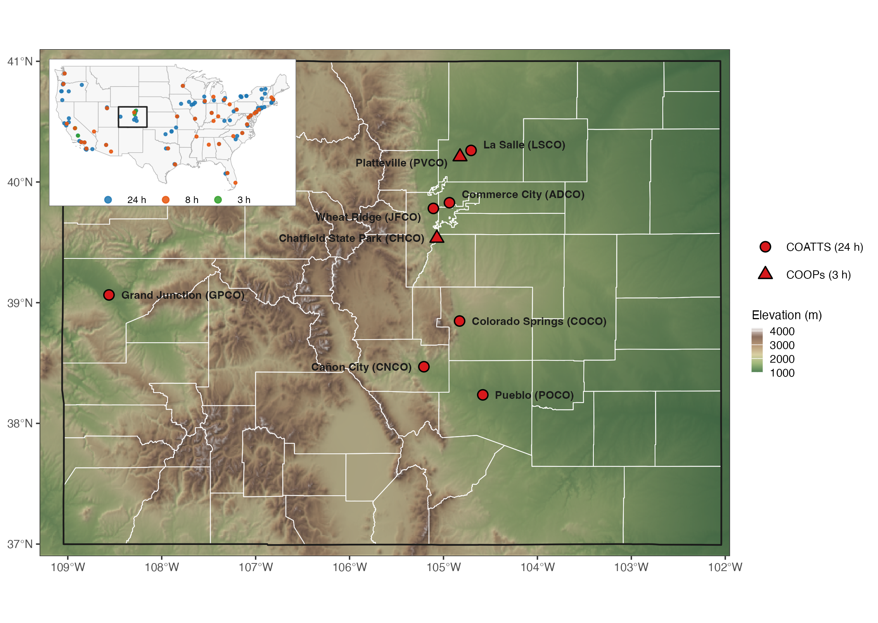
Figure S1. The Colorado sites: seven COATTS sites sampling 24 h integrated formaldehyde (circles) and two COOPs sites sampling 3 h integrated formaldehyde (triangles), over terrain and county boundaries. Inset: the 123 sites across the contiguous United States that reported formaldehyde to AQS in 2024-2025, coloured by sample duration, with Colorado outlined. Elevation is from AWS terrain tiles; boundaries are US Census cartographic files.
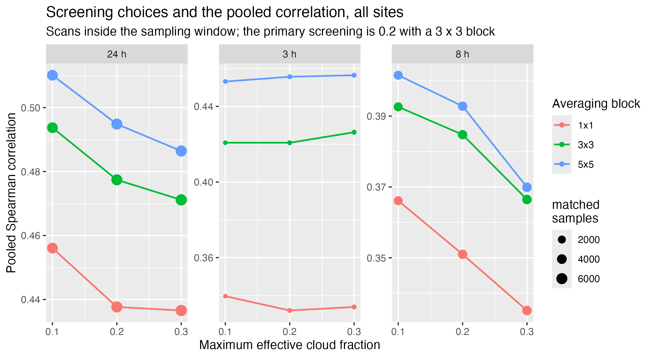
Figure S2. Pooled Spearman correlation between surface HCHO and the mean TEMPO column at every site in the comparison, as a function of the maximum effective cloud fraction and the averaging block (1 x 1, 3 x 3 or 5 x 5 cells), for scans inside the sampling window. Panels are sample duration; symbol size is the number of matched samples. The primary screening used throughout is a cloud fraction of 0.2 with a 3 x 3 block. The Pearson values quoted in the text follow the same ordering.
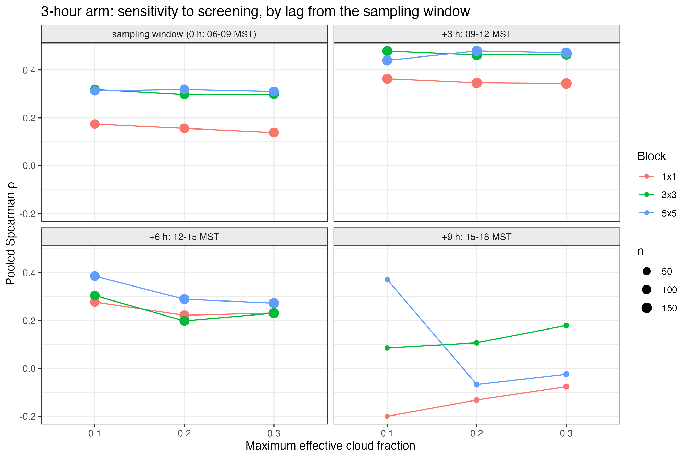
Figure S3. Pooled Spearman correlation between 3 h surface HCHO and the window-mean TEMPO column as a function of the maximum effective cloud fraction and the averaging block, for each lag from the sampling window. Symbol size shows the number of matched samples.
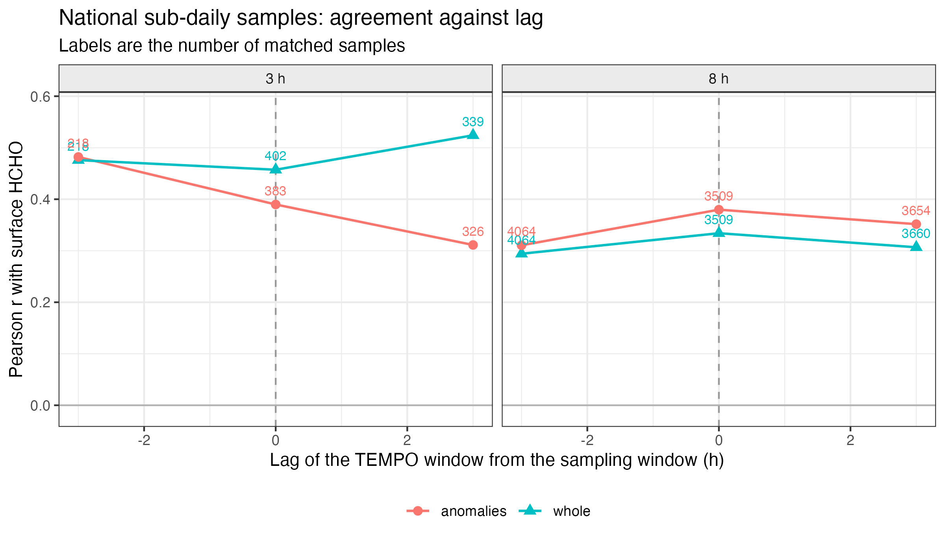
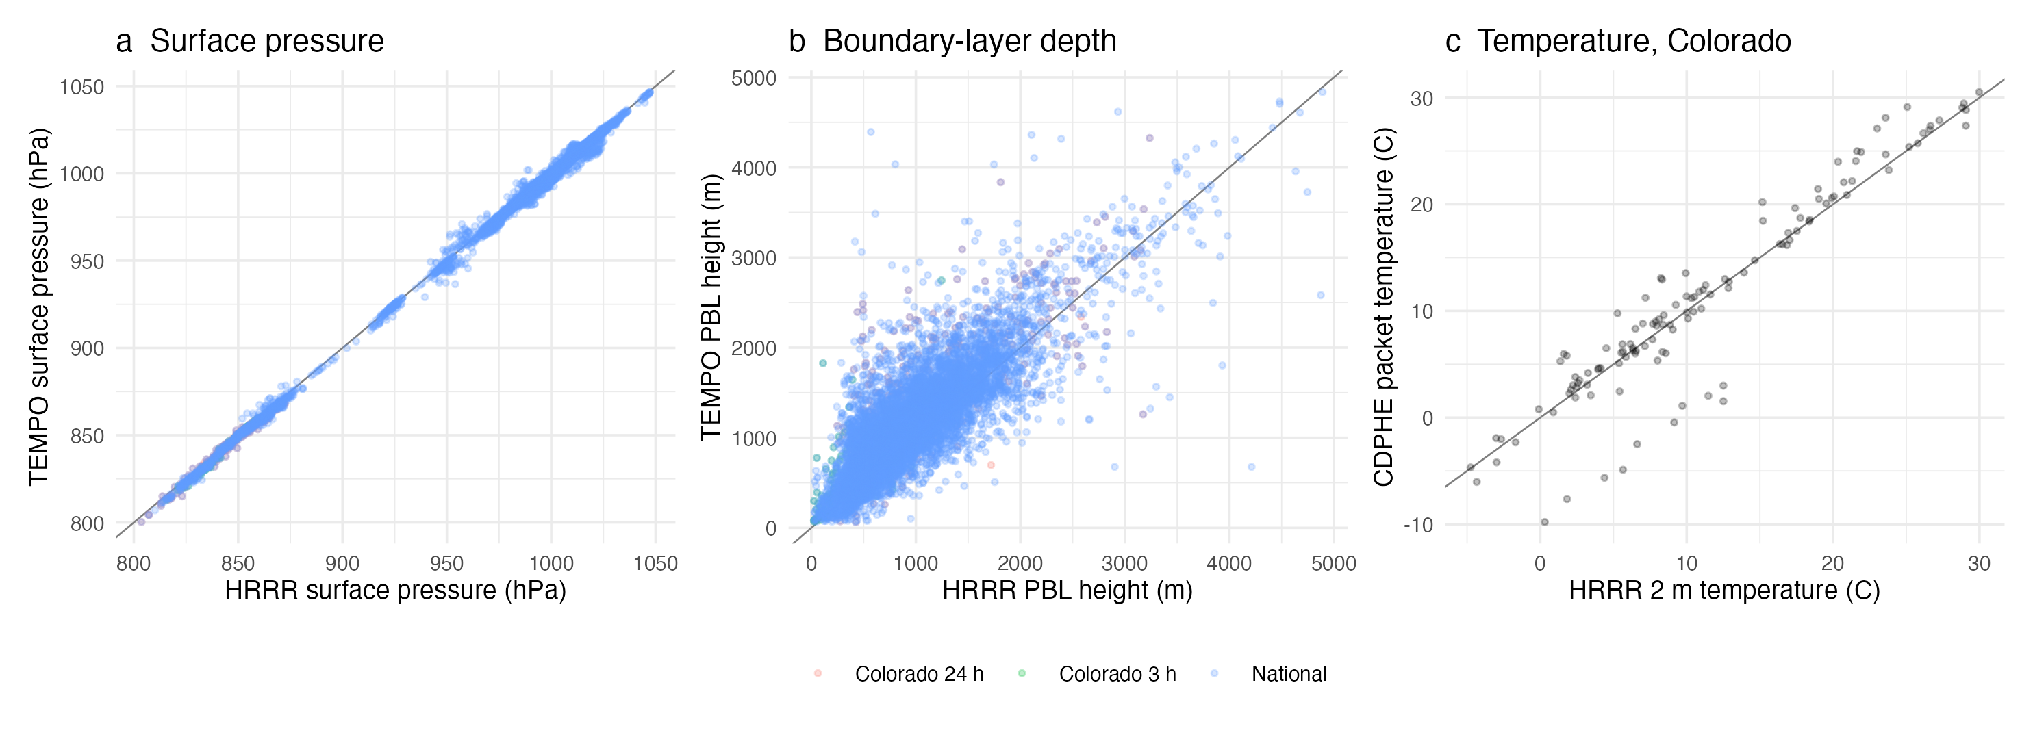
Figure S4. The HRRR meteorology used for the number density, compared with the meteorology supplied with the TEMPO retrieval and with the CDPHE sampler sensors, over the 10,465 matched samples of all three arms. (a) Surface pressure, HRRR against the value supplied with the retrieval. (b) Boundary-layer depth, HRRR against the GEOS-CF height supplied with the retrieval; both are averaged over the UTC hours in which that sample's valid TEMPO scans fell, so the two are sampled at the same times. (c) Two-metre temperature at the seven Colorado 24 h sites, HRRR against the temperature recorded in the CDPHE data packets. Colours denote the arm in (a) and (b); panel (c) draws the Colorado 24 h arm alone. The line is 1:1.
Figure S5. Pooled correlation between sub-daily surface HCHO and the mean TEMPO column as a function of the lag of the TEMPO window from the sampling window, for the 3 h and 8 h sites. "Whole" uses the concentrations as measured; "anomalies" uses deviations from site-month means. Labels give the number of matched samples. Because the sites pooled here sample different windows, a given lag corresponds to different times of day at different sites, which is why the main text reports agreement by window start hour instead.
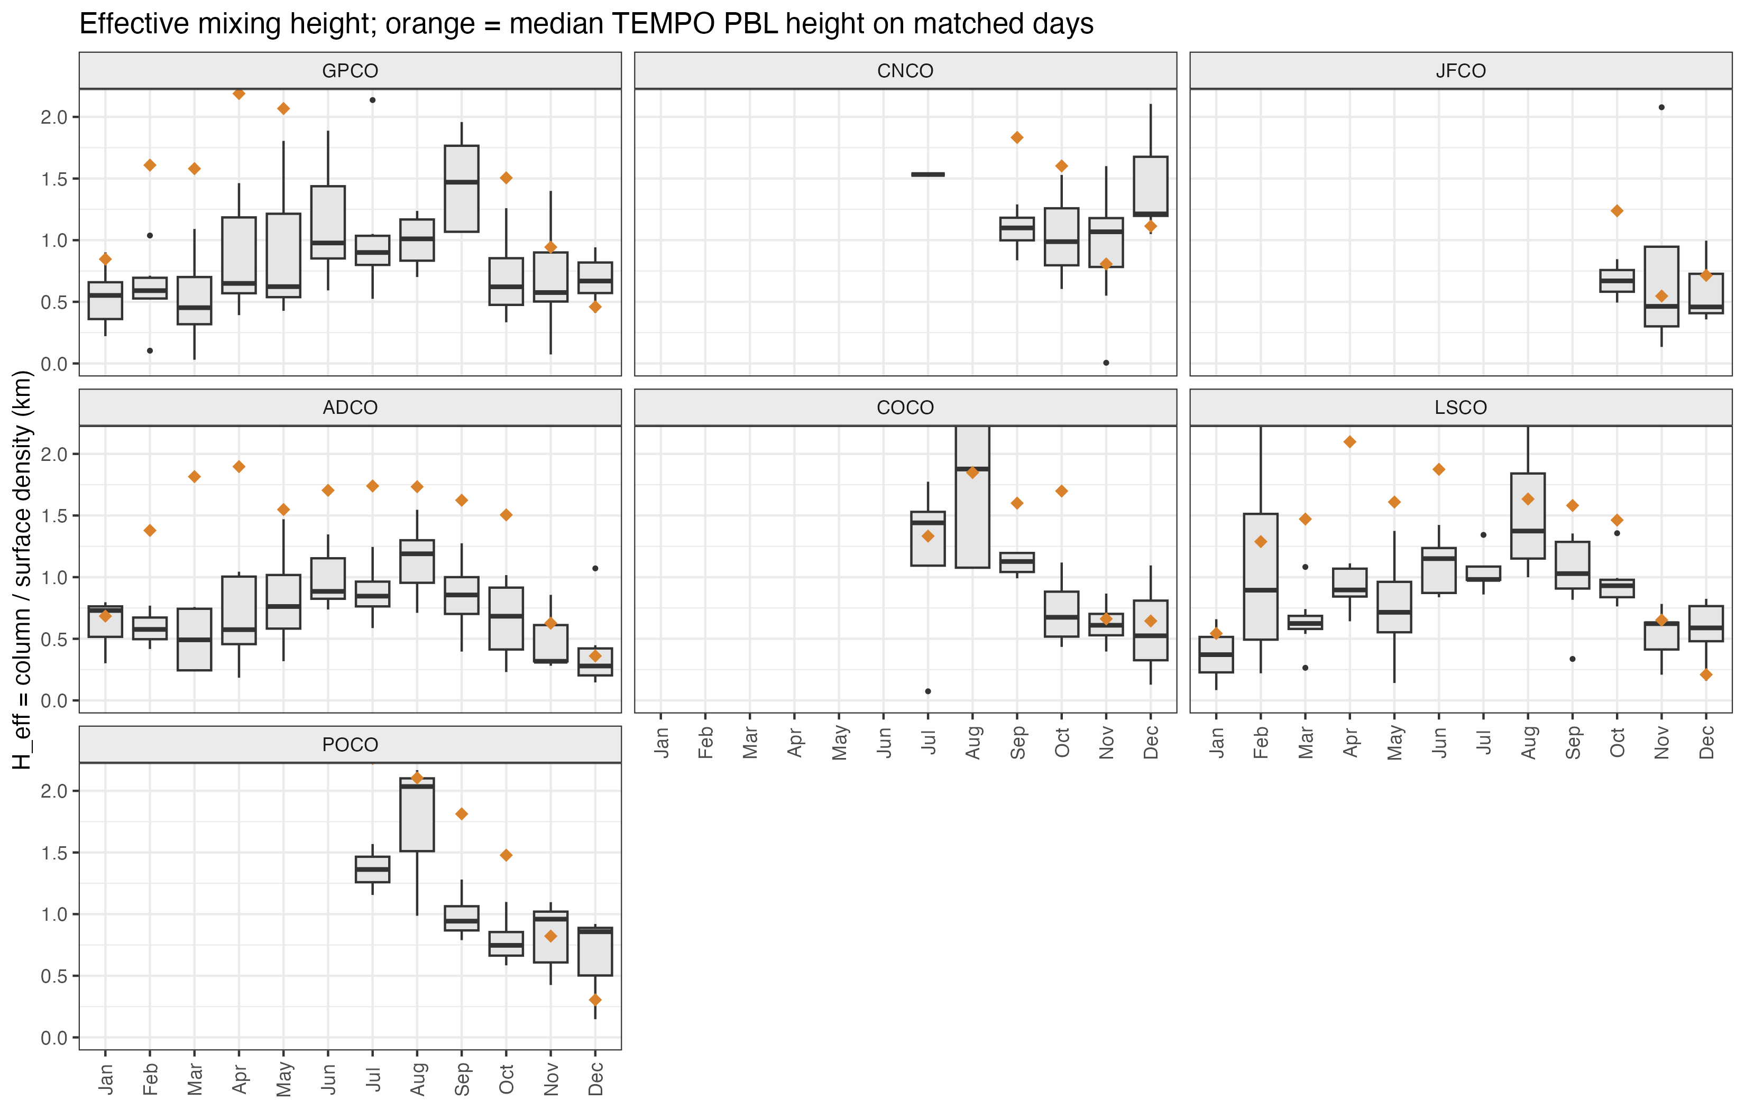
Figure S6. Monthly distributions of the effective mixing height H_{eff} on matched days by Colorado site. Orange diamonds show the median TEMPO PBL height on the same days. The vertical axis is truncated at the 98th percentile.
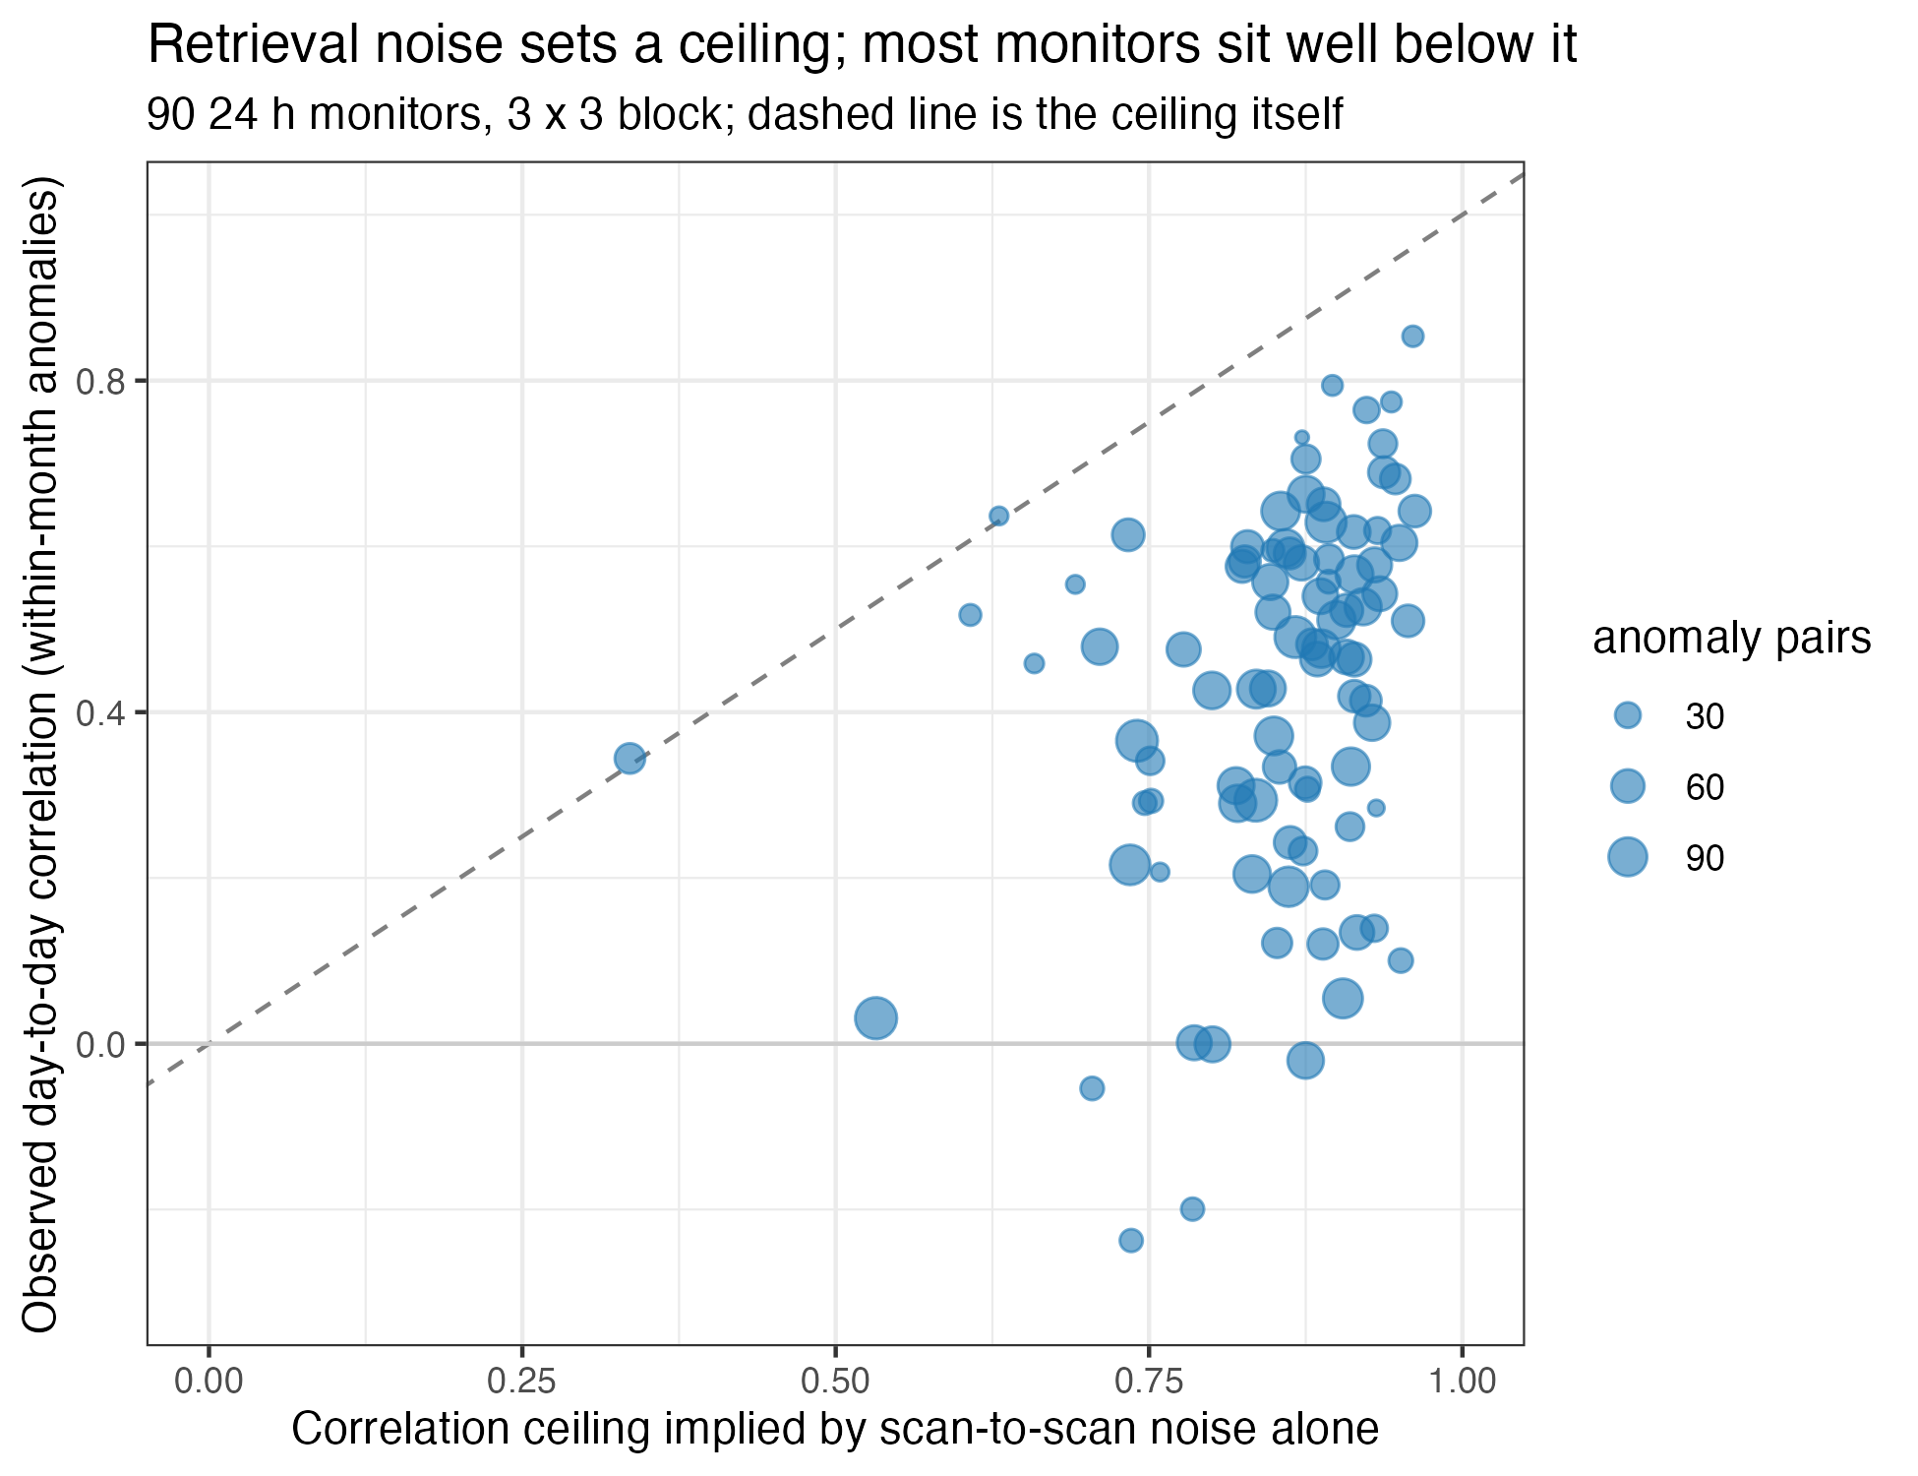
Figure S7. Observed day-to-day (within-month anomaly) correlation at each 24 h monitor against the ceiling implied by TEMPO scan-to-scan noise alone (3 × 3 block; 90 monitors with at least 20 successive-scan pairs and 10 anomaly pairs and a defined ceiling). The dashed line is the ceiling itself: a monitor on it would have its agreement limited only by retrieval noise. 2 monitors at which the noise bound exceeded the anomaly variance are not shown.
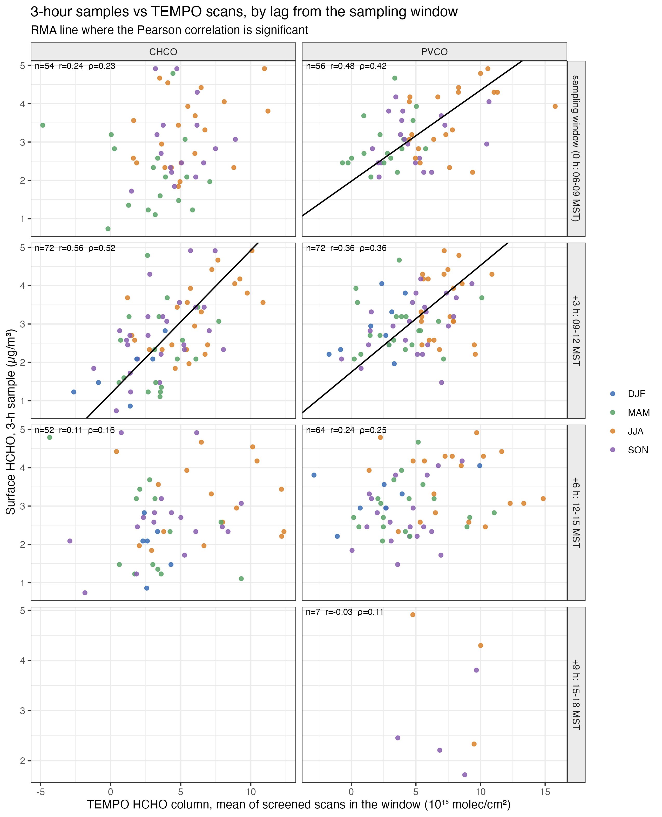
Figure S8. Three-hour surface HCHO at Chatfield State Park (CHCO, 2024-2025) and Platteville (PVCO, August 2023-July 2025) versus the mean TEMPO column in the sampling window (06:00-09:00 MST) and in windows shifted by +3, +6 and +9 h. The -3 h window is not shown because no scan passed screening in it, and the +9 h row holds only seven Platteville samples. Colours denote season; lines show reduced major axis fits where the Pearson correlation is significant.
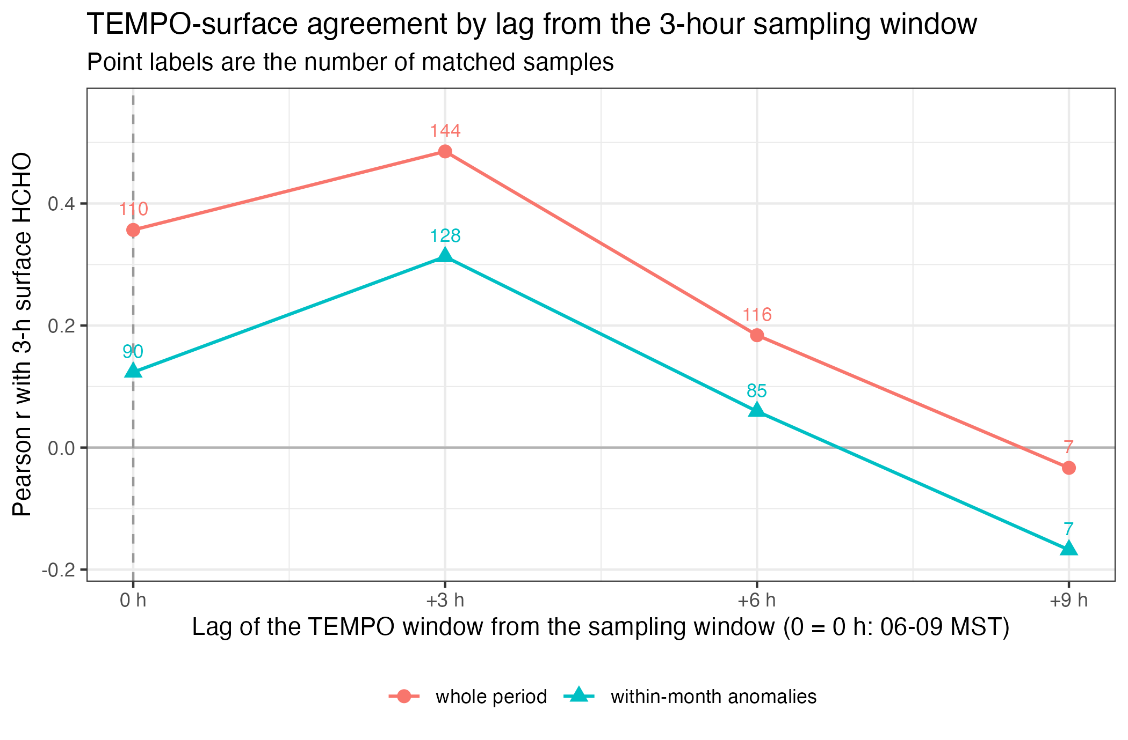
Figure S9. Agreement between 3 h surface HCHO and the mean TEMPO column as a function of the lag between the sampling window (06:00-09:00 MST) and the satellite window, for the whole period and for within-month anomalies. Labels give the number of matched samples. Agreement is highest in the window beginning when sampling ends (09:00-12:00 MST), when the median TEMPO boundary layer height has risen from 0.45 to 1.5 km; the pooled curve averages two sites that differ (Table S4).
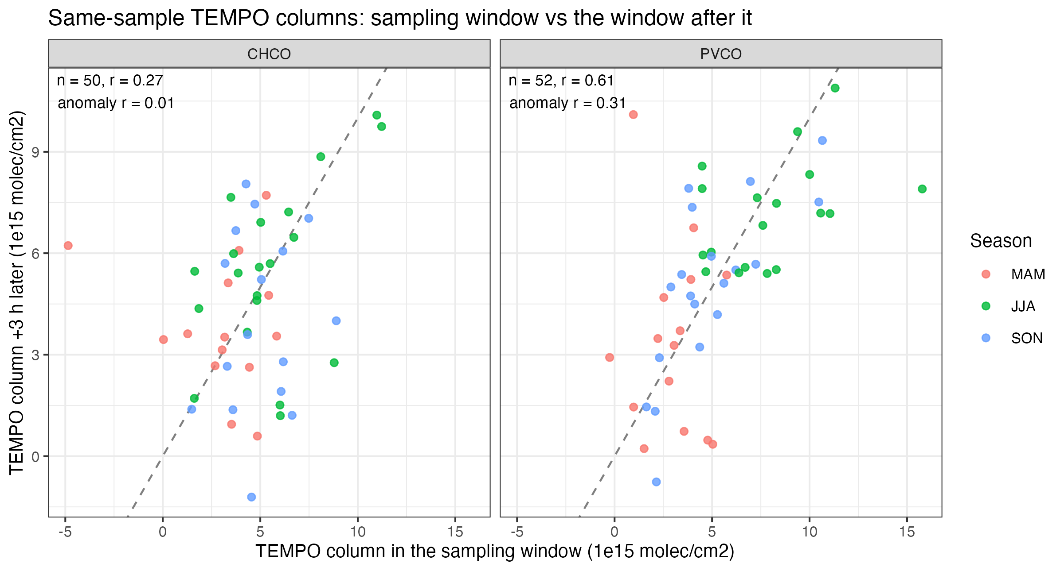
Figure S10. TEMPO columns for the same 3 h samples, measured in the sampling window (06:00-09:00 MST) and three hours later. The two differ substantially from day to day at Chatfield State Park and agree more closely at Platteville; the dashed line is 1:1.
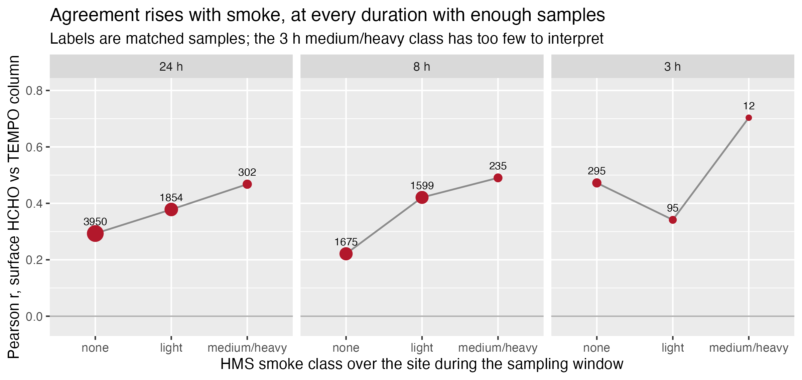
Figure S11. Pearson correlation between surface HCHO and the TEMPO column by HMS smoke class over the site during the sampling window, for the 24 h, 8 h and 3 h sites nationally. Labels are the number of matched samples. Agreement rises with smoke at both well-sampled durations; the 3 h medium–heavy class holds twelve samples and is not interpreted.
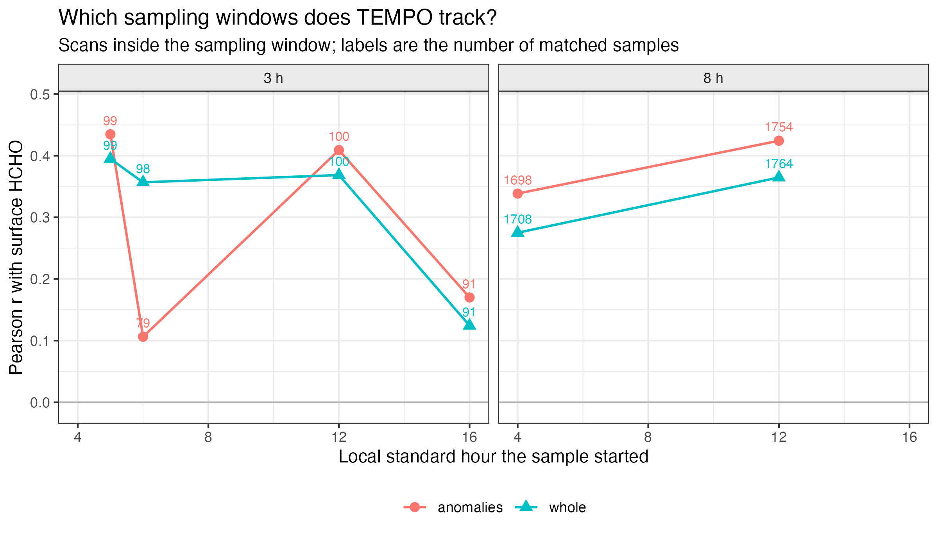
Figure S12. Correlation between sub-daily surface HCHO and the mean TEMPO column, grouped by the local standard hour at which the sampling window begins, using only scans inside the sampling window. "Whole" uses the concentrations as measured; "anomalies" uses deviations from site-month means. In the 3 h panel, the windows beginning at 05:00, 12:00 and 16:00 are the two California sites and the window beginning at 06:00 is the two Colorado sites; in the 8 h panel each point pools all 40 sites; the 3 h windows beginning at 23:00 (dark) and 08:00 (14 samples) are not shown. Labels give the number of matched samples.

References cited in the Supporting Information
5. Zoogman, P.; Liu, X.; Suleiman, R. M.; Pennington, W. F.; Flittner, D. E.; Al-Saadi, J. A.; Hilton, B. B.; Nicks, D. K.; Newchurch, M. J.; Carr, J. L.; Janz, S. J.; Andraschko, M. R.; Arola, A.; Baker, B. D.; Canova, B. P.; Chan Miller, C.; Cohen, R. C.; Davis, J. E.; Dussault, M. E.; Edwards, D. P.; Fishman, J.; Ghulam, A.; González Abad, G.; Grutter, M.; Herman, J. R.; Houck, J.; Jacob, D. J.; Joiner, J.; Kerridge, B. J.; Kim, J.; Krotkov, N. A.; Lamsal, L.; Li, C.; Lindfors, A.; Martin, R. V.; McElroy, C. T.; McLinden, C.; Natraj, V.; Neil, D. O.; Nowlan, C. R.; O'Sullivan, E. J.; Palmer, P. I.; Pierce, R. B.; Pippin, M. R.; Saiz-Lopez, A.; Spurr, R. J. D.; Szykman, J. J.; Torres, O.; Veefkind, J. P.; Veihelmann, B.; Wang, H.; Wang, J.; Chance, K. Tropospheric emissions: Monitoring of pollution (TEMPO). J. Quant. Spectrosc. Radiat. Transfer 2017, 186, 17-39. https://doi.org/10.1016/j.jqsrt.2016.05.008
8. Rawat, P.; Travis, K. R.; Henderson, B.; Crawford, J. H.; Judd, L. M.; Demetillo, M. A. G.; Lee, T. C.; Flittner, D. E.; Szykman, J. J.; Valin, L. C.; Whitehill, A.; Baumann, E.; Hanisco, T. F.; Pandey, A.; González Abad, G.; Nowlan, C. R.; Liu, X.; Chance, K. Spatiotemporal assessment of the TEMPO formaldehyde column retrieval using the Pandonia Global Network. J. Geophys. Res. Atmos. 2026, 131, e2025JD044788. https://doi.org/10.1029/2025JD044788
14. U.S. Environmental Protection Agency. Air Quality System (AQS) API and pre-generated data files; U.S. EPA, 2026. https://aqs.epa.gov/aqsweb/documents/data_api.html
15. U.S. Environmental Protection Agency. Compendium Method TO-11A: Determination of formaldehyde in ambient air using adsorbent cartridge followed by high performance liquid chromatography (HPLC). In Compendium of Methods for the Determination of Toxic Organic Compounds in Ambient Air, 2nd ed.; EPA/625/R-96/010b; U.S. EPA: Cincinnati, OH, 1999.
17. NASA Atmospheric Science Data Center. TEMPO Level 2/3 trace gas and cloud products user guide, version 2.1, 6 January 2026; NASA Langley Atmospheric Science Data Center, 2026. https://asdc.larc.nasa.gov/documents/tempo/guide/TEMPO_Level-2-3_trace_gas_clouds_user_guide_V2.1.pdf
18. Steiger, J. H. Tests for comparing elements of a correlation matrix. Psychol. Bull. 1980, 87, 245-251. https://doi.org/10.1037/0033-2909.87.2.245
19. R Core Team. R: A language and environment for statistical computing; R Foundation for Statistical Computing: Vienna, Austria, 2024. https://www.R-project.org/
21. Rolph, G. D.; Draxler, R. R.; Stein, A. F.; Taylor, A.; Ruminski, M. G.; Kondragunta, S.; Zeng, J.; Huang, H.-C.; Manikin, G.; McQueen, J. T.; Davidson, P. M. Description and verification of the NOAA Smoke Forecasting System: the 2007 fire season. Weather Forecast. 2009, 24, 361-378. https://doi.org/10.1175/2008WAF2222165.1
22. Brey, S. J.; Ruminski, M.; Atwood, S. A.; Fischer, E. V. Connecting smoke plumes to sources using Hazard Mapping System (HMS) smoke and fire location data over North America. Atmos. Chem. Phys. 2018, 18, 1745-1761. https://doi.org/10.5194/acp-18-1745-2018
25. Colorado Department of Public Health and Environment. Air Toxics and Ozone Precursor Data Repository; CDPHE, 2026. https://www.colorado.gov/airquality/air_toxics_repo.aspx
26. U.S. Environmental Protection Agency. Air Toxics Ambient Monitoring; Ambient Monitoring Technology Information Center, U.S. EPA, updated 1 April 2026. https://www.epa.gov/amtic/air-toxics-ambient-monitoring (accessed 20 September 2026)
27. NOAA Office of Satellite and Product Operations. Hazard Mapping System smoke polygons; NOAA OSPO, 2026. https://satepsanone.nesdis.noaa.gov/pub/FIRE/web/HMS/Smoke_Polygons/Shapefile/
28. Pebesma, E. Simple features for R: standardized support for spatial vector data. R J. 2018, 10, 439-446. https://doi.org/10.32614/RJ-2018-009
29. Bates, D.; Mächler, M.; Bolker, B.; Walker, S. Fitting linear mixed-effects models using lme4. J. Stat. Softw. 2015, 67, 1-48. https://doi.org/10.18637/jss.v067.i01
30. Amazon Web Services. Terrain Tiles, Registry of Open Data on AWS. https://registry.opendata.aws/terrain-tiles/
31. Hollister, J. W.; Shah, T.; Nowosad, J.; Robitaille, A. L.; Beck, M. W.; Johnson, M. elevatr: Access Elevation Data from Various APIs, R package version 0.99.0, 2023. https://doi.org/10.5281/zenodo.8335450
32. U.S. Census Bureau. Cartographic boundary files; U.S. Census Bureau, 2023. https://www.census.gov/geographies/mapping-files/time-series/geo/cartographic-boundary.html

