Q3 2026 Operations Report
Bellwether Freight (a fictional company). Sample document for pdfconversionapi.com, released under CC0 1.0.

1. Summary
Shipments grew in each month of the quarter, from 22,000 in July to 27,500 in September. On-time delivery held at 96.4%, and the new Reno cross-dock handled 18% of westbound volume by the end of September.
Three items need a decision before the next review:
- Whether to extend weekend hours at the Reno cross-dock past December.
- Which carrier takes the Denver to Salt Lake City lane when the current contract ends.
- How much of the 2027 budget goes to replacing the oldest forklifts.

2. Volume by month
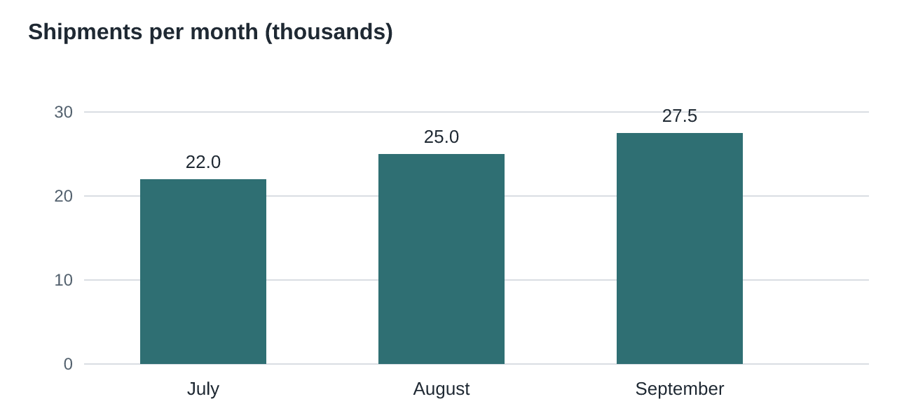
Month | Shipments | On time | Damage claims
July | 22,000 | 96.1% | 31
August | 25,000 | 96.5% | 28
September | 27,500 | 96.6% | 24
Quarter | 74,500 | 96.4% | 83

3. Sites
All four sites met their safety targets. Notes by site:
- Sacramento: dock 4 reopened on August 12 after the floor repair.
- Reno: second shift added on September 2; overtime fell 22% the following week.
- Denver: the yard management trial ended; results are in Appendix A.
- Salt Lake City: no changes this quarter.

4. Next quarter
We expect 80,000 to 84,000 shipments in Q4, with the usual peak in the two weeks before Thanksgiving. Temporary staffing requests are due by October 15.
Appendix A. Yard management trial, Denver
The trial ran from July 7 to September 26. Average trailer dwell time fell from 3.1 hours to 2.4 hours. Drivers reported fewer missed appointments, and the gate staff asked to keep the tablets. We recommend rolling the system out to Sacramento in Q1 2027.

