KEPLER ORBIT ELEMENTS TO ECI CARTESIAN COORDINATES CONVERSION

Elliptical Case (02/02/02)

Compute orbital position and velocity at time t given the orbital elements.
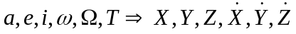
where  is the right ascension of the ascending node.

- Compute the mean anomaly, MA, (0° → 360°),
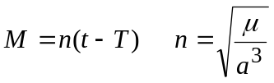

- Compute the eccentric anomaly, EA, (0° → 360°),

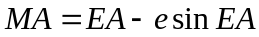

- Compute the true anomaly, , (0° → 360°),
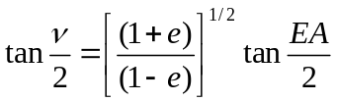

If EA < 180° then < 180° (There is no need to do a quadrant check. The equation above will automatically yield the correct value of .)

- Compute the radius, r,
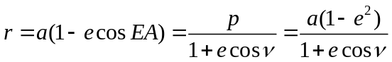
- Compute the specific angular momentum, h,
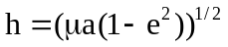

- Compute the position components, X,Y,Z

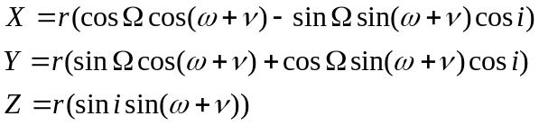

7. Compute the velocity components,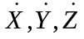

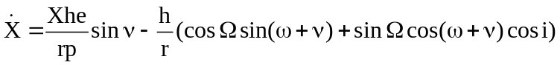
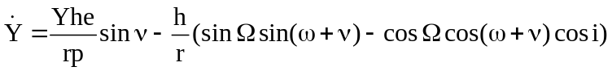
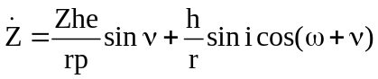
8. To obtain ECF (Earth Centered and Fixed) coordinates

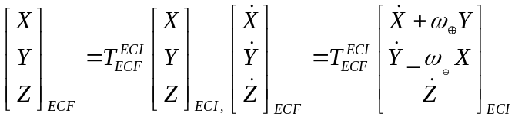

where 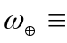rotation rate of the earth (7.2921158553 x 10⁻⁵ rad/sec)

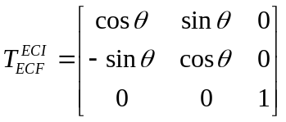

is the Greenwich hour angle of the Earth's prime meridian, i.e. the angle between the inertial X-axis and the ECF X-axis.

