Mini-sumo with the Pololu Zumo 2040 Robot
January 6, 2024 at Pololu - Paul Grayson - pdg@alum.mit.edu - paul@pololu.com
https://github.com/pdg137/sumo

Using Thonny
- Install from https://thonny.org/ (Windows/Mac/Linux)
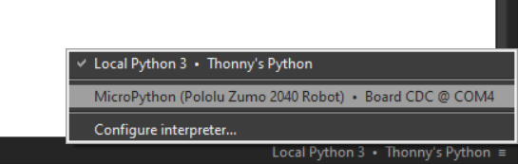
- Go to “Tools > Manage plug-ins...”, install thonny-pololu, and restart
- Connect the robot with USB-C cable, select Zumo in the lower-right:
- Open files on the “MicroPython” drive.
- Find my examples at https://github.com/pdg137/sumo

Tips:
- Click “Stop” to reconnect
- When you make progress “Save a copy” on your computer so you don’t lose your work!!!

The Pololu Zumo 2040 Robot
⚡Static precautions!⚡
- Avoid touching components and wires as much as possible
- Discharge yourself often (touch a metal door, etc.)
- When handing robot to another person, touch hands first 🤜🤛
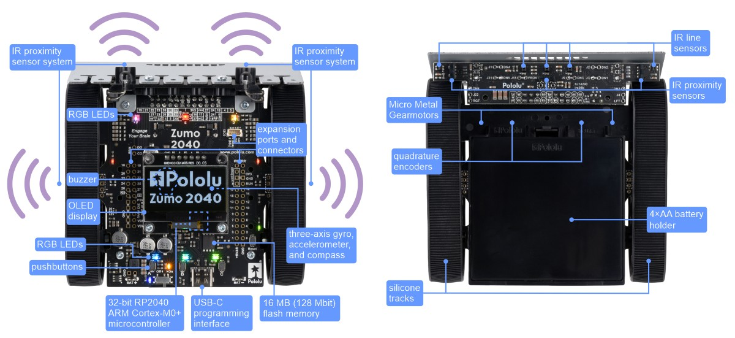

Using MicroPython
Standard MicroPython libraries: https://docs.micropython.org/en/latest/library
Pololu Zumo 2040 examples & libraries: https://github.com/pololu/zumo-2040-robot
Proximity sensing:
- Two sets of modulated IR emitters: left and right
- Three sensors (left, front, right) count reflected pulses
----> SIX sensing values.
For example, proximity_sensors.counts[1][0] gives the reading from the front sensor (1) when the left (0) LEDs are activated.

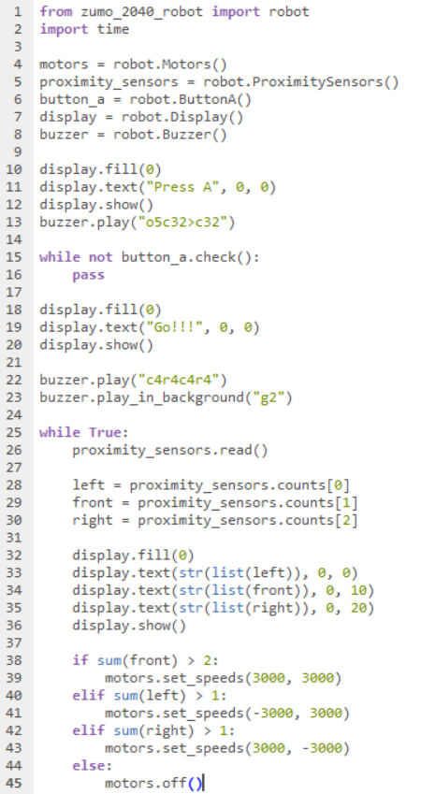
Structure of a robot program
1. imports
2. define variables
3. setup
4. main loop

