/ = “This is default”
/ about= give result ”mongodb express React and mongoose app,React runs in another application”
/addbooks = add book in MongoDB
/allbooks= shows all added book
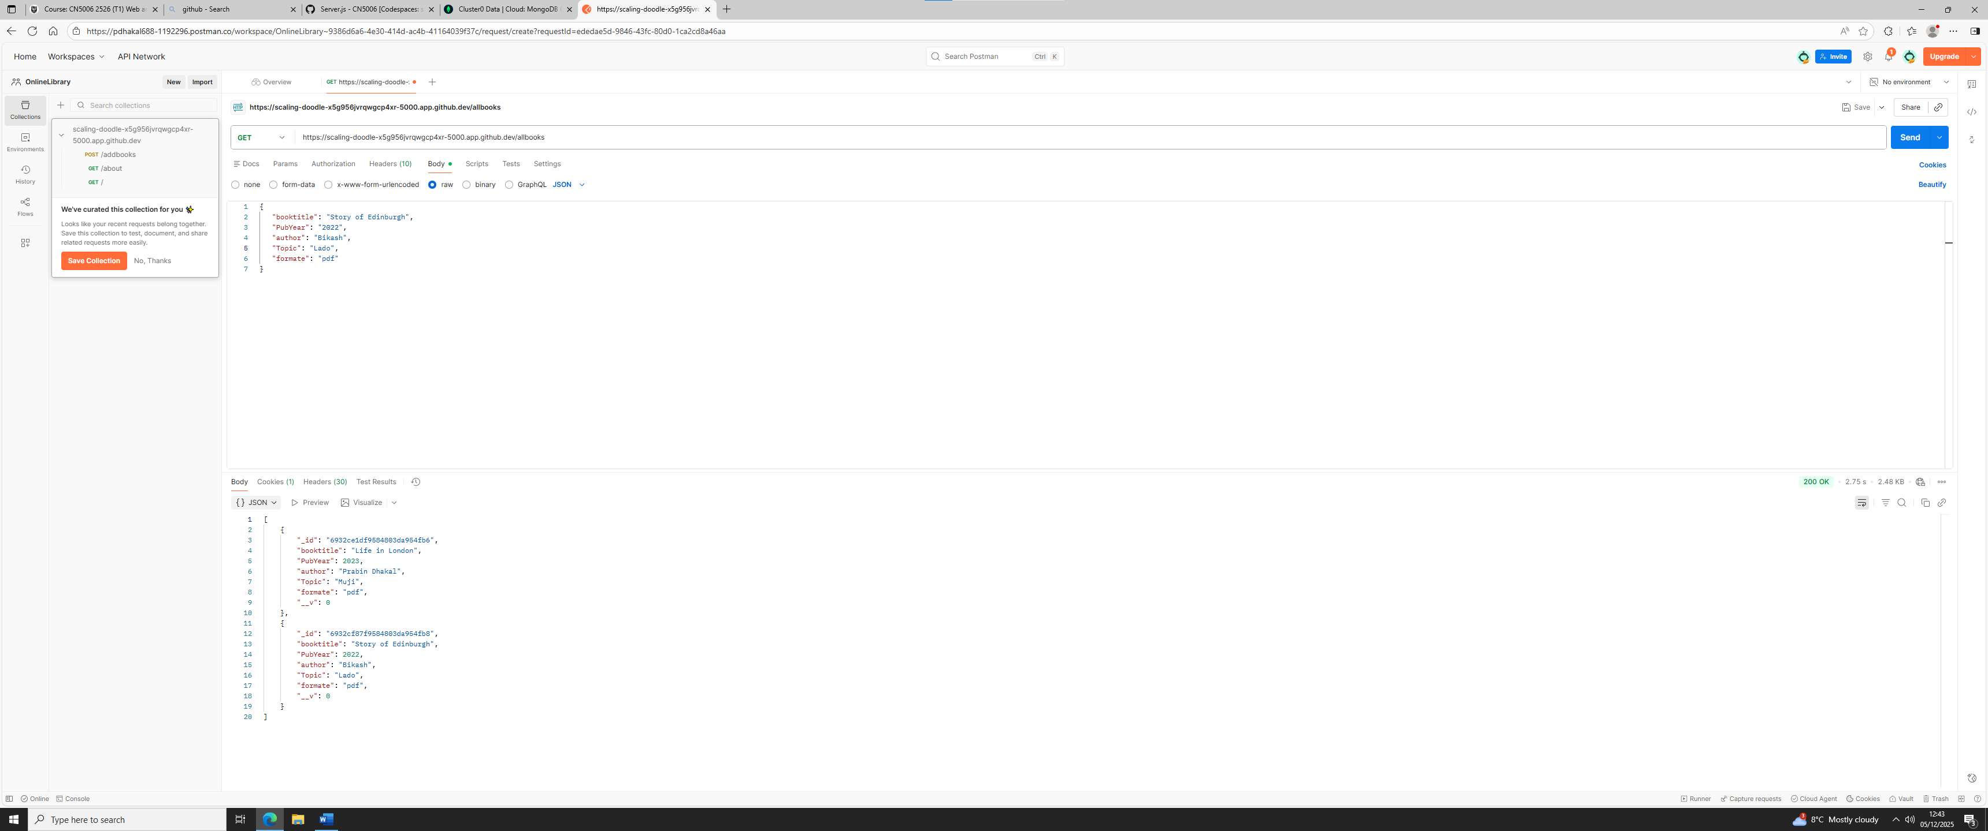

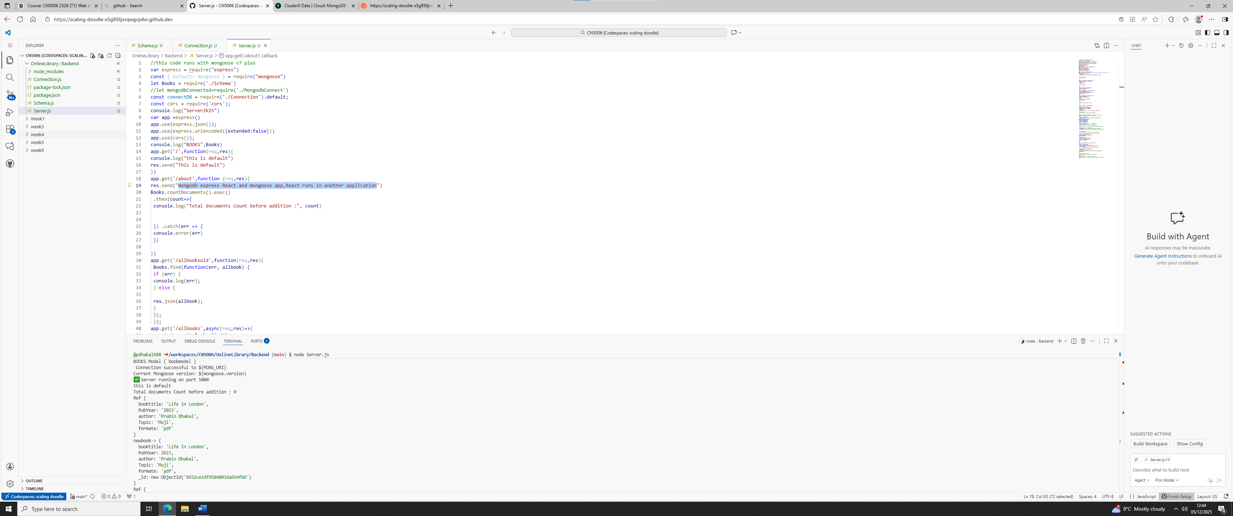

/deletebook/:id= delete the book
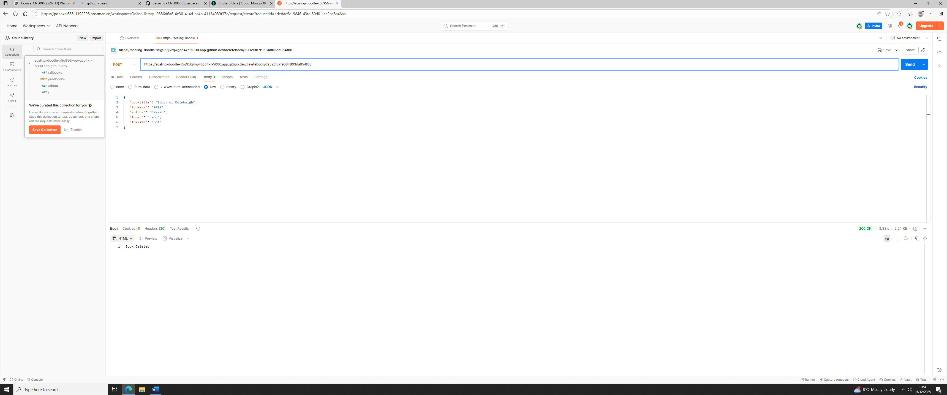

/updatebook/:= update the details of the book
