Folder Structure  
  
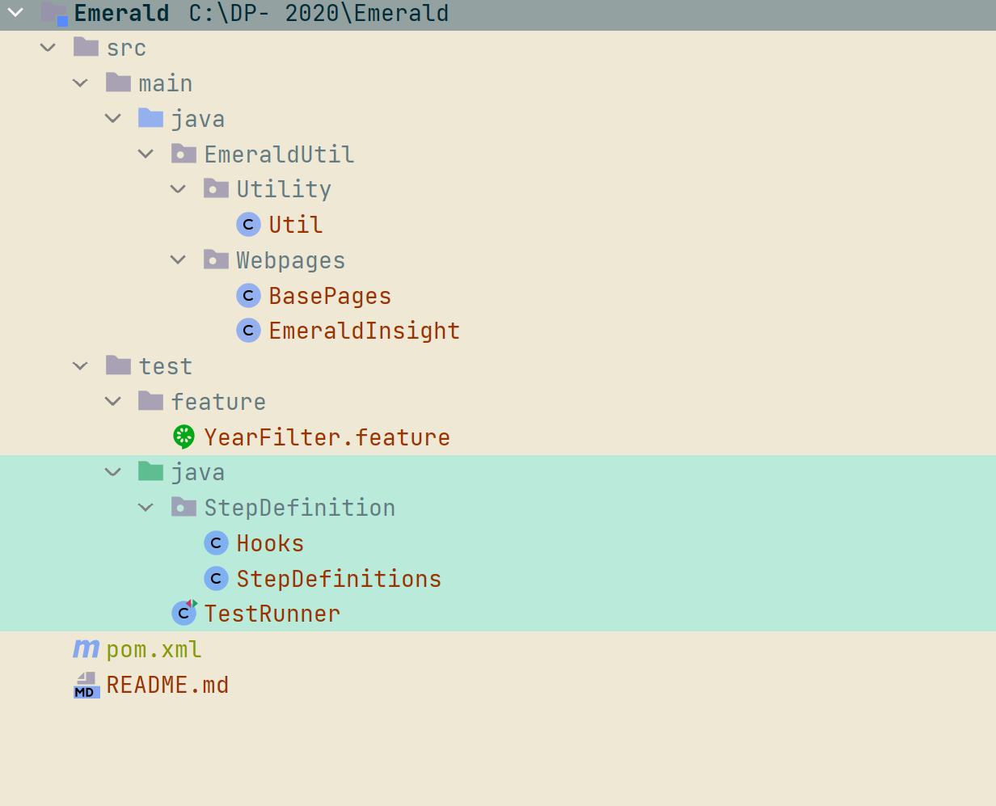

Test  
├── src  
| ├──test  
| | ├──Java  
| | └── com.pom.pages  
| | ├──BasePage # Initialisation of Common Test Data or common methods  
| | ├──HomePage # Implementation of Page methods for CoinMarketCap Home Page  
| | └──WatchListPage # Implementation of Page methods for CoinMarketCap Watch List Page  
| | └── com.test.commons  
| | ├──PropertyFileReader # To read data from Property File  
| | └── com.test.runners  
| | ├── TestRunner # Controller of all the tests  
| | └── stepdefs  
| | ├── Hooks # Implementation of Cucumber Hooks  
| | ├── StepDefenitionsFrontEnd # Implementation of Cucumber Step Definitions for front end tests  
| | ├── StepDefenitionsBackEnd # Implementation of Cucumber Step Definitions for back end tests  
| | ├──resources  
| | └── Features  
| | ├── ViewAll.feature # Frontend Task Test 1:  
| | ├── WatchList.feature # Frontend Task Test 2:  
| | ├── Filter.feature # Frontend Task Test 3  
| | ├── PriceConversion.feature # Back-end Task 1  
| | ├── CurrencyInfo.feature # Back-end Task 2  
| | ├── AreMineable(backEndTask-3).feature # Back-end Task 3 (Extra Points)  
| |

### Step 1) Analyze the product

### This Emerald insight is going to be used for

**Step 2) Develop Test Strategy**

### 2.1) Scope of Testing

### In Scope : Testing to be carried out of the Date filter as a functional testing

### Out of Scope : Non functional testing will be performed when require

### 2.2) Testing Type

### Unit test to verify date function

### 2.3) Risk & Issues

### Test colleague might not fully aware of testing tool in that case person should ask senior colleague

### 2.4) Test Logistics

### Test colleague will be carried out this year filter to check functionality

### Step 3) Test Objective

* Check that whether website Guru99 **functionality**(Account, Deposit…) is working as expected without any error or bugs in real business environment
* Check that the external interface of the website such as **UI** is working as expected and & meet the customer need