DPDPA Compliance Checker -- Rule Engine (Design Document)
This document describes the design of the rule engine -- the part of the tool that decides whether a company's privacy policy (and, optionally, its live website behaviour) complies with the DPDPA, 2023. It is a design document, not the code itself. Rules are drawn only from the sections of DPDPA that a text-based / website-based checker can realistically evaluate. Sections about the Data Protection Board's internal composition, appeals, and penalties (Sections 17-44) are excluded, since they describe how the regulator functions, not what a company's own policy or website must contain.

1. Purpose of the Rule Engine
The rule engine is the core logic layer of the checker. Its job is to take a company's privacy policy (and, with the behaviour-scan add-on, its live website activity) and compare it, clause by clause, against a fixed set of rules derived from the DPDPA, 2023 and the DPDP Rules, 2025. Each rule maps to one specific, checkable obligation -- not a vague reading of 'is this company compliant', but a yes/no/partial answer to a precise question, such as 'does this policy explain how to withdraw consent?'

2. How the Rule Engine Works (Workflow)
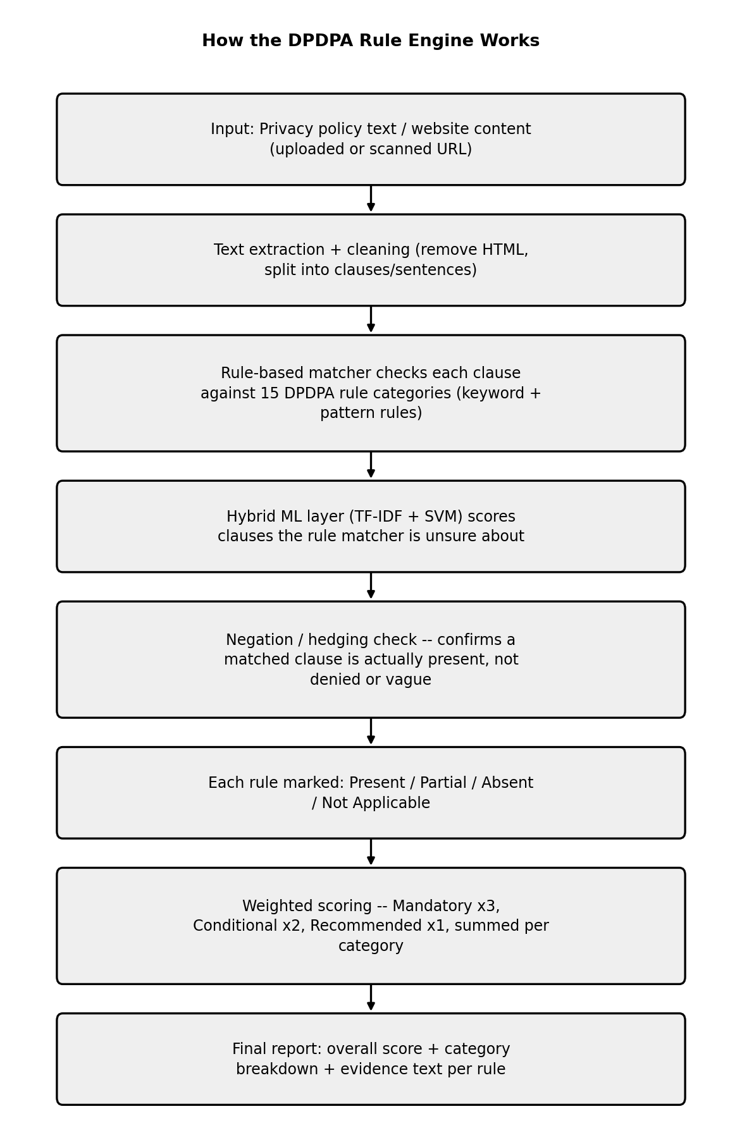
Each rule check has three possible outcomes: Present (the requirement is clearly addressed), Partial (mentioned but incomplete or vague), or Absent (not addressed at all). Conditional-category rules can also return Not Applicable -- for example, cross-border transfer rules don't apply if the company states all data stays within India.

3. Rule Categories -- Summary
15 categories, containing 37 individual checkable rules in total. This is more granular than the '22 clause categories' figure used earlier in the project deck -- that number was a rough estimate before the DPDPA text was read section-by-section; 37 individual rules across 15 categories is the number actually justified by the Act's text.
# | Category | Source Section | Weight
1 | Notice Requirements | Section 5, DPDPA 2023 | Mandatory
2 | Consent Validity | Section 6, DPDPA 2023 | Mandatory
3 | Children's Data Protection | Section 9, DPDPA 2023 | Conditional -- applies only if the service could reasonably be used by minors
4 | Grounds for Processing / Legitimate Use | Sections 4 & 7, DPDPA 2023 | Recommended
5 | Data Accuracy & Quality | Section 8(3), DPDPA 2023 | Recommended
6 | Security Safeguards | Section 8(4)-(5), DPDPA 2023 | Mandatory
7 | Breach Notification | Section 8(6), DPDPA 2023 | Mandatory
8 | Data Retention & Erasure | Section 8(7)-(8), DPDPA 2023 | Mandatory
9 | Grievance Redressal Mechanism | Section 8(10) & Section 13, DPDPA 2023 | Mandatory
10 | DPO / Contact Person Disclosure | Section 8(9), DPDPA 2023 | Mandatory
11 | Right to Access & Correction | Sections 11-12, DPDPA 2023 | Mandatory
12 | Right to Nominate | Section 14, DPDPA 2023 | Recommended
13 | Cross-Border Data Transfer Disclosure | Section 16, DPDPA 2023 | Conditional -- applies only if data is stored/processed outside India
14 | Significant Data Fiduciary (SDF) Obligations | Section 10, DPDPA 2023 | Conditional -- applies only to companies the Government notifies as Significant Data Fiduciaries
15 | Cookie & Tracker Behaviour Cross-Check | Practical implementation of Sections 5 & 6 (project-specific addition, not a direct statutory clause) | Recommended -- this is the project's differentiating feature

4. Rule Categories -- Full Detail

1. Notice Requirements
Source: Section 5, DPDPA 2023
Weight: Mandatory
What this category checks: Checks whether the company tells users what data is collected, why, and how to exercise their rights -- before or at the time data is collected.
- N1 -- States what personal data is collected and the specific purpose of processing (Sec 5(1)(i))
- N2 -- Explains how the user can exercise rights of access, correction, and erasure (Sec 5(1)(ii))
- N3 -- Explains how the user can complain to the Data Protection Board of India (Sec 5(1)(iii))
- N4 -- Notice is given before or at the time of data collection, not after the fact (Sec 5, timing requirement)
- N5 -- Notice is offered in clear, plain language, not just dense legal text (Sec 5(3), DPDP Rule 5)

2. Consent Validity
Source: Section 6, DPDPA 2023
Weight: Mandatory
What this category checks: Checks whether consent is actually valid under DPDPA -- free, specific, informed, unconditional, and easy to withdraw -- not just a checkbox that exists.
- C1 -- Consent request is specific to a stated purpose, not a blanket permission (Sec 6(1))
- C2 -- Consent requires a clear affirmative action (checkbox/button click); no pre-checked boxes or 'continued use = consent' language (Sec 6(1))
- C3 -- Policy does not bundle unrelated data collection as a condition for using the core service (Sec 6(1)(a))
- C4 -- A clear option to withdraw consent is described, and withdrawal is as easy as giving consent (Sec 6(4)-(5))
- C5 -- If a Consent Manager is used, its registration/role is disclosed (Sec 6(7)-(9))

3. Children's Data Protection
Source: Section 9, DPDPA 2023
Weight: Conditional -- applies only if the service could reasonably be used by minors
What this category checks: Checks for the extra protections DPDPA mandates when a child's (under-18) data may be processed.
- K1 -- States clearly whether the service processes personal data of children (under 18)
- K2 -- If yes, describes a verifiable parental consent mechanism
- K3 -- Explicitly states no behavioural tracking or targeted advertising is directed at children

4. Grounds for Processing / Legitimate Use
Source: Sections 4 & 7, DPDPA 2023
Weight: Recommended
What this category checks: Checks whether the company is clear about which legal basis it relies on to process data.
- G1 -- States the legal basis for processing (consent vs. a legitimate-use exemption under Sec 7)
- G2 -- If relying on a legitimate-use exemption, names which category applies (e.g. voluntary data sharing, employment purposes, medical emergency)

5. Data Accuracy & Quality
Source: Section 8(3), DPDPA 2023
Weight: Recommended
What this category checks: Checks whether the company commits to keeping data accurate, especially where that data is used to make a decision about the user.
- Q1 -- Describes steps taken to keep data complete, accurate, and consistent, particularly where data feeds an automated or manual decision about the user

6. Security Safeguards
Source: Section 8(4)-(5), DPDPA 2023
Weight: Mandatory
What this category checks: Checks whether the company discloses that it actually protects the data it holds, not just that it collects it.
- S1 -- States that reasonable technical security measures are used (e.g. encryption, access control)
- S2 -- Describes organisational measures in addition to technical ones (e.g. staff access restrictions, training)

7. Breach Notification
Source: Section 8(6), DPDPA 2023
Weight: Mandatory
What this category checks: Checks whether the company has committed, in writing, to telling the Board and affected users if a data breach happens.
- B1 -- Describes the process for notifying the Data Protection Board and affected users in the event of a personal data breach
- B2 -- Gives a timeline or commitment for how quickly breach notification will happen

8. Data Retention & Erasure
Source: Section 8(7)-(8), DPDPA 2023
Weight: Mandatory
What this category checks: Checks whether the company says how long it keeps data and when/how it deletes it.
- R1 -- States how long personal data is retained
- R2 -- Describes when/how data will be erased after consent withdrawal or once the purpose is served
- R3 -- Clarifies any legal retention exceptions (e.g. required under other Indian laws)

9. Grievance Redressal Mechanism
Source: Section 8(10) & Section 13, DPDPA 2023
Weight: Mandatory
What this category checks: Checks whether users have a clear, working internal complaint channel before they'd need to go to the Board.
- GR1 -- Provides a clear internal grievance/complaint channel (email, form, or helpline)
- GR2 -- States a response timeline for grievances

10. DPO / Contact Person Disclosure
Source: Section 8(9), DPDPA 2023
Weight: Mandatory
What this category checks: Checks whether there is a named, reachable person responsible for answering data-protection questions.
- D1 -- Publishes business contact information of a Data Protection Officer, or a designated person able to answer privacy questions

11. Right to Access & Correction
Source: Sections 11-12, DPDPA 2023
Weight: Mandatory
What this category checks: Checks whether users are actually told how to see, fix, or delete their own data -- not just that the right exists in theory.
- A1 -- Explains how users can request a copy/summary of the personal data held about them
- A2 -- Explains how users can request correction of inaccurate or incomplete data
- A3 -- Explains how users can request erasure of their data

12. Right to Nominate
Source: Section 14, DPDPA 2023
Weight: Recommended
What this category checks: Checks for a DPDPA-specific right that most companies forget: nominating someone to act on your data after death or incapacity.
- NM1 -- Describes how a user can nominate someone to exercise their data rights in case of death or incapacity

13. Cross-Border Data Transfer Disclosure
Source: Section 16, DPDPA 2023
Weight: Conditional -- applies only if data is stored/processed outside India
What this category checks: Checks whether international data transfer is disclosed and not routed through a government-restricted country.
- X1 -- Discloses whether personal data is transferred to or stored in servers outside India
- X2 -- Confirms the transfer destination is not a country restricted by the Central Government

14. Significant Data Fiduciary (SDF) Obligations
Source: Section 10, DPDPA 2023
Weight: Conditional -- applies only to companies the Government notifies as Significant Data Fiduciaries
What this category checks: Checks for extra obligations that apply only to large-scale processors (very large user bases / sensitive data volumes).
- SDF1 -- Discloses whether a Data Protection Impact Assessment (DPIA) has been conducted
- SDF2 -- Discloses whether an independent data auditor has reviewed data-handling practices
- SDF3 -- Discloses appointment of an India-based Data Protection Officer (mandatory only for SDFs)

15. Cookie & Tracker Behaviour Cross-Check
Source: Practical implementation of Sections 5 & 6 (project-specific addition, not a direct statutory clause)
Weight: Recommended -- this is the project's differentiating feature
What this category checks: Checks whether what the website actually does (cookies, trackers, third-party scripts) matches what its policy claims.
- BC1 -- Cookies/trackers actually detected on the live site match what the policy discloses
- BC2 -- No undisclosed third-party scripts collecting data are found running on the site

5. Scoring Logic
Each individual rule is scored based on its status and weight. Suggested point values: Mandatory rule = 3 points if Present, 1 point if Partial, 0 if Absent. Conditional rule = 2 points if Present, 1 if Partial, 0 if Absent (skipped entirely -- not counted in the denominator -- if Not Applicable). Recommended rule = 1 point if Present, 0.5 if Partial, 0 if Absent.
Category score = (points actually earned in that category / maximum possible points for applicable rules in that category) x 100. Overall compliance score = weighted average of all category scores, so that Mandatory categories (Notice, Consent, Security, Breach Notification, Retention & Erasure, Grievance Redressal, DPO Contact, Access & Correction Rights) count for more than Recommended ones.
This scoring approach directly matches what the project deck already proposed (weighted mandatory/conditional/recommended scoring, validated against manual review) -- this document supplies the actual rule set that scoring formula needs to run on.

6. What Was Deliberately Left Out
Sections 1-3 (definitions, applicability) -- background law, not a checkable company obligation.
Sections 18-32 (Data Protection Board structure, appeals, alternate dispute resolution) -- describes how the regulator itself is organised, not something a company's privacy policy would ever contain.
Sections 33-44 (penalties, miscellaneous powers) -- relevant to what a company risks if it fails a rule, but not something to search for inside a privacy policy itself. This can be shown to the user separately as "what happens if you fail this rule" context, rather than as a rule to check for.

7. Source
All rules above are drawn from the official DPDPA, 2023 section text as published on: https://www.dpdpa.com/ -- specifically Sections 4, 5, 6, 7, 8, 9, 10, 11, 12, 13, 14, and 16, cross-checked against the statutory text reproduced on that site. Rule Category 15 (Cookie & Tracker Behaviour Cross-Check) is a project-specific addition, not a direct statutory clause -- it implements the notice/consent obligations of Sections 5 and 6 in practice.

