EcoSort Campus: Smart Waste Segregation
Working Prototype Technical Documentation
"Know it. Sort it. Sustain it."
AI for Sustainability Virtual Internship 2026 (AICTE / 1M1B / IBM SkillsBuild)
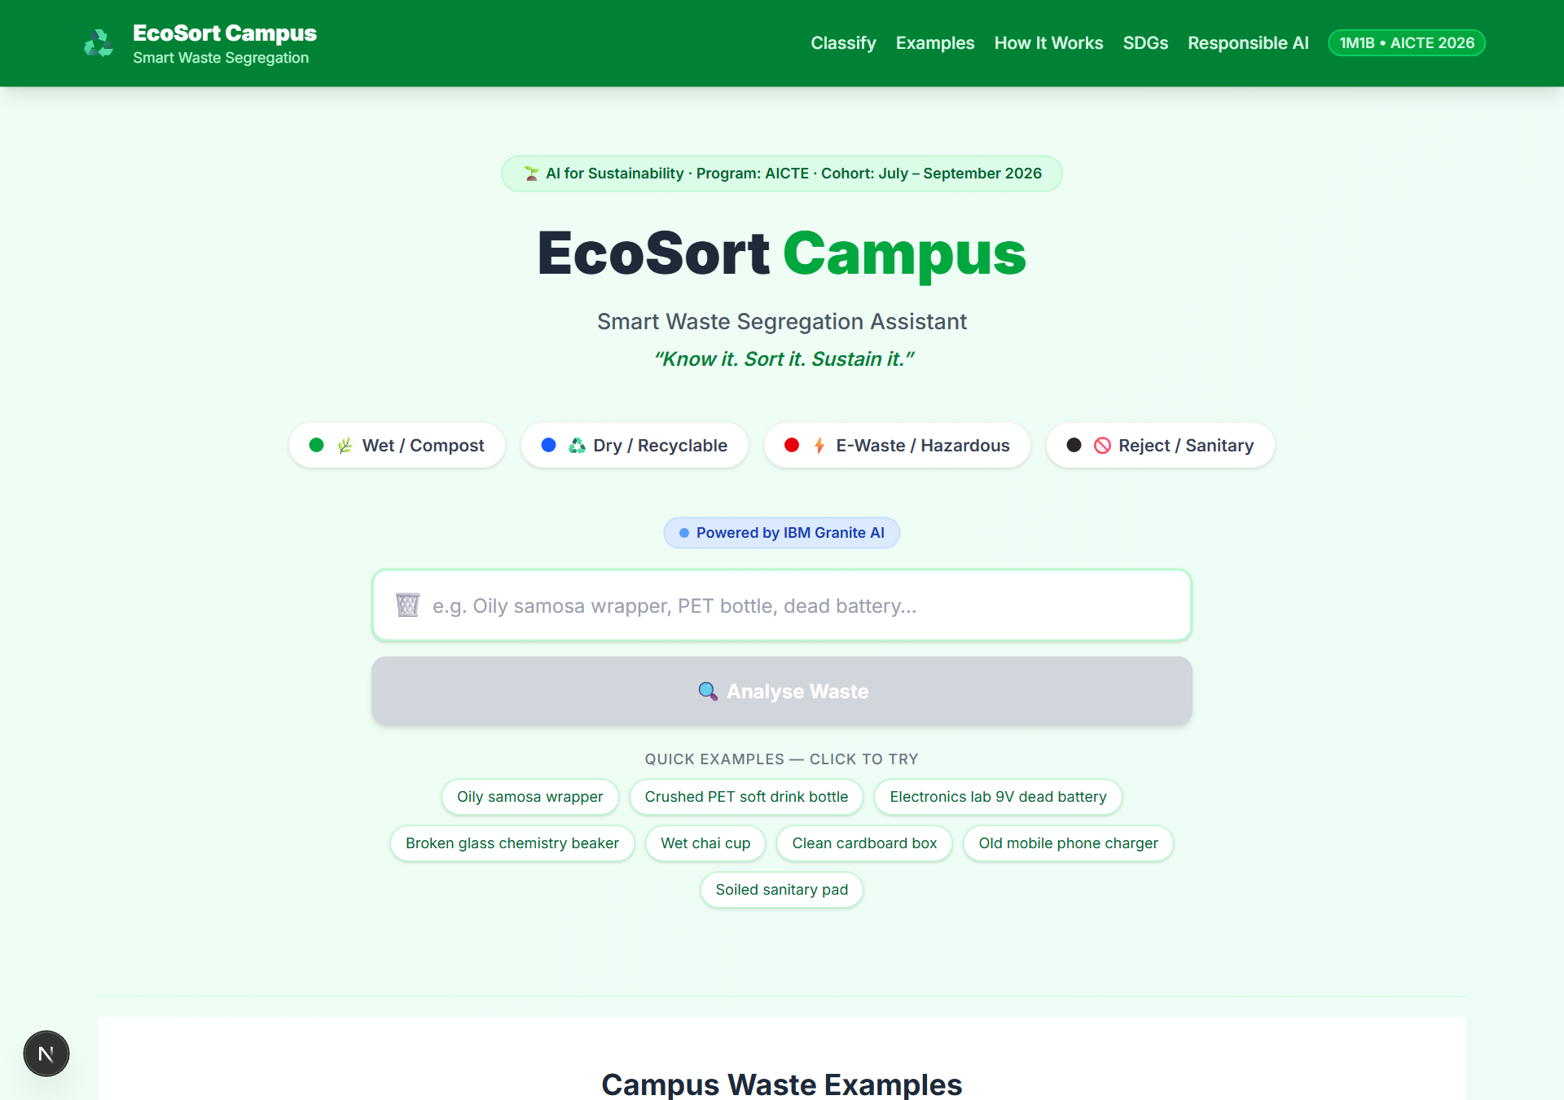
Figure: EcoSort Campus Main Application Interface

1. Problem Statement & Campus Waste Crisis
University campuses operate as micro-cities where thousands of students, faculty, and mess staff produce substantial volumes of mixed solid waste daily. In high-traffic locations such as cafeterias, lecture blocks, and hostels, waste segregation frequently fails.
Project Baseline Problem Statement (from Project PPT):
"Over 60% of recyclable materials on campus end up in landfills due to cross-contamination in high-traffic bins."
*(Note: Baseline problem observation from initial campus audit and proposal concept, not a measured municipal statistic).*

UN Sustainable Development Goals (SDGs)
• Primary SDG 12: Responsible Consumption and Production (Target 12.5) — Substantially reduce waste generation through recycling, preventing clean recyclables from being ruined by organic contaminants.
• Secondary SDG 11: Sustainable Cities and Communities — Reduces institutional environmental footprints and relieves local municipal landfill pressure.

2. Proposed AI Solution & Dual-Engine Architecture
EcoSort Campus uses natural language processing (NLP) and zero-shot entity extraction powered by IBM Granite foundation models (watsonx.ai). The solution is implemented cleanly as a full-stack Next.js web application with an App Router API backend (/api/classify).
Dual-Engine Reliability Strategy:
1. Live IBM Granite API: Interacts with ibm/granite-3-3-8b-instruct via watsonx.ai REST endpoints when credentials are provided in .env.local.
2. Rule-Based Fallback Engine: Provides deterministic classification across all four campus categories for seamless evaluation, offline demo resilience, and automated testing without exposing broken states.

3. Four-Bin Campus Classification System
Bin Colour | Category | Target Materials | Disposal Action
GREEN (#16a34a) | Wet / Compost | Food scraps, oily samosa wrappers, chai cups, greasy parcels | Tear clean dry margins; compost food/oil residue
BLUE (#2563eb) | Dry / Recyclable | Clean PET plastic #1, aluminium cans, dry cardboard boxes | Empty liquids completely; squash flat to save volume
RED (#dc2626) | Hazardous E-Waste | 9V/AA batteries, electronic scrap, lab chemicals, PCB parts | Tape terminals with cello-tape; drop in e-waste box
BLACK (#1c1917) | Reject / Sanitary | Broken beaker glass, thermocol (EPS), sanitary pads, bandages | Wrap glass securely in cardboard to protect workers

4. Test Cases & Verification Matrix (PPT Benchmark)
Input Item | Material Detected | Category & Bin | Safety Warning | Status
Oily samosa wrapper | Soiled Paper / Food Waste | Wet / Compost (Green) | Food oil contamination warning | PASS
Crushed PET soft drink bottle | PET Plastic #1 | Dry / Recyclable (Blue) | None (Safe to recycle) | PASS
Electronics lab 9V dead battery | Alkaline / Zinc Battery | Hazardous E-Waste (Red) | Chemical leak & fire hazard | PASS
Broken glass chemistry beaker | Borosilicate Glass | Sanitary / Reject (Black) | Sharp cut hazard for workers | PASS
Screenshots from the Live Application:
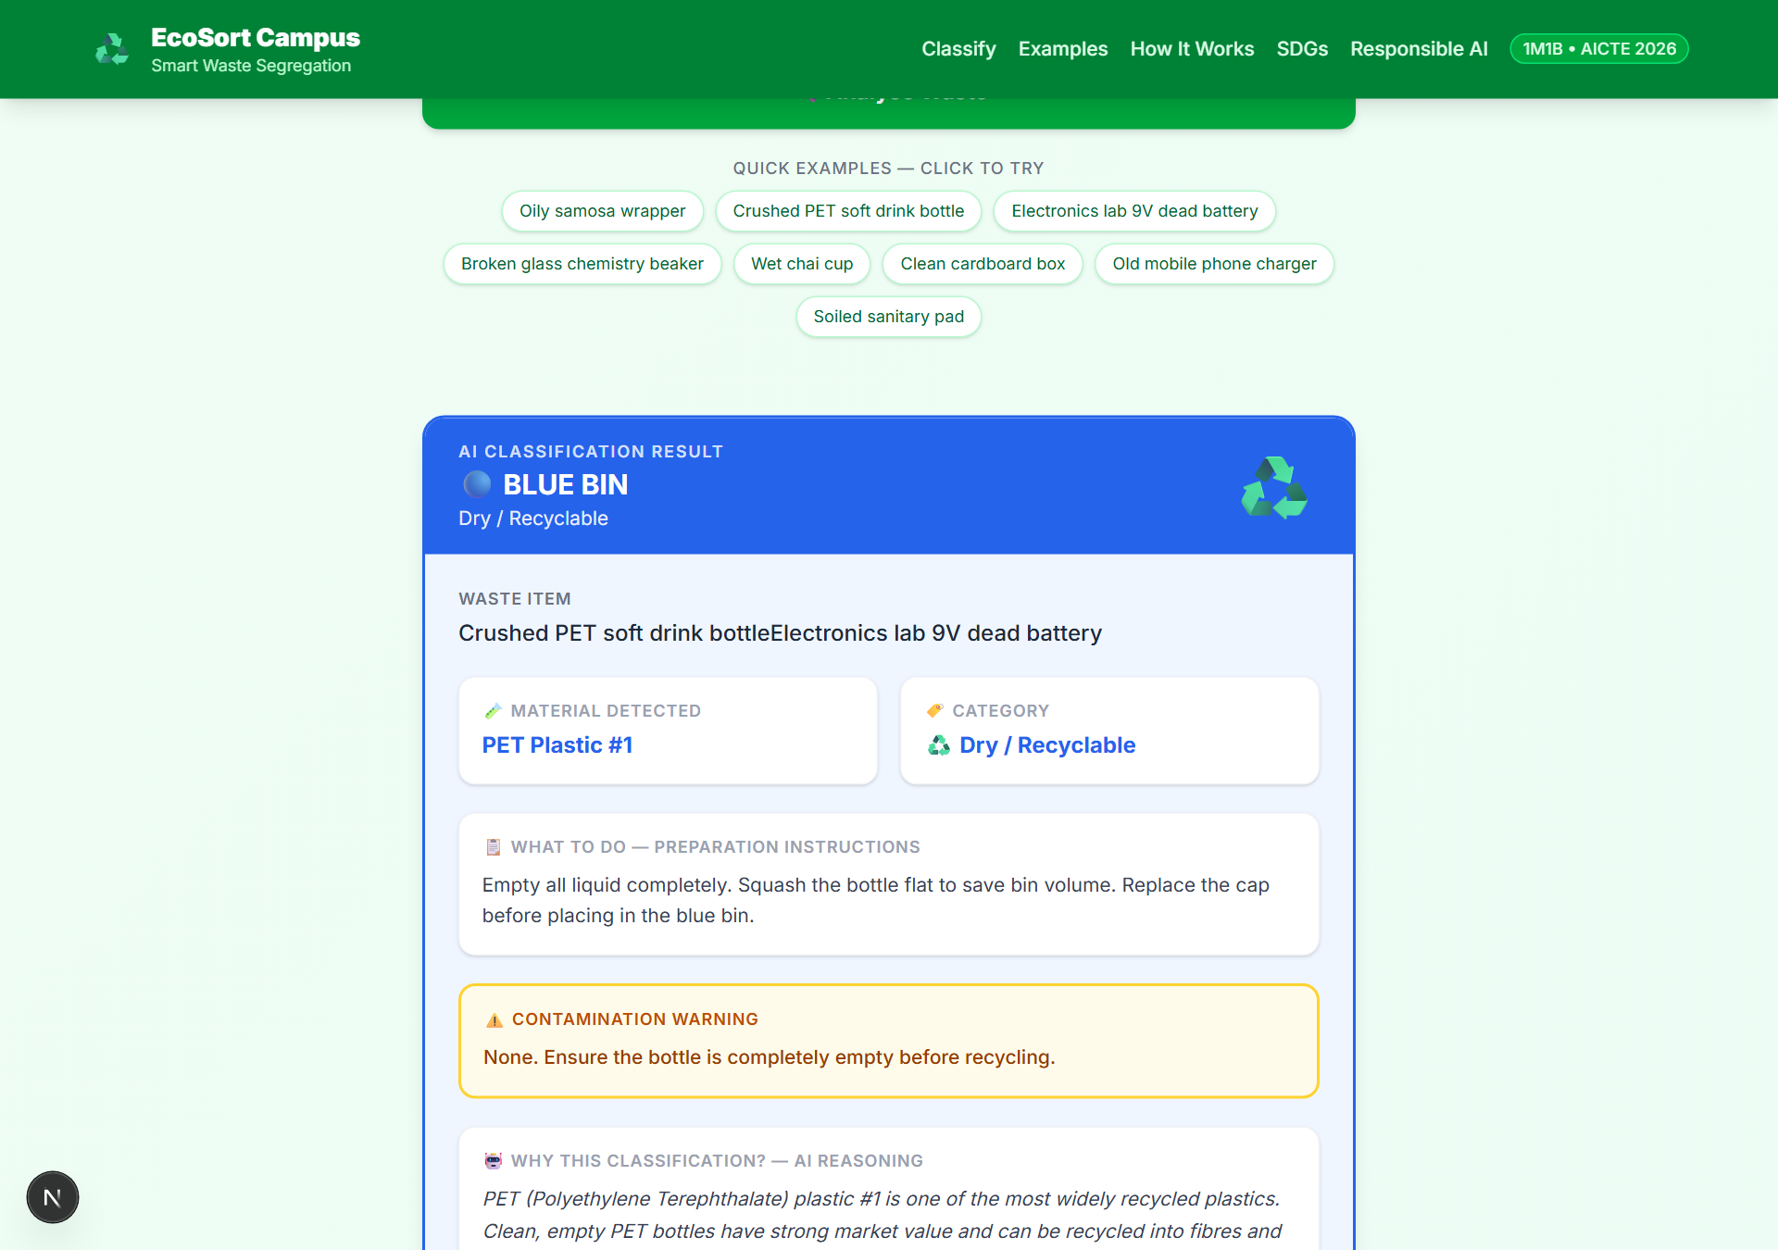

5. Responsible AI Framework
EcoSort Campus enforces six pillars of Responsible AI in its architecture:
1. Fairness & Inclusion: Calibrated for Indian campus contexts including regional packaging (chai cups, kulhad, samosa paper).
2. Transparency & Reasoning: Every response articulates the underlying physical explanation behind bin choices.
3. Privacy: Zero personal data retention. No student IDs, photos, device telemetry, or credentials stored.
4. Frontline Worker Safety: Proactive hazard guardrails mandate protective handling for broken glass and batteries.
5. Institutional Precedence: Local campus environmental protocols always supersede AI guidance.
6. Education Over Automation: Teaches sustainable habits by explaining 'why' rather than fostering blind compliance.
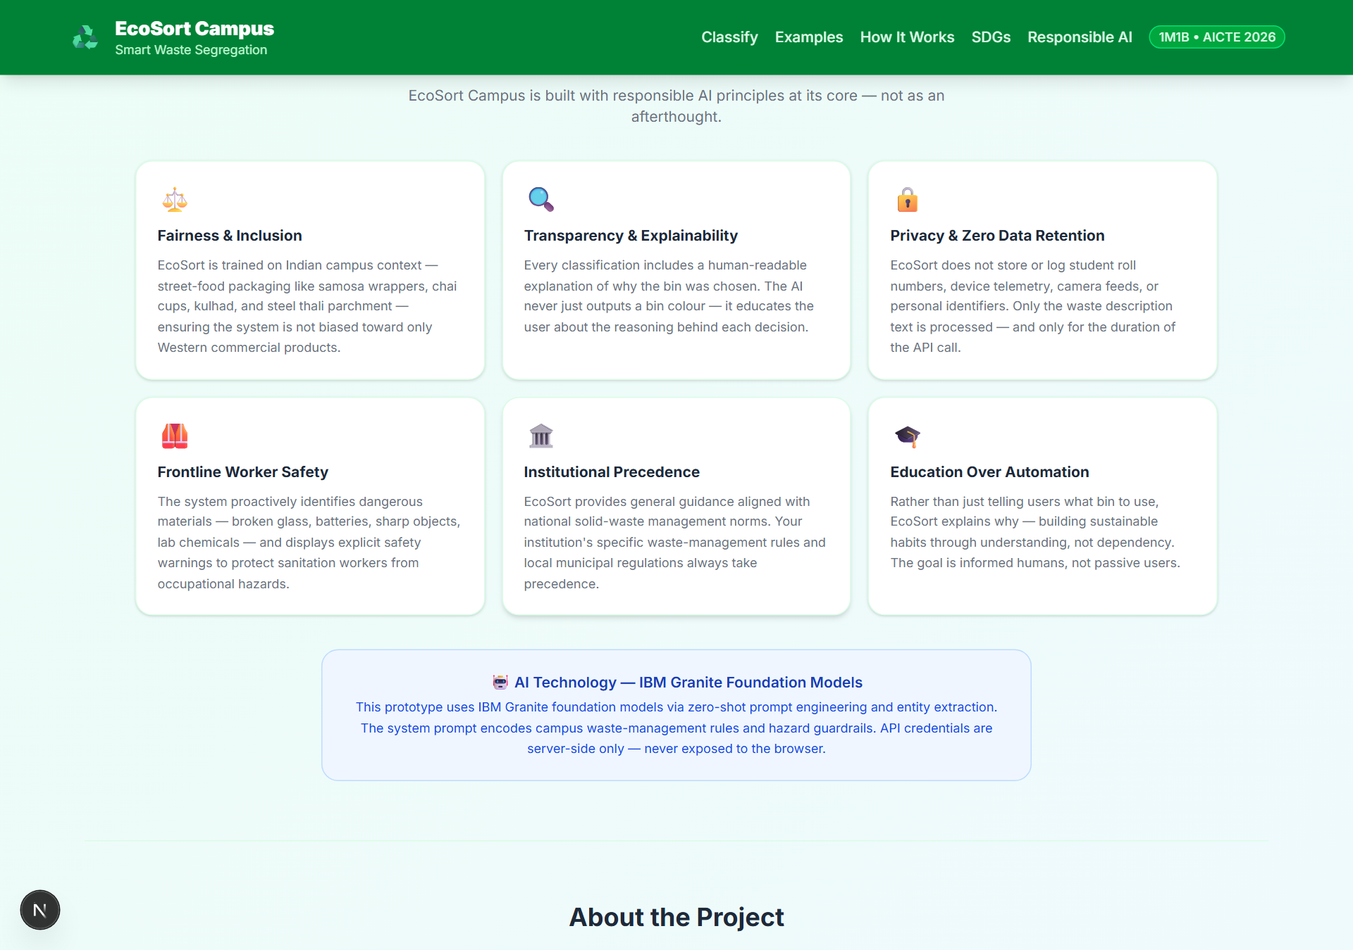

6. Projected Impact & Future Roadmap
Projected Impact (Concept Pilot Model):
"A pilot projection across a 3,000-student university campus indicates an average 70.2% overall diversion of municipal solid waste away from local landfills within 60 days of deployment."
*(Important: This figure represents an estimated model projection from the ideation slide deck, not a measured historical deployment result).*
Future Enhancements:
• Multimodal Computer Vision (IBM Granite Vision image recognition at bin stations)
• Multilingual voice and text input (Hindi, Tamil, Telugu)
• Ultrasonic IoT fill-level bin sensors
• Campus administrative analytics dashboard

Project Repository & Contact
• GitHub Repository: https://github.com/pdharv711/Ecosort-campus
• Documentation File: docs/EcoSort_Campus_Prototype_Documentation.pdf
• Author: Patel Dharv (GitHub: pdharv711)
• Program: AI for Sustainability Virtual Internship 2026 (AICTE / 1M1B / IBM)

