The Ohio State University

**Hurricane Power Outage Model GeoViewer**

**User Manual**

**Contents**

Introduction and Background #

Recourses and Technical Support #

Exploring the GeoViewer Workspace #

GeoViewer Layers #

Basemap Layers

Topography

Black Marble

Imagery

Light Grey

Additional Radar Overlay

Hurricane Tracking Layers

Atlantic/Caribbean Tropical Cyclones

Advisory Forecast Track

Additional Map Layers

Storm Surge Probabilities

Watches, Warnings and Advisories

User-defined Geographic Layers #

Exporting Files #

HPOM Features

HPOM Output

HPOM Output with Tract ID

References #

**Introduction and Background**

**Welcome to the Hurricane Power Outage Model GeoViewer**

Hurricanes devastate the Gulf Coast each year, with billions of dollars in damages, millions of people left without power, and human lives put at risk. Hurricanes present both direct and indirect hazards as they progress along their track. However, indirect hurricane-related hazards are often overlooked or difficult to predict. For example, hurricane-related power outages are among the most prevalent and hazardous effects of severe hurricanes, often lasting days or even weeks after a storm makes landfall. Model projections can predict the locations and durations of outages but can be hard to interpret for emergency decision-making.

The Hurricane Power Outage GeoViewer (HPOG) provides a user-friendly web-based application to help making hurricane preparedness and response decisions. This product incorporate projections from the Hurricane Outage Prediction Model (HOPM), developed by McRoberts et al. (2016), into a decision-support tool. This easy-to-use interface can represent HOPM output in conjunction to locations of critical public facilities, water treatment facilities, and geographic areas of vulnerability to better equip emergency managers with the tools to make informed decisions.

With this newly-developed geographic interface, users can get access to:

1. Near real-time Hurricane and tropical cyclone tracking
2. Interface to integrate spatial data layers of electric utilities, critical facilities, public health information
3. Modifiable power outage prediction models. A user-guide will be created to accompany this decision support tool

The app can be used for:

* Preparedness – "What-if" scenarios and model adjustments
* Timely Response – tied to real-time weather, forecast, and outage information
* Mitigation and Planning – identify vulnerabilities and predict power outage

**Resources and Technical Support**

Our HPOM GeoViewer can be accessed at [chapmanrebecca.com/AppliedClimate/index.html](http://chapmanrebecca.com/AppliedClimate/index.html). If you have further questions about this product, please contact us at:

|  |  |
| --- | --- |
| **Steven Quiring**  **Professor**  Department of Geography  Ohio State University  154 N Oval Mall, Columbus, Ohio 43210 [quiring.10@osu.edu](mailto:quiring.10@osu.edu) | **Emily Sambuco**  **Masters Student**  Department of Geography  Ohio State University  154 N Oval Mall, Columbus, Ohio 43210 [sambuco.8@osu.edu](mailto:sambuco.8@osu.edu) |
| **Yuechun Wang**  **PhD Student**  Department of Geography  Ohio State University  154 N Oval Mall, Columbus, Ohio 43210  [wang.8869@osu.edu](mailto:wang.8869@osu.edu) | **Rebecca Chapman**  **Masters Student**  Department of Geography  Ohio State University  154 N Oval Mall, Columbus, Ohio 43210 [chapman.751@osu.edu](mailto:chapman.751@osu.edu) |

**Exploring the GeoViewer Workspace**

Map Box

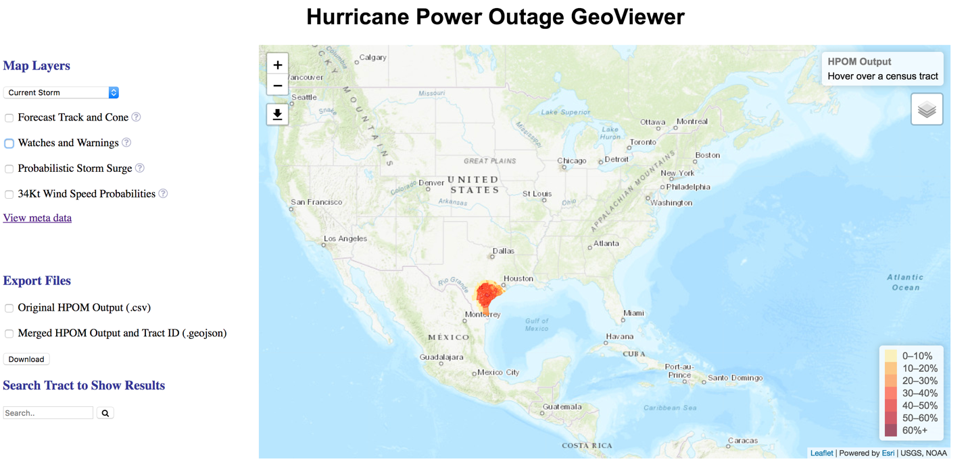

**Data Tabs**

**Basemap Options**

**GeoViewer Map Box**

The HPOM GeoViewer site displays a large geographic map tool, with manipulation capabilities and alternative viewing options.

**Map Manipulation**

* Zoom capabilities – Users can zoom in or out to any desired location on the map, by either scrolling or utilizing the (+/-) icons to the top left of the map bounding box.
* Hover tool – By hovering the mouse over a county of interest, more information appears in the top right output box, overlaid onto the GeoViewer map. By hovering over an individual county, users are able to determine specific Tract ID numbers and HPOM percentages.

**HPOM Output Legend**

* **The HPOM Legend is located on the right side of the GeoViewer map.**
* **This legend depicts the percent of customers effected by power outage.**

**Basemap Options**

A girded icon is located in the top right corner of the GeoViewer map, just below the HPOM information box. When the gridded icon is clicked, it reveals different basemap viewing options.

Due to the nature of a basemap layer, only one can be selected at a time. Each option lays at the base of the map, and other additional layers can be added over top. They will appear to be layered on top of the selected basemap.

The following options can be clicked on and off:

**Topography**

* This option shows normal topography as a base. Roads, city/state names, and hydrologic features are easily viewed with this basemap option.

**Black Marble**

* This option depicts the Earth at night, allowing for easier viewing of high-energy-consumption areas. This product is made available through NASA’s satellite VIIRS.

**Imagery**

* This option shows satellite imagery of land surface. This option allows for easy viewing of land surface characteristics.

**Light Grey**

* This option shows a neutral grey tone basemap containing basin topographic information. This viewing option is a simplified version of the “Topography” option and shows only subtle state names and boundaries. This simplified basemap allows for easy viewing of multiple, complex layers overtop.

In addition, a moving radar overlay is available to click on and off. Because this layer is not a basemap, it can be clicked on and off in addition to which ever basemap is chosen.

**Additional Radar Overlay**

* This option shows current radar in the United States and can lay overtop of any basemap. The radar image is static and automatically generates the most recent information from XXX.

**GeoViewer Map Layers**

On the left side of the GeoViewer map, additional layers are listed with check-boxes. Each layer is clickable and able to be turned on and off of the map. A more outlined description of each layer can be found in subsequent sections.

**Hurricane Tracking Layers**

The following layers relate to current hurricanes influencing the Texas Gulf Coast:

* **List of things**
* **List of things**
* **List of things**
* **List of things**

**Additional Map Layers**

The following layers contain supplemental geographic information to aid in decision support:

* **List of things**
* **List of things**
* **List of things**

**Additional Layer Information – (?) Icon**

To the right of each layer, there is a (?) icon. When clicked, this question-mark icon reveals a brief description of the layer, what is being displayed, and in what units the product appears. To make the information box disappear, click the (?) icon once more.

There is also an option to view layer metadata. This link is located directly underneath the “Map Layers” section. The link will navigate you away from the GeoViewer page and to the NOAA National Hurricane Center GIS Products service site. A more detailed description of each layer can be found at this site.

**Current and Historical Storm Options**

At the top if the “Map Layers” section, there is a drop-down box with options to view either current storms or sample historical storms. To make a selection, click the drop-down box and select the preferred storm option. Once this option is selected, each subsequent map layer will correspond to the above selected storm. For example, if “Sample- Harvey 2017 #15” is selected, each map layer added will show historical Hurricane Harvey data.

**File Export**

The file export section is located in the bottom left-hand side of the web page, the the left of the GeoViewer map. This tool allows for exportation of HPOM data files.

**HPOM Output**

* This option allows for “.csv” or Comma Separated Value files to be exported from the GeoViewer
* By clicking the box next to this option, a file will automatically start to download and will be accessible in “.csv” format

**Merged HPOM Output and Tract ID**

* This option allows for “.geojson” or a Json file with geometries to be exported from the GeoViewer
* By clicking the box next to this option, a file will automatically start to download and will be accessible in “.geojson” format

**GeoViewer Layers**

[will add to this section]

Basemap Layers

Topography

Black Marble

Imagery

Light Grey

Additional Radar Overlay

Hurricane Tracking Layers

Atlantic/Caribbean Tropical Cyclones

Advisory Forecast Track

Additional Map Layers

Storm Surge Probabilities

Watches, Warnings and Advisories

**User-defined Geographic Layers**

[will add to this section]

**Exporting Files**

**HPOM Features**

**The HPOM model is computed through R and run under Linux system. The CSV file will be updated automatically every 6 hours. Each file includes:**

* **Tract_ID – county code**
* **P2010 – number of population**
* **Full_reduced – percentage of population influenced**

**Example HPOM Output**

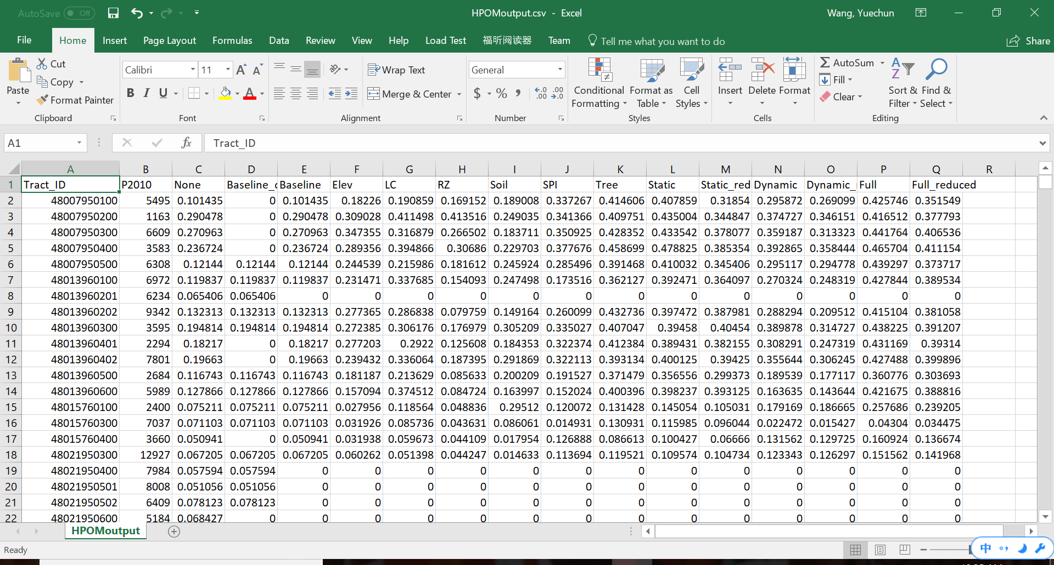

**Original HPOM Output (.csv)**

**To download original HPOM output in .csv format, simply select the option “original HPOM output” underneath the “Export Files” section and press “download”. The .csv file should automatically begin downloading. This file should look identical to the example output displayed above.**

**Merged HPOM Output and Tract ID (.geojson)**

**Along with original output, there is also a .geojson file download option. TO download this file type, select the check box next to the “Merged HPOM Output and Tract ID” option underneath the “Export Files” section and then press “download”.**

**References and Additional Resources**

McRoberts, D. B., S. M. Quiring, and S. D. Guikema, 2016: Improving Hurricane Power Outage Prediction Models Through the Inclusion of Local Environmental Factors: Improving Hurricane Power Outage Prediction Models. Risk Analysis, doi:10.1111/risa.12728.