**Exercise 1a:**

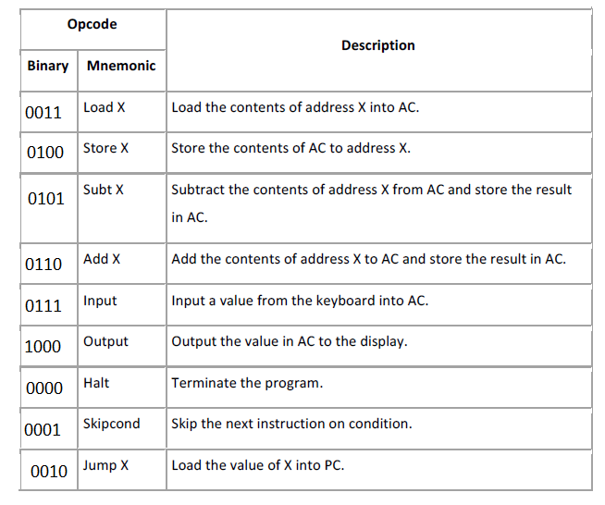

**Exercise 1b:**

|  |  |  |
| --- | --- | --- |
| Opcode | | Description |
| Binary | Mnemonic |
| 1001 | JZE X | Set PC to X if AC is 0. |
| 1010 | JNZ X | Set PC to X if AC is NOT 0. |
| 1011 | SubtI X | Subtract the immediate value X from AC and store the result in AC. |
| 1100 | AddI X | Add the immediate value X to AC and store the result in AC. |

**Exercise 1c:**

If the operand of the Skipcond instruction is 000000000000 (0dec) and AC < 0, the next instruction is skipped (PC = PC + 2). Otherwise, the next instruction is executed (PC = PC + 1).

If the operand of the Skipcond instruction is 010000000000 (1024dec) and AC == 0, the next instruction is skipped (PC = PC + 2). Otherwise, the next instruction is executed (PC = PC + 1).

If the operand of the Skipcond instruction is 100000000000 (2048dec) and AC > 0, the next instruction is skipped (PC = PC + 2). Otherwise, the next instruction is executed (PC = PC + 1).