DWP Authenticate

Discussion guide: Add a service group (1)

# Objectives

* To understand more about the role of service management
* To explore the journey for a system admin adding a service group.
  + Check understanding of the dashboard
  + Explore whether the flow of the journey/screens make sense to users
  + Explore users understanding of the permissions/roles

# Introduction

* First of all, thank you for taking time to talk to us today. My name is Fern and we’ll be together for around 30 minutes if that’s ok?
* The purpose of the research today is for you to help us explore how the admin portal for authenticate needs to work.
* There are no right or wrong answers, we would like to hear your thoughts so we can improve the process for everyone.
* __________ from the team is observing this session in order to take some notes, if that’s ok with you? The notes will allow us to analyse the feedback in more detail later.
* The notes and information from the project will be anonymised, so your identity is not associated with your responses.
* Does that all sound ok? Do you have any questions?
* can I ask you to read a complete this consent form?
* Please get in touch with me if you have any questions after todays session.

# About the participant

* How comfortable are you using a computer and the internet?
* Starting with outside of work, how often do you use technology?
  + What time kind of devices do you have?
  + What kind of things do you do online?
* Is there anything you wouldn’t do online? (online banking? Online shopping?) if so, why?
* Do you ever need someone else to show you how to use a device or certain types of technology? Could you give me an example?
* Do you think you could teach someone else to use or do something on a device/online?
* Please can you tell me a little bit about your role here in the department
* We’re going to be looking at a system where you’ll be able to manage people using authenticate to allow them to self-manage. Could you tell me about your awareness of this, if anything?
  + Do you have any expectations for what the system will allow you to do?
  + Do you have any concerns about the system?

# Prototype

We’re now going to have a look at an example of how the system may look and work. It’s currently in the early stages and therefore some things may not work as you’d expect. I’d like you to use the website however you’d like to and I’d like to hear your thoughts as we go through. I may also ask you some questions as you’re using the website too – is that ok?

This is the first thing you would see once you’ve signed in.

Dashboard

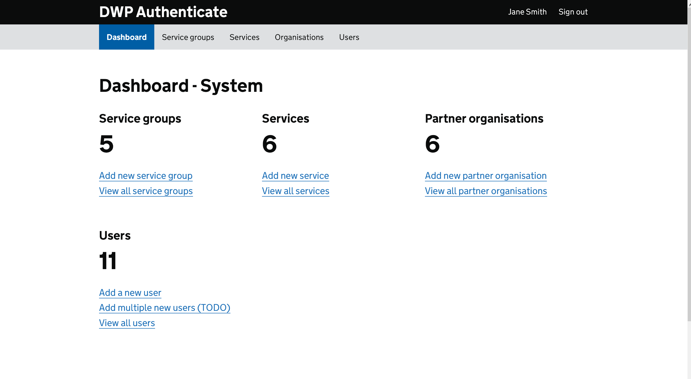

* What’s your understanding of this page?
* What do you think you can do from this page?
* What’s your understanding of the different titles?
  + Service group?
  + Services?
  + Partner organisations?
  + Users?

Scenario

You’ve been asked to on-board Health to the admin portal. The first person you’ll be on-boarding to the system is

Joe Bloggs

[Joe.bloggs3@dwp.gov.uk](mailto:Joe.bloggs3@dwp.gov.uk)

07401 123456

Please can you show me how you would on-board them to the system.

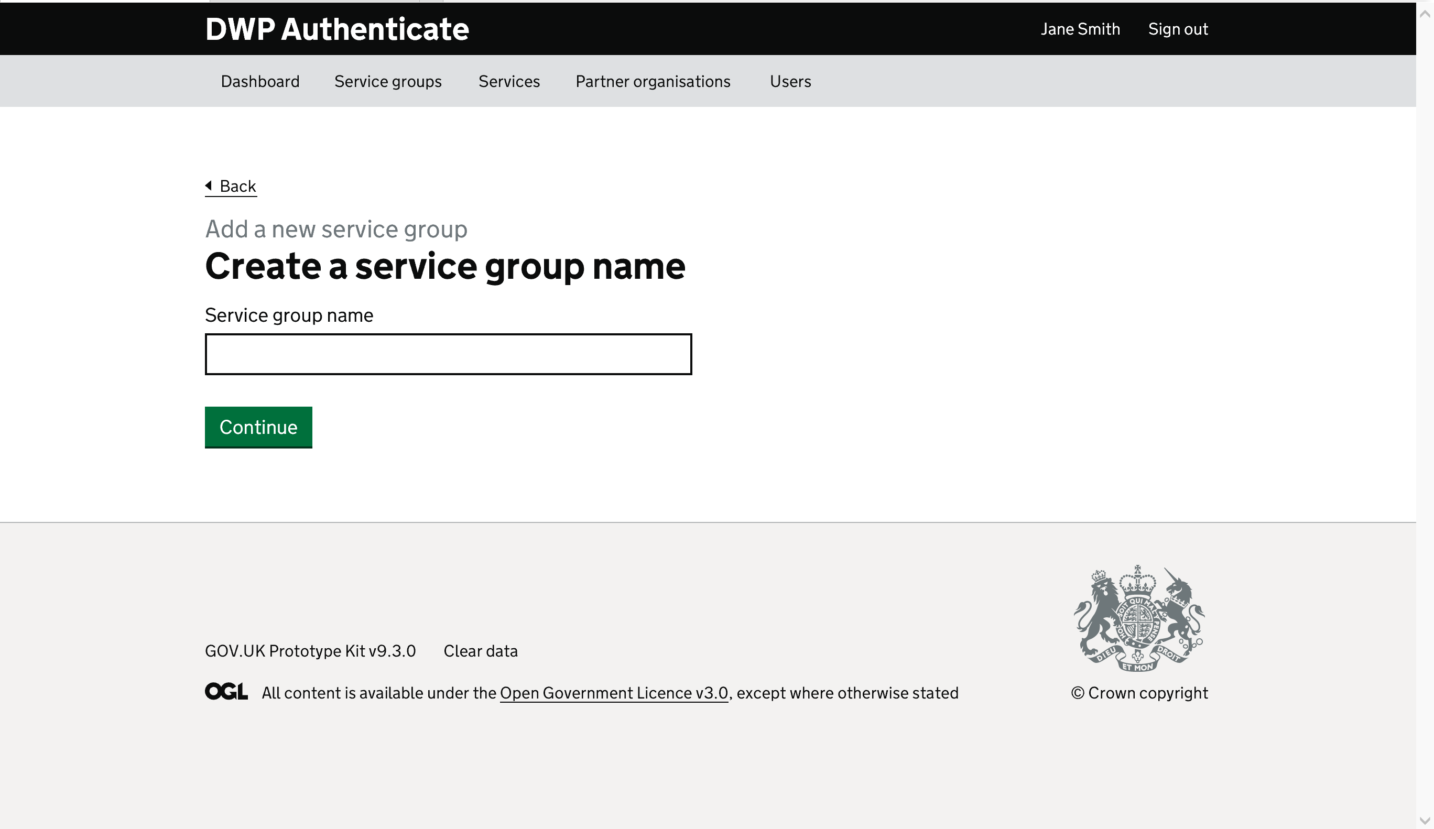

* Observe for any issues on this page
* How did you decide what to type there?
* What would you expect next?

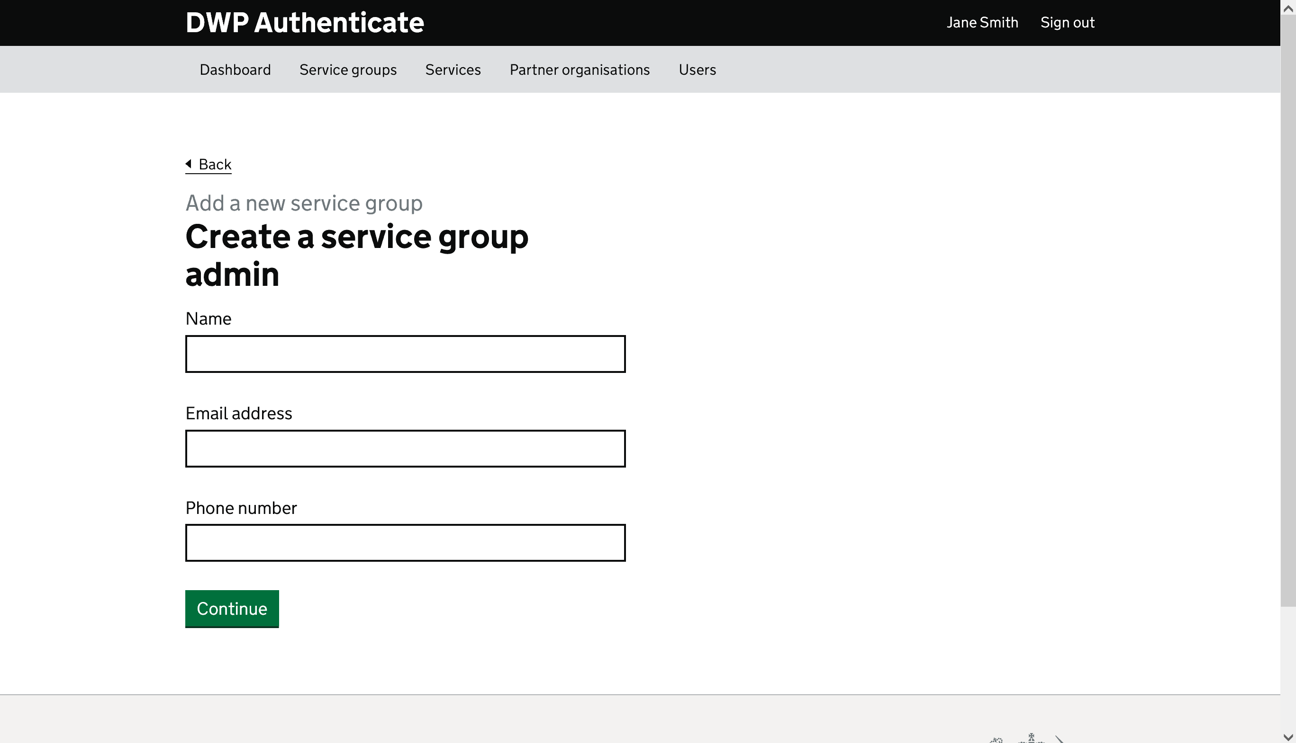

* What’s your understanding of what you’re doing here?
* What’s your thoughts on the information your having to input?
* Is there anything missing?

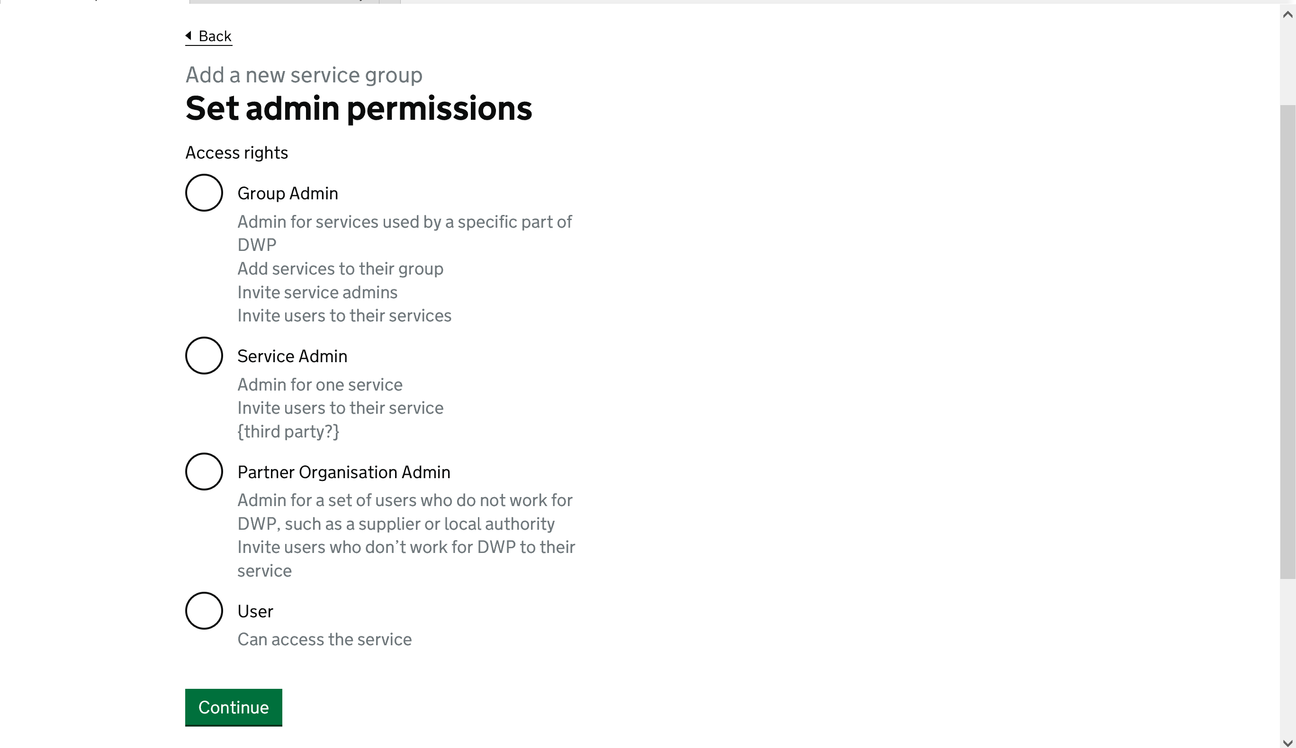

* What’s your understanding of this page?
* What does each group mean to you?
* Is there any way it could be made clearer?
* What would you expect next?

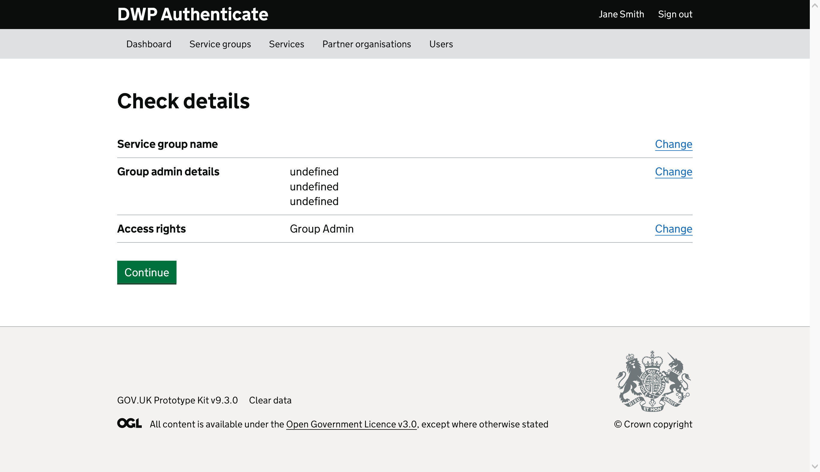

* Can you tell me about what this page?
* If you noticed you’d made a mistake, what would you do?
* What would you expect next?

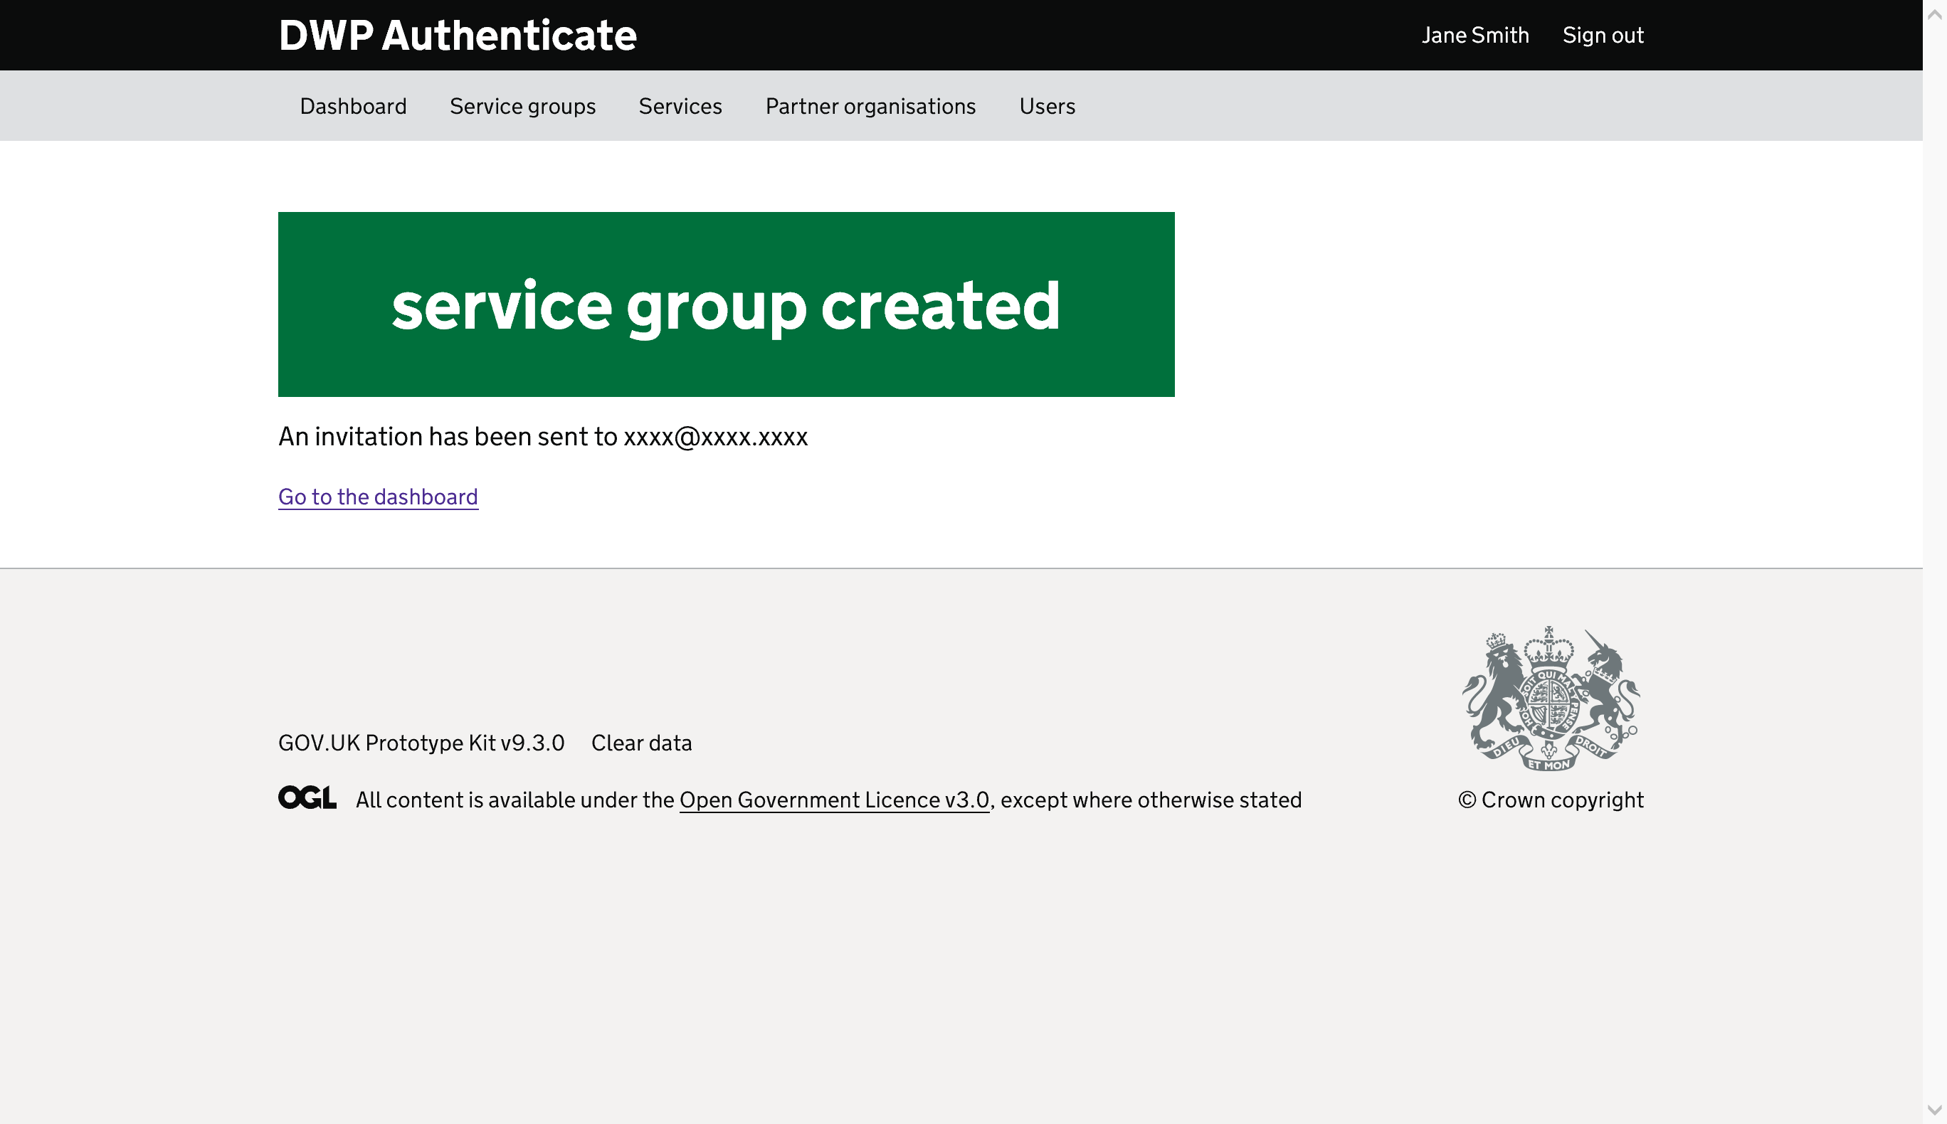

* Is there anything else you would want to do from this page?
* What would you do next? (to understand whether they find and click the dashboard link or do they use the top nav)

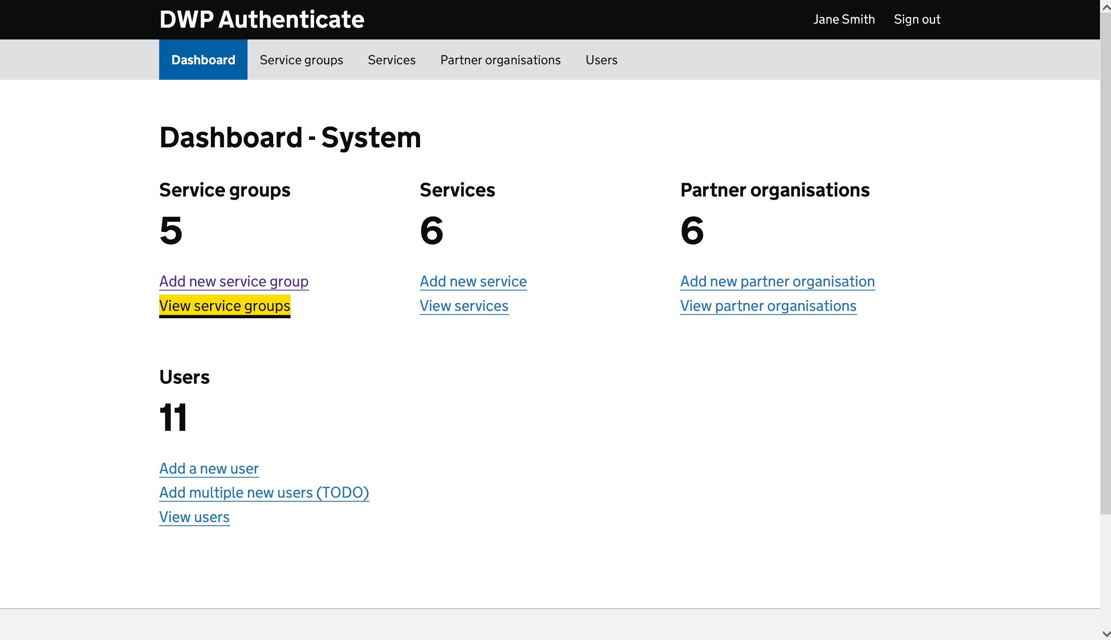

[once they are on the dashboard] **now you’ve added Health what would you do to check they’ve been added?**

* Why did you go there?

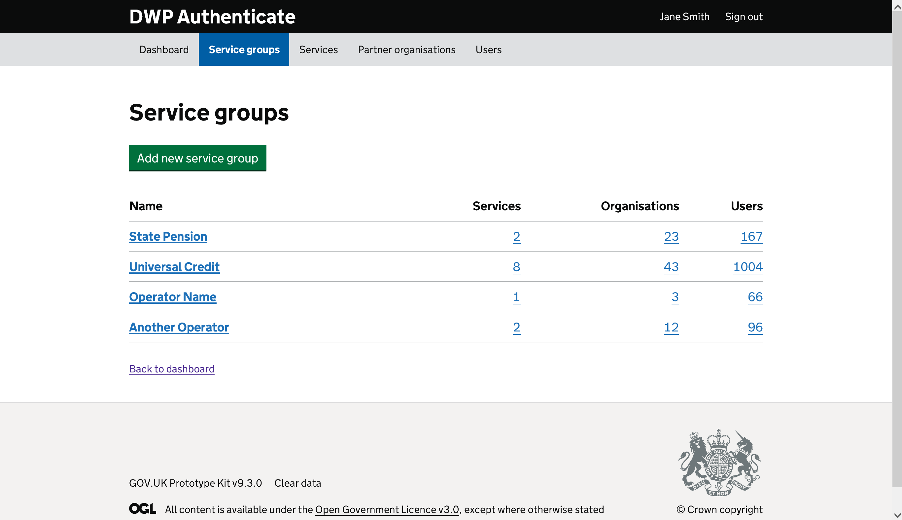

* What’s your thoughts about the page you’ve come to?

# Post session questions

That’s everything we’re going to be doing on the website today.

* What are your overall thoughts about what we’ve looked at?
* Are there any particular things you think should be improved?
* Was there anything missing?