Annotation - The XYOUTS Procedure

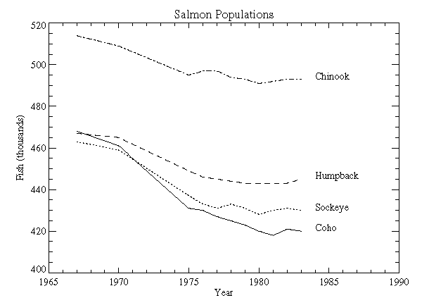
XYOUTS, X, Y, STRING
NAMES=['Coho','Sockeye','Humpback', 'Chinook']
; Define variables:
@plot01
; Index of last point:
N1 = N_ELEMENTS(YEAR) - 1
; Plot first graph. Set the y-axis min and max
; from the min and max of all data sets. Default linestyle is 0.
PLOT, YEAR, COHO, YRANGE = [MIN(ALLPTS), MAX(ALLPTS)], $
TITLE='Salmon Populations', XTITLE = 'Year', $
YTITLE = 'Fish (thousands)', XRANGE = [1965, 1990], $
/XSTYLE
; Loop for the three remaining scores, varying the linestyle:
FOR I = 1, 3 DO OPLOT, YEAR, ALLPTS[*, I], LINE = I
; Append the title of each graph on the right:
FOR I = 0, 3 DO XYOUTS, 1984, ALLPTS[N1, I], NAMES[I]

