
Guidance notes
and summary of material
produced by Dunstable College
on the use of graphs and charts
with tips for use in enhancing
teaching and learning
through the use of
spreadsheet technology
March 2006

Contents
Introduction 3
Selecting the data for a chart 7
Hiding columns or rows 8
The problem with years 9
Is your data in rows or columns? 10
The colours are all wrong 12
Which type of chart? 14
Area Charts 14
Bar Charts 14
Column Charts 14
Line Charts 14
Pie Charts 15
Scatter Plot 15
3-D Charts 15
Misleading charts 16
Other things buried in Excel 19
Stacking images 19
Changing the gaps between columns or rows 21
Transferring charts to other applications 22
Examples of charts in use 23
Barriers to e-learning 23
Misleading charts 23
Charts in quizzes and other bits 23
More information 23

Introduction

This project is about presenting numeric data a bit more clearly. There will be some people out there who simply love sheets of figures and can quite easily make sense of them in that form – this is not meant for them. It is for all the others who would like to turn them into graphs or charts which many find a lot easier to understand.

Here's a set of figures which represent how respondents to a survey felt about their progress in meeting some ILT standards in 2004.

Standard | Code | 2003 | 2004 | 1 | 1% | 2 | 2% | 3 | 3% | 4 | 4% | 5 | 5%
A1 | 1 | 145 | 76 | 12 | 8.275862 | 46 | 31.72414 | 67 | 46.2069 | 15 | 10.34483 | 5 | 3.448276
A2 | 2 | 142 | 73 | 38 | 26.76056 | 49 | 34.50704 | 32 | 22.53521 | 19 | 13.38028 | 7 | 4.929577
A3 | 3 | 139 | 74 | 72 | 51.79856 | 16 | 11.51079 | 20 | 14.38849 | 6 | 4.316547 | 5 | 3.597122
B1 | 4 | 134 | 71 | 8 | 5.970149 | 18 | 13.43284 | 59 | 44.02985 | 33 | 24.62687 | 4 | 2.985075
B2 | 5 | 132 | 71 | 10 | 7.575758 | 32 | 24.24242 | 64 | 48.48485 | 21 | 15.90909 | 5 | 3.787879
B3 | 6 | 131 | 72 | 18 | 13.74046 | 31 | 23.66412 | 39 | 29.77099 | 30 | 22.90076 | 10 | 7.633588
C1 | 7 | 126 | 70 | 8 | 6.349206 | 30 | 23.80952 | 60 | 47.61905 | 26 | 20.63492 | 11 | 8.730159
C2 | 8 | 125 | 71 | 9 | 7.2 | 34 | 27.2 | 45 | 36 | 27 | 21.6 | 8 | 6.4
C3 | 9 | 125 | 71 | 28 | 22.4 | 19 | 15.2 | 30 | 24 | 15 | 12 | 4 | 3.2

As well as not being particularly well set out and containing some superfluous data, it really doesn't get much of a message across. Now let's try a chart.

Distribution of level 1 responses to standards A B and C.
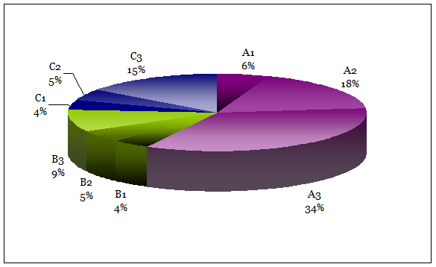
Now this doesn't include all the data. It just shows the distribution of people who said that they were just starting to meet the standards but it does that quite clearly – you can see that the A group is the main area of concern, with A3, A2 and C3 being those that might warrant some more examination.

You would need four similar charts to complete the picture but the picture they would paint would be much more likely to be a clear one.

You might have wished to show the distribution of responses at levels 1 to 5 for just standard A1. This would look like this:

Standard A1: Distribution of responses at levels 1 to 5
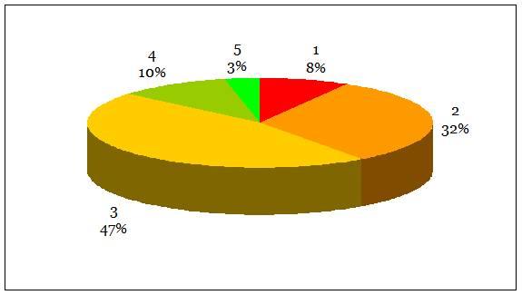
Again, it's pretty clear that most people are at level 2 or 3, and use of colour to show the area of concern as red and the advanced group green helps too.

A series of little charts might then be satisfactory for many purposes. Let's try:

A1: comparison of confidence levels 1 to 5  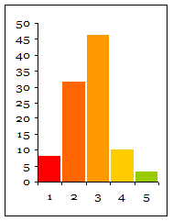 | 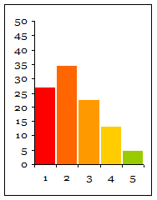  A2: comparison of confidence levels 1 to 5 | 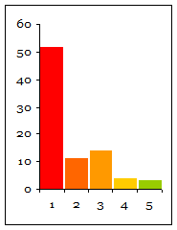  A3: comparison of confidence levels 1 to 5

Or, all three could be combined in one, like this, which is probably the best idea, especially as for the data above, you would have needed nine separate charts which might have been a bit much.

Overall confidence levels from 1 to 5 for standard A
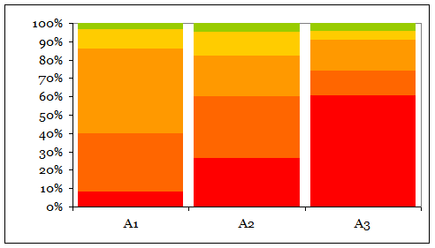
Or even use some pictures and have them stacked up in proportion to the responses, like this.
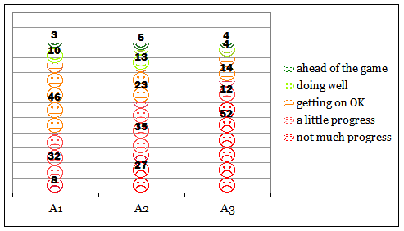
Both the above make it very clear that not many respondents said they felt they were very far advanced (the level 5 response) in any of the A standards at the time. (You could probably have gathered this from the data table but perhaps not as immediately.)

So far, a range of techniques have been used, some fairly simple and others which are buried quite deep in Excel's menus. In this project we shall try to take you through how to select just the bits of data to include in a graph, how to select which type of chart or graph to use and how to change the default display in Excel. We'll use the examples shown above but hopefully you'll then be able to apply the techniques to the data you wish to display.

Selecting the data for a chart

Unless you're really lucky, the data you have will have a whole pile of stuff that isn't needed in the chart. So selecting the whole table and hitting the chart icon won't be very helpful to anyone. You need to decide what the chart needs by way of data and just pick out those bits. There are two ways to do this – one will work just about all the time and the other won't. The best way is to use the Ctrl key to help you skip rows or columns.

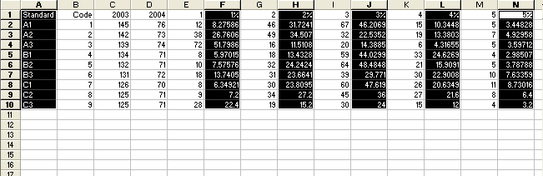
In this example, just columns A, F, H, J, L and N have the data needed. Start by highlighting the cells A1-A10. Hold the Ctrl key down and then highlight F1 -F10, then still holding the key down, J1-J10 and so on. The top cell of the last row you select will appear white with a border – it may look odd but that's correct.

You could achieve a similar result by selecting A1, then Ctrl-selecting, or jumping, to F1, H1, J1 etc then back to A2, F2, H2, J2 etc. Which of the two routes you take is probably best left to the 'try-it-and-see' method. They may produce different initial charts so go for the one that appears to give you something like what you want.

When missing out columns or rows like this it is important that you select similar areas in each row or column. Selecting 5 cells in one column, 6 in another will not work. Each row or column has to match.

Another problem can be if you stop half-way through the selection and either try and go back to include something you missed or select the same cell or block more than once. You may get a chart but it's unlikely to be of any use. Annoying as it may be, you just have to click somewhere to get rid of all the selections and start again.

Once you get the hang of the method, though, it is really useful and avoids some of the pitfalls in the next method which, whilst apparently easier, can go wrong easily.

Hiding columns or rows

If you prefer selecting a simple continuous block of data for the chart then it may be possible to hide the columns you don't want included. Hide columns or rows by clicking any cell in the column or row and using Format|Column (or Row)>Hide. Check carefully, though, any results from formulae – for example, totals will not change – which might give odd results.

Whilst hiding things is fairly easy, unhiding them can be a pain sometimes, especially the first row or column, and in a large sheet of data it may not always be obvious what is hidden, or has been hidden by someone else.

If you've hidden column B, for example, and want to get it back then select a cell in columns A and C, bridging the gap, as it were, and use Format|Column>Unhide.

To get a hidden column A back the simplest way is to click on a row number at the left of a row – this selects the whole row – and use Format|Columns>Unhide. That may, however, produce unexpected results and unhide a whole load of other columns you either didn't want shown or didn't even know were hidden in the first place. If that happens hit Ctrl+Z to undo the disaster and try another way.

There should be a box, just above cell A1, top left of the sheet. Type A1 there and hit Enter. A1 is now selected, even though you can't see it. So now you can use the Format menu to unhide that column or row. (This technique is also a good way to get out of trouble if you find you drag a row or column to some tiny width or size. As it's not 'hidden' just very small, you can't unhide it and have to change its height or width in the Format menu instead to make it visible again).

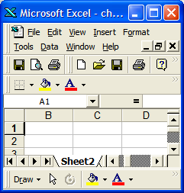
The problem with years
(or numbers generally as headings)

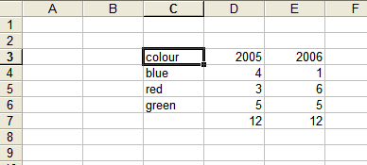
You have a nice simple bit of data. Hardly needs a chart but let's say you want one anyway. What could be simpler? Select the area C3 to E5 and away you go. Wrong. This is what Excel offers you:

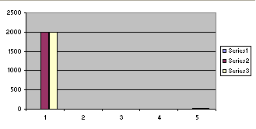
What you'd like, and might reasonably have expected Microsoft to have offered straightaway, is this:

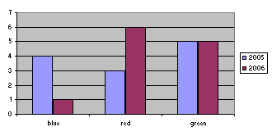
OK, so the default colours will confuse everyone – we'll deal with that in another section – but that's basically what you need. There is a complicated way to get there by changing the name of 'Series1' to 'blue', 'Series2' to 'red' etc in this part of the Series window

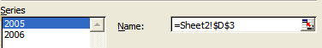
but an easier way is this: just delete the content of the top left box of your selected area, in this case where the word 'colour' appears.
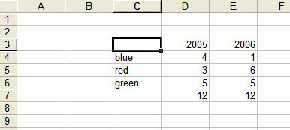
Then you'll get what you want first time. It's best not to ask why.

Is your data in rows or columns?
Good question. You'd probably say both. Excel will, however, produce a different chart, depending on what you answer.

The charts above are what it offers for columns. This is what it offers for rows.

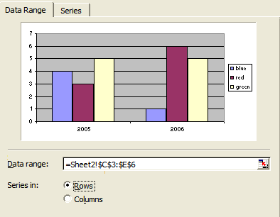
The first shows how the colour data changed each year very nicely. But if you'd wanted to illustrate the comparative make-up of the three colours in each year then the second is better.

It's really difficult to be able to tell in advance which will give you the best result so, as it entails just a click on a radio button to preview the change, look at both before continuing. Very often you'll find one or other can also give you a fresh view of the data itself too and reveal a trend or comparison previously not so obvious.

The colours are all wrong

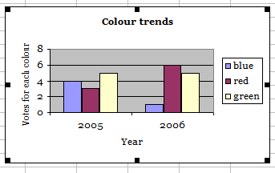
Or you just don't like the default Excel offering. You can change it. Here's how. We'll use the 'years' data as an example.

Before doing anything else, though, get rid of the awful grey background. It seldom makes any contribution to clarity and uses a huge amount of ink for no good reason. Click on the background (Plot Area) to select it.
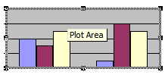
Then click on the little arrow on the colour fill icon which is usually on the formatting toolbar.
You're probably familiar with this icon – it offers a great range of options, including fancy gradients, awkward shading, quite smart textures and even pictures, but more often than not the best option is No fill. And while you're at it click on the Value Axis Major Gridlines and delete them and, unless you really like boxes everywhere, right click on the legend box and Format it, selecting None in the Lines department.

In most cases, removing the clutter improves things immensely. Now back to the colours. .

Click on one of the bars (or segments of a pie chart, or lines of a line graph). That single click will select all in that series. To select just that one part you would need to click again in the same place. That can be tricky but it's not impossible. In this case we'll leave all the blue areas selected.

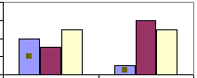
Now use the colour fill icon to choose what you'd like – in this case a brighter blue. Repeat the process for purple to red and yellow to green.

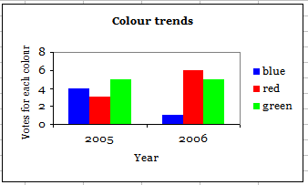

That's much clearer now, and you would be able to get rid of the legend box completely in this case too.

Here's how a pie chart for one year might look:

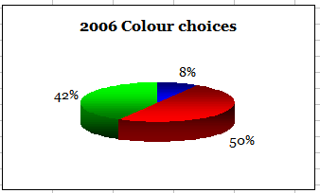

Which type of chart?

Area Charts
Area charts show the relative contributions over time that each data series makes to a whole picture. For example, an area chart would be good to show how much the relative amounts of the principal and interest change over time of a mortgage.

Bar Charts

Bar charts compare distinct items or show single items at distinct intervals. Usually, a bar chart is laid out with categories along the vertical axis and values along the horizontal axis. In other words, the bars are horizontally placed on the page. Bar charts are useful for comparing data items that are in competition, so it makes sense to place the longest bars on top and the others in descending order beneath the longest one.

Column Charts

Column charts are like bar charts because they compare distinct items or show single items at distinct intervals. However, column charts have the categories arranged along the horizontal axis and the values along the vertical axis, so the bars are vertical on the chart.

A very common use for column charts is to display how values change over discrete units of time (monthly or yearly change, for example).
Line Charts
A line chart plots the value of the variable as a specific point, then 'connects the dots' in order to give you some idea of the relationship of consecutive points. Line charts may also be used to show how the value of a variable changes over time. Unlike bar and column charts, line charts imply continuous change rather than a number of discrete points. For this reason, line charts are better at implying a trend. For example, if you are doing an experiment about the number of fish in a certain pond, you might be interested in the number of fish in the pond at a certain time, but you may also be very concerned with the trend of the fish population. Is it increasing or decreasing?

Just because a line chart implies trends does not necessarily mean they are there! Be careful when interpreting such charts that you do not automatically assume intermediate values by the line placement.
Pie Charts
A pie chart is used to show proportions of a whole. It is very useful for figures that relate to a larger sum, such as demographic data or budget information. It is easy to get a feel for the relationship between component values when they are placed in a pie chart. Be careful that you do not have too many slices in the pie, or they will become meaningless.

Also, note that a pie chart is usually used as a snapshot of ONE moment in time. If you want to show relationships as part of a whole over time, you would use an area chart. If you want to look at a number of pie charts at once, you might consider a doughnut chart.
Scatter Plot
A scatter plot is the simplest type of graph. It simply plots the data points against their values, without adding an connecting lines, bars or other stuff. This is visually the least appealing type of graph, but the lack of bells and whistles can actually be an advantage. Since all the other types of graphs tend to have some kind of psychological implication built in (eg bar charts imply comparison, line graphs imply continuity), scatter diagrams are devoid of this type of clutter. If you are searching for the patterns and meaning in a graph, you may find the scatter diagram the clearest representation of the data. Once you understand what it means, you can use one of the other types of graph to give your readers whichever impression you choose.

3-D Charts
Many of the above charts can be created in 3-dimensional forms. The charts work pretty much the same way, but they can be a little more complex to work with. A three dimensional chart can be rotated so that it can be seen from other perspectives. 3-D charts are often used for the added dramatic impact they provide to a presentation.

(With acknowledgements to Michael Friendly at York University, California for the above 'dictionary definitions'. You can find more at BBC Online – just go to bbc.co.uk/education and search for charts.)
Misleading charts

Graphs can send a very powerful message to people. The use of images makes a much more vivid impact that straight numbers. Graphs also have the capability to strengthen implications about data based on the type of graph, colours used, and other tools. Just because you see a graph does not mean you should believe it. Here's a simple example.
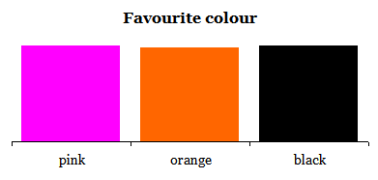
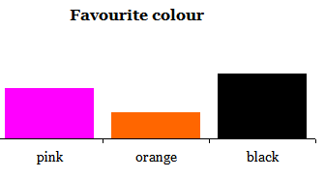
Each of these bar charts has been produced with exactly the same data. From the first it would seem reasonable to assume that everyone had pretty much the same feelings about those three colours. In the second you would be tempted to deduce a strong preference for black compared to orange.

Here is another, illustrating data over four years using a 3D default colour Excel offering and no tricks:

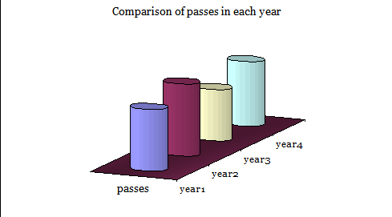
One might conclude that year 4 showed a return to year 2 levels and quite an improvement on year 1.
Check out the actual data in the file misleading.xls on the web site.

Lastly, here is a super example of a totally meaningless chart, reproduced with permission from Michael Friendly at York University, California, who has many more worth viewing at http://www.math.yorku.ca/SCS/Gallery/

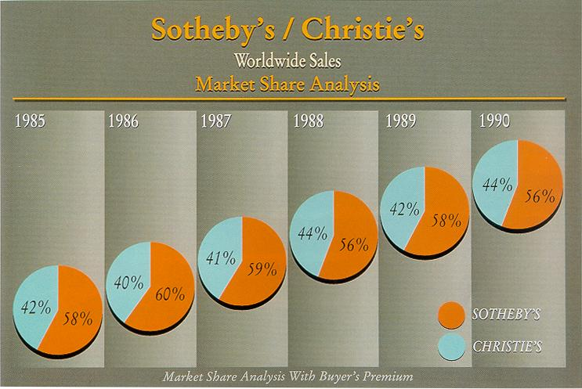
- Just what is the point? There's precious little movement either way.
- Why do the pies ascend?
- Even for the Nineties, when this was produced, the background gradients don't sit well with flat pie circles
- I won't mention the colour choice
Was there really no other auction house with any market share at all (they all add up to 100%)

I think what they were trying to illustrate was the change in market share of each over the 5 years.

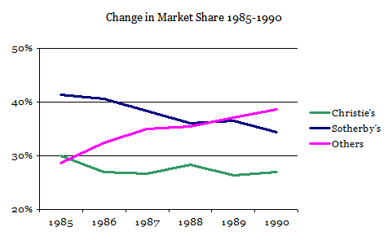
Bringing in the 'others' and choosing a more appropriate scale and type of graph makes it all make some sense. Basically one house lost out considerably more to the 'others' than another.
Other things buried in Excel
Stacking images

Sometimes it can be fun and even useful to feature little pictures or icons instead of bars in comparative charts. It is however, by no means clear where you go to get these in Excel, although it's not terribly difficult once you know how to do them.

Imagine you had some data about clipboards and pens to display. This is what you might aim for:

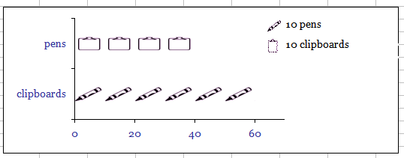

First you need to have the images – in this case a clipboard and a pen. Their original size isn't too important although they should each be of similar dimensions. Excel will scale them down for you. You should also avoid rectangular blocks which may finish up being joined together and not having the desired effect. Save the images somewhere sensible.

To feature them on your chart, click on a series – be careful to ensure that all the series is selected and not just the single data point. Click on the Fill colour icon:

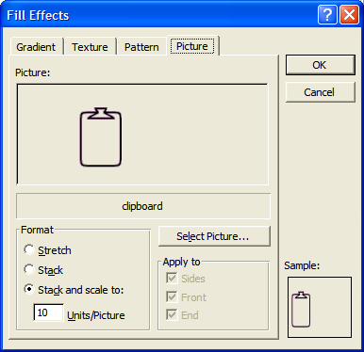

Use the Picture tab and then click on Select Picture. Navigate to where you saved what you propose to use and OK to 'insert' it. The most useful 'stacking' option is Stack and scale to: and then enter a suitable number for each icon to represent. (That will depend on the scale of your data – it may be one for one or one for 1000). Press OK and you'll see the result for that series. Repeat the process for the others.

You may need to fine tune things a bit, or find another icon. If you have lines around the series they can be removed by right clicking the series and under Format Series selecting None for the Line option.

Resizing the area occupied by the chart can improve the spread or proportions of the icons too.

Changing the gaps between columns or rows

Whilst Excel tries its best to display things in a reasonable layout, things can often be made much clearer, especially when you have a lot of columns or rows to manage, if you change the gap between them. This is something else that is not at all obvious as to where to go to make a change, but it's worth the effort.

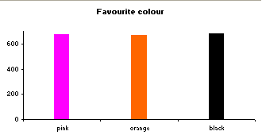
This chart could be improved by making the columns much fatter.
Right click on any series bar and select Format Series.

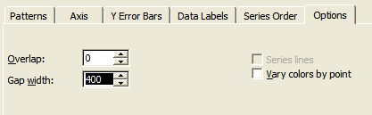
Under Options change the Gap width. A lower number will bring bars or columns closer together and to achieve that Excel broadens them. Note that just resizing the chart area doesn't help at all.

To get the display below the gap was reduced from 400 to 20.

Transferring charts to other applications

Excel charts can be simply copied and pasted into Word or Powerpoint but they don't always behave themselves when you do so. A common problem is minute text or things going wrong when you try to resize the pasted chart to fit your new document or slide. This usually happens when you try to use a chart located as a sheet on its own (rather than as an item on a sheet). You get the choice at the last stage of creating a chart. For printed posters or full page display in a report then the full sheet display is best but for most other purposes the other 'location option' is best.

It is simple to change the location of a chart. Just select it and use the Chart menu and switch it under Location. (After transfer you can always re-locate if necessary). You may have to adjust the font size and layout for the new, more compact, chart.

Whilst there are options to keep the chart linked to its data sheet in Excel, this can complicate matters later and you'll probably find it much simpler to make the chart a picture and use that just as you would any other image. Word and Powerpoint offer Paste as a picture as an option which will be fine in most circumstances but for complete control over what it looks like, and particularly for illustrating on the web or featuring in notes like the hard copy version of these which has been prepared in a non-Microsoft product, it's worth getting to know how to make the chart a picture without Microsoft's help.

Select the chart and copy it. Open your photo editor (Irfanview from irfanview.com is excellent, free and is ideal for this type of job as well as quick screen prints – others will work fine though, once they're up and running). Paste it in (as a new image if asked). Then save it, or export it, depending on the software terminology, ideally as a png file. This format works well for both photo-type content if you've used any in the background or fill and solid colours or shading. (Gif format will produce bands on gradients but is good for block colours and most normal charts. Jpg format tends to blur text and blocks of colour but is best for detailed photos.)

You should also get an indication of the file size occupied by the chart and be able to adjust quality of the output to get the best combination of a light file (especially where there are several charts) and display quality. With the vast majority of likely viewers now having broadband, download speeds for e-mail and on the web can cope with much bigger files efficiently but if you don't need an xMB file it's helpful to others to make the effort to reduce it if you can.

Examples of charts in use

Barriers to e-learning

This file contains a survey sheet and two types of display for the results. It also has some spare sheets you can use with ready-made charts linked to them. Either use them to collect similar data (always welcome!) or change the questions and titles to suit some completely different purpose,

Misleading charts

Examples of the actual charts – so you can take them to pieces or play with them – used for illustrations in this report
Plus: a re-working of the 'auctions' data to show just how silly the published one was

Charts in quizzes and other bits

The data for some other illustrations used in this report with a couple of fun items which you can do what you like with.

More examples will be added in future: contact Andrew Hill at design@ahi2000.com for any updates or to contribute more.
More information
There are two web sites available: the mini 'Charts' site provides an overview of the project and will also feature updates and further developments, and the contents of these notes, plus access to the data files and actual charts, can be found at the main Chart Project site.

See the mini-site at http://andrewx.com.googlepages.com/charts

View the main site at http://ahi2000.com/q/charts

These will also be available on Dunstable College's site at: http://online.dunstable.ac.uk/moodle
and in a DVD and materials database being developed by LSDA and its successor organisation LSN.

