Whilst Excel’s Chart Wizard will help you to produce most charts pretty easily, there are some that can be initially troublesome. Two good examples are illustrated here. The first is what should be a simple bar chart comparing values over a period of years. The second is the slightly more difficult chart showing the same data as a line and also featuring a line for the number of transactions over the same period.

Here is the data.

 | A | B | C
1 | Year | Value | Sales
2 | 1980 | 12 | 3400
3 | 1985 | 17 | 3600
4 | 1990 | 8 | 2400
5 | 1995 | 16 | 2700
6 | 2000 | 22 | 4000

The bar chart

For this you need just the Year and Value data so select cells A1:B6. Hit the Chart Wizard button and, remembering to choose Column not Bar, press Next and Step 2 will look like this:

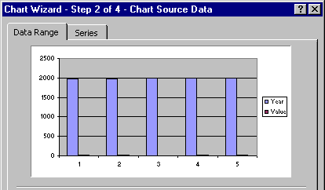

This is of no use to anyone. The problem stems from the fact that both columns contain numbers and Excel simply can’t decide which set is to be used as labels and which is variable for the bars. It ought, in my view, at least offer you a good guess – it’s an enormously powerful program and it seems strange that it doesn’t make such a guess but that’s life. The fact is that it doesn’t so you need to use the Series tab.

Click on the Series tab and the lower section is enough to worry most normal people:

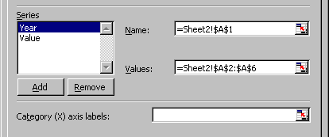

You need to tell Excel that your Year data is not a Series (in Plain Englsih that means the years are just labels). Do this by clicking on the word Year and then hitting the remove button. Now you need to tell the program where to find the labels. Near the bottom of the Chart Wizard window is this strange box, with the even stranger button at its right end. Click the anonymous button.

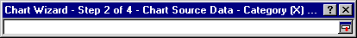

You arrive back at the data sheet, accompanied by the strange bar. Select the cells that you wish to contain your labels – in this example the years in A2:A6. Be careful not to include the heading text itself. Your selection is translated into the expression shown in the strange bar.
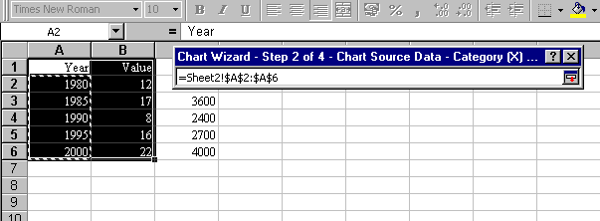

Now click on the anonymous button once more. How anyone is expected to figure out that pressing that button will whisk them back to the Chart Wizard window I have no idea. But it does.

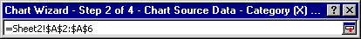

Now the Chart Wizard window should display a much more useful chart and you can safely go Next and produce the required chart without more ado.

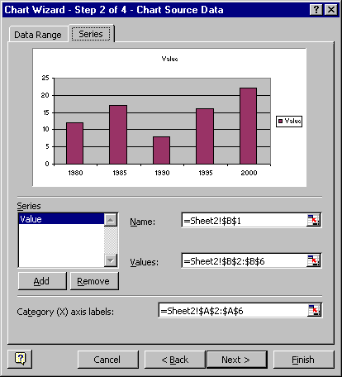

The combined line chart

The next task is to produce a chart which features two lines. The idea is to show the link between the change in values and the number of transactions. Separate graphs are OK but this is a better solution.

Select all the data this time, from A1:C6. Get the Chart Wizard going. There’s nothing of interest in the initial display of Standard types so you’ll need to click on the Custom types and scroll down the list until you find a couple that will do what you want. In this case the best is called Lines on 2 Axes. Select this.

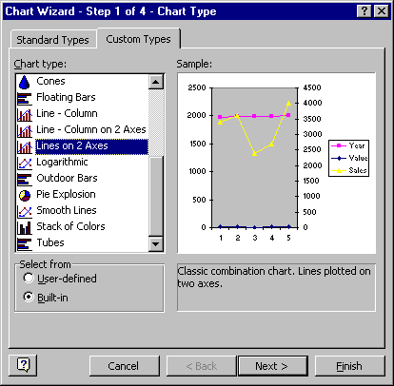

Press Next. Once again you’ll have to go to series and Remove the Years and use the strange bar to add the years in as Category (X) axis labels. Excel has correctly guessed the vertical axes.

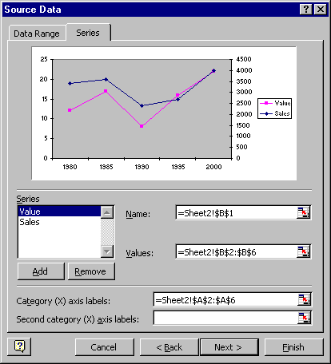

You will now have a respectable-looking chart in the making and just need to put some labels on in the next steps. There will be two Y axis labels, one for the left and one for the right. Trial and error is as simple a method to adopt when deciding which is which as there is no obvious guidance! The finished chart will be something along the lines of the example below.

