1) Welcome screen- <http://localhost:8080/SweetyApp>

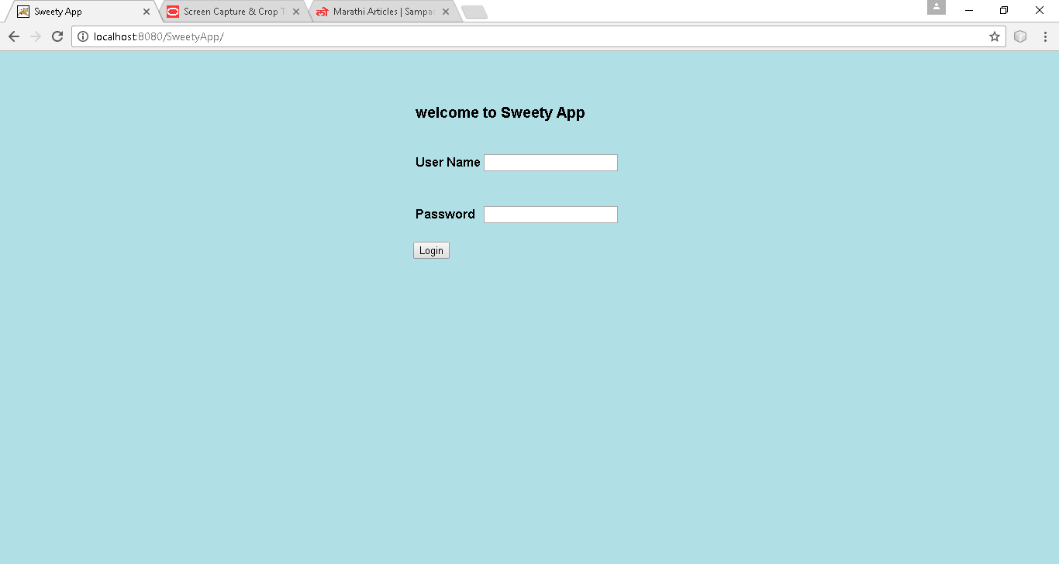

2) After entering valid login and password:

<http://localhost:8080/SweetyApp/LoginServlet>

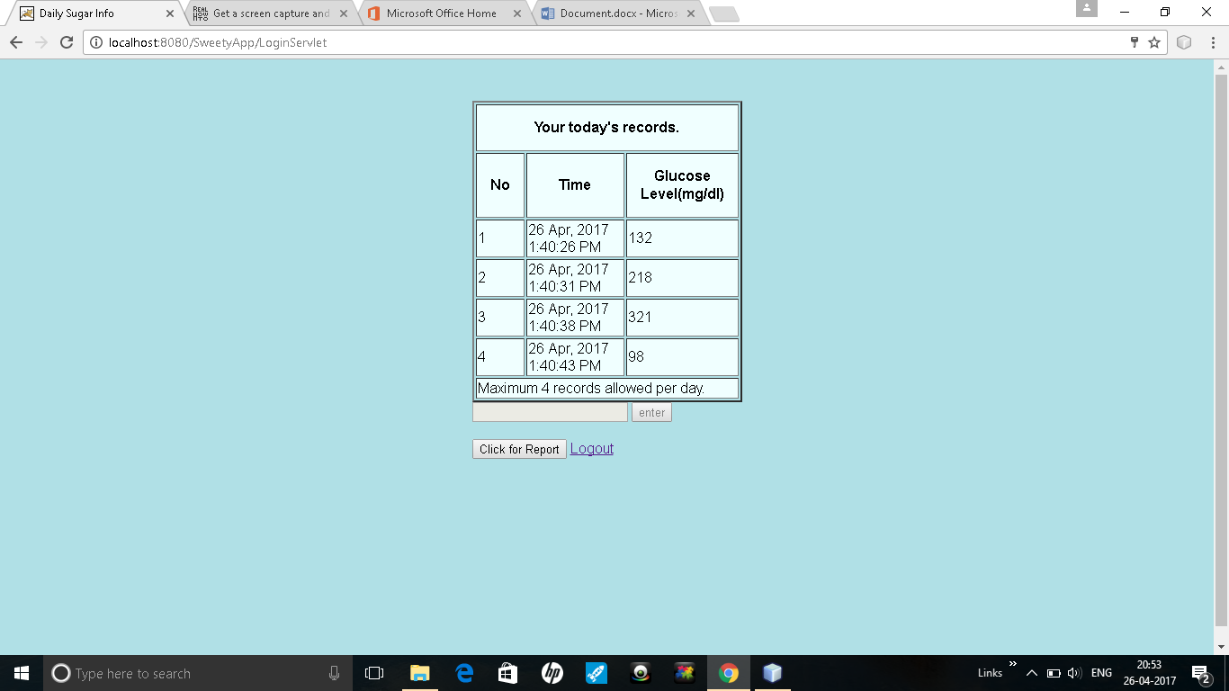

When user has entered two records-

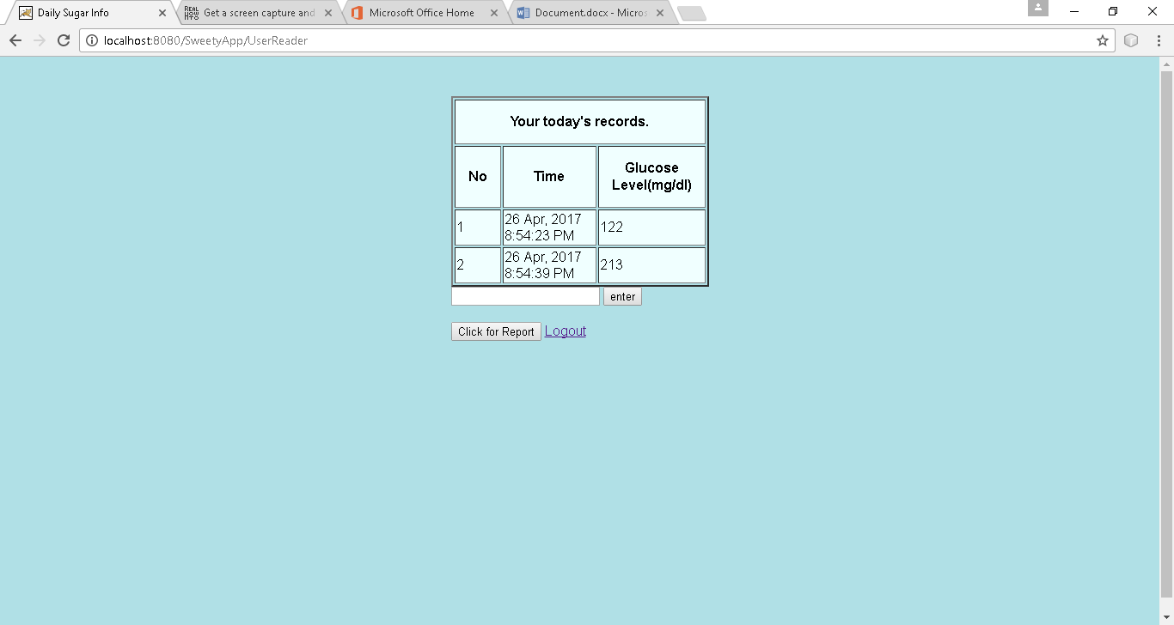

When user clicks on "Click for Report Button, following screen is displayed.

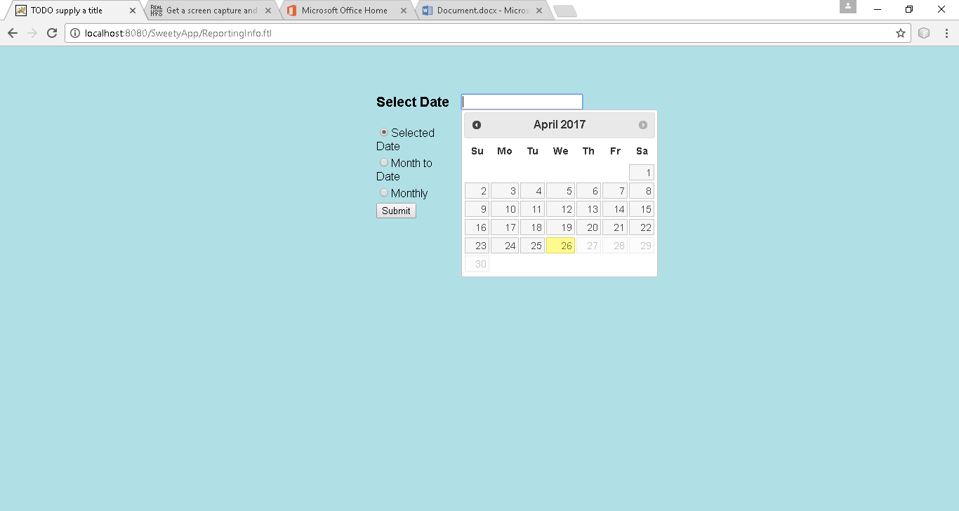

Monthly report generated for April- 2017

