**FPT University**

System/Software Requirements Specification

for

REVIEW SYSTEM

Version 1.0

Prepared by Pham Duy Khanh

Group 4 – SE1432

7-21-2021

Table of Contents

Table of Contents ii

Revision History iii

1. Reasons for choosing Project 1

2. Project introduction 1

3. Technology and platform 1

4. Function of Project 2

4.1 Data Model 2

4.1.1 Entity Relationship Diagram 2

4.1.2 Table Detail 4

4.2 Class Diagrams 5

4.3 Use case Diagrams 5

4.3.1 UC001 – Login 5

4.3.2 UC002 – Logout 6

4.3.3 UC003 – Post new evaluation 6

4.3.4 UC004 – Evaluate post 7

4.3.5 UC005 – Edit evaluation 7

4.3.6 UC006 – Delete evaluation 8

4.4 Sequence Diagrams 8

4.4.1 Login 9

4.4.2 Logout 10

4.4.3 Post new evaluation 10

4.4.4 Evaluate post 11

4.4.5 Edit evaluation 11

4.4.6 Delete evaluation 11

4.5 Activity Diagrams 12

4.5.1 Evaluation Post 12

4.6 User Interface Design 13

4.6.1 Class Layer 14

Revision History

|  |  |  |  |
| --- | --- | --- | --- |
| **Name** | **Date** | **Reason For Changes** | **Version** |
| Create SRS Document | 7/21/2021 | Create new | 1.0 |
|  |  |  |  |

# Reason for choosing Project

* Help the products and objects to be evaluated for quality by the users themselves.
* Improve user experience.
* Help users have a more general and objective view of the product they are looking for.
* Easy to use and manipulate

# Project introduction

* This project is an independent platform for users to exchange experiences and evaluate products in an objective and understandable way. Help users actively search for quality products shared by the people who use those products

# Technology and Platform

|  |  |
| --- | --- |
| Software | Version |
| SQLServer | 2019 |
| Language | C Sharp |

|  |  |
| --- | --- |
| Framework | Version |
| ASP.NET | 2020 |

# Functions of Project

## Data Model

### Entity Relationship Diagram

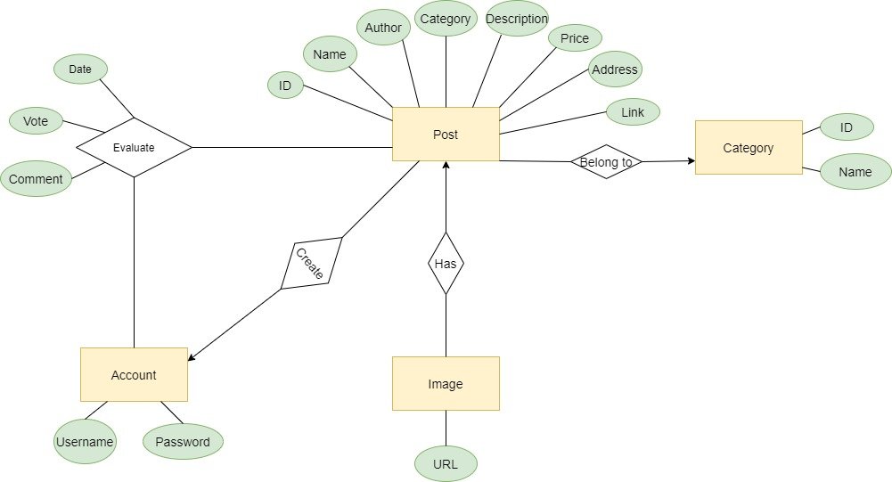

### Table Detail

#### Table name: Account

|  |  |  |  |
| --- | --- | --- | --- |
| **Field name** | **Type** | **Size** | **Note** |
| Username | String | 50 | Primary key |
| Password | String | 50 |  |

#### Table name: Category

|  |  |  |  |
| --- | --- | --- | --- |
| **Field name** | **Type** | **Size** | **Note** |
| ID | int |  | Primary key, Indentity(1,1) |
| Cate_Name | String | 50 |  |

#### Table name: Evaluate

|  |  |  |  |
| --- | --- | --- | --- |
| **Field name** | **Type** | **Size** | **Note** |
| Account | String | 50 | Foreign key to Account table (Username) |
| Product_ID | int |  | Foreign key to Product table (ID) |
| Vote | int |  |  |
| Comment | Text |  |  |

#### Table name: Image

|  |  |  |  |
| --- | --- | --- | --- |
| **Field name** | **Type** | **Size** | **Note** |
| Product_ID | int |  | Foreign key to Product table (ID) |
| Image_Url | String | 500 |  |

#### Table name: Product

|  |  |  |  |
| --- | --- | --- | --- |
| **Field name** | **Type** | **Size** | **Note** |
| ID | int |  | Primary key, Indentity(1,1) |
| Name | String | 50 |  |
| Author | String | 50 | Foreign key to Account table (Username) |
| Category | int |  | Foreign key to Category table (ID) |
| Description | Text |  |  |
| Price | String | 100 |  |
| Address | String | 200 |  |
| Link | String | 200 |  |

## Class Diagrams

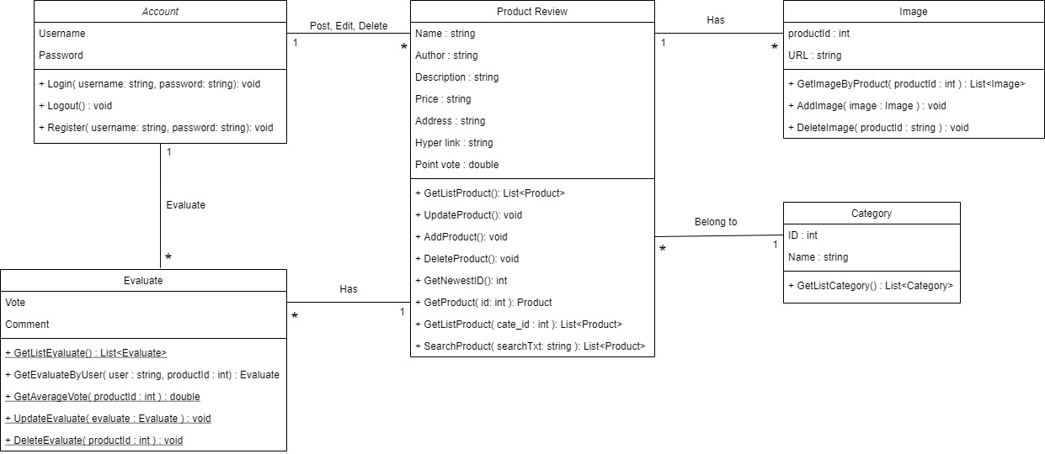

## Use case Diagrams

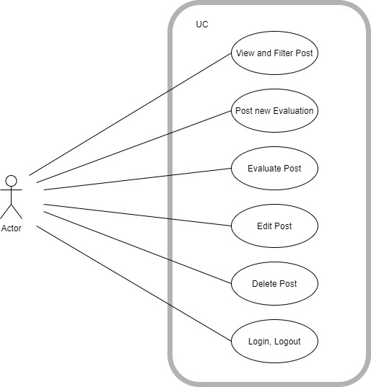

User

### UC001 – Login

|  |  |  |  |
| --- | --- | --- | --- |
| UC ID and Name: | UC001 – Login | | |
| Created By: | KhanhPD | Date Created: | 7/21/2021 |
| Primary Actor: | User | Secondary Actors: | User |
| Trigger: | Click the Login Button | | |
| Description: | Used to Login to the website | | |
| Preconditions: | User Not Logged In | | |
| Postconditions: | Enter the correct username and password | | |
| Normal Flow: | 1. Enter username and password. 2. Login | | |
| Alternative Flows: |  | | |
| Exceptions: | Login with wrong username or password | | |
| Priority: | High | | |
| Frequency of Use: | High | | |

### UC002 – Logout

|  |  |  |  |
| --- | --- | --- | --- |
| UC ID and Name: | UC002 – Logout | | |
| Created By: | KhanhPD | Date Created: | 7/21/2021 |
| Primary Actor: | User | Secondary Actors: | User |
| Trigger: | Click the Sign Out button | | |
| Description: | Used to Logout from the website system | | |
| Preconditions: | User Not Logged Out | | |
| Postconditions: |  | | |
| Normal Flow: | 1. Click the Sign Out button 2. Log out to the login screen | | |
| Alternative Flows: |  | | |
| Exceptions: | If user are not logged in, user will not be able to log out | | |
| Priority: | High | | |
| Frequency of Use: | Normal | | |

### UC003 – Post new Evaluation

|  |  |  |  |
| --- | --- | --- | --- |
| UC ID and Name: | UC003 – Post new Evaluation | | |
| Created By: | KhanhPD | Date Created: | 7/22/2021 |
| Primary Actor: | User | Secondary Actors: | User |
| Trigger: | Click on create button | | |
| Description: | Used to create new evaluation post | | |
| Preconditions: |  | | |
| Postconditions: | All necessary field must not empty and in correct format | | |
| Normal Flow: | 1. Click on Post on Menu 2. Fill all necessary field 3. Click on create button 4. Redirect to View Screen | | |
| Alternative Flows: |  | | |
| Exceptions: | 1. Empty field 2. Incorrect format | | |
| Priority: | High | | |
| Frequency of Use: | High | | |

### UC004 – Evaluate post

|  |  |  |  |
| --- | --- | --- | --- |
| UC ID and Name: | UC004 – Evaluate post | | |
| Created By: | KhanhPD | Date Created: | 7/22/2021 |
| Primary Actor: | User | Secondary Actors: | User |
| Trigger: | Click on Evaluate button | | |
| Description: | Used to evaluate existence post | | |
| Preconditions: | The post must be exist on View Page | | |
| Postconditions: | All necessary field must not empty and in correct format | | |
| Normal Flow: | 1. Click on title of post in View Page 2. Vote and comment in Evaluate box 3. Click on Evaluate button | | |
| Alternative Flows: |  | | |
| Exceptions: | Not comment | | |
| Priority: | High | | |
| Frequency of Use: | High | | |

### UC005 – Edit Evaluation post

|  |  |  |  |
| --- | --- | --- | --- |
| UC ID and Name: | UC005 – Edit Evaluation post | | |
| Created By: | KhanhPD | Date Created: | 7/22/2021 |
|  |  |  |  |
| Primary Actor: | User | Secondary Actors: | User |
| Trigger: | Click on Save button | | |
| Description: | Used to edit evaluation post | | |
| Preconditions: | Evaluation must be posted by user | | |
| Postconditions: | All necessary field must not empty and in correct format | | |
| Normal Flow: | 1. Click on Edit button equivalent to Post 2. Change information 3. Click on Save button | | |
| Alternative Flows: |  | | |
| Exceptions: | 1. Empty field 2. Incorrect format | | |
| Priority: | High | | |
| Frequency of Use: | High | | |

### UC006 – Delete Evaluation post

|  |  |  |  |
| --- | --- | --- | --- |
| UC ID and Name: | UC006 – Delete Evaluation post | | |
| Created By: | KhanhPD | Date Created: | 7/22/2021 |
| Primary Actor: | User | Secondary Actors: | User |
| Trigger: | Click on Delete button | | |
| Description: | Used to delete existence evaluation post | | |
| Preconditions: | Evaluation must be posted by user and still exist | | |
| Postconditions: |  | | |
| Normal Flow: | 1. Click on Delete button equivalent to Post 2. Load page again | | |
| Alternative Flows: |  | | |
| Exceptions: |  | | |
| Priority: | Normal | | |
| Frequency of Use: | Normal | | |

## Sequence Diagrams

### Login

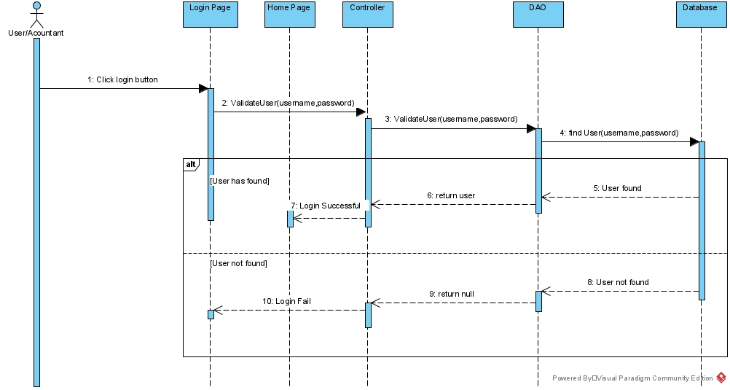

### Logout

### Post new Evaluation

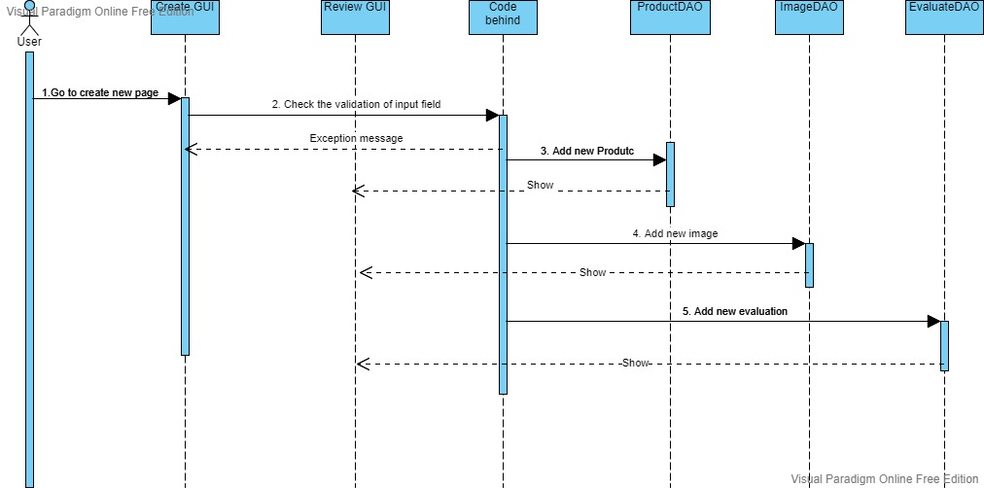

### Evaluate post

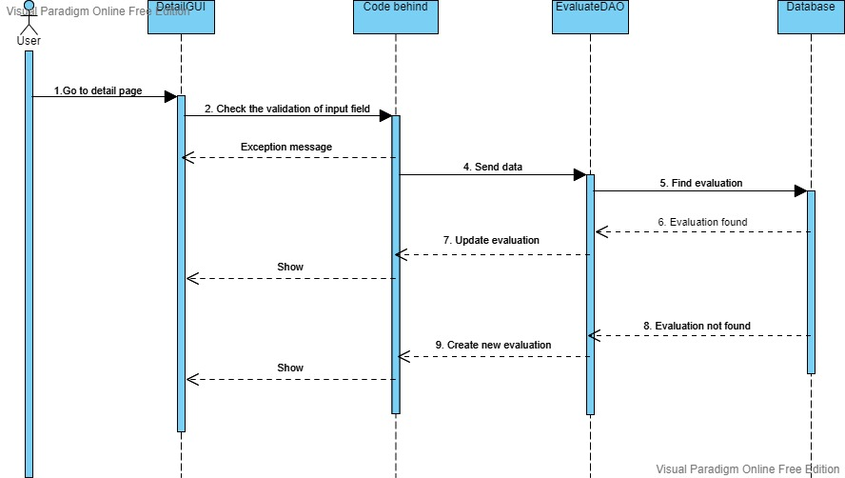

### Edit evaluation post

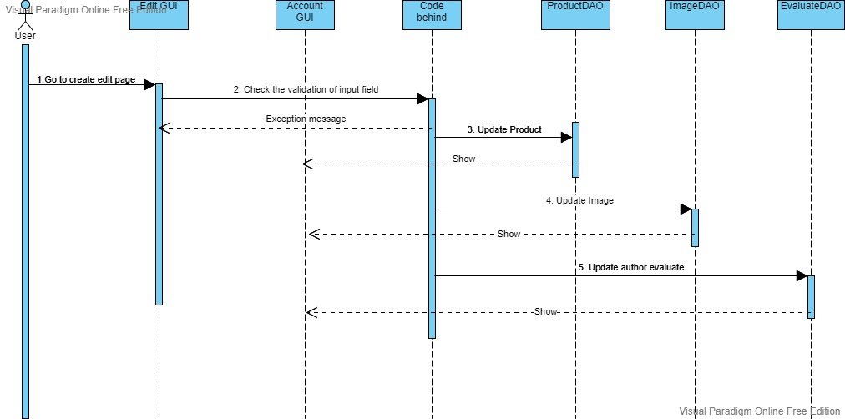

### Delete evaluation post

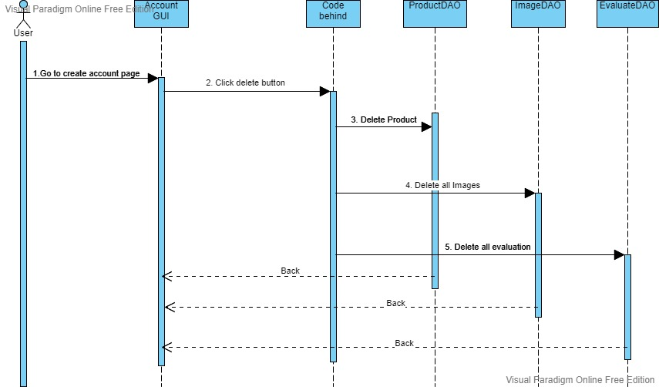

## Activity Diagrams

### Evaluation Post

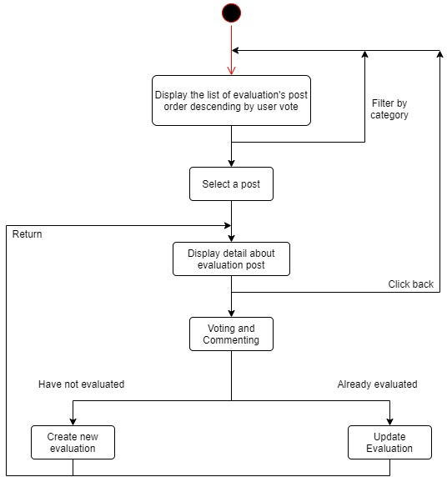

## User Interface Model Design

### Layer of Class

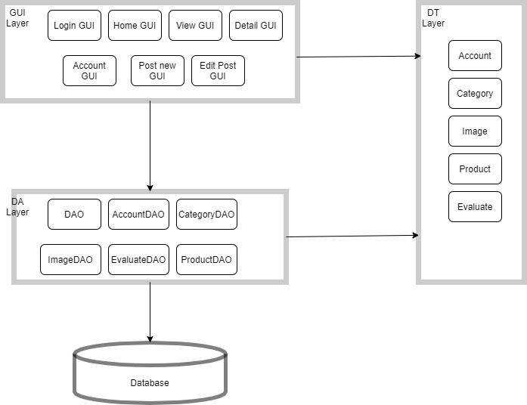

**----running screen stream**

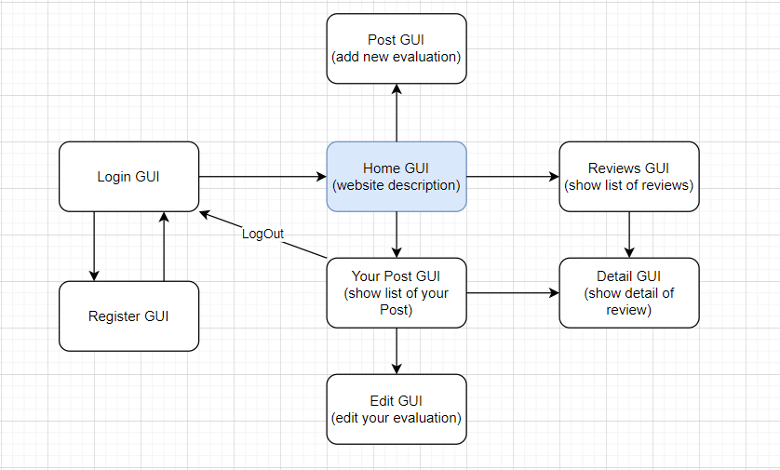

### Login account

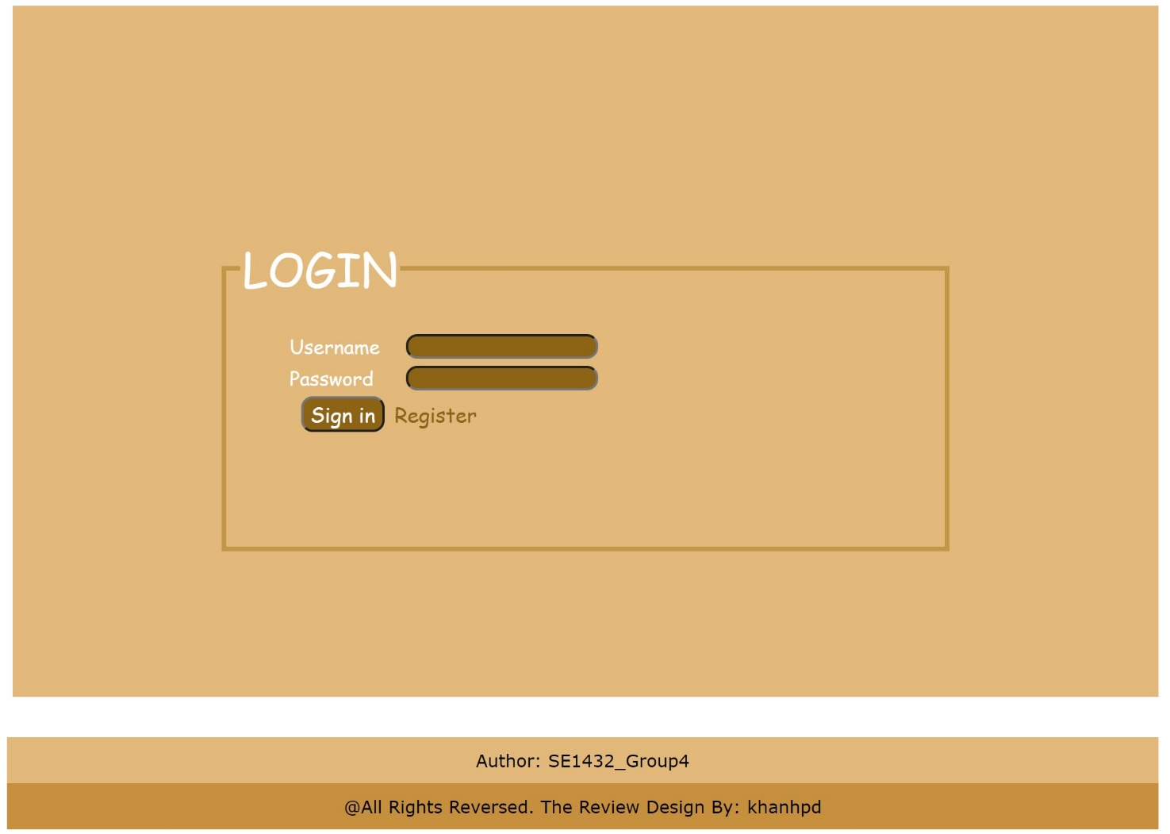

### Register account

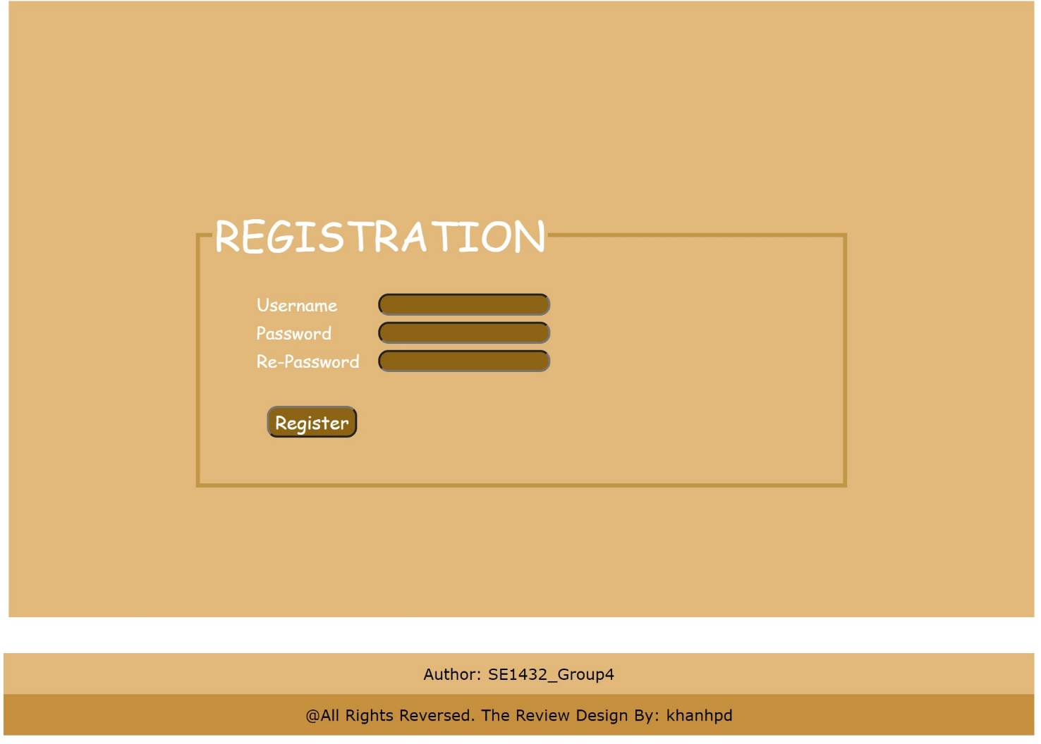

### Home (website description)



### Show list all evaluation of everyone



### Show Detail Post

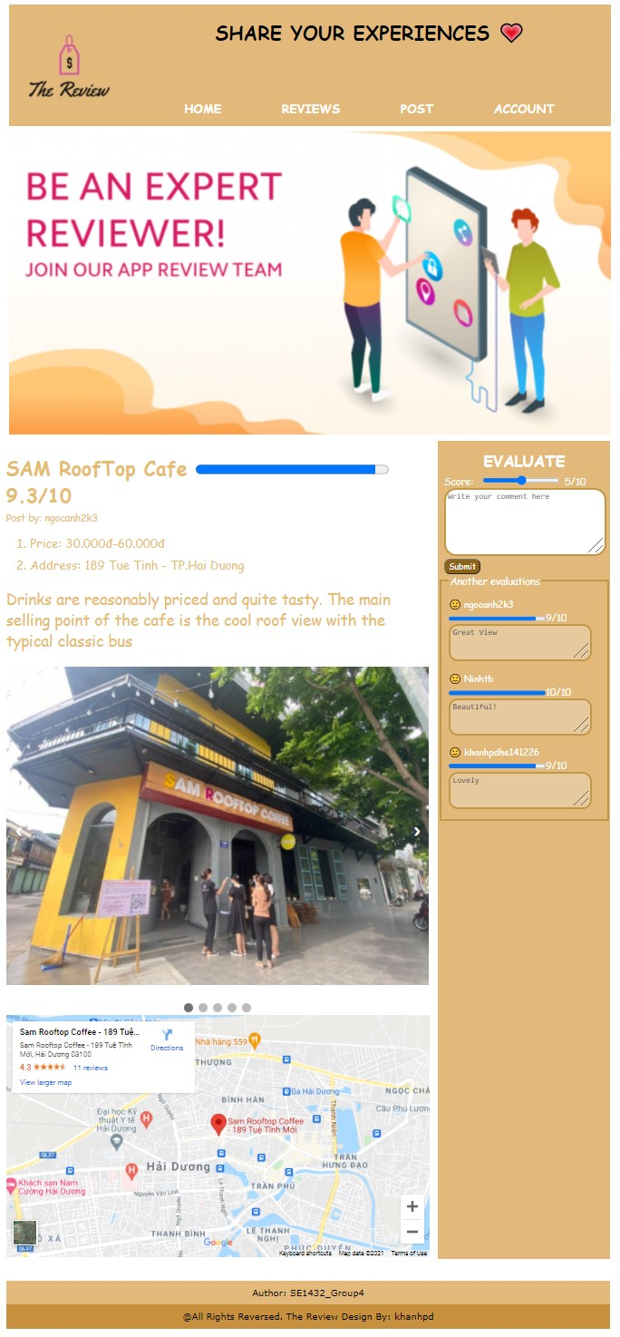

### Create your Post new



### List of post your Account



### Edit your Post

### 