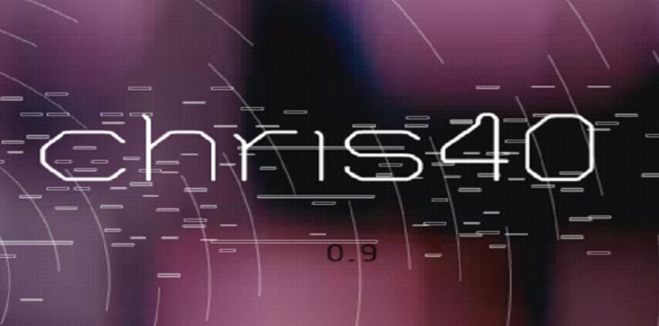

Chris40

Version 0.9

Phil Kramer | September 14, 2016

“Happy Birthday Mom” Release

# Overview

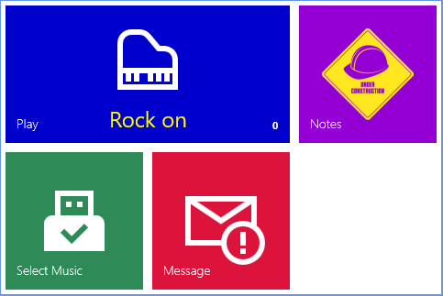

The function of Chris40 is to display PDF files. Typically these PDF files contain sheet music, and along with the AirTurn pedals you can turn pages hands free while performing!

The program is written as a Universal Windows Platform application and can be used on a Raspberry Pi, laptop, or desktop PC. It is touch enabled for platforms that have a touch display.

You should plan on attaching a mouse to the Raspberry Pi and optionally a keyboard. Any USB port can be used for any device, including removable storage. Note that the current version of Chris40 is based on a Raspberry Pi 3. It already has onboard wireless networking and Bluetooth so these devices do not need to be attached separately.

You can display sheet music PDF files either from an attached removable storage device (e.g. thumb drive or external hard drive), or from the device’s internal (local) storage.

When the program launches it will default to using the local storage for the PDF files. At the bottom right of the *Play* tile you see a count of the files available. (It is zero in my screen shot above since I do not have any PDF files moved to internal storage yet).

Using the *Select Music* tile you can choose whether to use removable storage or local storage PDF files. You can also move files to internal storage using this tile.

The *Message* tile shows information about the application. In the *Notes* tile you will see this document.

# Selecting Music

Press the *Select Music* tile and you are presented with a screen where you can choose to use removable storage for your PDF source or local storage. If you choose to use removable storage you can then also request that the files on removable storage are copied to local storage. You can also choose to clear everything in local storage before the new files are copied, creating a mirror of the remote storage files in local storage.

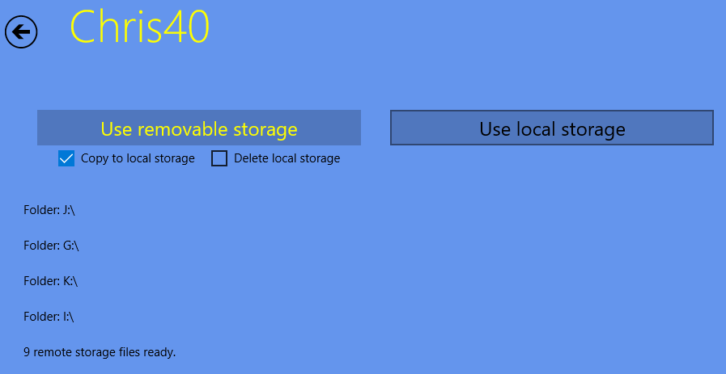

When using removable storage **the PDF files must be in the root directory of the device.**

In the example above, removable storage was selected with the option to copy those files to local storage. Chris40 enumerated all attached removable storage on the PC until it found a PDF file in the root directory of the device. It then copied the PDF files to local storage.

Realistically, on a Raspberry Pi this will just be the E:\ folder if you have removable storage attached.

You can then continue your performance with removable storage or you could specify to use local storage since your files have been copied there. If local storage is selected the removable storage device can be removed.

If no PDF files could be found you will be notified of this fact.

When you press the *Back* button to return to the main menu, the *Play* tile will display some song names on the tile, and the notification area will show the total number of PDF files available on the selected storage device.

# Play

Press the *Play* tile to display your PDF files. The screen is divided into four sections.

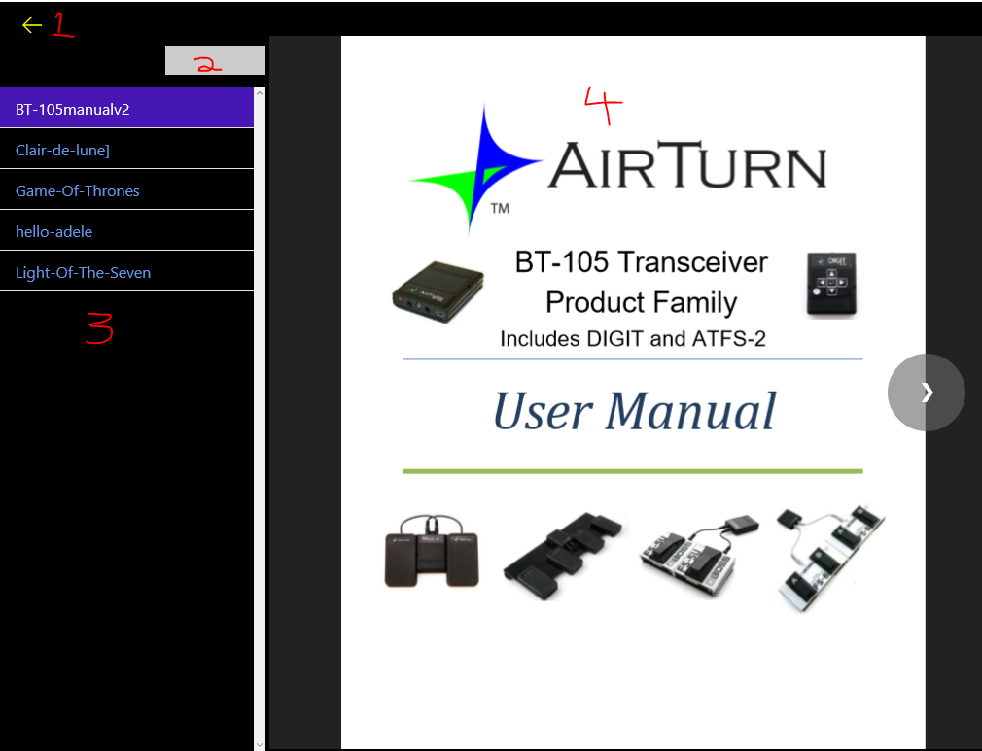

Note that colors and sizes have been optimized for a performance environment. The design goal is to give as much screen space as possible to the PDF document and make sure that it is the focus of attention. Everything else is darkened for a low-light environment.

## Section 1

This is the back button. Pressing this returns you to the main tile display.

## Section 2

To search through your PDF files enter any part of the file name. The list of PDF files will be filtered accordingly. By default all PDF files are shown.

* Note that this assumes you have a keyboard attached!

## Section 3

Here is the list of your PDF files sorted alphabetically. Clicking on a file name brings up that document in section 4. The scroll bar may disappear when the section loses focus, but it will reappear when the mouse is over the section. You can use the Airturn, mouse, keyboard, or touch to scroll through the files.

## Section 4

Your selected document is shown in this section. The display will be free of any other clutter unless the mouse is moved over the section. Then the page turning buttons, the current page number, total number of pages, and other elements will be displayed as appropriate.

There are several ways you can turn pages forwards and backwards:

* Press the right and left AirTurn pedals.
* Click the mouse on the *forward* and *backward* buttons displayed on the document when the mouse moves over them.
* Use the mouse wheel.
* If you have a touch display, swipe across the document right or left.
* If a keyboard is attached, use the right and left arrow keys, or the page-down and page-up keys.

After selecting a file from Section 3 be sure to click in section 4 so that the application knows that all mouse, keyboard, and AirTurn events should be directed at the displayed document.

You can right-click in Section 4 to display additional menu options. These options can be used to control how the document is scrolled, go to a specific page number, change the page zoom level, etc. (Future versions of the program may have additional features.)

## Future Developments

* To ensure that the displayed PDF document is focused you may need to click on it after selecting it in Section 3. Future versions may shift the focus for you automatically.
* Bookmarks are not supported in the PDF document yet. (The button that appeared in earlier versions of Chris40 to add bookmarks has been removed until this feature is implemented.)

# Messages

The *Message* tile has vital messages, along with status information about the device.

# Notes

Selecting the *Notes* tile will let you see this document.

# Chris40 Raspberry Pi Access

The Raspberry Pi provides a web site that you can use to configure the device. On the *Message* tile you will see the Raspberry Pi’s IP address. For example, let’s say it shows 10.0.0.76. In your web browser you can then browse to that web site http://10.0.0.76:8080

Log in with the user name “Administrator” and password “Chris40”.

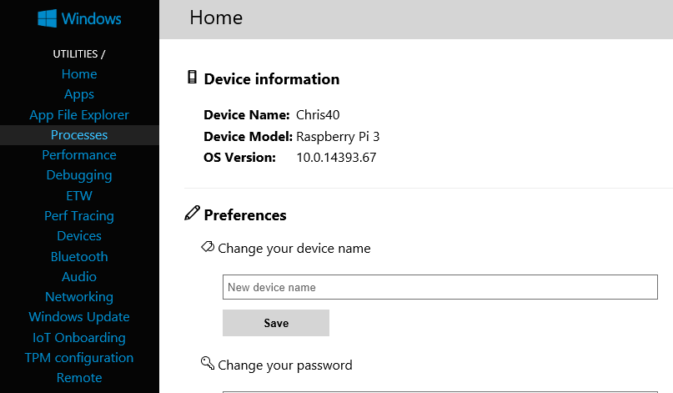

How to use the web site is outside of the scope of this document.

# GitHub

I am providing this application as open source, using a non-restrictive license as yet to be determined (e.g. MIT License). All source code is available at https://github.com/pdkramer/chris40. Most of the source code is in readable text files. The GitHub repository can be viewed in place or the source code can be downloaded (or “cloned” if using Git source control). Anyone that wants to contribute to the project is welcome!