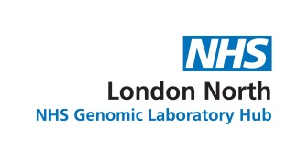

**Rare & Inherited Disease Genomic Laboratory**

Great Ormond Street Hospital for Children NHS Foundation Trust

Levels 4-6 Barclay House, 37 Queen Square, London WC1N 3BH

**Director:** Lucy Jenkins FRCPath

**Head of Service (Cytogenetics):** Deborah Morrogh FRCPath

**Head of Service (Molecular Genetics):** Sam Loughlin DipRCPath

**Telephone:** 020 7829 8870; **Fax:** 020 7813 8578; **Email:** Genetics.Labs@gosh.nhs.uk

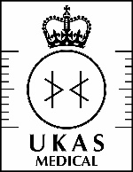

**7883**