*Dipak Poudel*

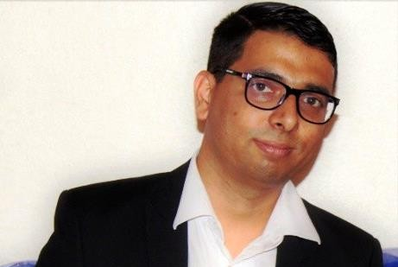

Kopparvägen 49, Lgh 1701, 17672 Järfälla Email: [dipak_45poudel@hotmail.com](mailto:dipak_45poudel@hotmail.com) Mobile: (+46) (0) 76-583-4103

Personal Summary

A highly self-motivated and dedicated individual with a solid interest in implementation, integration, and operations of company values and culture in everyday working life. Carries excellent analytical and troubleshooting skills with the self-initiative sense. A goal orientated individual and have potential to play a key role in analyzing a problem and to come up with creative solutions as well as producing methodologies. I am a quick learner and have good communications and interpersonal skills.

# Areas of Interest

Skills

Experience

* Branding, Marketing,
* Managing human resource
* Decision analysis and risk management
* Leadership
* Web Development
* Bigdata management
* Team building and project management
* Strategic planning and negotiation
* Qualitative research
* Business Management
* HTML5, CSS3, JavaScript
* **Scandinavian Service Partner 2015- Currently, Sweden**

Shift-manager

* **Secondary Mathematics Teacher** Jun 2007 - July 2008 Ex-Army Secondary Public School, Nepal

# Education

## Masters’ Program (Full Stack Web Developer)

### Online program from Edureka (Bangalore, India February 2019 – July 2019)

**Courses:** Web Development, jQuery UI Development, Angular, Node.js, MongoDB, ReactJS, PHP, MySQL, Git and GitHub, Fundamental of clouding

## MSc (Decision support and risk analysis)

### School of computer and system science (Stockholm University, Sweden, 2016-2017)

**Courses:** Decision Theory, Decision Support Methods, Business Intelligence in Computer and System Sciences, Scientific Communication and Research Methodology, Analysis bases for decisions

## MSc (Business administration and Management)

### Stockholm Business School (Stockholm University, Sweden, 2014- 2017)

**Thesis:** Influences of Leadership styles on employees’ performance in IT Sector

**Courses**: Management Theory and Analysis, Business and Society, entrepreneurship and the Entrepreneurial Self, Marketing and Management in a Globalized World, Managing Human Resources, Power, Change and Resistance in Organizations, Qualitative Research, Leadership & Management in Organizations, Branding: Strategic and Cultural Perspectives, Market-oriented business models, The Challenges of Ethnic Diversity

## BA (Political Science and Government)

### School of Global Political Studies, Malmo University, Sweden, 2009-2013

**Thesis:** Issue of Enforced Disappearance in Nepal: The impact of inadequate government responses on solving the issue of enforced disappearance to the victims ‘family members.

**Courses:** Peace and Conflict studies (I, II, III), Human rights, Anthropology, International migration and ethnic relation

# Training

Academic Projects

* Foundation of Shift management
* Serve safe International
* Microsoft office package
* Interactive and integration teaching
* Project management
* Making global local (A project work of Oriflame’s Multilevel marketing )
* Branding and Business Model (A case study of Volvo car and Svenska

Cellulosa Aktiebolaget’s

* Fun Management’ as a tool to connect people in an Organization ( At

‘Spotify’)

* Leadership in an IT- sector (Thesis related to leading IT employees performance