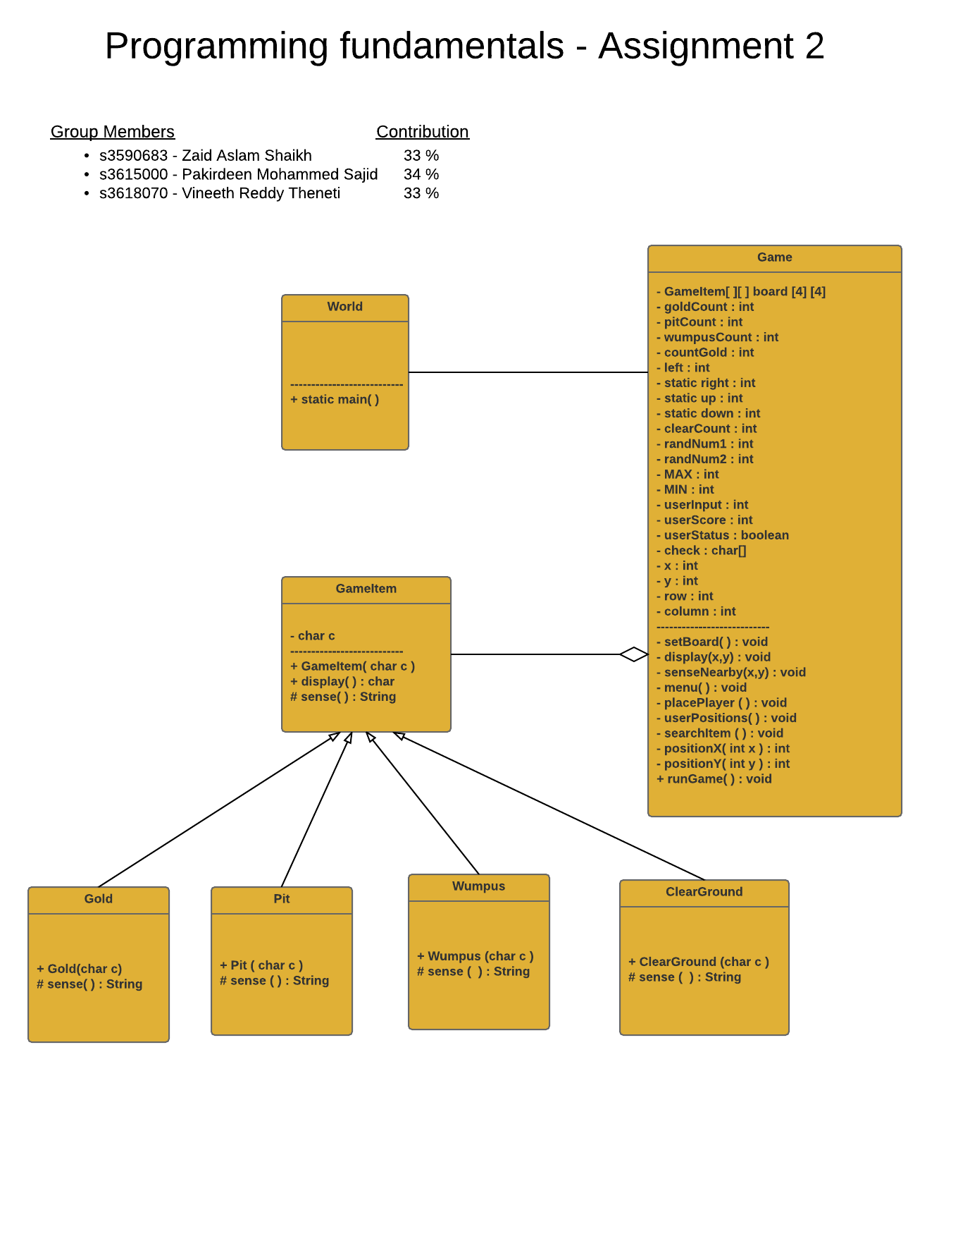

**Screen shots of the Wumpus Game**

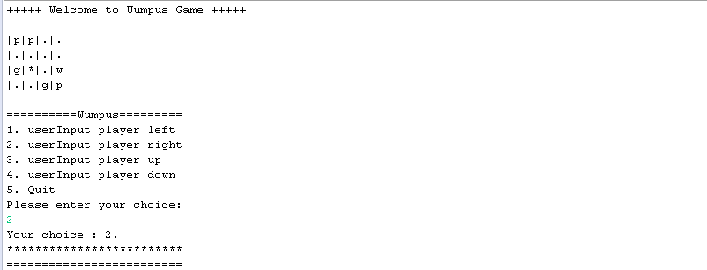**\*User started the game**

**\* Sensing and collecting Gold**

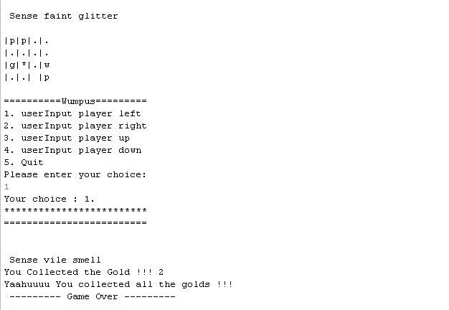

* **Moves to Pit**

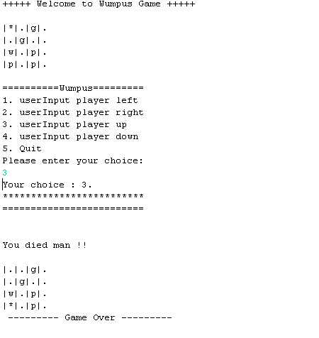

* **Moves to Wumpus**



* **User input error checking**

