class04.R
patri
2026-01-16
X <- 1:50
plot(X)
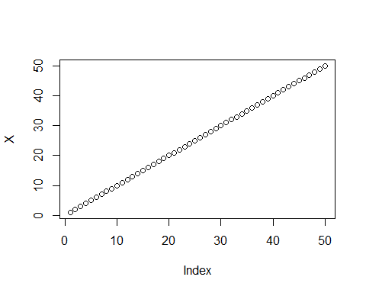
plot(X, sin(X), typ="l", col="purple", lwd=3,xlab="is it lunch time yet")
