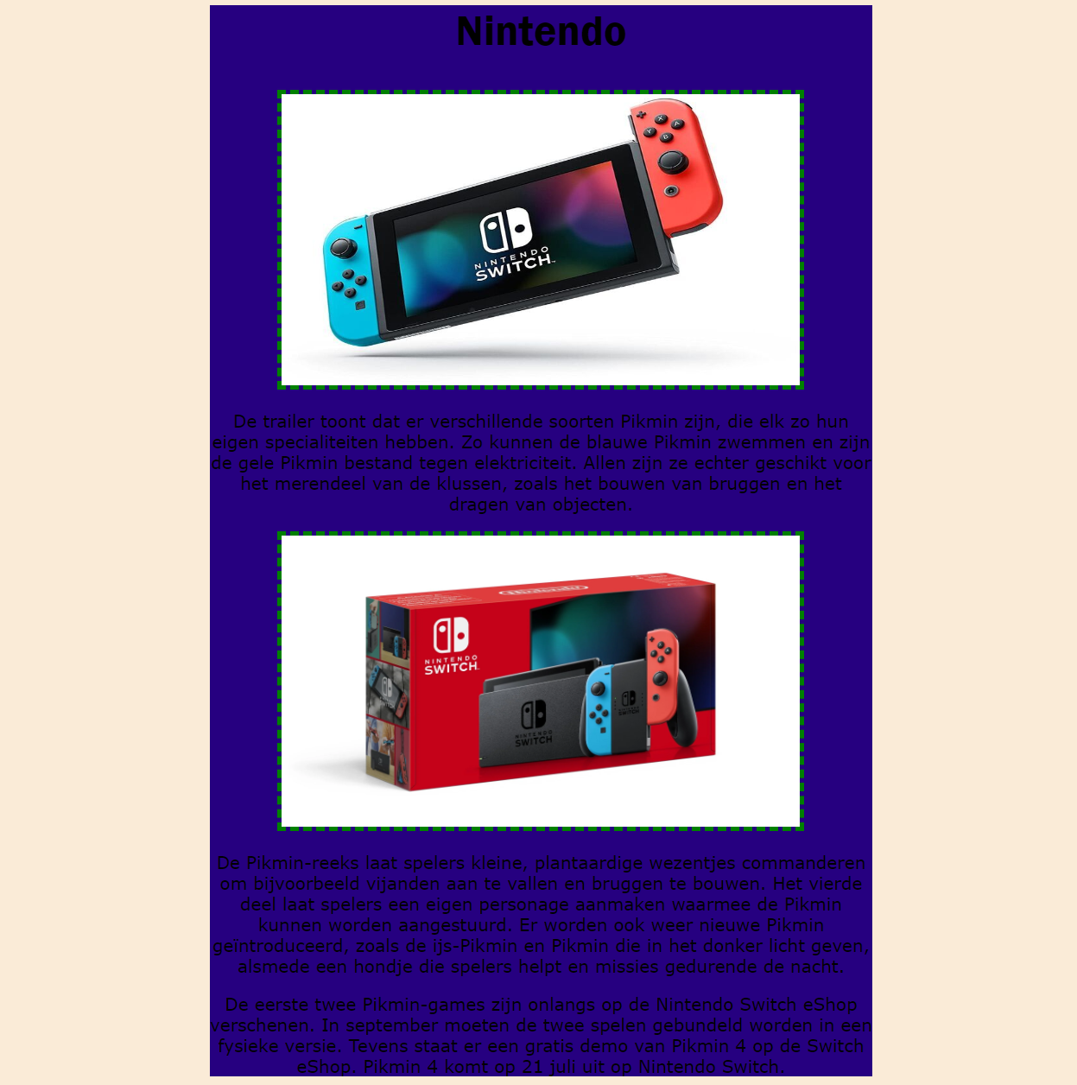

https://38427.hosts2.ma-cloud.nl/Blog/

