Website 1
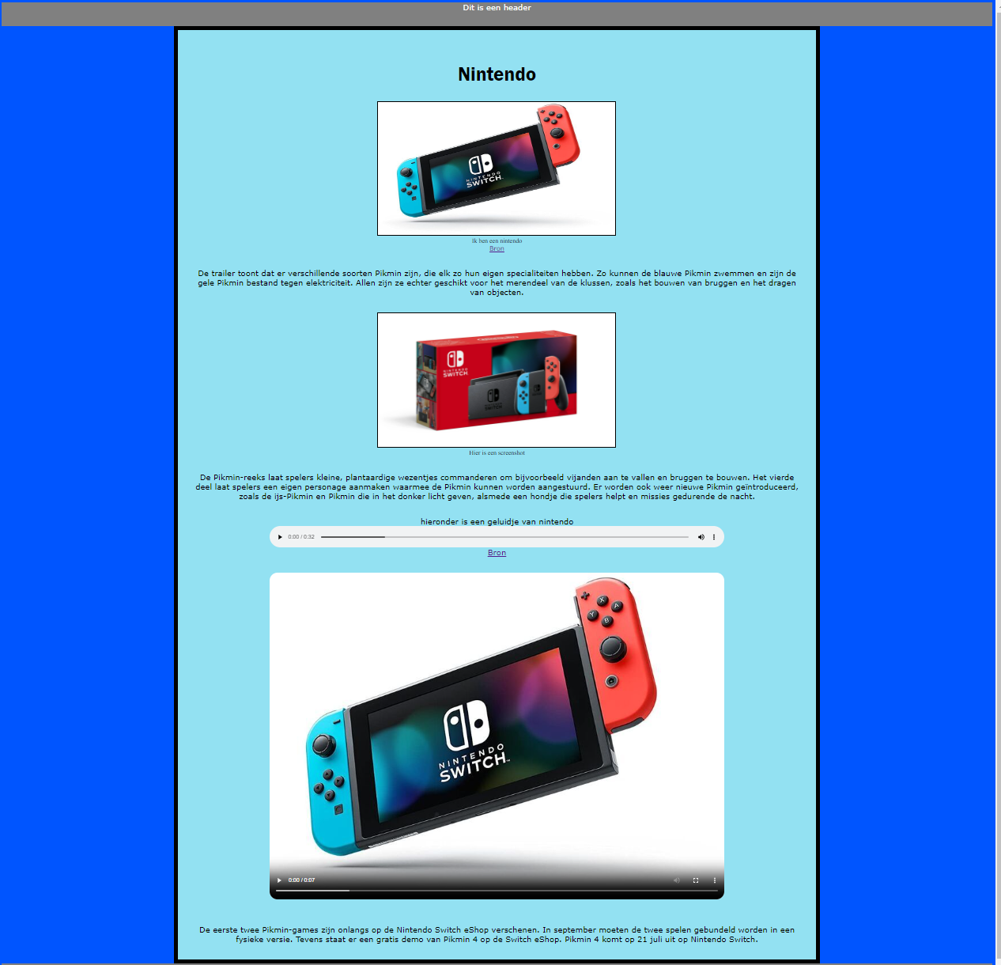
https://38427.hosts2.ma-cloud.nl/Blog/
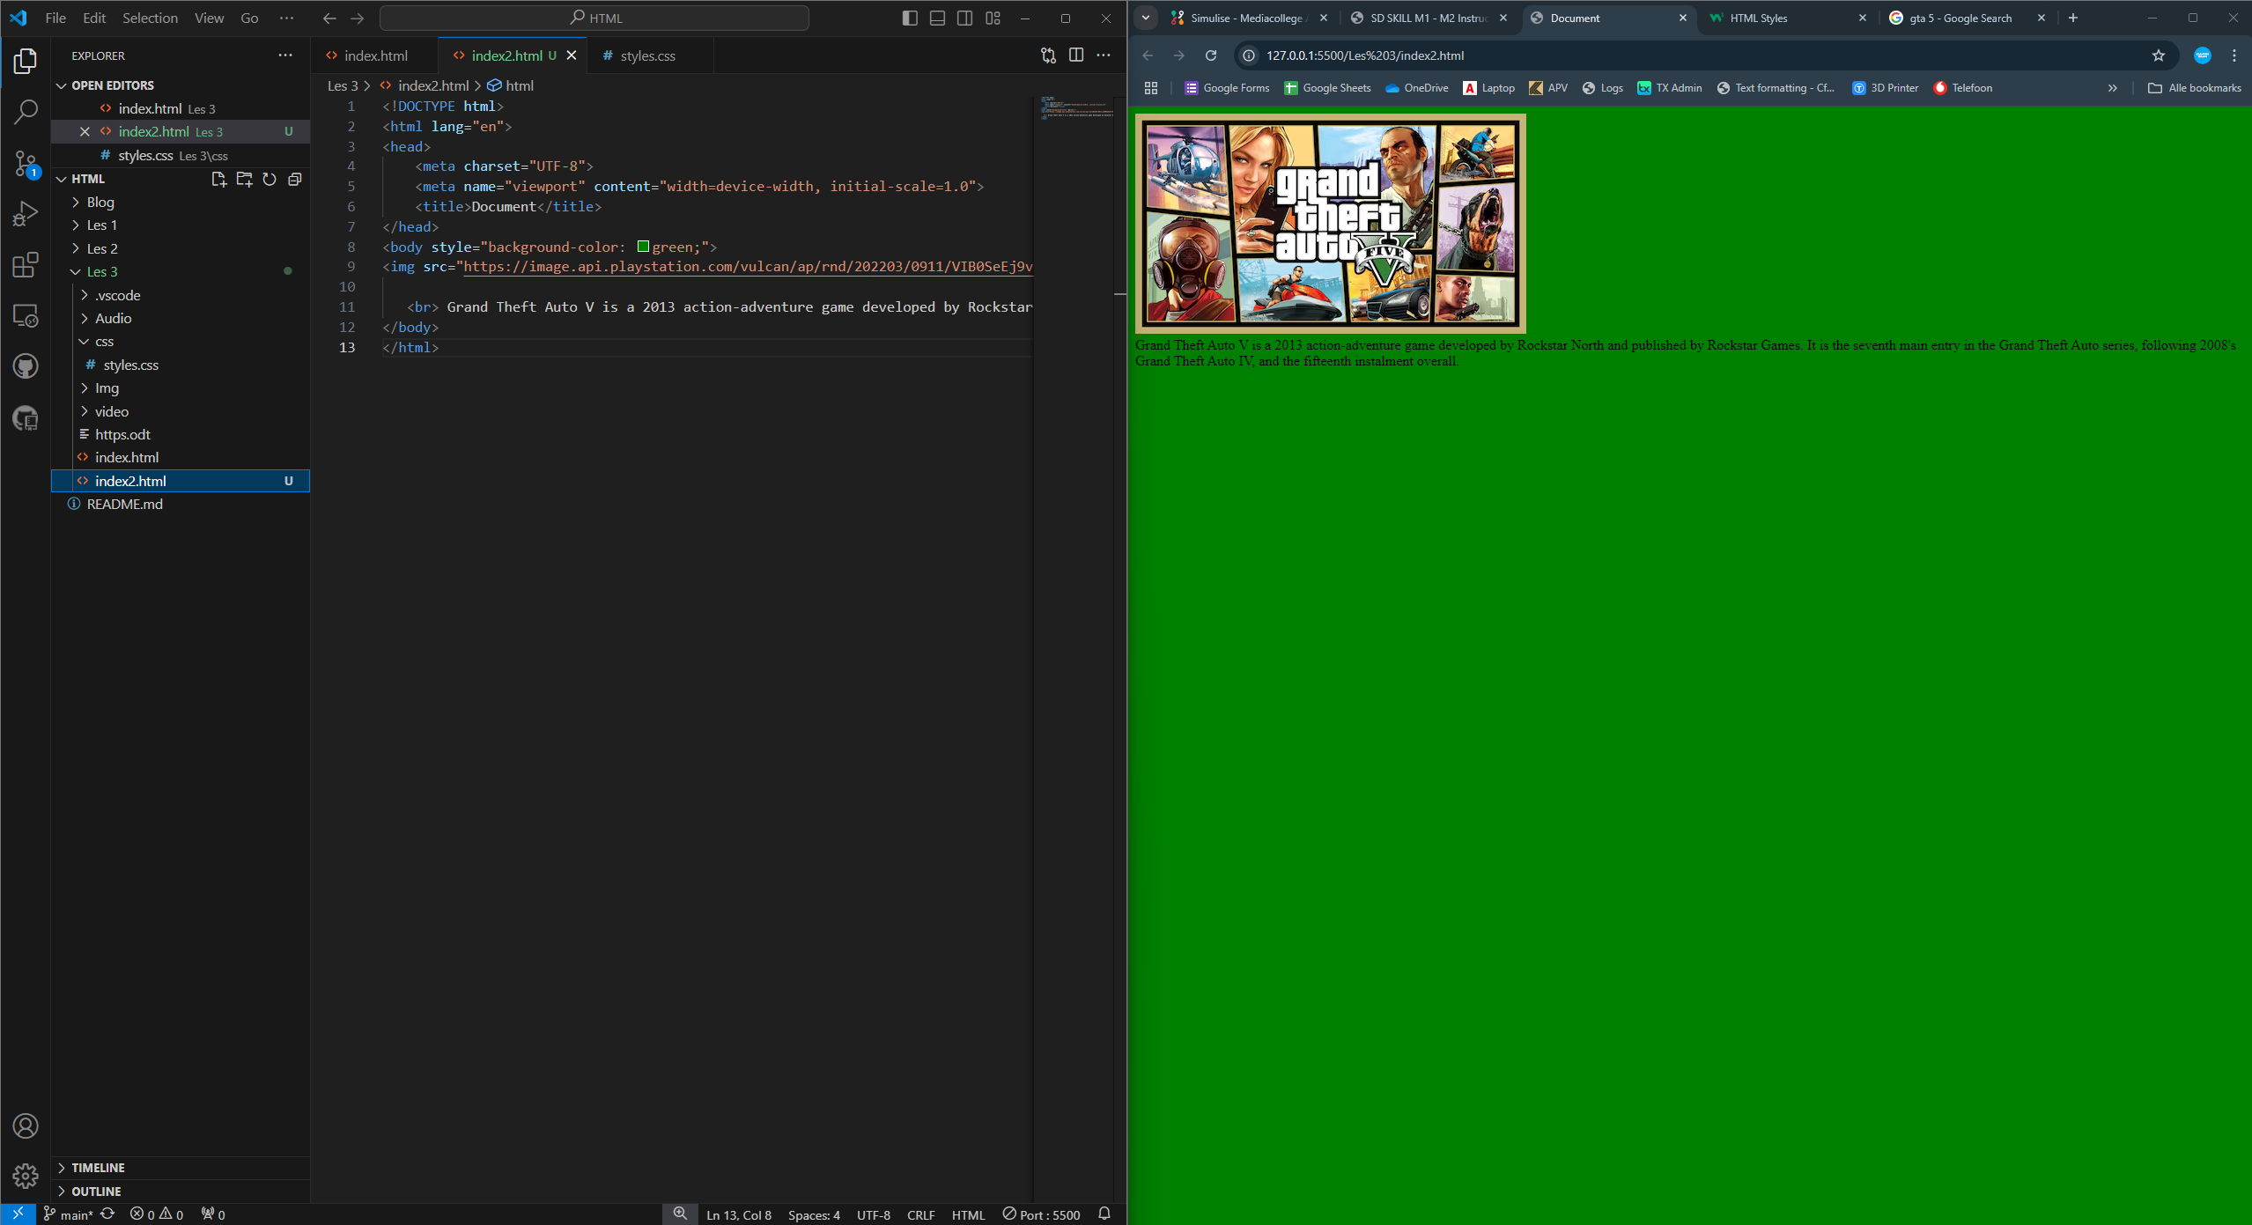
Webiste 2

