Ideas for analyses:

i) Title: Co-occurrence of gadoid species in the Celtic Sea,
a.k.a. breaking the co-production link between species in Celtic Sea mixed fishery.

Questions: Can cross-species correlations from survey data be used to predict spatial occurrence ?
Are there correlations among size/age groups ?
Does inclusion of covariates (habitat, depth, temp) improve predictions ?
What advantages of using SDFA over, for example, spatial GAMM ?
Advantages of a multi-variate fit over single-species ? [covered in Methods in ecol and evol paper]

Approach: Fit SDFA model to survey time-series i) by species, ii) as multivariate fit

Data: Multiple surveys
French EVHOE fisheries independent survey (Q4, 1997 - 2015)
Irish groundfish fisheries independent survey (Q4, 2003 - 2015)
Cefas old Celtic Sea groundfish survey (?, 1983 - ~ 2005)
Cefas Celtic sea beam trawl survey (?, ? - 2015)
Cefas Western Channel beam trawl survey (Q1, ? - ?)

[Fall-back is to fit to North Sea where many surveys available on Datras]

Ideal to use high-resolution commercial data also but may be difficult given availability from different countries

Impact: Ability to predict correlations among species/size classes provide the basis for advice on avoidance of hot-spots for a given species. When quota is low, this allows maximising uptake of other target species in mixed fisheries
Lends itself naturally to inclusion as covariates in a fleet dynamics model

ii) Title: Seasonally changing availability at a fine spatial scale

Questions: Catch is a function of both availability and selectivity, how do these change over a year?
Can changes to seasonality of fisheries decouple production across species?

Approach: Fit weekly spatial delay-diff model assuming immigration / emigration from local area, or
SFA, breaking down the data seasonally (monthly) and looking at how correlations change over the year

Data: Fine-scale positional and catch information (full census) from a small set of vessels for a year.

Impact: Ability to exploit changing species correlation relationships over a small spatial scale may allow adaptation to catch restrictions under landing obligation where vessel has limited ability to move.
Also potentially lay groundwork for simplified bio OM within a fleet dynamics model as part of MSE

iii) Title: Correlations among catches of species in mixed fisheries

Questions: Joint production in mixed fisheries occurs due to the inability to decouple catches of one species from another – to what extent is this true?
Do these correlations change in space/time?
Does habitat use change in time (seasonally) ?

Approach: Use haul-by-haul data to examine correlations in catches of species. Models can include multivariate state space time series analysis with time-varying correlation (e.g., parametric correlation forms or might be nice to look at stochastic volatility type models)

Data: VMS-linked logbook landings data assigned to hauls (estimated) and/or observer trip data

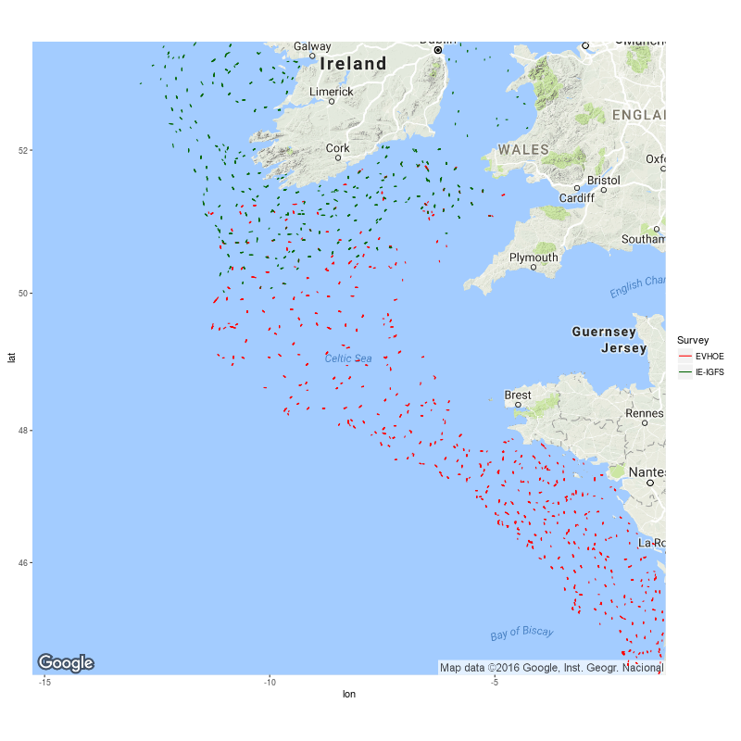
Figure – French (EVHOE, 1997 - 2015) and Irish (IE-IGFS, 2003 - 2015) survey stations in the Celtic Sea (shoot and haul lines), both in Q4: On DATRAS
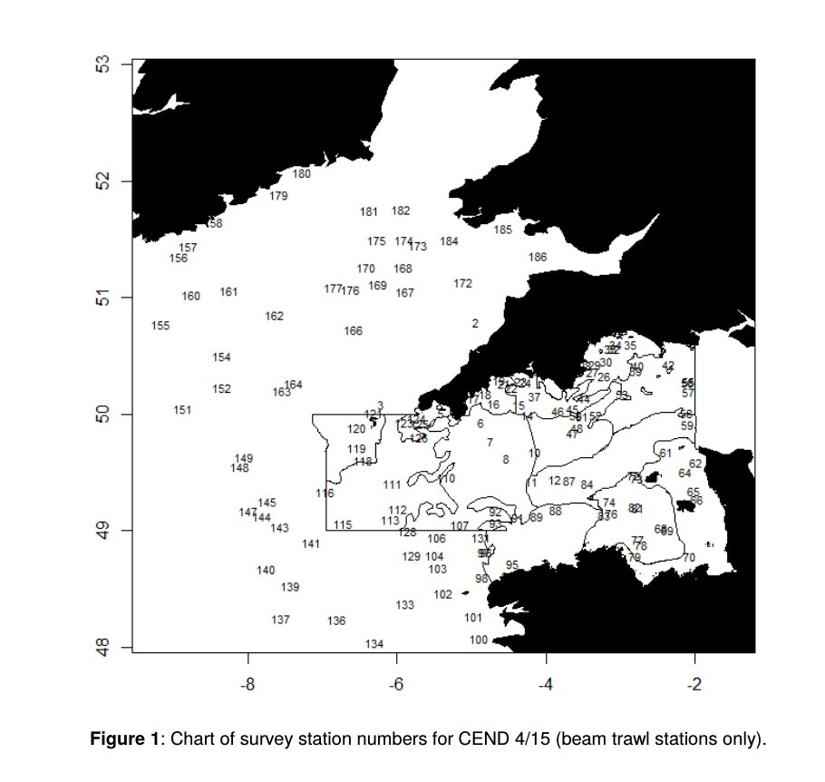
Cefas Q1 beam trawl survey stations from most recent trip – not on DATRAS, but should be possible to get hold of from Cefas systems.

