The EVHOE survey (France)

Area covered and season

For the 1987 to 1996 period, the Survey EVHOE has been conducted in the Bay of Biscay on an annual basis with the exception of the years 1993 and 1996. It has been conducted in the third or fourth quarter except in 1991 where it took place in May. In 1988 two survey were conducted, one in May the other in October.

The Celtic Sea was surveyed from 1990 to 1994 but the sampling was restricted to a small geographical area. The duration is between 40 to 45 days depending on year and availability of ship. Since 1997, the survey covered all the Celtic Sea and Bay of Biscay during the 4th quarter.

Objectives

Since 1997 the main objectives have been :
- the construction of time series of abundance indices for all the commercial species in the Bay of Biscay and the Celtic Sea with an emphasis on the yearly assessed species where abundance indices at age are computed.
- to describe the spatial distribution of the species and to study their interannual variations.
- to estimate and/or update biological parameters (growth, sexual maturity, sex ratio...)

Sampling strategy.

The stratification scheme adopted defines 6 depth strata according to the following criteria:

depth stratum depth range
1 0- 30m
2 31 - 80 m
3 81-120 m
4 121 - 160 m
5 161 - 200 m
201 - 400 m

A geographic stratification separates the Bay of Biscay in 2 areas and the Celtic Sea in 3 areas according to the Figure 1.

The sampling strategy is of a stratified random allocation the number of set per stratum being optimised by a Neyman allocation on numbers variance averaged on the 4 most important commercial species (hake, monkfishes and megrim) leaving of course at least two stations per stratum. 140 sets are planned every year. This number of sets is adjusted according to the time at sea available.
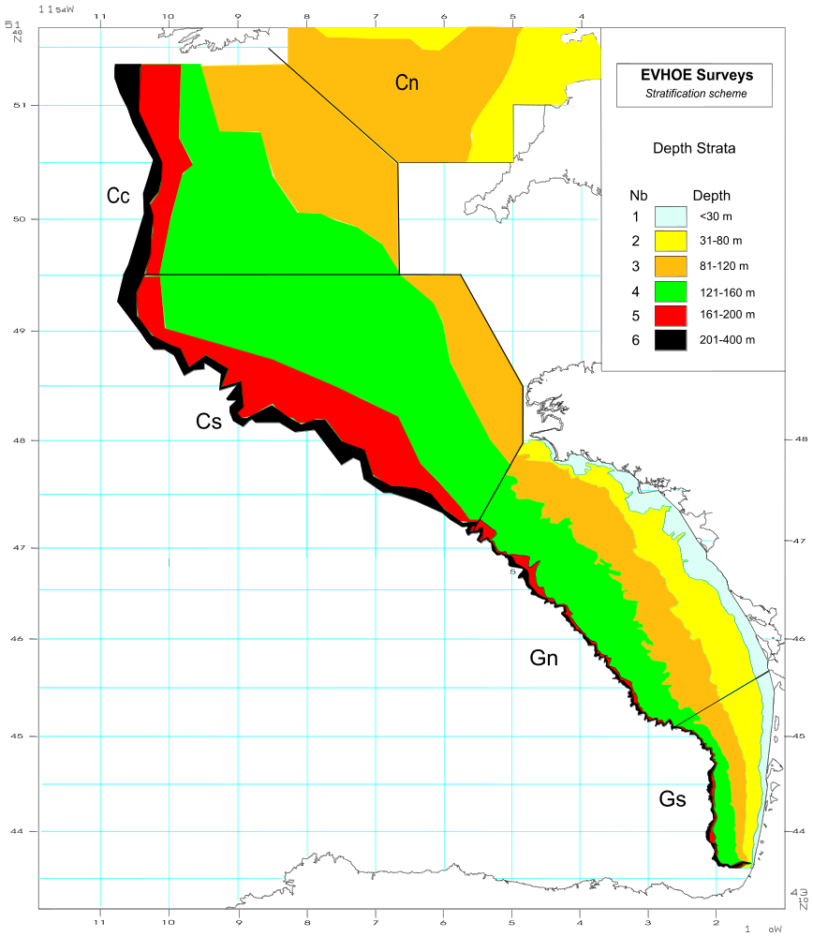
Figure 1. - Area covered and stratification used in the EVHOE surveys

The Gear

The trawl is a GOV 36/47 as described in the IBTS Survey manual except that the exocet Kite is replaced by additional buoyancy 66 floats instead of 60 and weight of Scanmar sensors placed in the middle of the headline has been balanced by adding 21 4l floats. Generally, the gear has a horizontal opening around 20 m and a vertical opening of 4 m. The doors are plane-oval of 1350 Kg. The net is fitted with a 20 mm codend liner. The characteristics of the gear and the rigging are given in Figures 2 and 3.
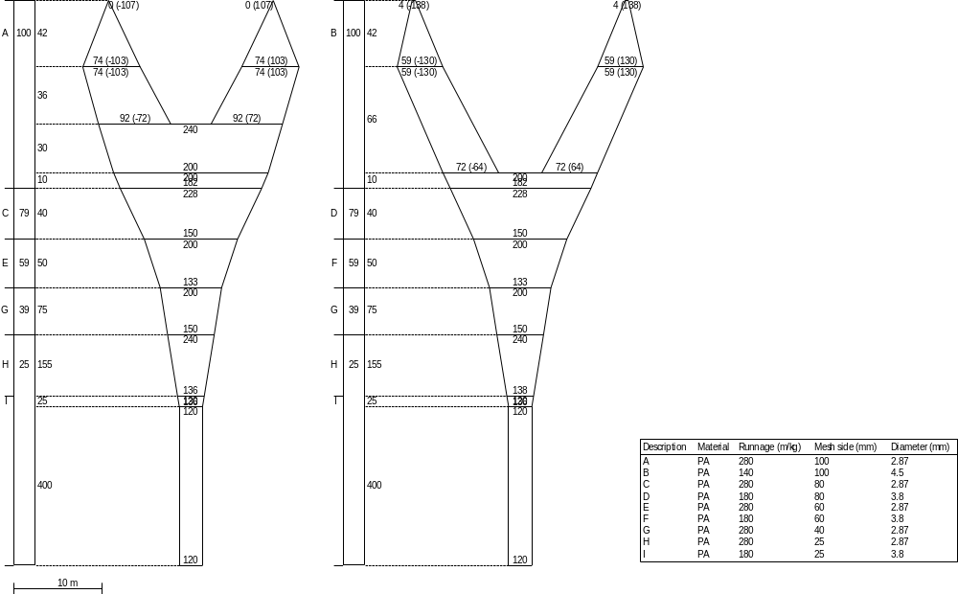
Figure 2 – The GOV 36/47 trawl used on board the R/V Thalassa
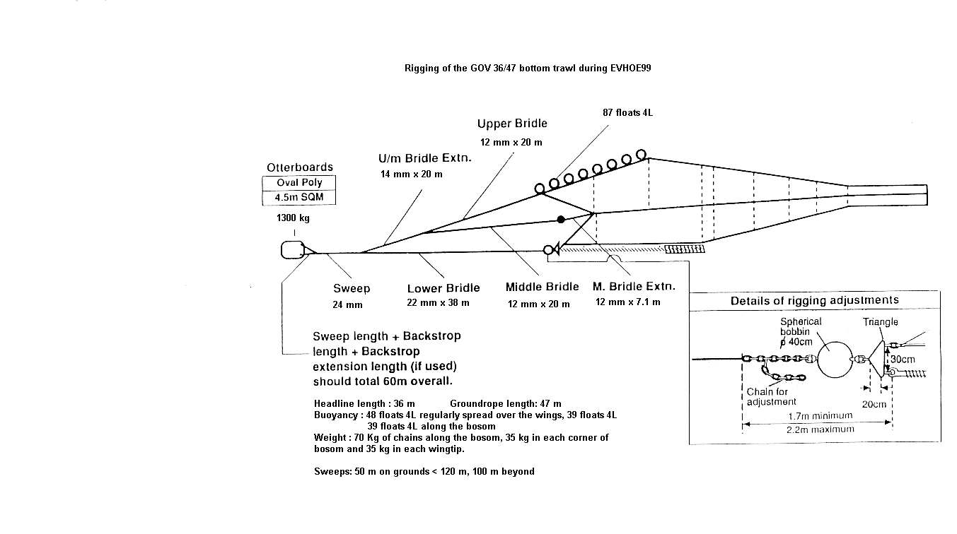

Figure.3 Rigging of GOV 36/47 used during EVHOE surveys

The hauls

Starting in 1997, the survey is has been undertaken on the R/V Thalassa, a stern trawler of 73.7 m long by 14.9 m wide, gross tonnage of 3022 t.
The sets are straight tows, 30 minutes long and are carried during daylight at a towing speed of 4 knots. During the sets, the gear parameters are monitored by Scanmar and the parameters are stored in the boat computer system. The parameters that are monitored are door spread, wing spread, headline height, height of groundrope. Additionaly, a number of navigational parameters were also monitored.

Information collected

The treatment of the catch is identical to the method used in the ISCGS surveys. The total catches are always weighed raw and are sorted by species except in the case of a huge catch of one dominant species where only a fraction of the catch is sorted. In case of sub sampling, the total to sample weigh ratio is used as raising factor. All species of fish are measured, for some species other biological samplings are made (individual weight, maturity, measurement by sex, ageing material). All commercial species are sexed when measured and the ageing material collected is following a stratified allocation by length class and by sex, therefore separate ALKs per sex are constructed. The allocations per length class are different depending on species and area and are given in the following table.

Species | Otoliths
Whiting | 1/10/cm/sex/haul (1)
Angler fishes | 3/cm (2)
Pollock | 3/cm
Megrim | 6/cm
Sole | 5/cm
Hake | 8/cm/sex/area (1)
Ling | all
Cod | all
- Separate ALKs are constructed for the Celtic Sea and the Bay of Biscay areas
- Illicium and 2nd ray of first dorsal fin

Computation of global abundance indices

The construction of raw abundance indices in Total Weight and number per set (stratified mean 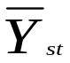 and its variance 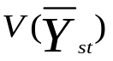) are computed following the stratified random sampling formulas as described by Pennington and Grosslein (1978) :
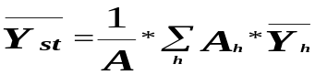
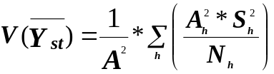
where :
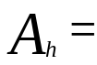 area of the 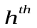 stratum
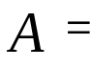 the total area
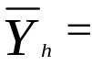 sample mean catch per tow in the stratum
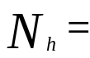 number of tows in the stratum
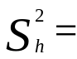 sample variance in the stratum

Computation of abundance indices at age

a. First phase, computation of average numbers at length and associated variances.

Estimation of average numbers at length j for a group of h strata (stratified mean 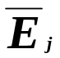) and its variance 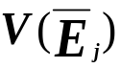) is computed according to the random sampling strategy already described for computation of global indices:

For each length class j :
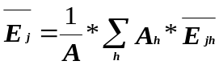 (1)
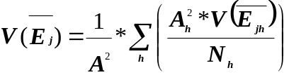 (2)
where :
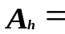 area of stratum h
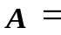 total area of the group of strata st
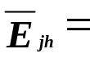 mean number per haul in length j for stratum h
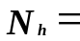 number of hauls in stratum h
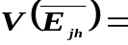 variance of the mean number in length class j for stratum h
b. Second phase, building the age-length key, computation of the proportions at age i per length class j and associated variances.
For each length class j the proportion of age i and its variance is computed :
(3)
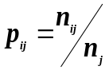
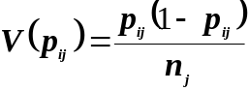
(4)

where :

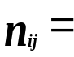 number of otoliths of age i in the length class j

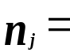 total number of otolith in the length class j

c. Third phase, computation of mean numbers at age and the associated variances.

The mean numbers at age are given by :

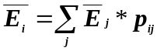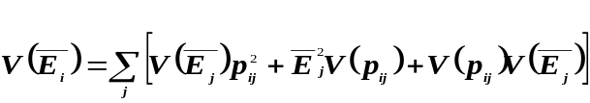The associated variance :
(5)

These computations are done by sex and the total age composition is given for each age i by:
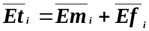

Its variance :
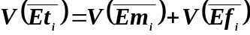
(6)

The sampling being independent on sex the covariance is not considered.

Environmental data

Hydrological stations are occupied after each set by mean of a CTD probe (Temperature and salinity by depth). All information is stored in a database in MS Access format.

Pennington M.R. and M.D. Grosslein, 1978. Accuracy of abundance indices based on stratified random trawl surveys. ICNAF Res. Doc. 78/IV/77 : 42 p.

