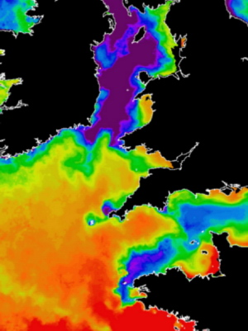

Figure 2. A typical summer sea surface temperature image of the Celtic and Irish Seas, from the Advanced Very High Resolution Radiometer satellite sensor. Orange and red (17 – 19°C) shows areas of relatively weak tides where summer stratification has developed. Purple and blue (12 – 14°C) shows tidally energetic regions where the water remains vertically-mixed all year. Sharp tidal mixing fronts (between Ireland/Southwest Wales) separate the stratified and mixed regions. A band of cooler water (southwest of Britanny) lies along the continental shelf edge due to strong mixing by an internal tide. The partitioning into mixed, frontal, and stratified regions is consistent between years. Image supplied by Remote Sensing Division, Plymouth Marine Laboratory, NERC

https://www.liverpool.ac.uk/climate/research/shelf/

