Code Deliverable

// i/o
#include <stdio.h>
// pid
#include <wait.h>
// uint types
#include <stdint.h>

int main(int argc, char* argv[])
{
pid_t childID = fork();
fprintf(stdout, "%llu\n", (uint64_t)childID);
return 0;
}

Output Screenshot
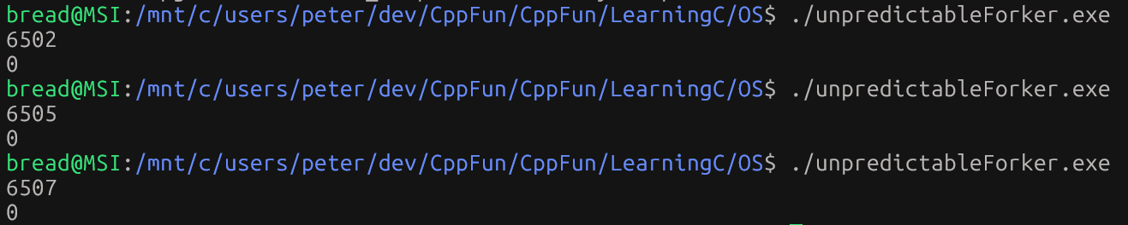

Group Members:
- [Your Name]
- [Member's Name]
[For each member - fill out five reporting criteria]
- Role:
  - [Specify role]
- Tasks Completed:
  - [List specific tasks or activities the student was responsible for.]
- Challenges Faced:
  - [Highlight any challenges the student encountered and how they addressed them.]
- Achievements:
  - [Mention any notable achievements or contributions the student made to the project.]
- Contribution and Performance Rates:

