Step 1 – Output
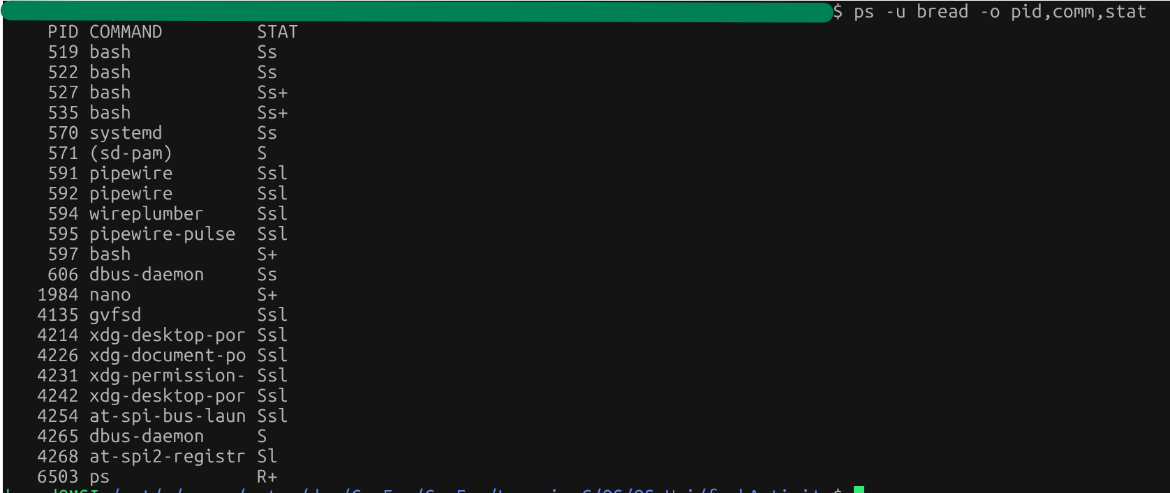

Step 2 – Output
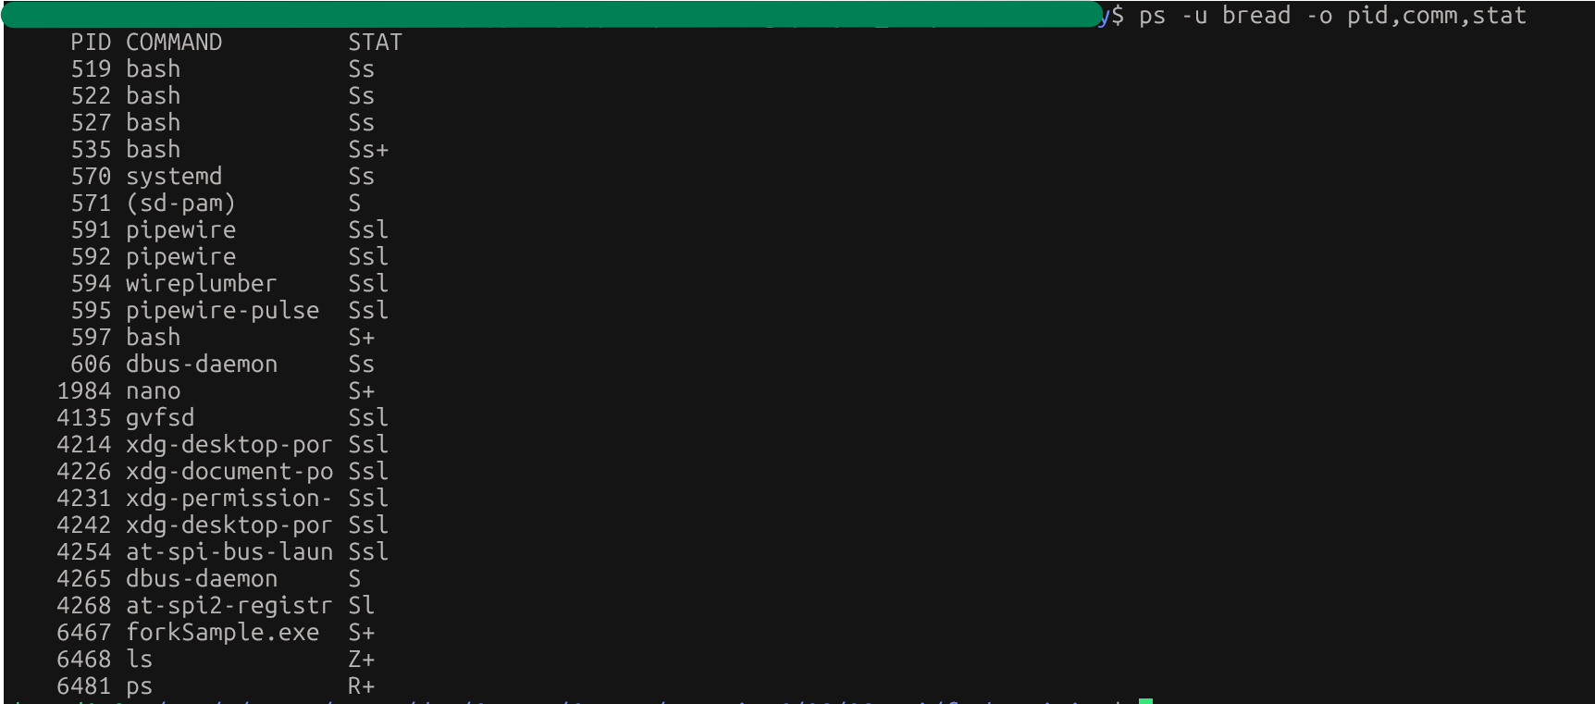
- We can “ls” is the zombie process. It has the Z+ stat next to it.

Step 3 – Output
- The original parent was terminated while the child was sleeping. When that happened, the child was orphaned. I assume that process 524 is used for child process clean-up once they complete execution?

