She stresses different modes of learning

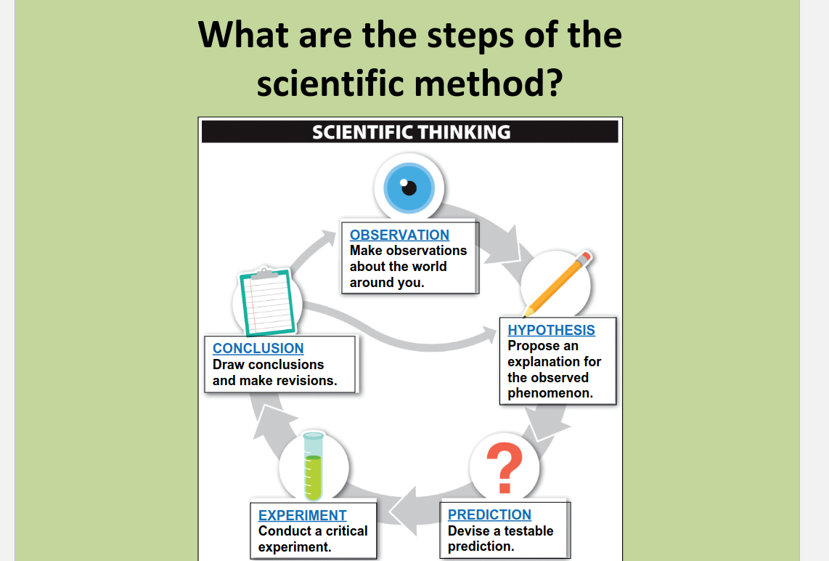

Biological literacy impacts what we believe is true when science is used to sway opinions in news/media.

Step 1: observation

Step 2: hypothesis

* “A proposed explanation for observed phenomena”
* To be most useful
  + It must establish an alternative explanation for a phenomenon
  + It must generate **testable predictions**

Step 3: Testable Prediction

* Only way to validate a hypothesis
  + “if… then…” (under certain observations)

Step 4: Critical experiment

* Experiment that decisively determines whether a particular hypothesis is better than an alternative.

Step 5: Draw Conclusions, make revisions

* *Science includes a great deal of Trial and Error*
  + An unexpected result does not make it the “wrong answer”

Everyday “Theory” vs. Scientific Theory

* Everyday: a hunch or guess or speculation.
* Scientific: a theory with a hyptothesis

Hypotheses and Theories

* Theory: an explanatory hypothesis for natural phenomena that is ***exceptionally well-supported*** *by data*
  + Stood the test of time. **Unlikely to be altered by any new evidence**
  + Repeatedly tested
    - no observations or experimental results have contradicted
    - Nearly same confidence as fact
    - Broader in scope than hypotheses
      * i.e. cell theory, theory of evolution by natural selection, etc.

Major Themes in Biology: What is life? How distinguished from non-life?

* **Characteristics shared by all living organisms:**
  + - Complex, ordered organization consisting of one or more cells
    - Use and transformation of energy to perform work
    - Sensitivity and responsiveness to the external environment
    - Regulation and homeostasis
    - Growth, development, and reproduction
    - Evolutionary adaptation leading to descent with modification over time
* **Two Unifying Themes in Biology**
  + 1) hierarchical organization
    - Life is organized on many levels **within individual organisms** (i.e. atoms, cells, tissues, and organs)
    - **Organisms themselves are organized into many levels**: populations, communities, and ecosystems within the biosphere
  + 2) **The power of evolution**
    - The change in genetic characteristics of a population over time
    - Accounts for the diversity of organisms, but also explains the unity among themselves
    - Organisms divided into **three domains**
* **Classification Systems**
  + Two-kingdom system (1700s)
    - Animals and plants
      * plants can make their own food but can’t move
      * Animals can’t make their own food, but can move
  + Five-kingdom system (1960s)
    - Prokaryotic cells vs. Eukaryotic cells
    - **Bacteria vs. plants, animals, fungi, and protists**
  + 1970s and 1980s began classifying organisms by examinging their **nucleotide sequences**.
  + Compared the **evolutionary relatedness of all organisms present on earth today** by comparing **ribosomal RNA among all species**
  + **Based on the genetic sequence data, all living organisms are currently classified into one of three groups**
    - Bacteria
      * tremendous biological diversity
      * biomass greater than that of all the plants and animals on earth
      * Features all bacteria have in common
        + **Prokaryotic**
        + **Single-celled** organisms with **no nucleus or organelles**
        + One or more **circular** molecules of DNA
        + Use several methods of exchanging genetic information
      * **Asexual** organisms
        + **\*\*Not all bacteria are bad – Some species are essential to our lives!\*\***
    - Archaea
      * Different form bacteria
      * Prokaryotic, single-celled (like Bacteria)
        + **BUT:** Although Archaea physically resemble Bacteria they are **more closely related to Eukarya**
      * Divided into five groups
        + Thermophiles (“heat lovers”)
        + Halophiles (“salt lovers”)
        + High- and low-ph tolerant
        + High-pressure tolerant (2.5 miles deep)
        + Methanogens: are anaerobic and produce methane
    - Eukarya
      * **Four kingdoms:** Plants, Animals, Fungi, and Protists
        + Three can be see with naked eye
        + Made up of **Eukaryotic cells**

**have a membrane-enclosed nucleus** – each kingdom is *almost* entirely multicellular

* + - * + **Protists**

Many **microsocopic, single-celled organisms** (i.e. Amoeba, Paramecium)

new species discovered at high rate