She stresses different modes of learning
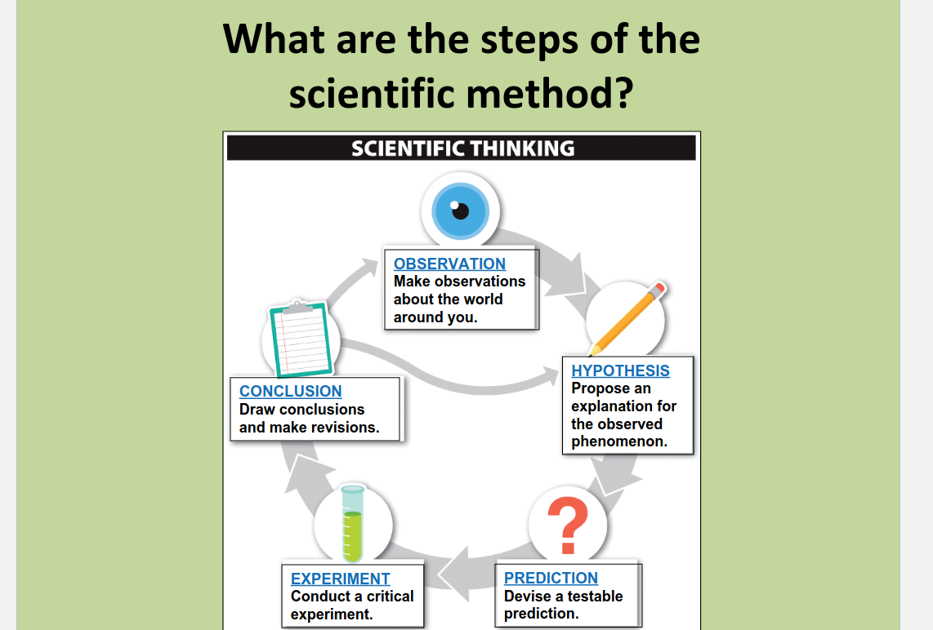

Biological literacy impacts what we believe is true when science is used to sway opinions in news/media.

Step 1: observation
Step 2: hypothesis
- “A proposed explanation for observed phenomena”
- To be most useful
  - It must establish an alternative explanation for a phenomenon
  - It must generate testable predictions
Step 3: Testable Prediction
- Only way to validate a hypothesis
  - “if… then…” (under certain observations)
Step 4: Critical experiment
- Experiment that decisively determines whether a particular hypothesis is better than an alternative.
Step 5: Draw Conclusions, make revisions
- Science includes a great deal of Trial and Error
  - An unexpected result does not make it the “wrong answer”

Everyday “Theory” vs. Scientific Theory
- Everyday: a hunch or guess or speculation.
- Scientific: a theory with a hyptothesis

Hypotheses and Theories
- Theory: an explanatory hypothesis for natural phenomena that is exceptionally well-supported by data
  - Stood the test of time. Unlikely to be altered by any new evidence
  - Repeatedly tested
    - no observations or experimental results have contradicted
    - Nearly same confidence as fact
    - Broader in scope than hypotheses
      - i.e. cell theory, theory of evolution by natural selection, etc.

Major Themes in Biology: What is life? How distinguished from non-life?
- Characteristics shared by all living organisms:
    - Complex, ordered organization consisting of one or more cells
    - Use and transformation of energy to perform work
    - Sensitivity and responsiveness to the external environment
    - Regulation and homeostasis
    - Growth, development, and reproduction
    - Evolutionary adaptation leading to descent with modification over time
- Two Unifying Themes in Biology
  - 1) hierarchical organization
    - Life is organized on many levels within individual organisms (i.e. atoms, cells, tissues, and organs)
    - Organisms themselves are organized into many levels: populations, communities, and ecosystems within the biosphere
  - 2) The power of evolution
    - The change in genetic characteristics of a population over time
    - Accounts for the diversity of organisms, but also explains the unity among themselves
    - Organisms divided into three domains
- Classification Systems
  - Two-kingdom system (1700s)
    - Animals and plants
      - plants can make their own food but can’t move
      - Animals can’t make their own food, but can move
  - Five-kingdom system (1960s)
    - Prokaryotic cells vs. Eukaryotic cells
    - Bacteria vs. plants, animals, fungi, and protists
  - 1970s and 1980s began classifying organisms by examinging their nucleotide sequences.
  - Compared the evolutionary relatedness of all organisms present on earth today by comparing ribosomal RNA among all species
  - Based on the genetic sequence data, all living organisms are currently classified into one of three groups
    - Bacteria
      - tremendous biological diversity
      - biomass greater than that of all the plants and animals on earth
      - Features all bacteria have in common
        - Prokaryotic
        - Single-celled organisms with no nucleus or organelles
        - One or more circular molecules of DNA
        - Use several methods of exchanging genetic information
      - Asexual organisms
        - **Not all bacteria are bad – Some species are essential to our lives!**
    - Archaea
      - Different form bacteria
      - Prokaryotic, single-celled (like Bacteria)
        - BUT: Although Archaea physically resemble Bacteria they are more closely related to Eukarya
      - Divided into five groups
        - Thermophiles (“heat lovers”)
        - Halophiles (“salt lovers”)
        - High- and low-ph tolerant
        - High-pressure tolerant (2.5 miles deep)
        - Methanogens: are anaerobic and produce methane
    - Eukarya
      - Four kingdoms: Plants, Animals, Fungi, and Protists
        - Three can be see with naked eye
        - Made up of Eukaryotic cells
          - have a membrane-enclosed nucleus – each kingdom is almost entirely multicellular
        - Protists
          - Many microsocopic, single-celled organisms (i.e. Amoeba, Paramecium)
          - new species discovered at high rate

