Pedram Doroudchi

LISUM14

10/28/22

Data Glacier

Flask Deployment Tutorial

1. Imported a toy dataset named “Salary_Data.csv” which includes 30 observations of employee years of experience and salary
2. Created “model.py” script to train and test simple linear regression of salary against years of experience with dataset:

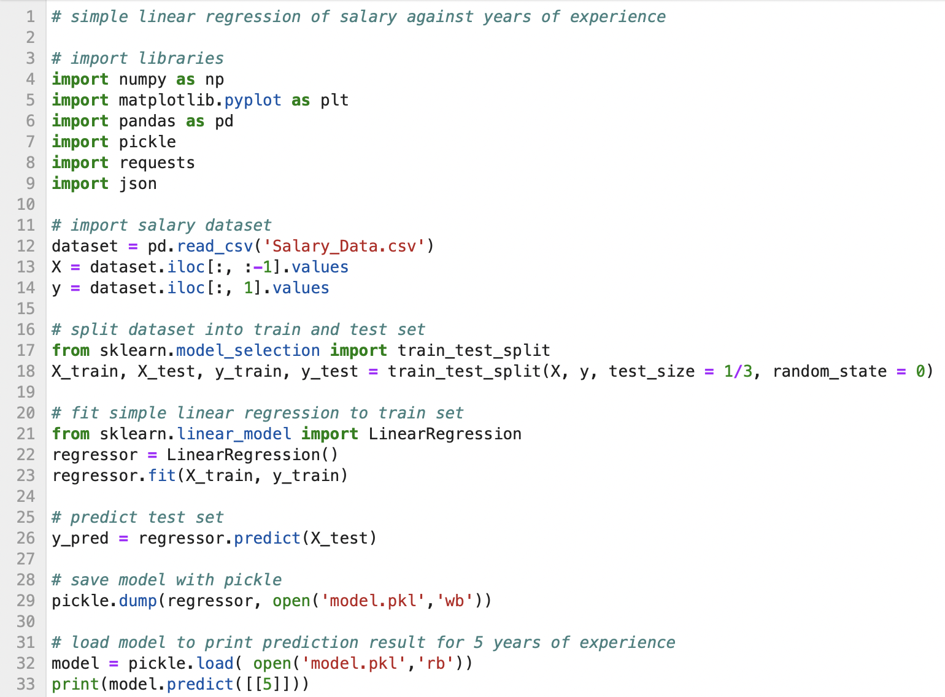

1. Created “index.html” script to format web application template:

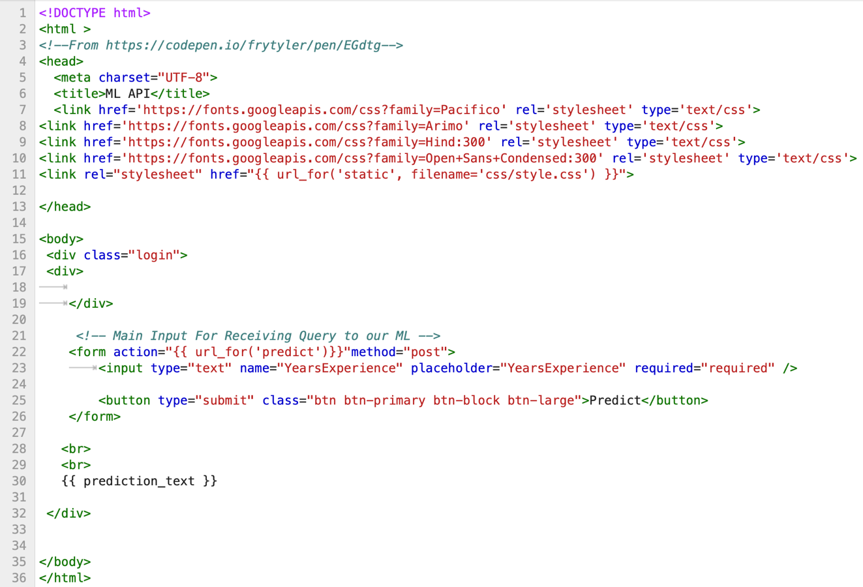

1. Created “app.py” script which contains flask code and runs the web app:

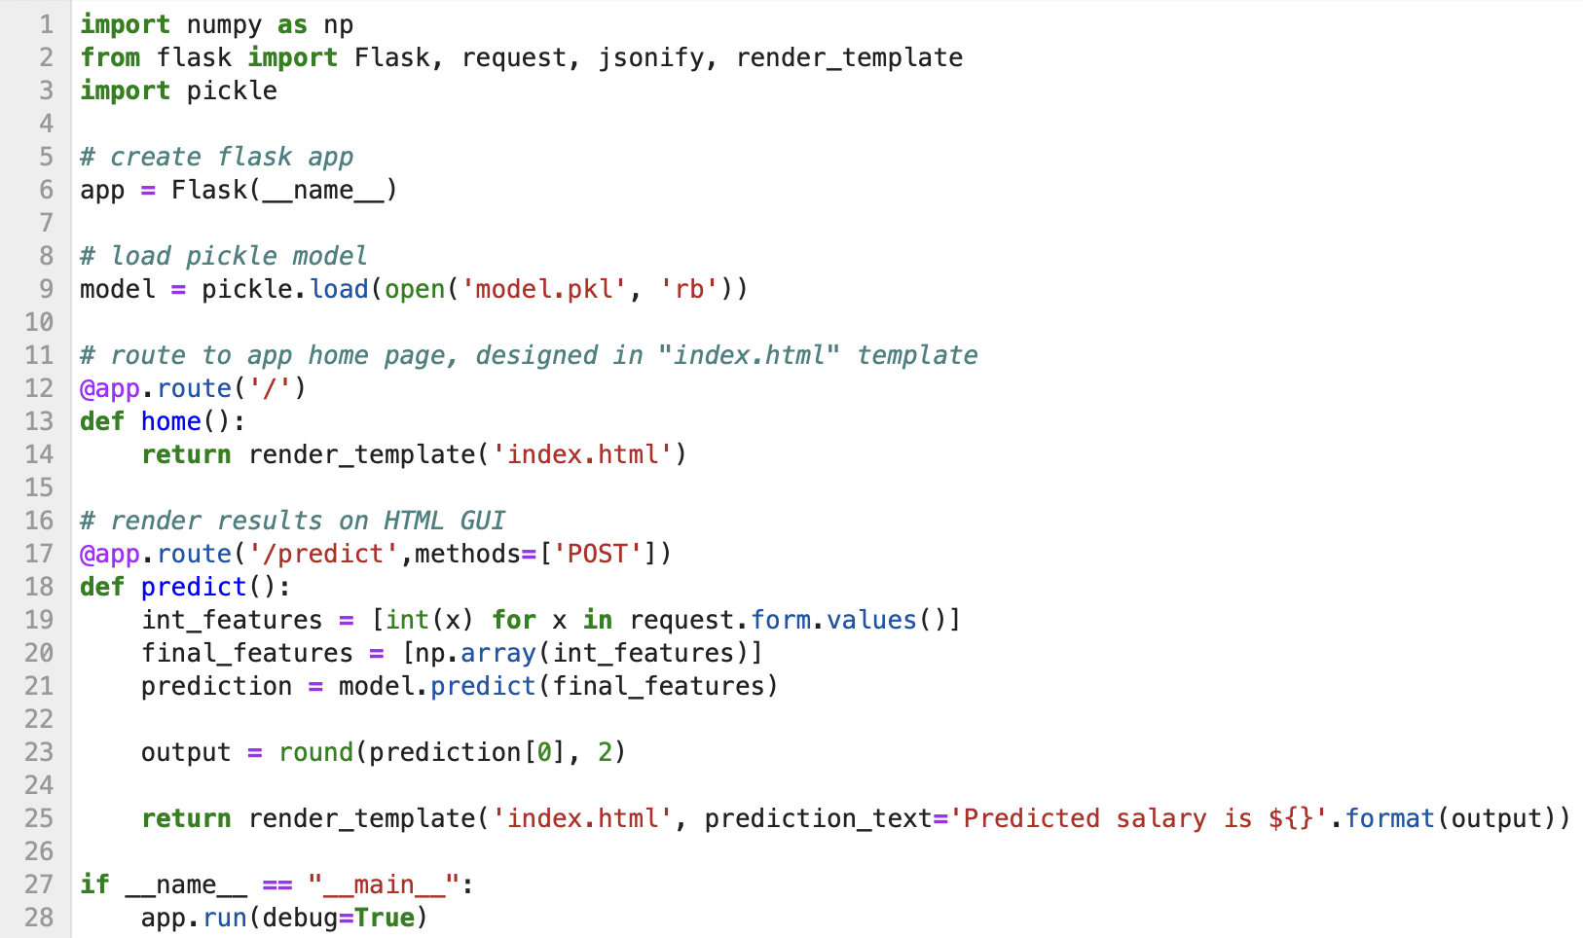

1. Opened computer terminal and ran “model.py” / “app.py”

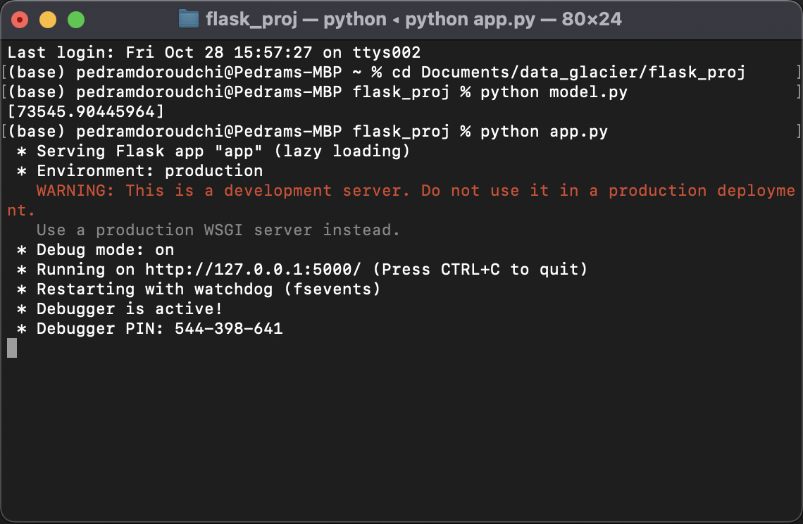

1. Copied and pasted HTTP address into web browser to access web app and verified predicted salary given 5 years of experience:

