Pedram Doroudchi

LISUM14

11/05/22

Data Glacier

Heroku Deployment Tutorial

1. Create ML Model and save (pickle) it
2. Create Flask files for UI and python main file (app.py) that can unpickle the machine learning model from step 1 and do predictions
3. Create requirements.txt to setup Flask web app with all python dependencies

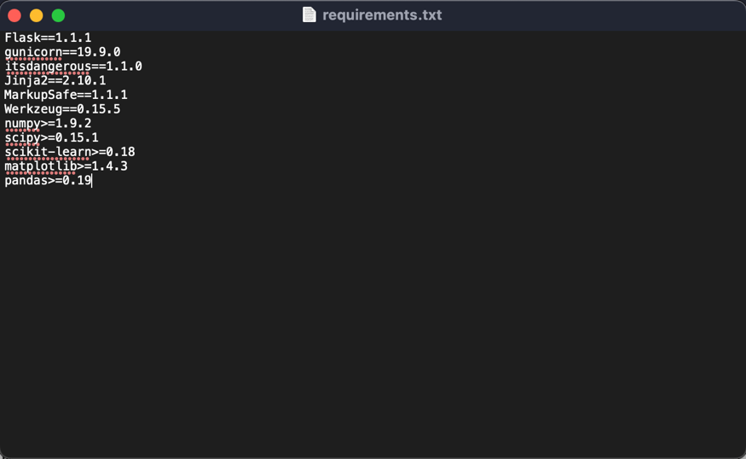

1. Create Procfile to initiate Flask app command

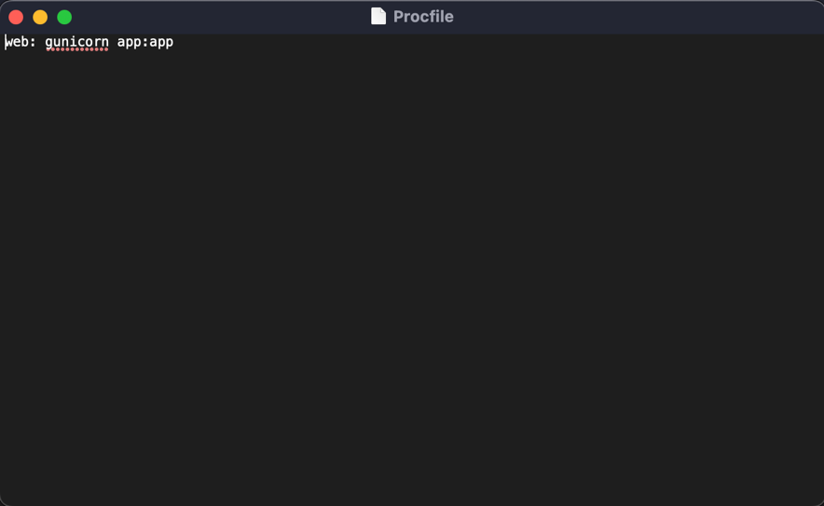

1. Commit files from Step 1, 2, 3 & 4 to GitHub repo

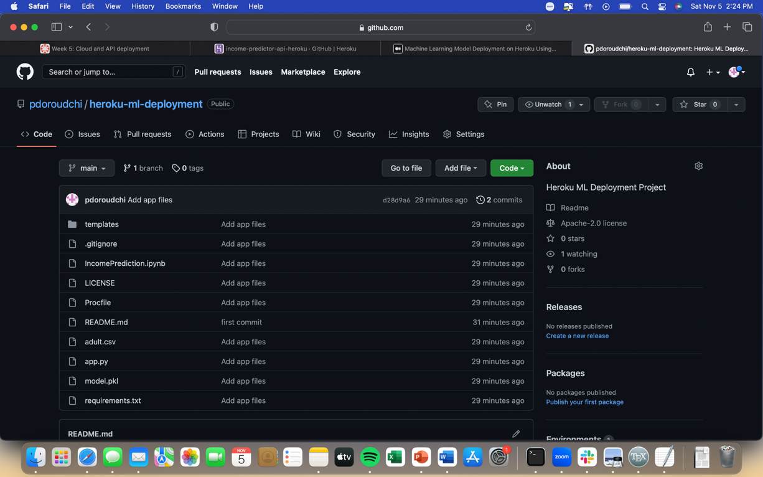

1. Create account/Login on Heroku, create an app, connect with GitHub repo, and select branch

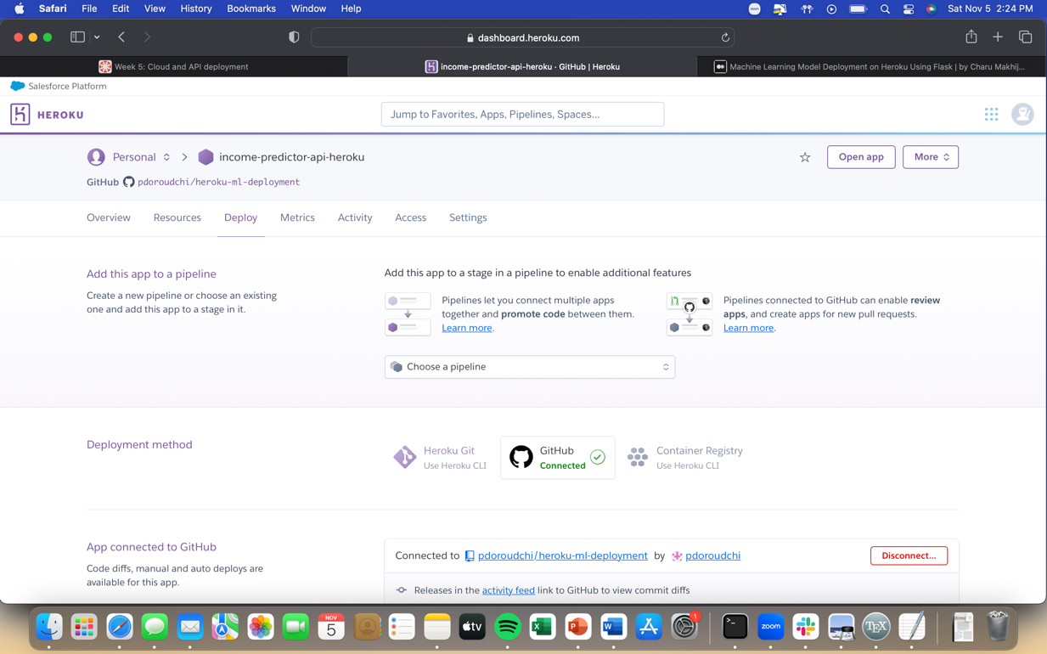

1. Manually deploy on Heroku

