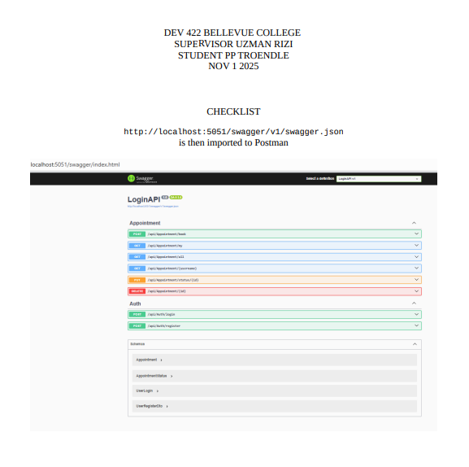
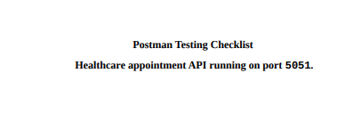

Healthcare Appointment Booking System API – Minimal Checklist

1. User Registration
- POST /api/auth/register OK ENDPOINT 200
  - Can register Patient, Doctor, Admin with role assigned.

2. Authentication
- POST /api/auth/login OK ENDPOINT 200
  - Returns JWT token for valid credentials.
- Token used to access protected endpoints.

3. Role-Based Authorization
- Patient can book and view own appointments only.
- Doctor can view/manage own appointments only.
- Admin can view all appointments only.
- Access blocked for unauthorized roles.

4. Appointment Management
- POST /api/appointment/book – Patient books appointment. OK ENDPOINT 200
- GET /api/appointment/my – Patient views own appointments. OK ENDPOINT 200
- GET /api/appointment/doctor – Doctor views appointments. OK ENDPOINT 200
- GET /api/appointment/all – Admin views all appointments.
- PUT /api/appointment/{id} – Doctor/Admin updates appointment.
- DELETE /api/appointment/{id} – Patient cancels appointment.

5. Appointment Status
- Doctor/Admin can update status (Pending → Confirmed → Canceled).

6. User Profile
- GET /api/user/profile – View profile.
- PUT /api/user/update – Update info.
- PUT /api/user/change-password – Change password.

7. Testing
- All endpoints tested in Postman or Swagger.
- Verify JWT authentication and role restrictions.

POST /api/auth/register
POST /api/auth/login
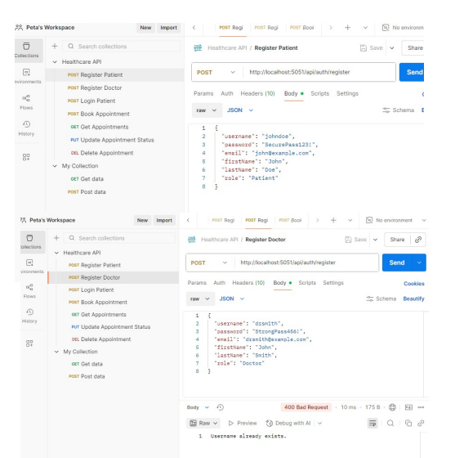

Patient can book and view own appointments only.

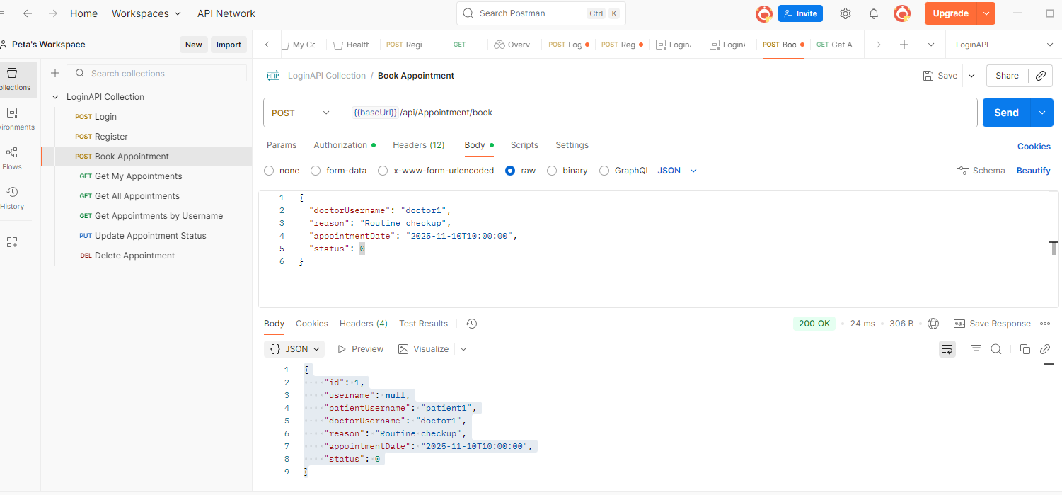

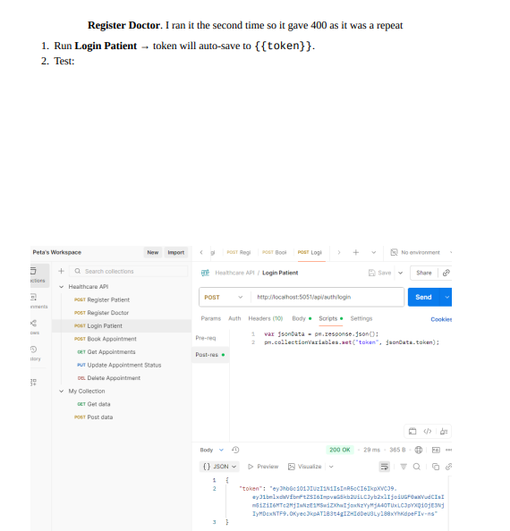

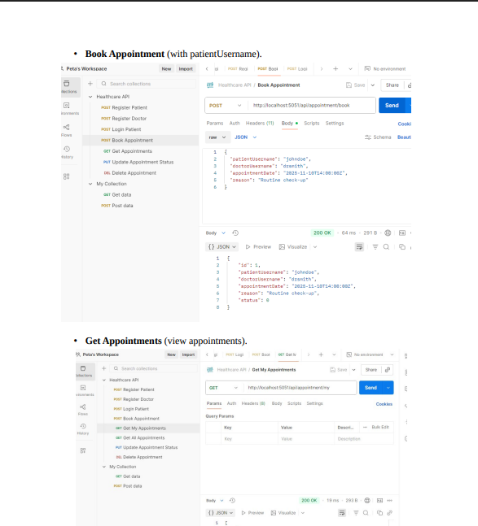

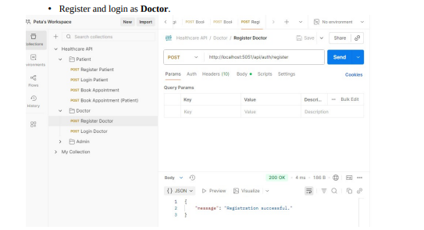
As Admin
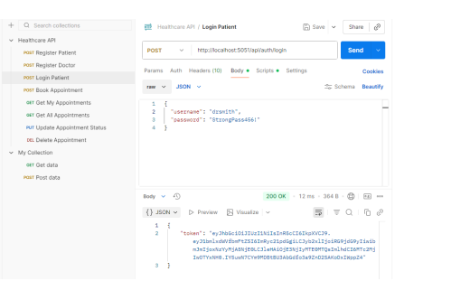

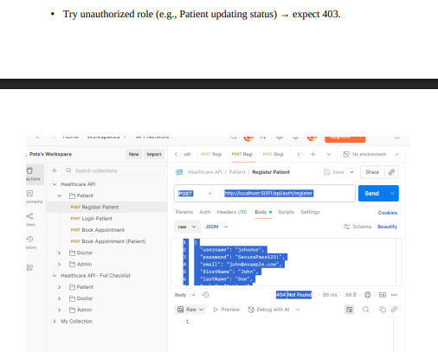

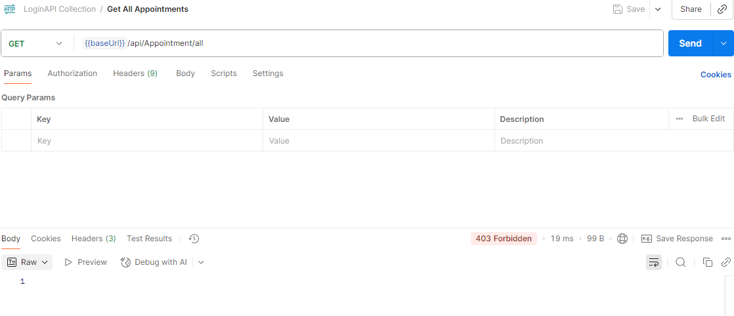

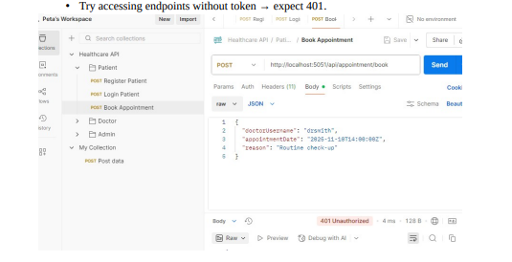

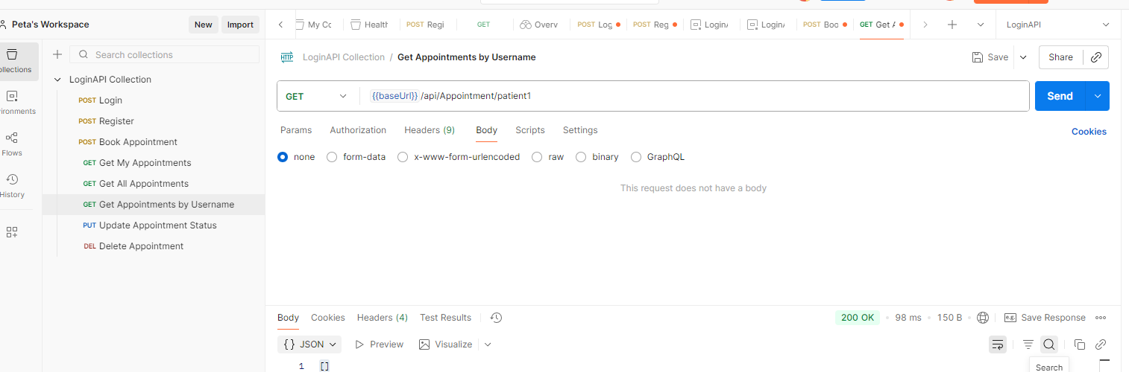
{{baseUrl}}/api/Appointment/patient1

{{baseUrl}}/api/Appointment/my

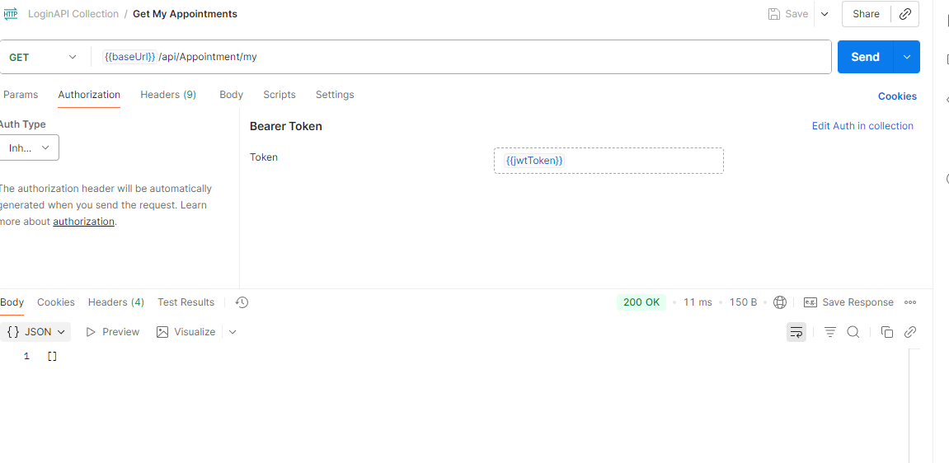
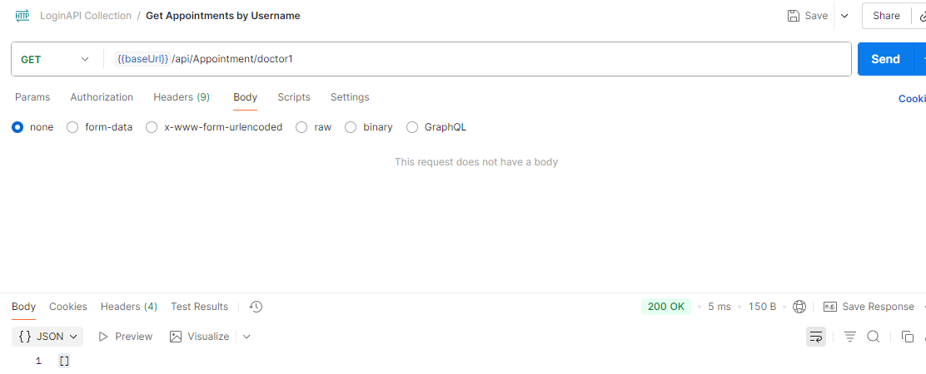
{{baseUrl}}/api/Appointment/doctor1

Postman Test Flow
- Register Patient
POST {{baseUrl}}/api/Auth/register
Body:
{
"username": "patient1",
"password": "NewPass123!",
"email": "patient@example.com",
"firstName": "John",
"lastName": "Doe",
"role": "Patient"
}
Expected: 200 OK
- Register Doctor
POST {{baseUrl}}/api/Auth/register
Body:
{
"username": "doctor1",
"password": "DocPass123!",
"email": "doctor@example.com",
"firstName": "Alice",
"lastName": "Smith",
"role": "Doctor"
}
Expected: 200 OK
- Login Patient
POST {{baseUrl}}/api/Auth/login
Body:
{
"username": "patient1",
"password": "NewPass123!"
}
Expected: 200 OK with token
- Book Appointment (Patient only)
POST {{baseUrl}}/api/Appointment/book
Headers:
Authorization: Bearer <token>
Body:
{
"doctorUsername": "doctor1",
"reason": "Routine checkup",
"appointmentDate": "2025-11-10T10:00:00",
"status": 0
}
Expected: 200 OK with appointment details
- View Own Appointments
GET {{baseUrl}}/api/Appointment/my
Headers:
Authorization: Bearer <token>
Expected: List of appointments for patient1
- Admin View All
GET {{baseUrl}}/api/Appointment/all
Headers:
Authorization: Bearer <admin token>
Expected: All appointments

