Trend from Linear Regression
  - Examination of two use cases: (1) data with transients and (2) testing multiple data subsets

March 2026
Pete Dowty

1 Linear regression with fully conforming data 2
1.1 The regression model 2
1.2 The assumptions 2
1.3 Line fitting vs slope significance 4
1.4 Regression trend detection visualized with simulated data 4
1.5 Sampling design considerations 5
2 Data with Transients 5
3 Testing Multiple Data Subsets 5
4 Alternative Approaches to Trend 5
5 Exploration with Selected Nearshore Data 5
6 References 5

Purpose: to summarize a quantitative investigation into the use of linear regression for trend analysis in two specific cases that arise in Nearshore analyses: (1) when transients are present in the data and (2) multiple data subsets are tested for trend. Questions about the reliability of linear regression in these cases could not be answered satisfactorily. This investigation was undertaken to assess the performance of linear regression in these two use cases, and to discuss alternative approaches.

Linear regression with fully conforming data
This section will introduce key elements of linear regression and visualize statistical performance with simulated data that fully conforms with the linear regression model.

It is reasonable to consider the term ‘linear regression’ in a general sense as any process of fitting a line through data points, e.g. linear regression by method of drawing a line with a transparent ruler. But here we use the common convention of using the term to mean linear regression specifically by the method of Ordinary Least Squares (OLS). This method includes a line fit by minimizing squared residuals. If the data meet certain conditions, then the method produces model coefficients with known probability distributions that can be used in statistical testing.

The regression model
In any analysis that utilizes linear regression, the first step of interest here is when the analyst decides to use the linear regression model. Here, the analyst makes a judgement that the linear regression model is a reasonable representation of the data being analyzed.

The term “linear regression model” can have different meanings. It can refer to a data object returned by a linear regression function that contains coefficients of a specific fitted model. The term can also refer to the general relationship between x and y in a form such as
 | $y_{i}=β_{0}+β_{1}x+ϵ_{i}$. | Equation 1

Here it will be useful to think of the linear regression model as a model of a data stream. When we collect data, we are grabbing discrete data values from a stream of possible values, each reflecting different instances of random errors. When we adopt the linear regression model, we accept important constraints on the nature of the data stream, even before any calculations occur. This is meaning of ‘linear regression model’ that we want to use here.

Prior to the model fitting and estimation of slope and intercept, a data stream that conforms to the linear regression model can be visualized by a set of possibilities that differ in stope and intercept. Figure 1 shows examples of four such data streams that differ in model slope.

The specific criteria that can be used to formally assess whether a data stream conforms with the linear regression model are presented as a series of assumptions.

The assumptions
The distributional assumptions of linear regression are the specification of the linear regression model for a data stream. There are five assumptions (Finch et al., 2019):
- Linear: the relationship between x and y is linear. If the data are not linear then the model is misspecified (Finch et al. 2019).
- Homoscedasticity: variance in the y dimension is constant across the domain of x values.
- Normality: the residuals about the line are normally distributed with a mean of zero (i.e. a normal distribution in the y dimension that is centered on the line).
- X has no error: the x values of the data points are known exactly (no error). This may not hold in any given case, but linear regression is robust even when x has error (Finch et al. 2019). In trend analysis based on collected data (in situ or remote sensing), the time of data collection can often be considered exact.
- Independence: the residuals are independent. There should be no pattern in the residuals.

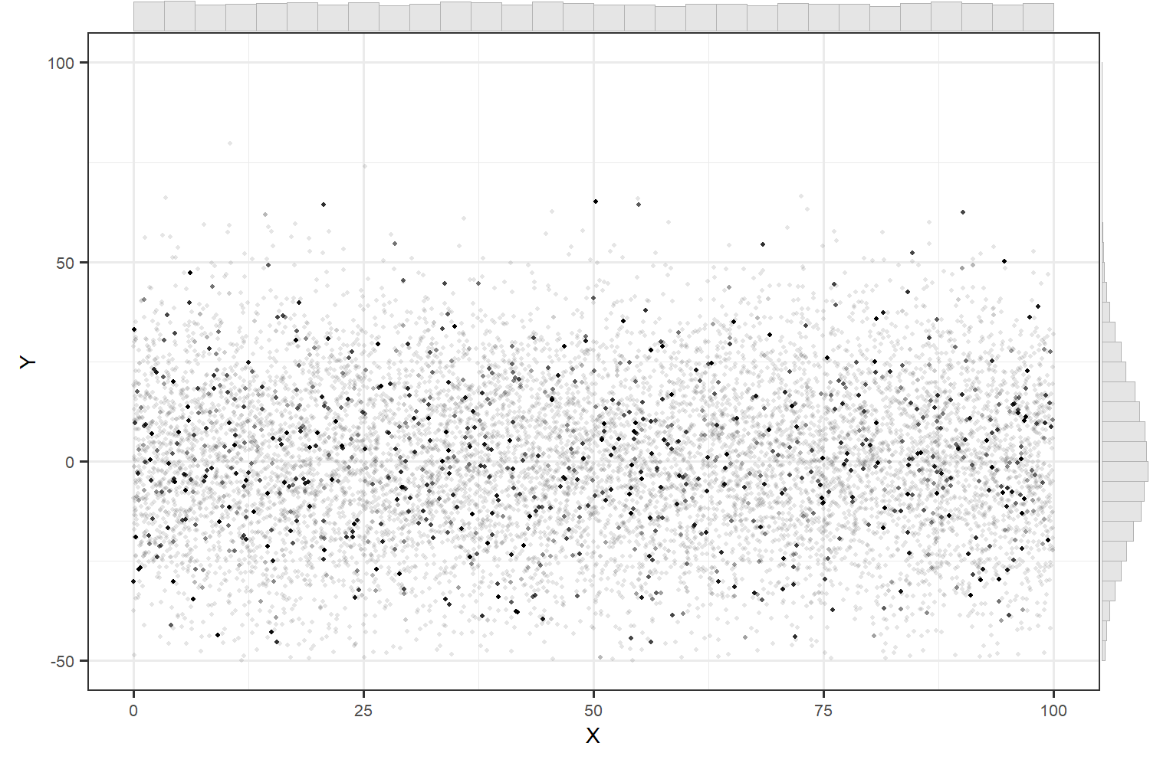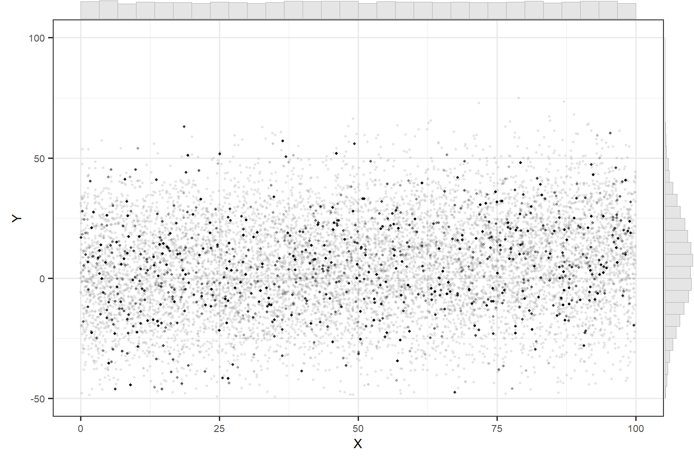
(b)
(a)
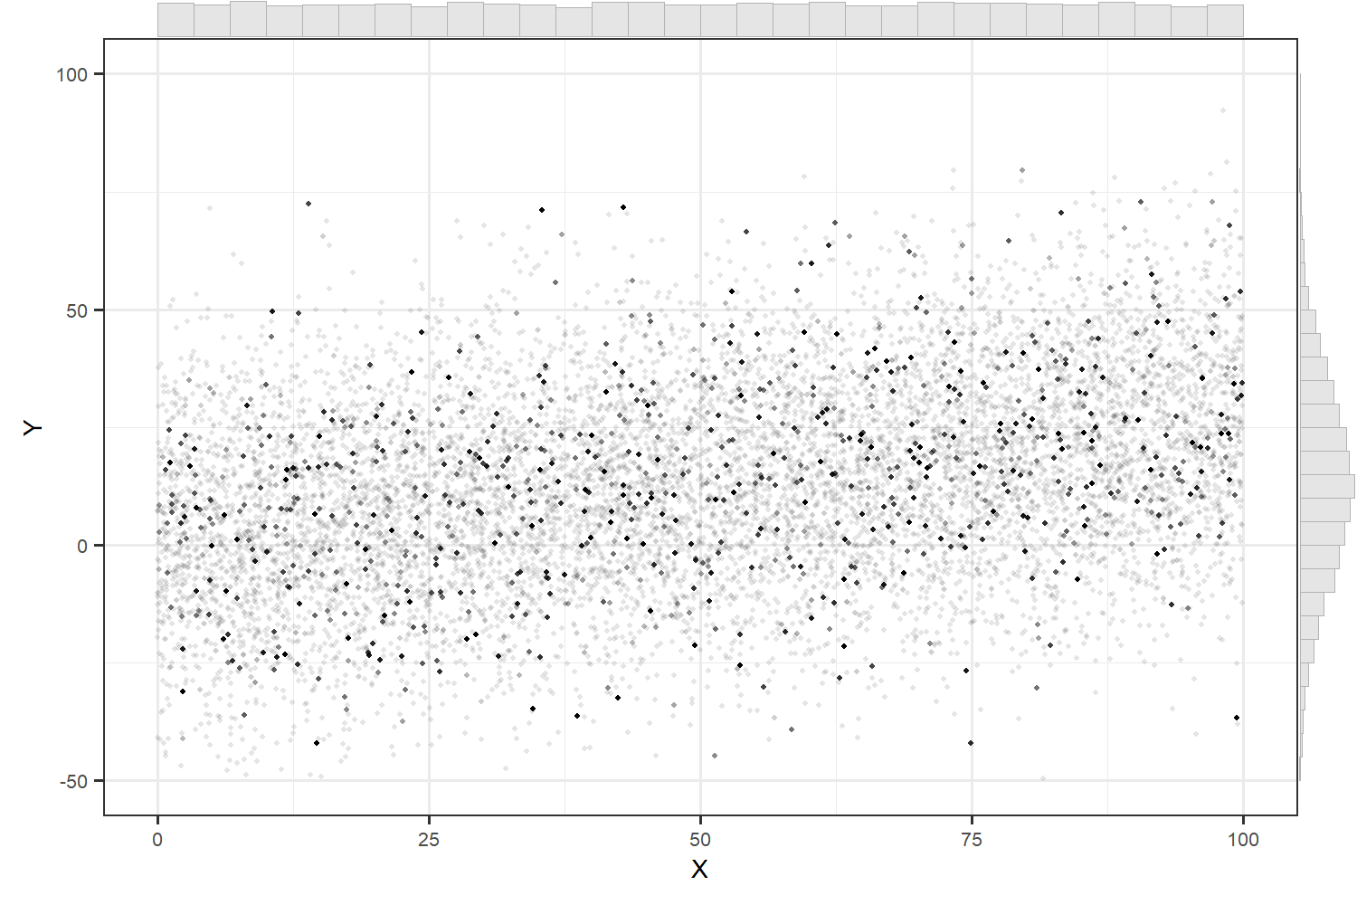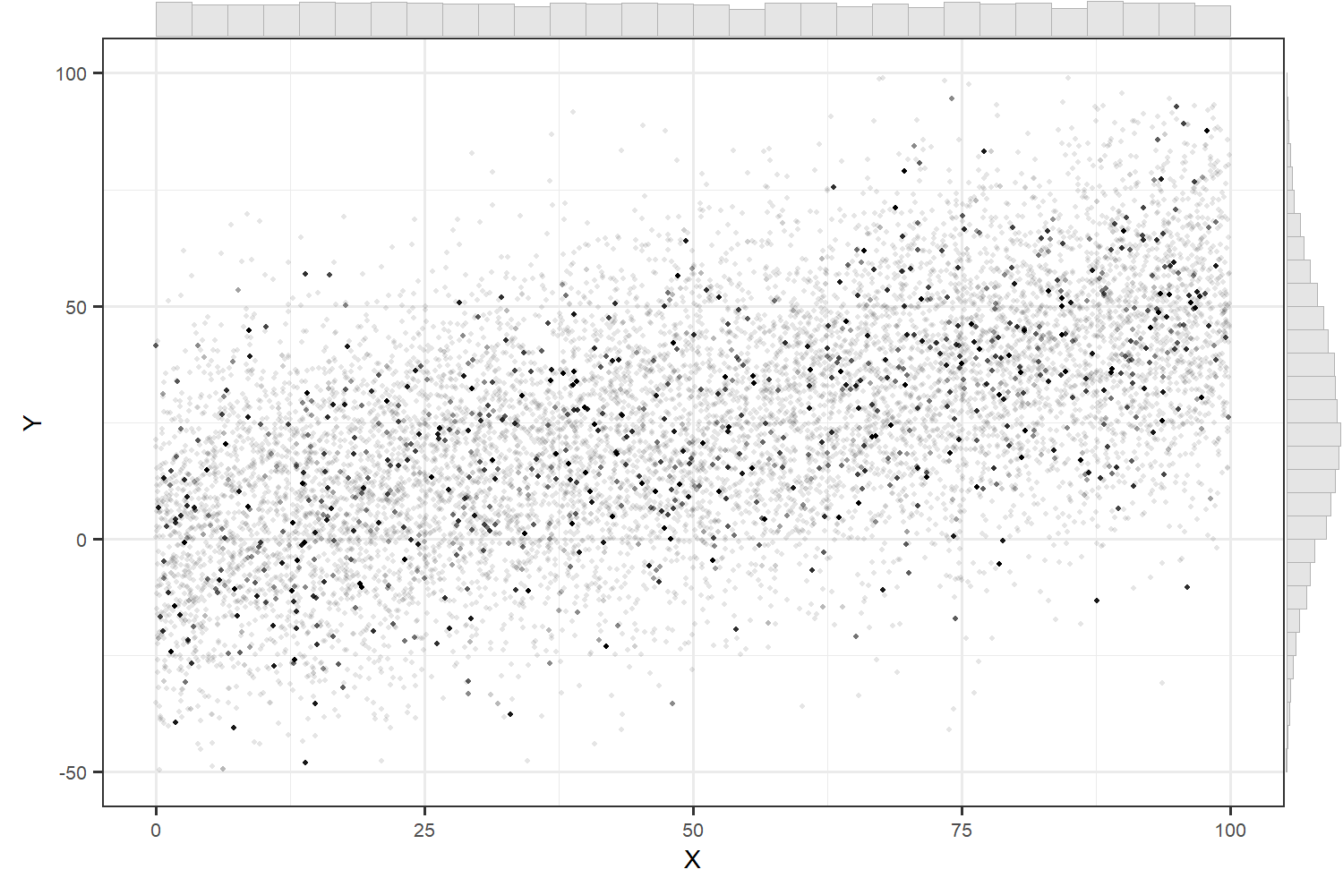
(d)
(c)
Figure 1. A visualization of the linear regression model as a model of the data stream. Prior to conducting a sample analysis, the linear regression model is a set of constraints (assumptions) within which there is a set of specific possibilities such as these. The data stream is a large or infinite number of possible data points from which we select sample data. Each panel contains a data stream that conforms to the linear regression model. In a trend detection context, the x-axis would be time and we typically test whether there is evidence to reject the null model (a) where no slope is present. Slopes of these data stream models are (a) 0, (b) 0.1, (c) 0.25 and (d) 0.5, and all have an intercept of 0. Residuals are drawn from a normal distribution with σ = 20.

Line fitting vs slope significance
It is useful to think of the application of linear regression as having two distinct parts. These two parts each represent a set of mathematical procedures, and the two parts are applied in sequence.

The first part is the line fitting. Given a set of x-y data, linear regression includes determination of the line that best fits the data according to OLS criteria. This line fitting by itself has no distributional assumptions with no concerns of statistical violations. We are free to fit a line to any x-y data.

The second part is where the assumptions come in. Here the data must conform to the linear regression model in order for the distributions of the model parameters to be known thereby making possible the unbiased estimation of statistical probabilities.

As we will see later, the separation of these two parts is useful because we then have the option to use just the line-fitting of linear regression and then rely on a different, e.g. non-parametric, method to determine the significance of the slope estimate.

Regression trend detection visualized with simulated data
Here we look at patterns in simulated data and in linear regression coefficients derived from simulated data. The data was generated to be fully compliant with the linear regression model as represented by the model assumptions. Figure 1 shows the data streams we will work with (x domain = [0,100], y standard deviation = 20, y-intercept = 0).

Trend detection is based on data collected over time. This data could be direct measurements or the data could be estimates derived from sample data. In either case the data stream is a set of possible values that each reflects different instances of random errors.

Trend estimates apply to specific time periods defined by the temporal range of the input data. Donner (1984) looks at how the distribution of data within that time period in the temporal dimension can directly affect the estimated linear regression coefficients (e.g., annual surveys vs some other temporal sampling scheme). We won’t consider these effects.

All linear regression results presented will reflect the use of annual surveys. This could be thought of as systematic sampling in the time dimension but in the case of nearshore vegetation this seems simplistic – the surveys are not intended to be representative of the entire year, but rather peak canopy conditions. An alternative would be to think of “peak” canopy as a periodic population that exists within a ~3 month period that we survey in a haphazard way in time (however the initial field schedule or flight plan was selected) with stickiness of timing across years (if we aim for proximal survey dates across years).

Residuals
When the data conforms to the linear regression model and the number of data points is high, the residual distribution is well-defined and recognizable as normal (the vertical marginal histogram of Figure 1a).

2-3 examples of low N=10 sample instances:
- sample pt graph/over muted stream
- residual freq. histogram
- residual time series
- QQ
- Shapiro Wilks result

Shapiro rate of non-normal
Power of Shapiro not assessed.

Slope significance test
- t Test – slope/trend connection, hypothesis logic, null model and get critical t
- slope estimates frequency histogram with accept/reject zones & t dist curve
- R lm output table / Python output table
- Confirm with simulations

Power
- Null and alternate t curves with zones as a concept
- Noncentral t power analysis
- Confirm with simulations

Sampling design considerations

repeated measures sampling – common but likely does not meet assumptions (Donner 1984). Repeated measures in a census situation is not repeated measures sampling situation.
repeated measures census
rotation

Data with Transients

Testing Multiple Data Subsets

Alternative Approaches to Trend
What do we want to get out of trend?
don’t care about linear
up or down (2nd order yeh, but start here)
longer term, not interannual noise
interested, even if some strong transient pattern dominates
Non-parametric slope test (permutation test)
Spearman
Kendall Tau

Exploration with Selected Nearshore Data
SVMP time series
COSTR time series
kelp kayak site time series

References
Donner, Allan. 1984. Linear regression analysis with repeated measurements. Journal of Chronic Diseases. 37(6):441-448. Abstract: https://www.sciencedirect.com/science/article/abs/pii/0021968184900274

Finch, W. Homes, Bolin, Jocelyn E. and Ken Kelley. 2019. Multilevel Modeling Using R, Second Edition. CRC Press New York.

Appendix A – Effect of periodic sampling on decadal mean estimates

