**CS5590BD BIG DATA ANALYTICS**

**INCREMENT -1 PROJECT REPORT**

**Group 8 Team:**

Sindhu Koneru

Sujitha Onteru

Prathyusha Dinne

Anudeep Vattipalli

Roopesh Utukuri

**PROJECT GOAL AND OBJECTIVES**

***INTRODUCTION:***

Best bud is a mobile app that provides its user quick feed on their workout statistics through interactive graphs, calorie burn meter, work out pro levels and many more. It provides them the essential joy in working out by earning themselves awards and to also challenge others. By allowing other user to join in their workouts sessions, users will be able to compare with each other thus creating a competitive environment and give them the essential boost to do more.

Other than the above mentioned features, we are including some more additional functionality into our app. User will be able to provide their GPS location and using it, app will prompt happening events in and around user’s current location.

As we are still in the process of requirement gathering and playing around with sensor, if we can find any other useful feature, we will try to implement it into it.

***OBJECTIVES:***

Best bud’s main objective is to provide its user’s a continuous update on their fitness levels. It is a natural habit for people to easily give up on one’s fitness but with our app it makes its users connected and become fitter and healthier day by day. It also helps its user to constantly increase their fitness levels interactively and challenge other group users and grow collectively.

***SIGNIFICANCE:***

Our app keeps collecting data from user’s workout (jogging, running and walking) activities and prompts details of it to encourage the user to do more. It keeps people close to him always connected and help them shape themselves to become more healthy and fit.

**ACTIVITY RECOGNITION SCENARIO AND DATA COLLECTION**

Devices/Sensors being used:

**1) Sensor Tag:**

It is an excellent development kit when used along with a smart phone. It is an inspiring design for various other accessories of the smart phone. It is very useful to the smart phone app developers.It has the sensors for magnetometer, pressure, gyroscope, humidity, accelerometer, temperature. In total 6 sensors available.

**2) Chronos Watch:**

It is a profound integrated device with a wireless development system. It has a motion sensitive control accelerometer and a pressure sensor along with LCD display .It is a wireless system which is hub by surrounded wireless sensors. We can reprogram it as we want by disassembling it.

**3) Android Device:**

To connect the sensor tag we need an android device which has 4.3 or above OS.And it should have Bluetooth 4.0 compatible android device.

**Data Collection:**

We use Apache Hbase to access our data. We first collect the data .We record it into a file. We will read the file and push data to Apache HBase. We use a java program to read local file and push data to hbase.

**DESGIN OF MOBILE CLIENT**

Below is the screenshot of home page in our app. User needs to login with his credentials for logging in and to check his details.

***FEATURES:***

**Event Finder:** We have included this functionality to track users GPS location through the sensor tag. Using this, we will be looking for happening events in and around his location and prompt the user. Additionally, we will include user to mark his event so as to store the event in the DB and remind him before the event and notify him just like an alarm.

**Work Stats:** Using the sensor tag, while workout (running, jogging and walking) we will keep tracking user location continuously by tracking through GPS and store the data. In the backend we will process all this data and use them to calculate calories burnt in a session. We will be keeping all this data for a week or month and plot graphs using amount of calories burnt per each day over a week or month. And also, user can compare with other users he/she is connected to and look into performance levels of each user. Apart from this, all the group user details are collected including the phone numbers. So when a user needs to talk to one of the group member while looking at quick work stats, he just need to click on call button right from the app instead of going out of the app and searching for them in the contact list

**Awards:** As previously said, users will be able to join groups with few members and constantly keep an eye over their calories burnt in regular session. As all the group users data is collected, every week/month, an award or a medal of honor will be presented to the best performer. This keeps the users much more excited about their fitness and makes them to strive more in building themselves stronger, fitter and healthier.

**Videos:**  We have a section in best bud where we include motivational and training videos pertaining to their workout. Users can view apps on the go.

**Game:** Apart from the above mentioned features, we have decided to make our application more interesting by including a game which captures user’s movement to control the game using a sensor tag. This is one additional feature which makes our app more reachable to users.

**Weather:** By gathering users GPS coordinates, we will be prompting the user of weather conditions in his location. This way when going out for a workout, if the weather does not suite for work out scenarios, user can be aware of it.

**Friends:** This feature is provided to add, delete users into existing groups.

***TECHNOLOGIES USED:***

* HBase Database
* Java
* Android Platform
* Hadoop & Cloudera

**SCREEN SHOTS:**

***HOME PAGE:***



***LOGIN PAGE:***

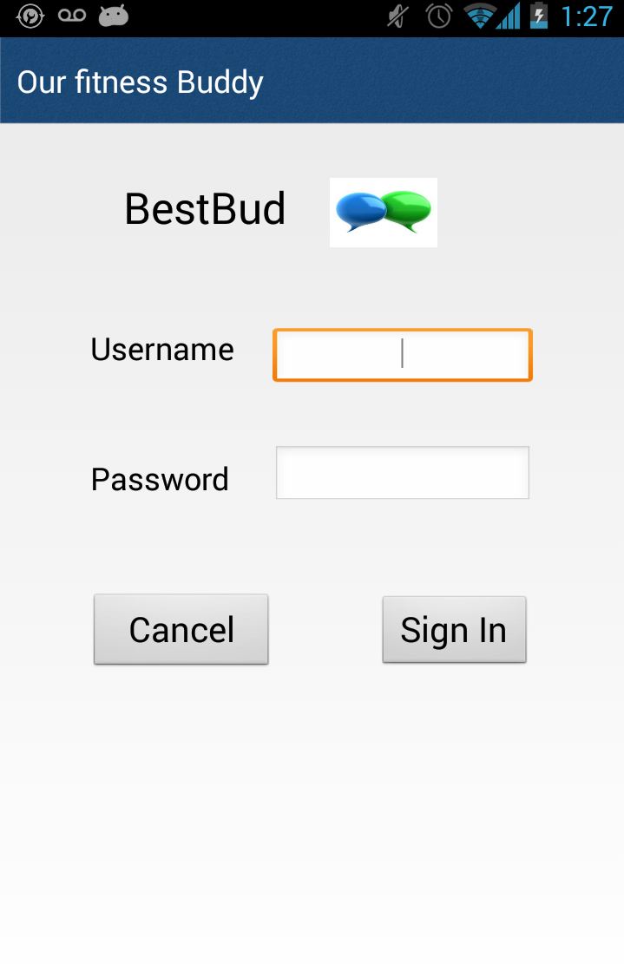

**FEATURES INCLUDED IN OUR APP:**

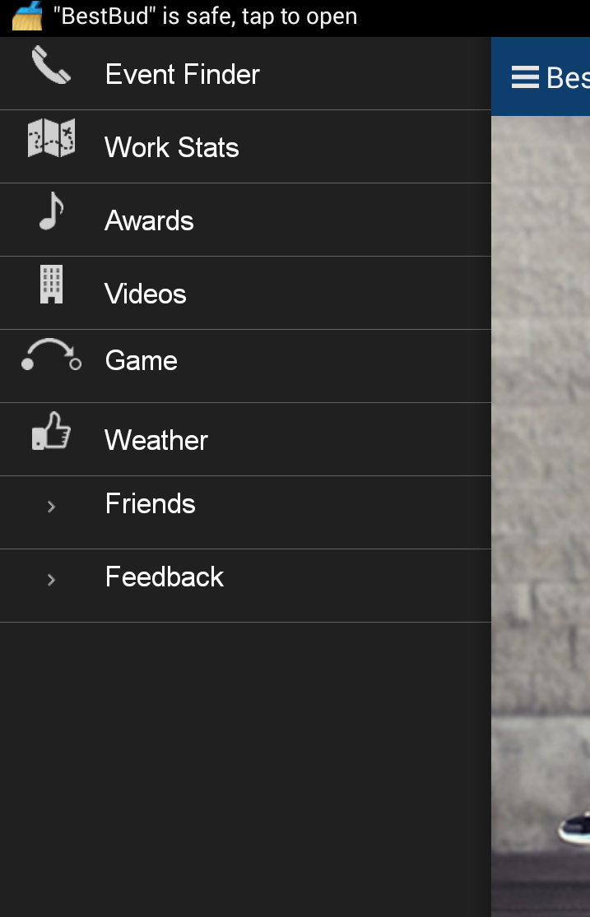

**PROJECT PLANNING WITH SCRUMDO:**



