**CS551 ASE - LAB 1 ASSIGNMENT**

**Name: Prathyusha Dinne Student ID: 16161128**

**1)**

**UML Class Diagram for Home Security System:**

User can either be an owner or operator where both uses keypad to enter the security code, set corresponding threshold and delay values for alarm. Entry, smoke, temperature and flood sensors inherit Sensor class. The output of controller when intruder tries to open the door, will generate alarm, calls owner and displays message on panel. User holds attributes like name, id and each sensor have unique identity code attribute. Output class have state attribute to know the status of the alarm and digital display panel.



**UML Sequence Diagram for Home Security System:**

Operator switches the system on by entering the security code. Upon entry of intruder, the alarm triggers and owner gets a call. Upon activation of all sensors, operator would then enter the security code to switch off the system. Owner has the right to set threshold limit, delays for alarms and also can program phone numbers in order to receive phone calls.

2) **GitHub Account Creation:**

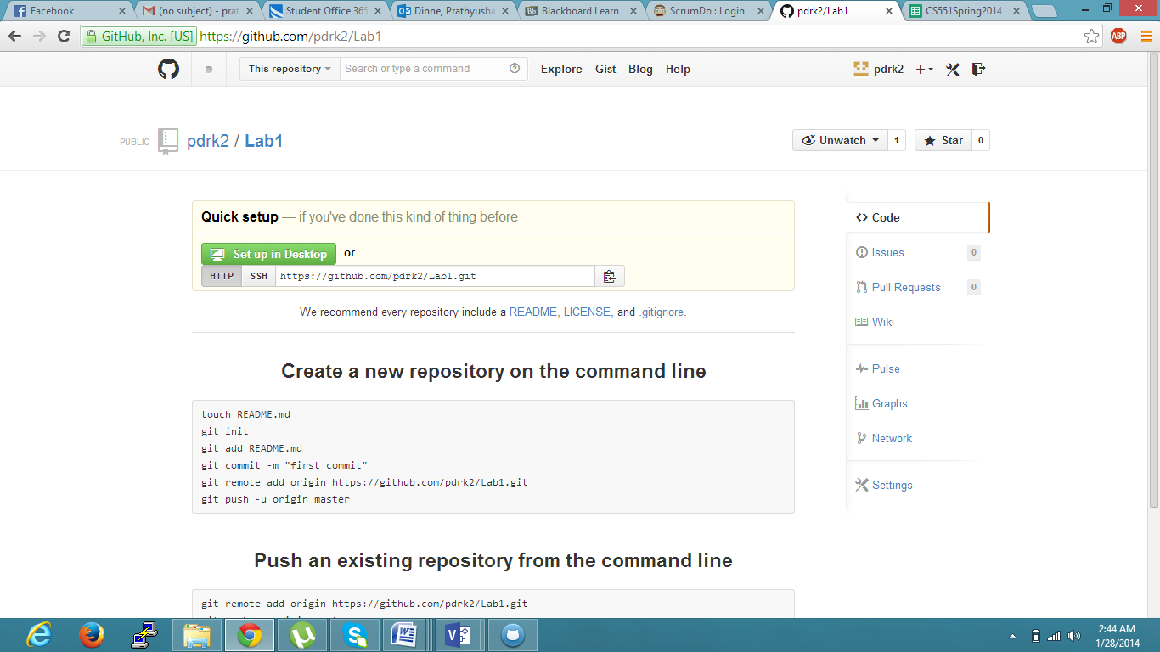

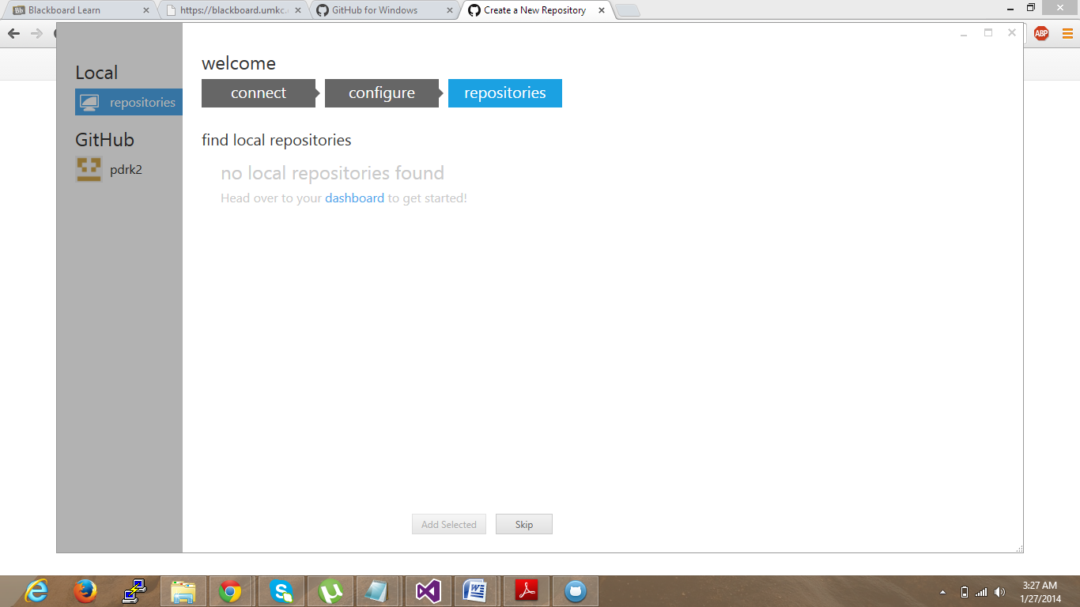

3) **SrumDo Account Creation and Task/Plan/Delivery for Lab1 assignment:**

