**Task 2 – Couldera Installation and Wordcount Execution**

**Name: Prathyusha Dinne (16161128)**

**Cloudera Installation**



**Login Page:**

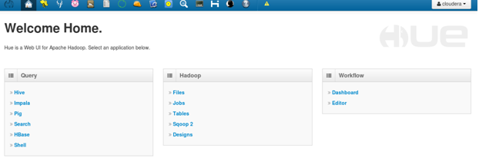

**Cloudera Manager Login Page:**

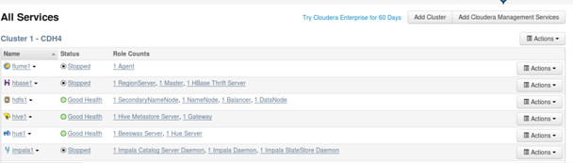

**WordCount – Mapreduce Execution:**

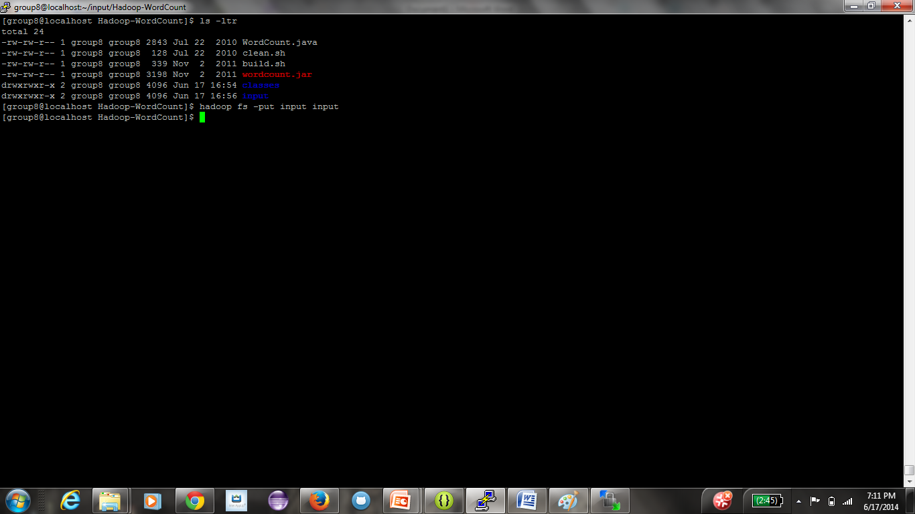

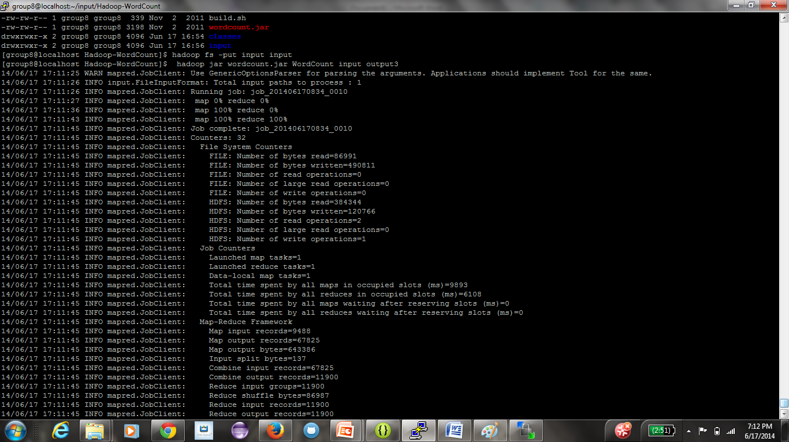

**Output of Wordcount:**

