**CS551 – ADVANCED SOFTWARE ENGINEERING**

**LAB 2 ASSIGNMENT**

**Name:** Prathyusha Dinne **Student ID:** 16161128

* Please find below link for Mobile Web Client Application using Javascript, HTML, CSS and jQuery Mobile.

[**http://jsfiddle.net/KR5Q5/113/**](http://jsfiddle.net/KR5Q5/113/)

* I have designed a mobile application for organizing an event where in user has the option to select particular venue, catering, theme and photography of the events.
* The user can check the route and weather of the event location before planning to avoid any inconvenience.

Please find below screenshots of my mobile application:

* Below is the home page of event organizer mobile application.

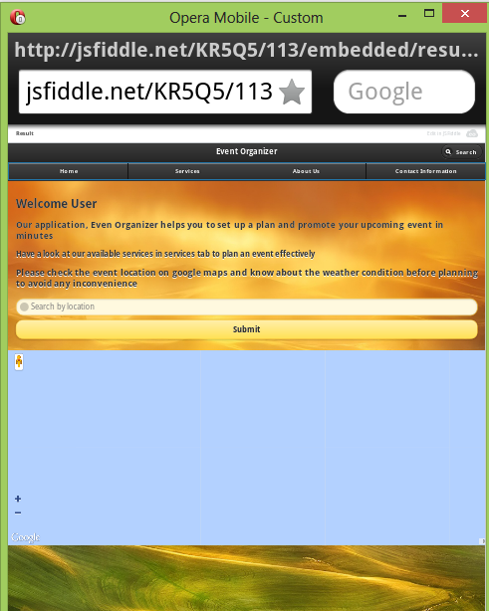

* Checking the place and weather of event location on google maps using the search bar provided on home page.

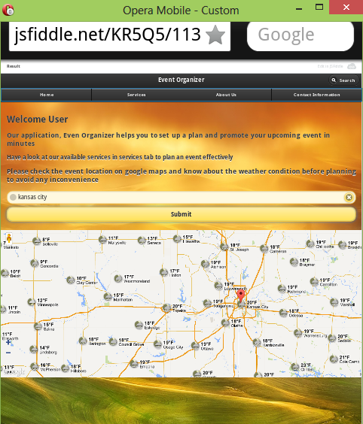

* Users are provided the services to select venue, decorations, photographer and catering as per their wish. These options were provided in services tab.

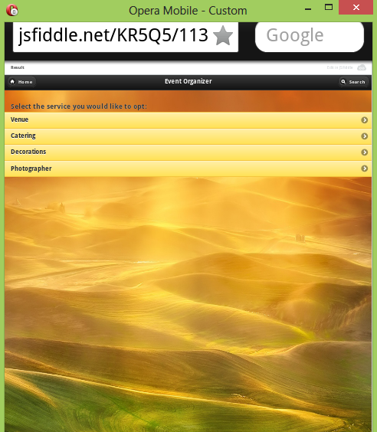

* Clicking on Venue button in services tab, all the top venues were listed. User can select required venue and opt for the number of guests option to place order. User can also find the place of venue on google maps.

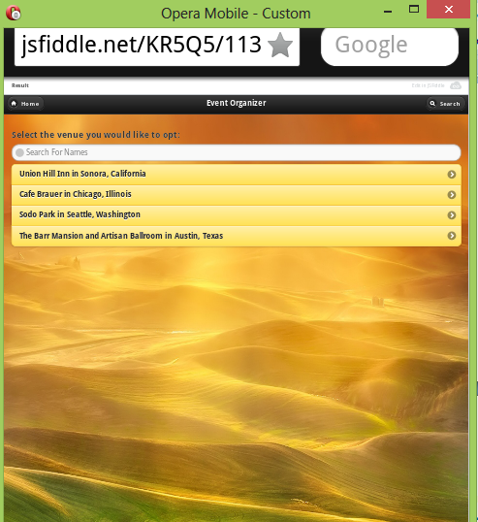

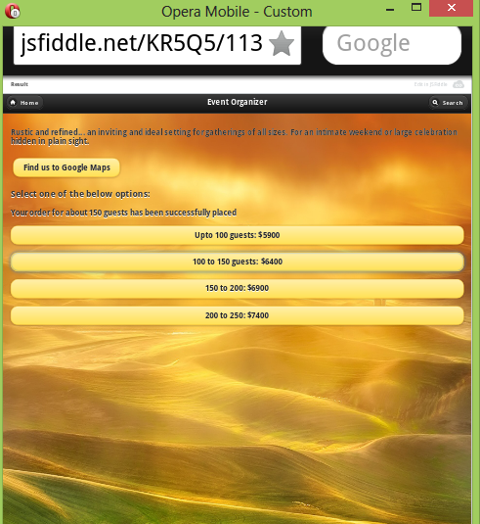

Venue location on google maps:

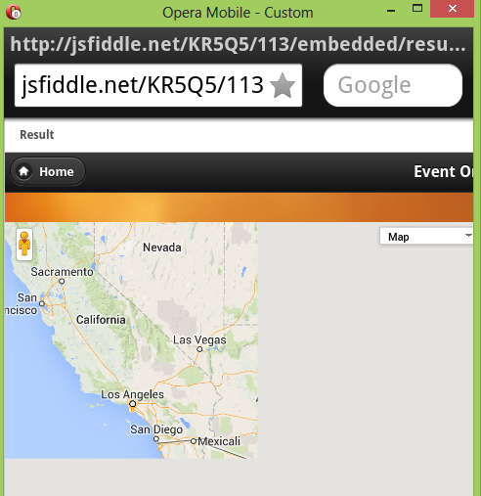

* User has the option to select best caterers and place the order.

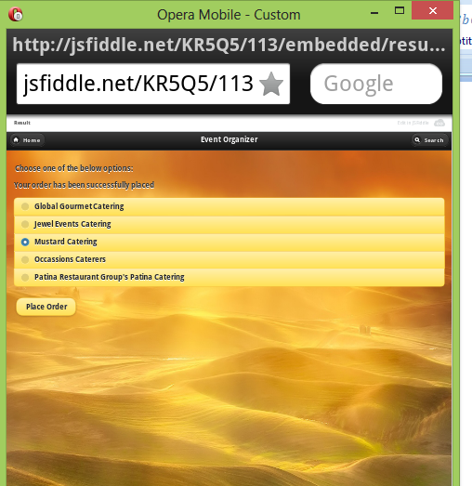

* User has the option to select the decorative items to decorate their event depending on their interest.

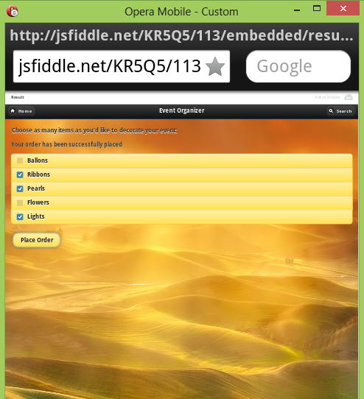

* User has the option to choose if he wants the photographer to be offered by our event organization.

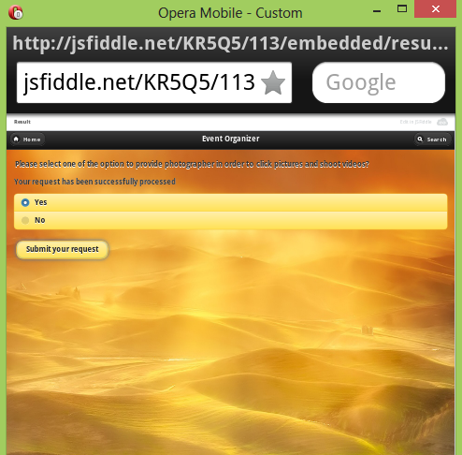

* You can get more information about our organizer in “about us” tab on our website.

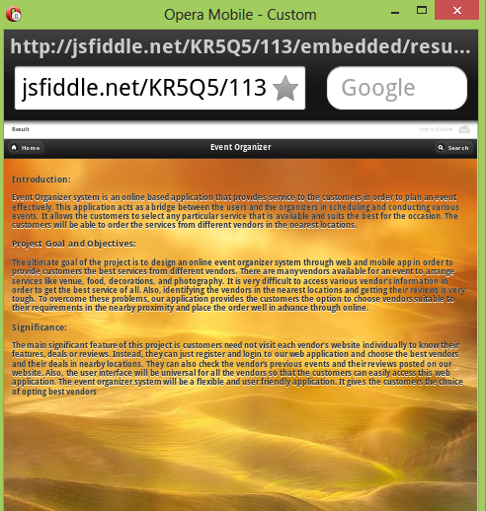

* User can contact us at any time. The required information is provided in contact information tab on our website.

