**CS5590BD – BIG DATA ANALYTICS**

**LAB2**

**Name:** Prathyusha Dinne (16161128)

**Task1:**

The current code was changed and four types of information like time, GPS, acceleration and gyroscope values were recorded. The code was also modified in order to get pressure and humidity values.

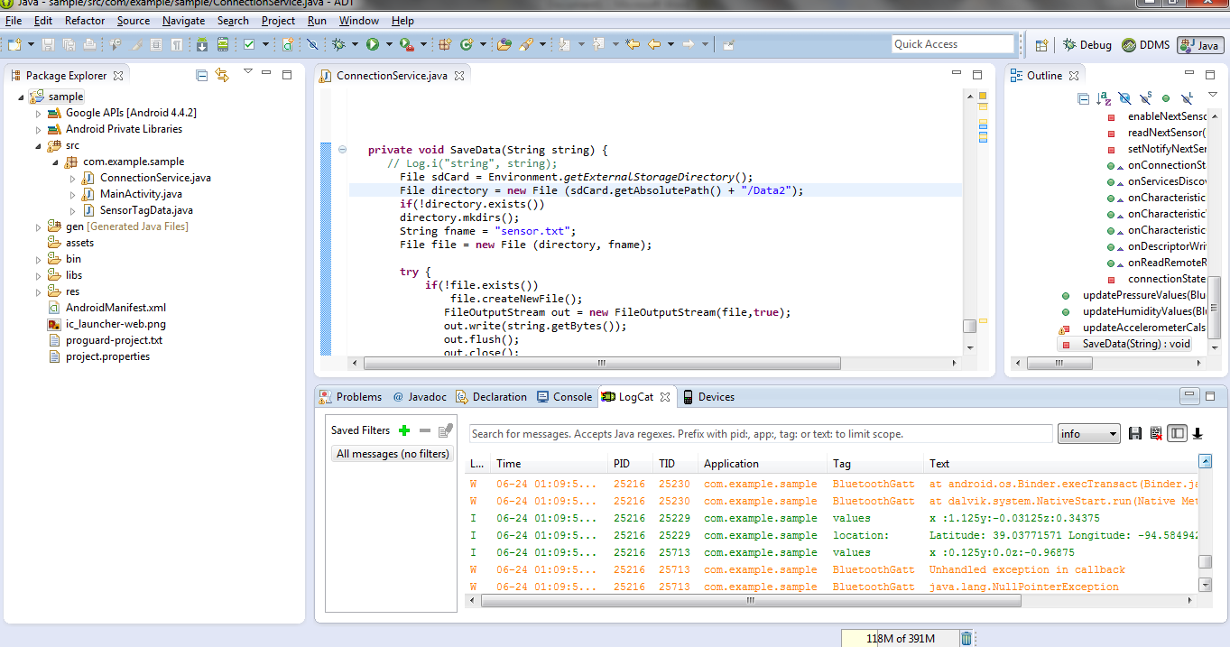

The text file was stored in location DATA2 in astro file manager on android device.

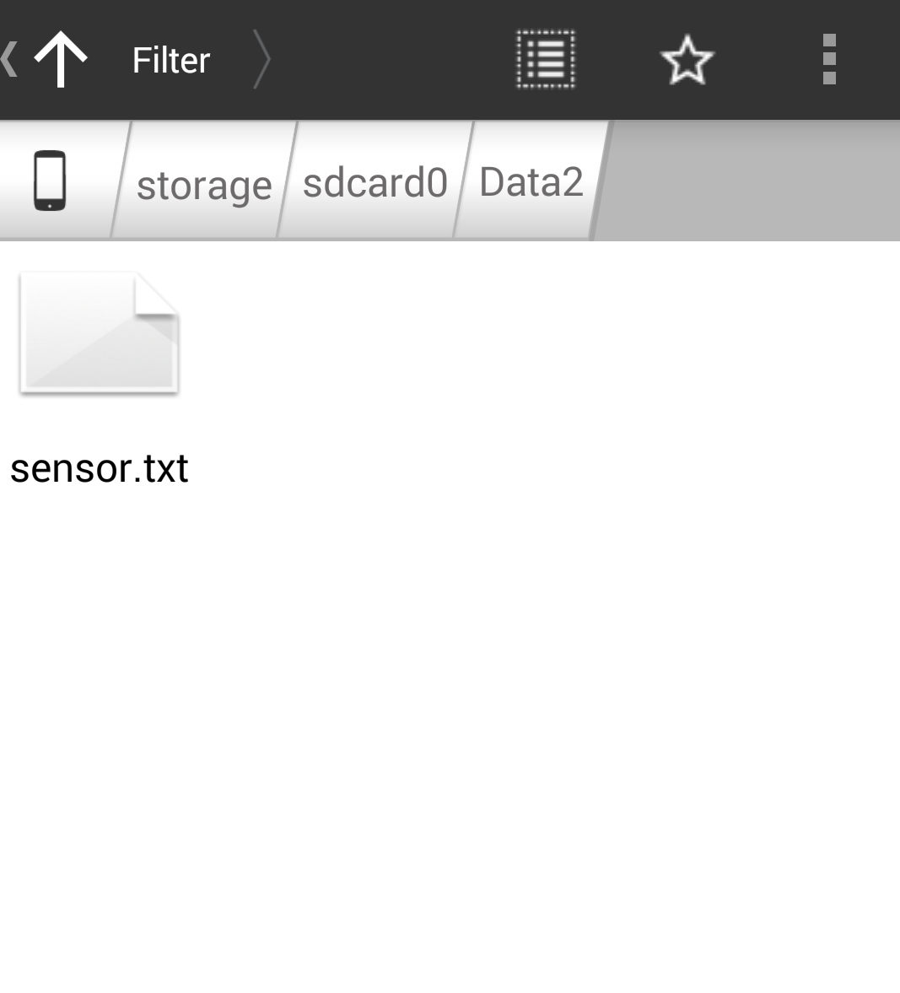

1. The first two boxes represent latitude and longitude values which are GPS readings.
2. The next box represents the Time stamp value.
3. The next 3 boxes represent the acceleration readings.
4. The next 3 boxes represent the gyroscope values.

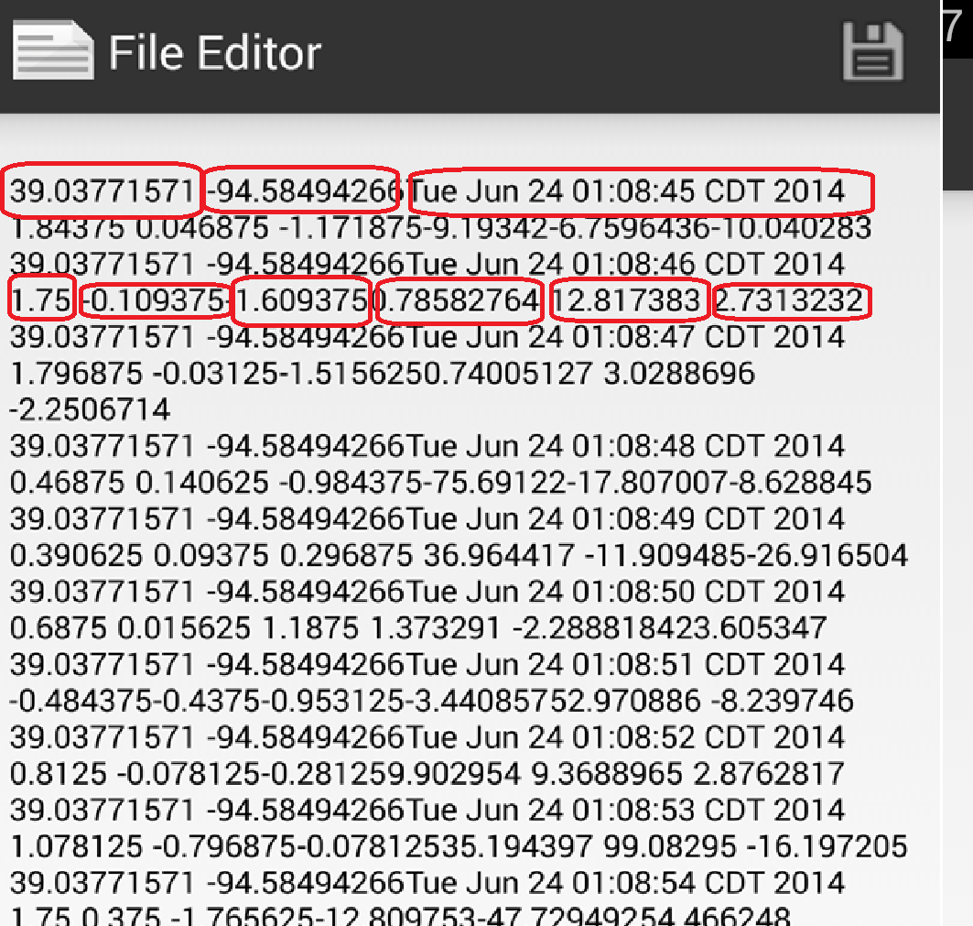

**Task2:**

**HBASE CLIENT APPLICATION:**

I have created table called “SensortagTable-888”

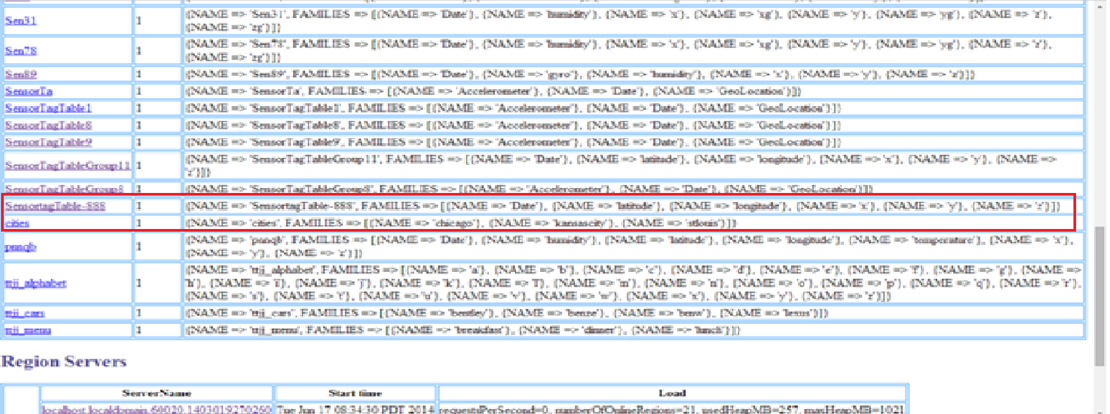

The data is inserted into the table. The number of requests increase as in the data is inserted.

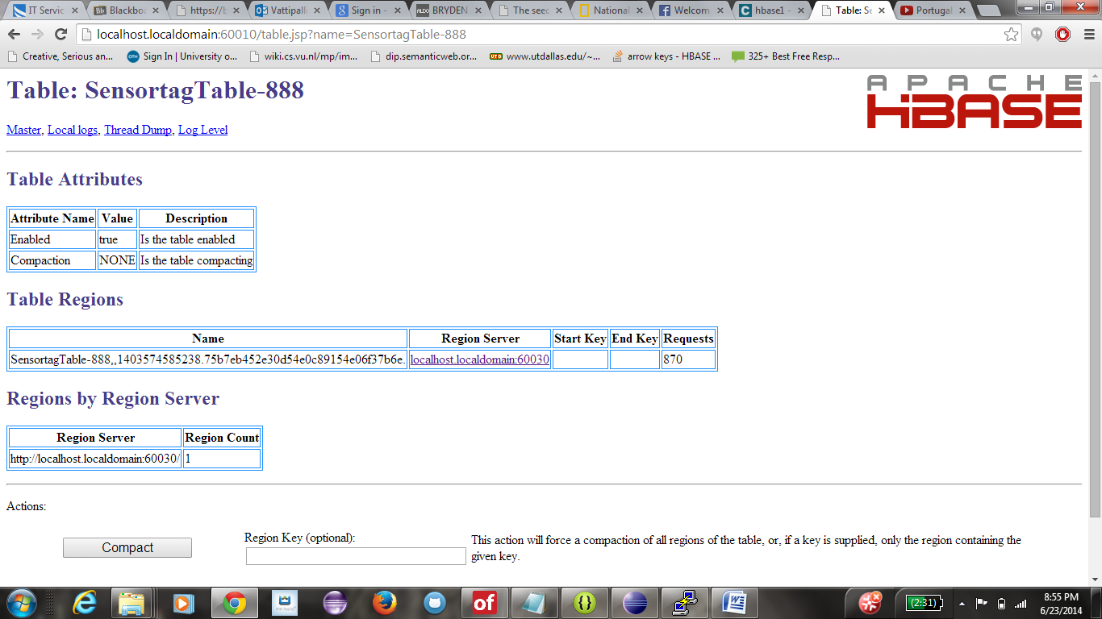

The values from the text file are displayed in the console.

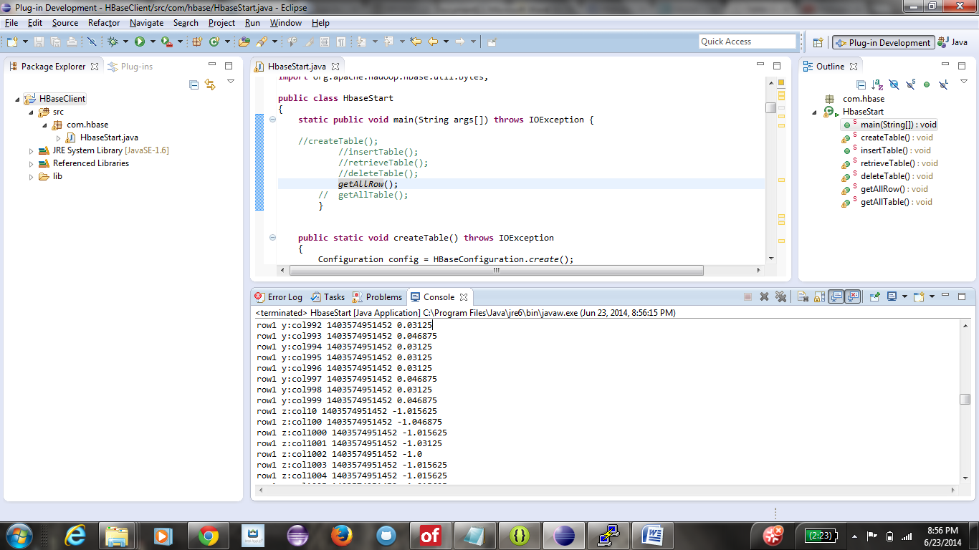

The table is deleted upon executing the delete table command.

