**CS5590BD – BIG DATA ANALYTICS**

**LAB3 REPORT**

**Name:** Prathyusha Dinne (16161128)

**Sensor Data Collection:**

The have collected the Accelerometer, geo location and date values to a sensor.txt file.

Accelerometer data:

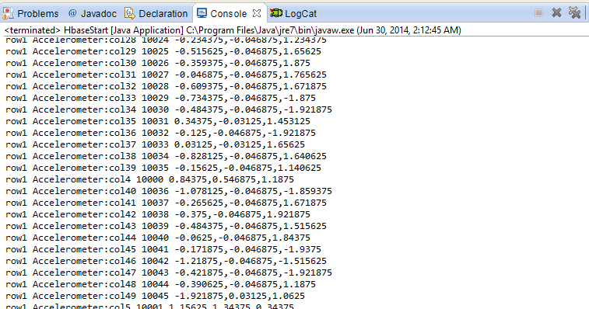

Date data:

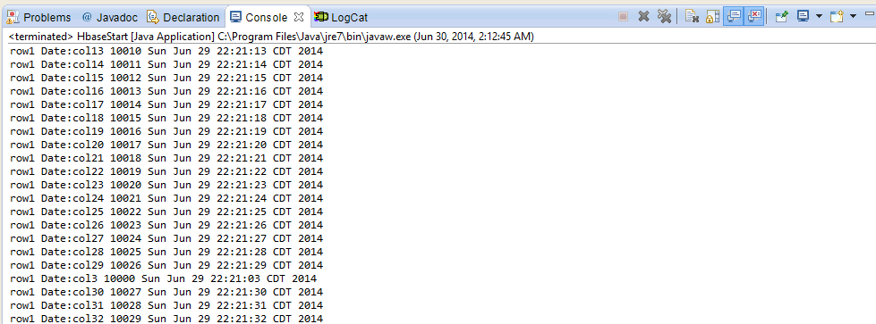

Geolocation data:

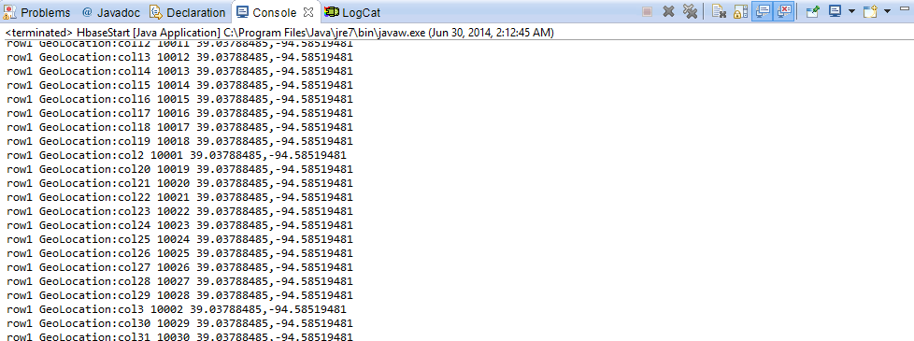

**File transfer using web services:**

ConnectSSH was ran to transfer file from local D drive to cloudera.

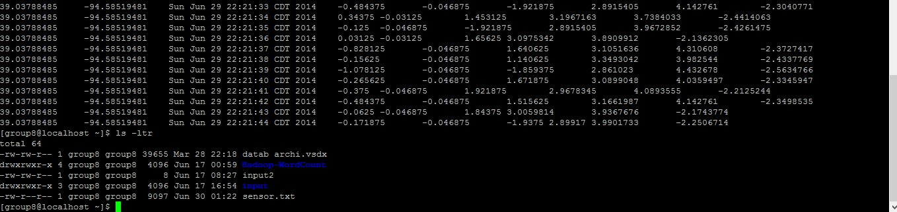

**Glassfish Installation and Deployment**

The glassfish was installed on system and started.

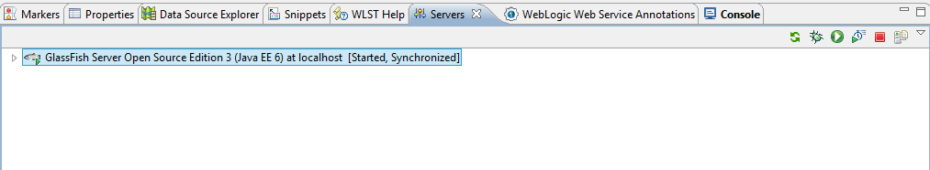

The HbaseWS file was imported and run on server to test if it works fine without any errors. If no errors, sample hello world will be displayed as below.

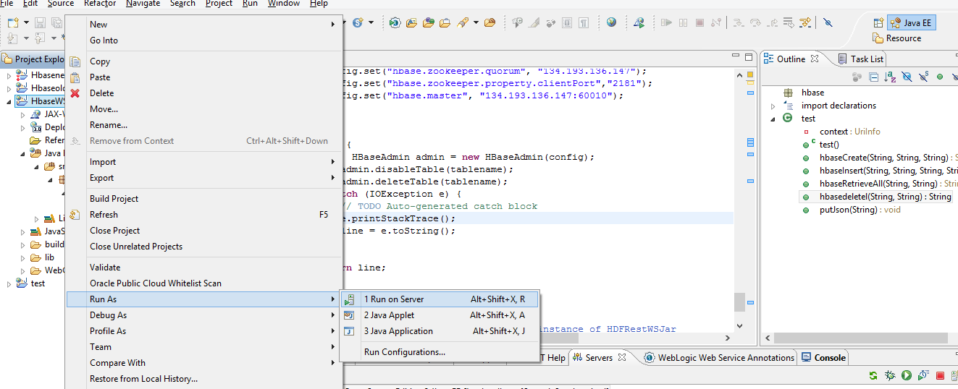

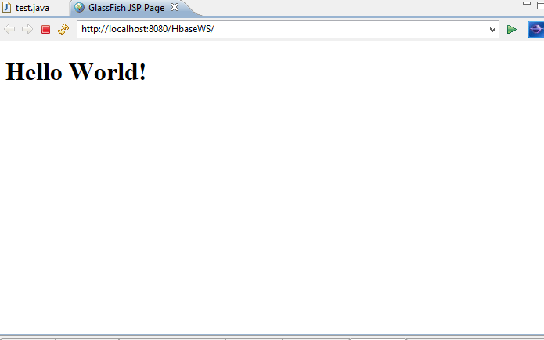

Then WAR file is then exported and saved on local disk.

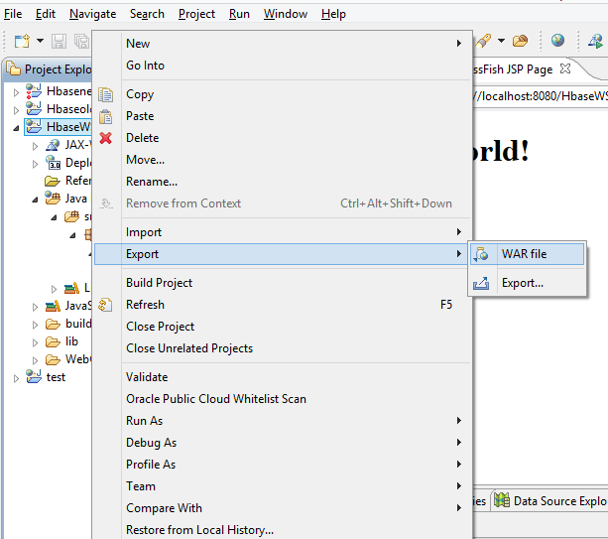

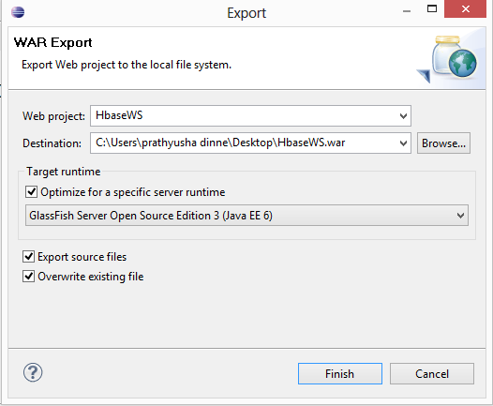

On 134.193.136.147:4848, the WAR file is deployed as below and launched.

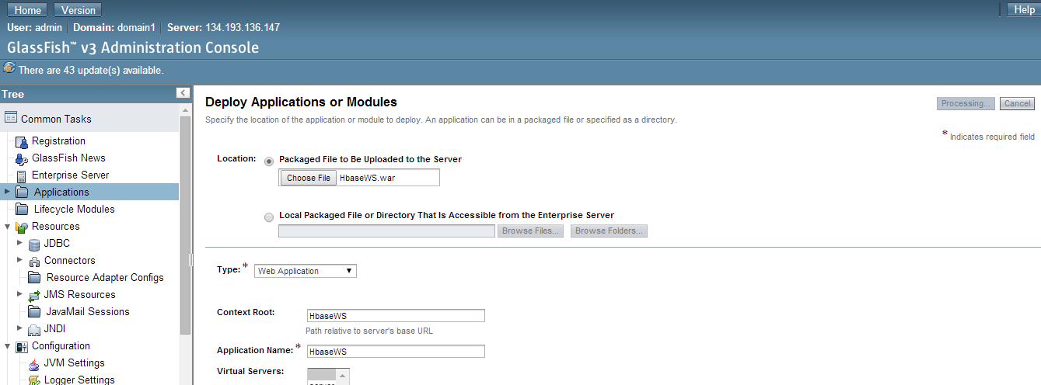

If launched correctly, the Hello world is displayed.

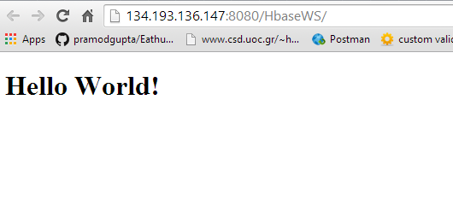

**Hbase CRUD Operations:**

**Creation of table:**

After successful launch, below URL is used to create “pdtable” with column families Geolocation, Date and Accelerometer. After successful creation of table, “Create success” is displayed.

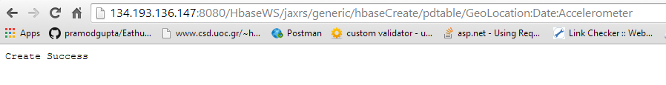

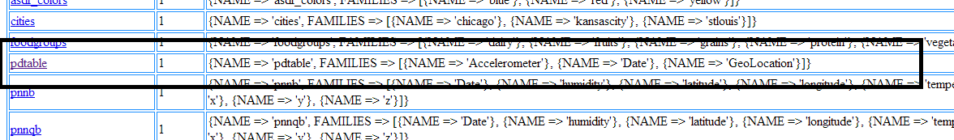



**Insertion of table:**

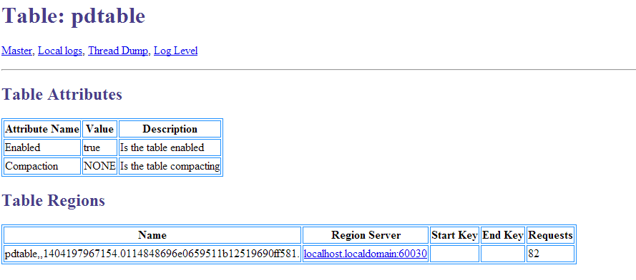

**Data retrieval:**

Data is retrieved using below URL. Therefore, accelerometer, geolocation and date values are displayed.

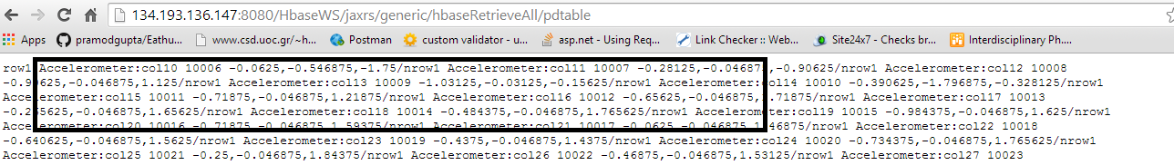

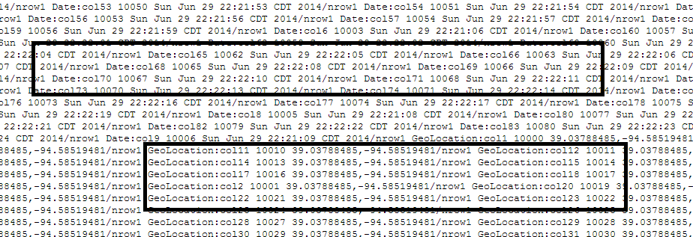

**Deletion of table:**

“Delete success” message displayed after successful deletion of table using below URL.



Table creation in console:

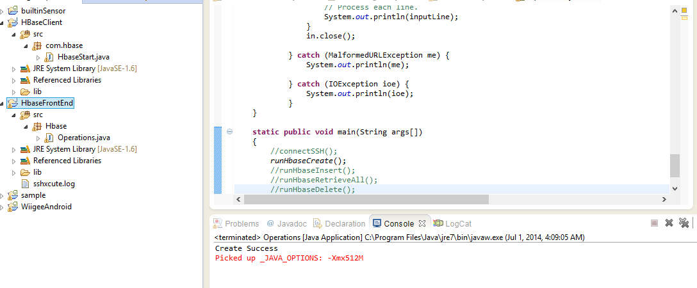

Table deletion in console:

