**CS551 – ADVANCED SOFTWARE ENGINEERING**

**ASSIGNMENT - LAB - 4**

**Name:** Prathyusha Dinne **Student ID:** 16161128

**Implementation of SOAP Web Service on Android:**

A SOAP web service was created to get the city, state and miles where in we give zip code as the input.

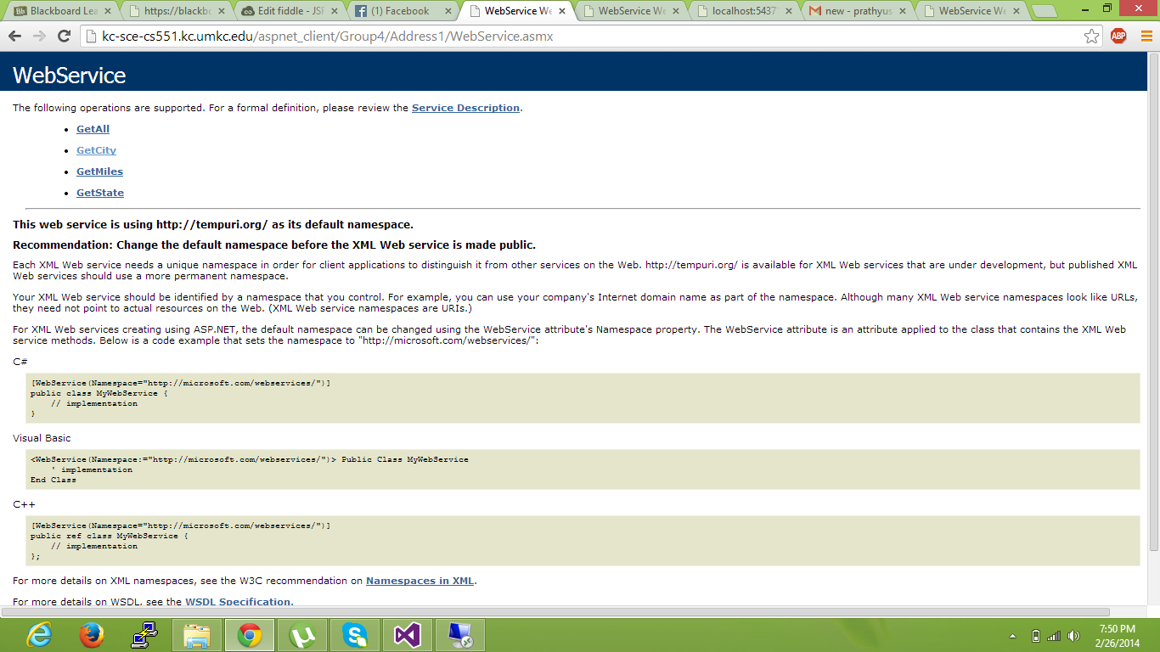

On clicking Get City, we will be asked to enter zip code. Upon giving 64112 as input in zip code text box, the city name is displayed.

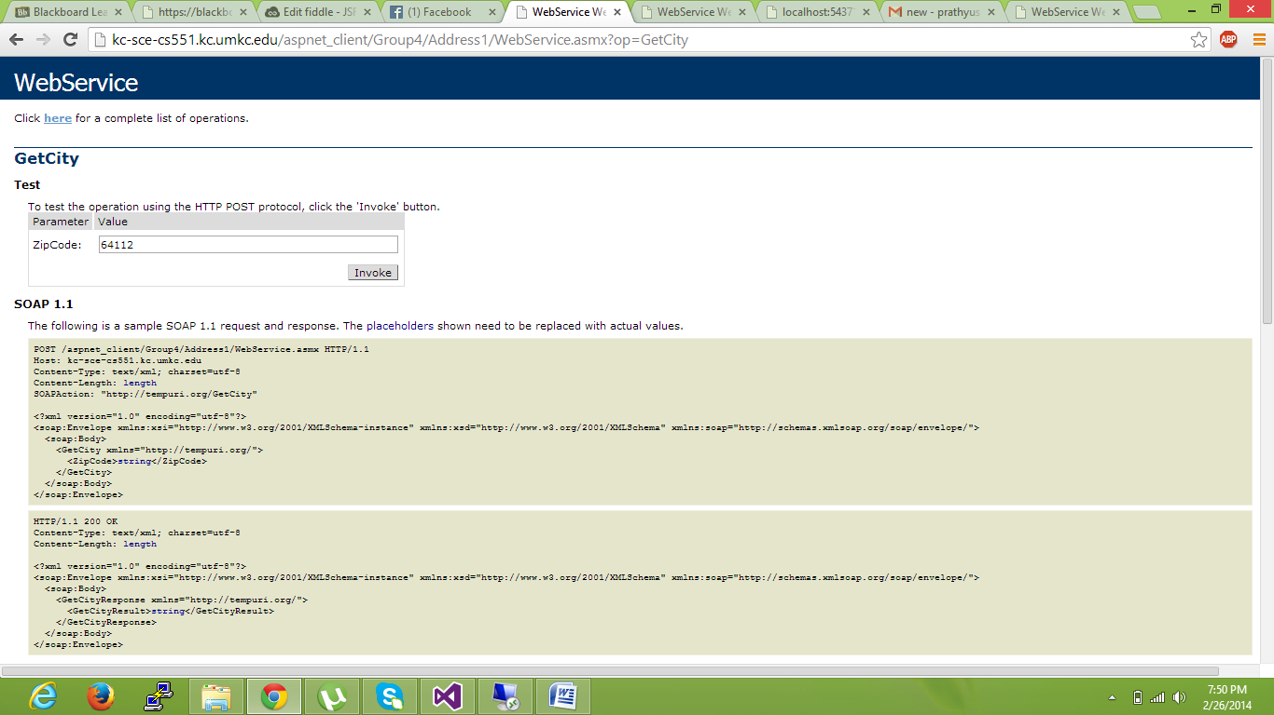

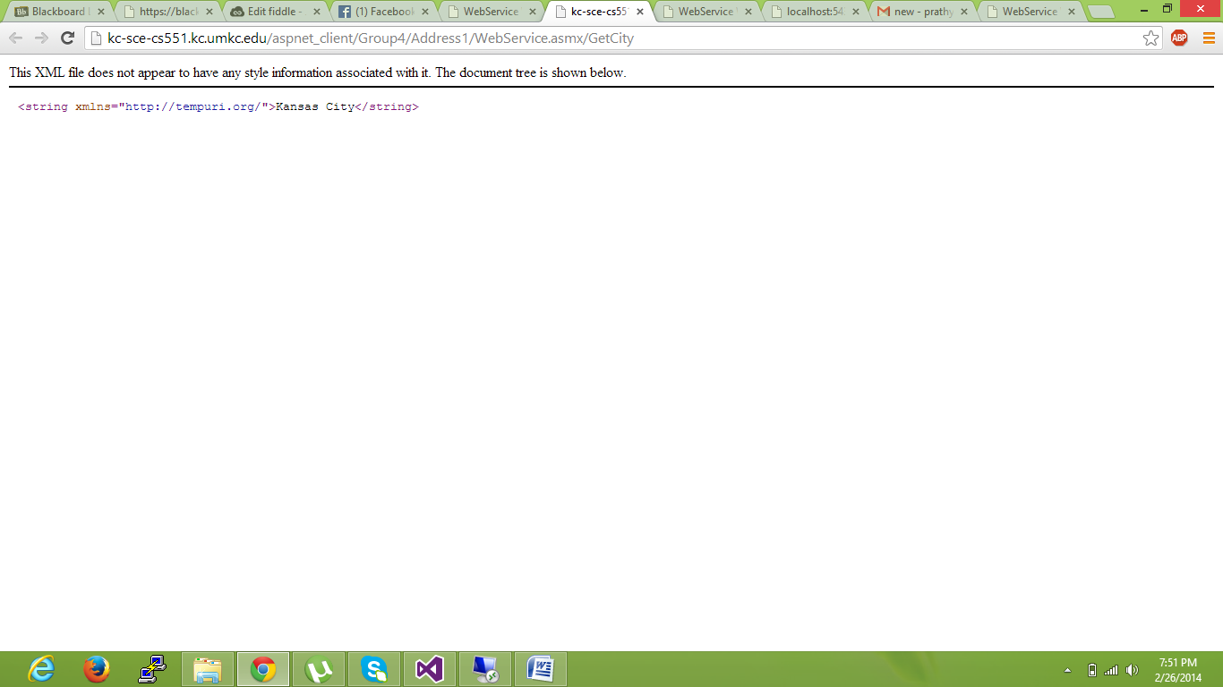

Similarly, state and miles are displayed upon giving zip code as the input.

We use this soap web service in android to retrieve the values of the given zip code. Below is the screenshot of Android emulator which displays the city corresponding to given zip code. The code to parse soap web service is given below:

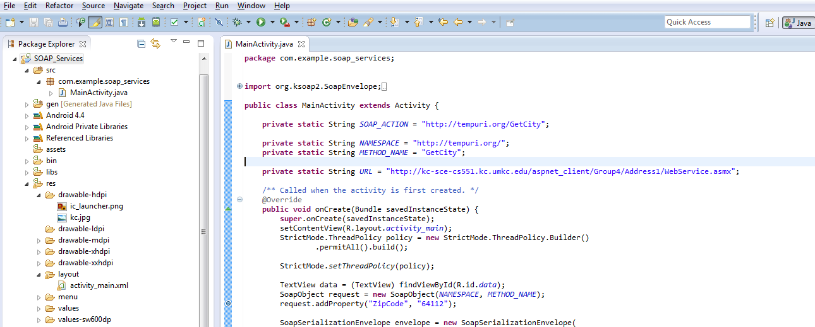

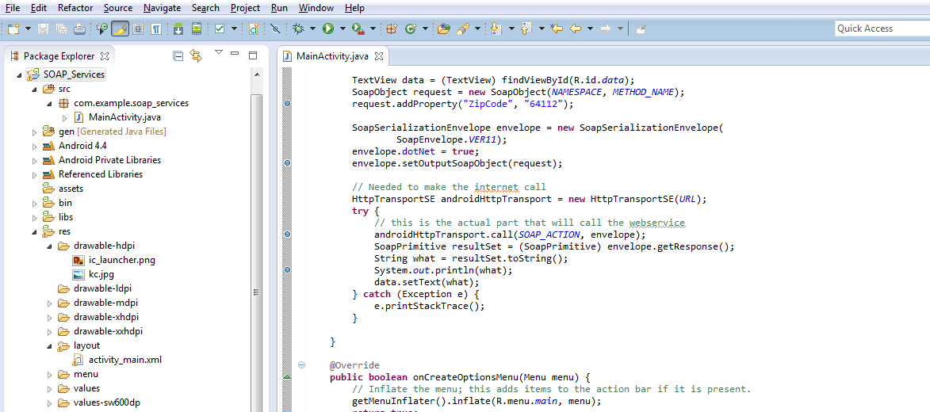

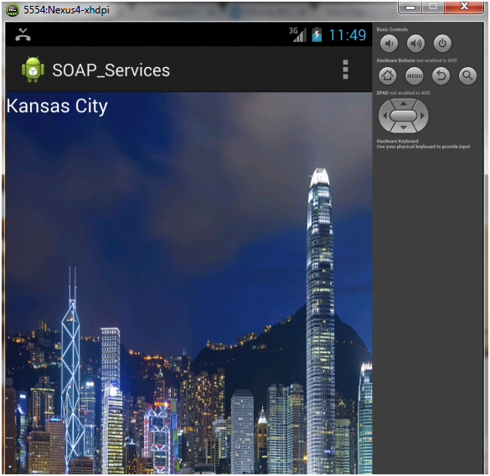

**Implementation of SOAP Web services to insert, retrieve and delete data from database:**

Soap web service was implemented with local database to add and delete the vendors. Also we can get all the information of vendors.

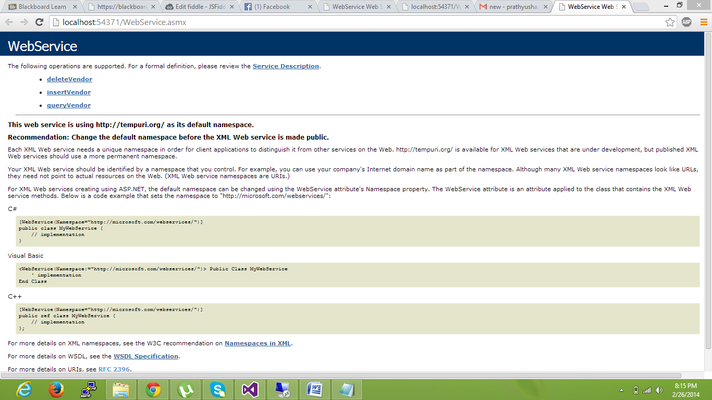

Upon clicking the insert vendor option, id and password text boxes were displayed. Giving the id and password on this web page, the vendor details were stored in database and success message displayed.

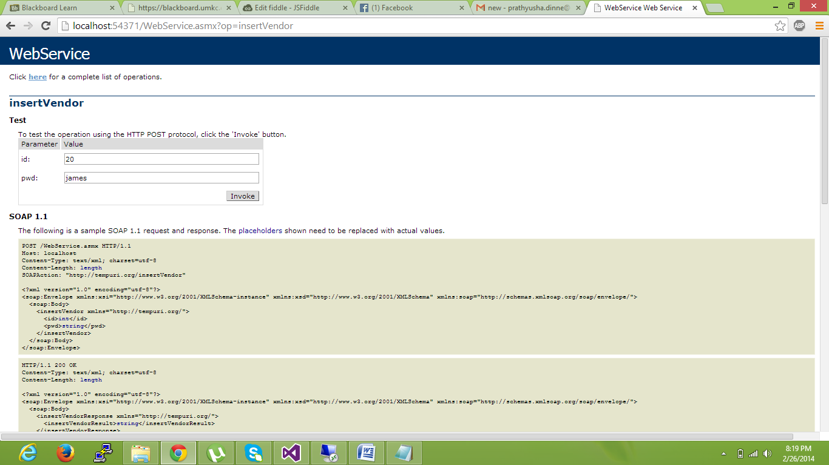

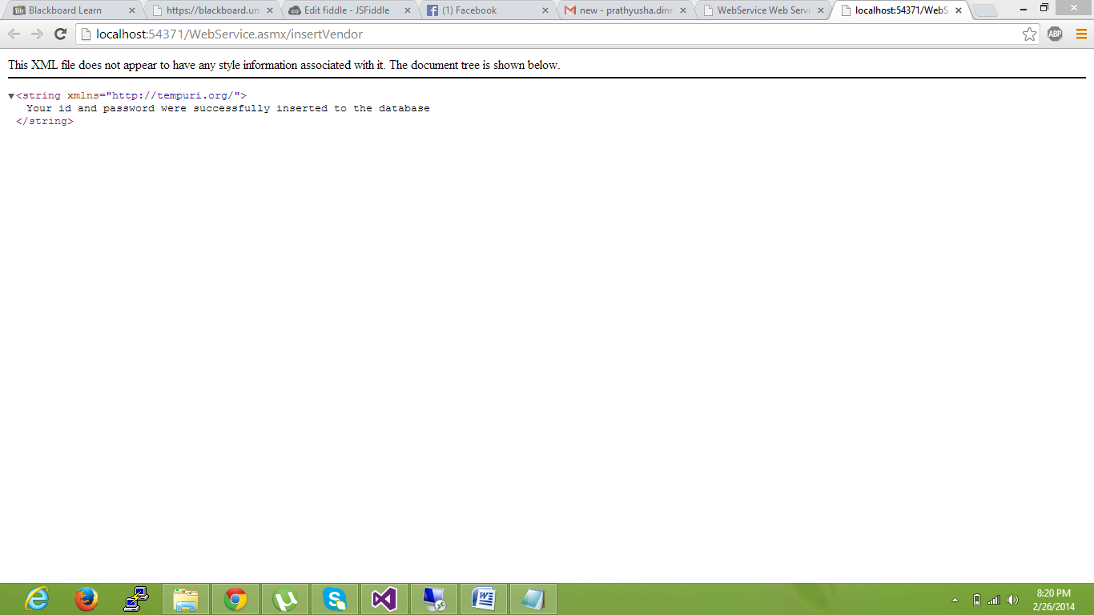

Upon clicking the delete vendor option, id text box was displayed. Giving the id on this web page, the vendor details will be deleted from database and deletion message displayed.

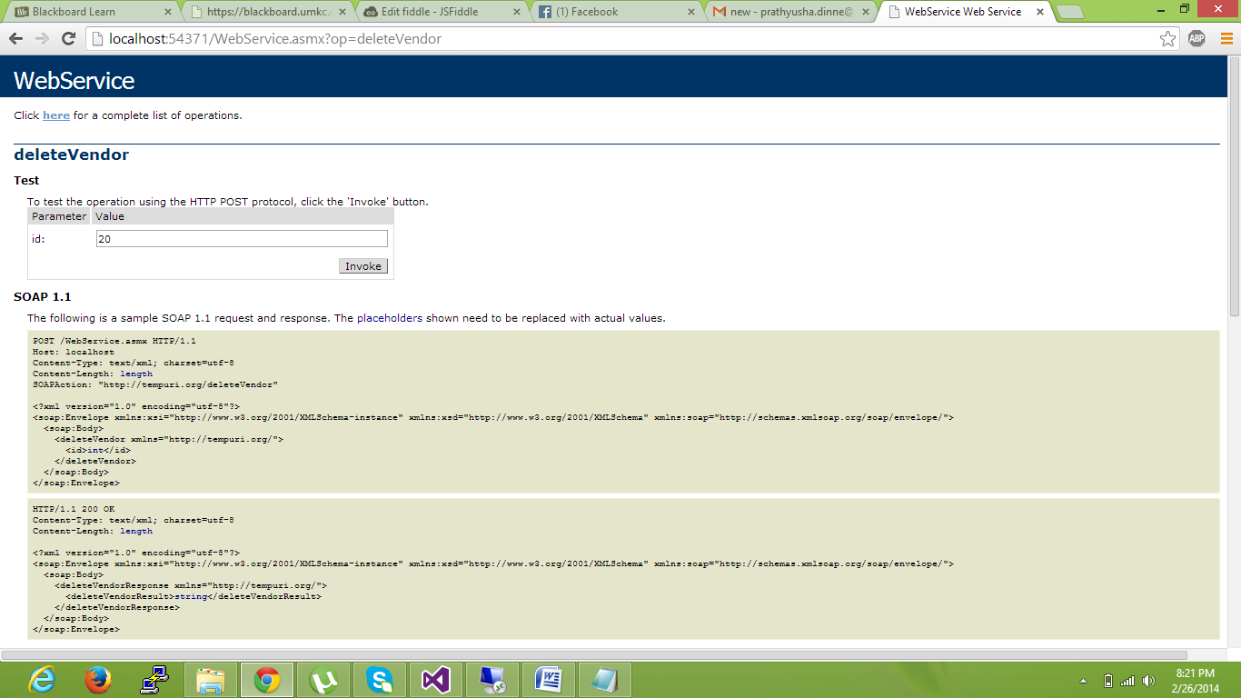

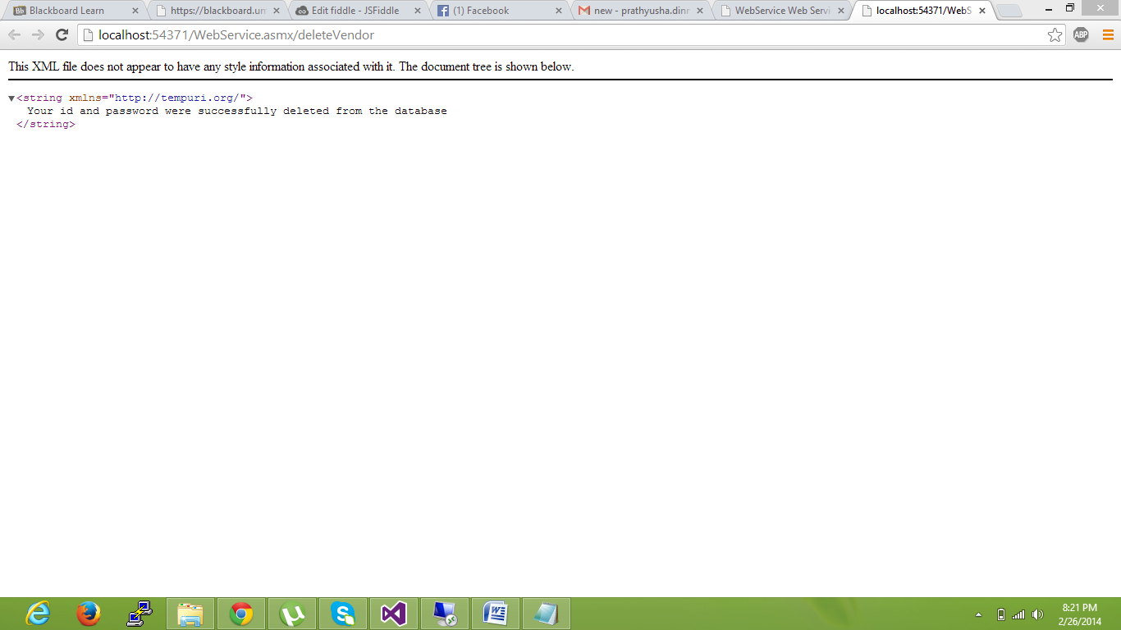

**Implementation of Rest Web Services with local databases:**

A rest web service was created with local database in order to insert, delete and retrieve vendor details. Below screenshot shows that john has been added to vendor list.

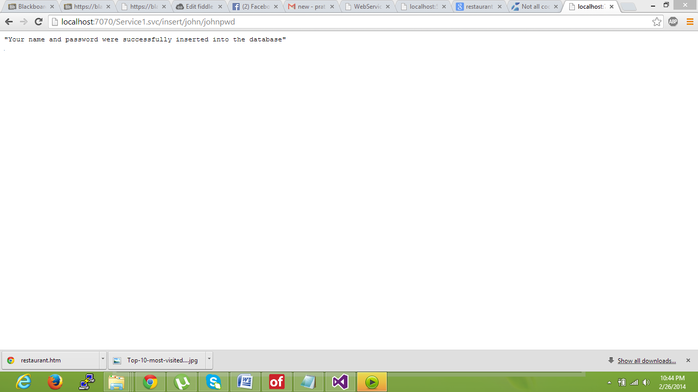

Below screenshot shows that values (john name and password) are inserted to the table in database.

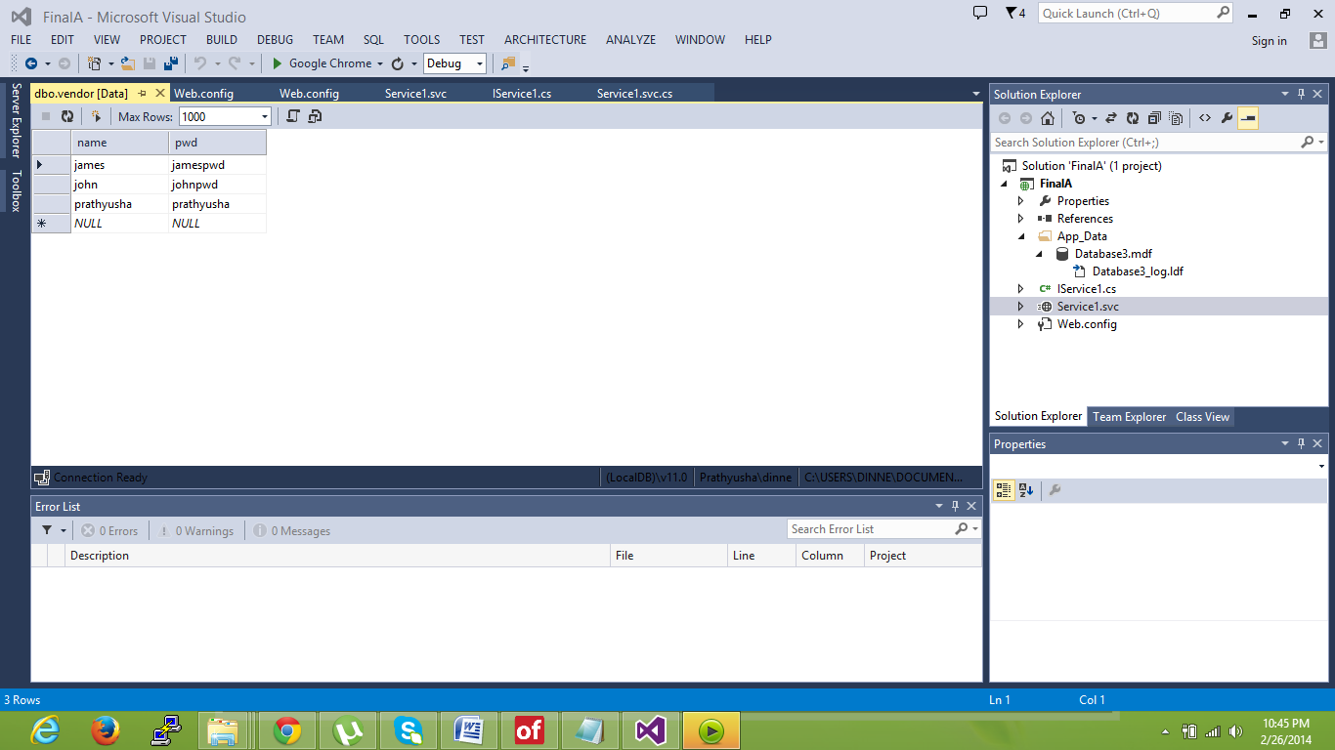

Below screenshot retrieves the information of john by doing a select query on vendor tables in database.

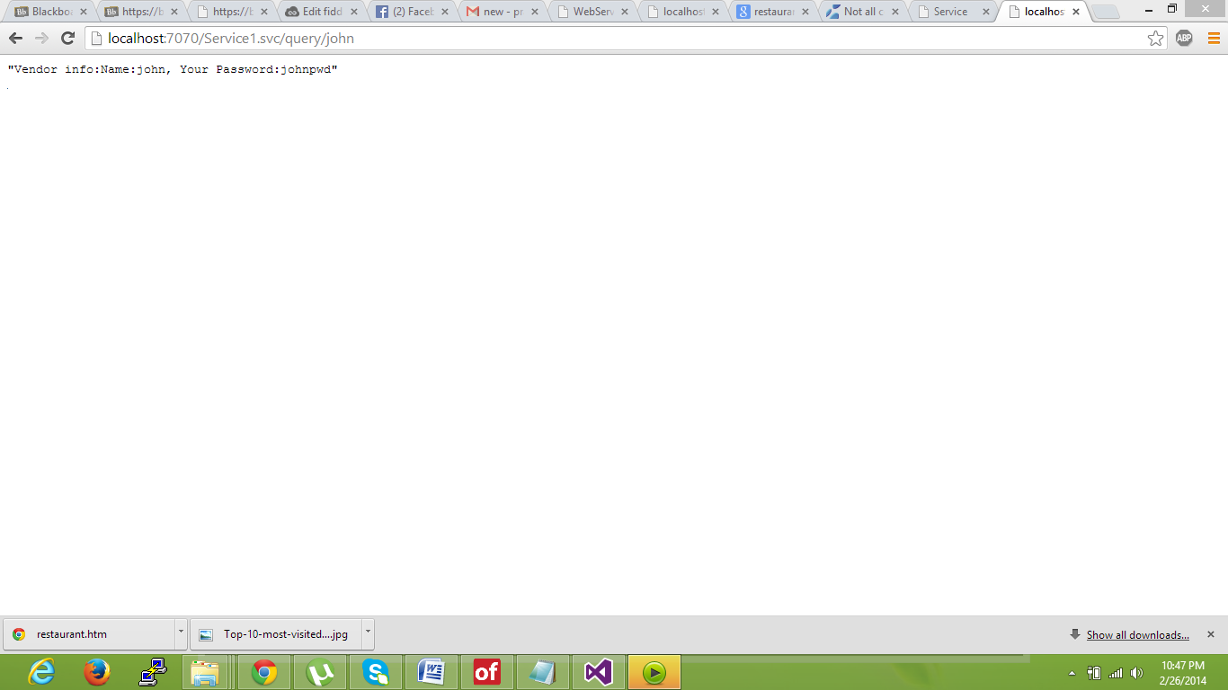

Below screenshot will delete the vendor (john) from the list.

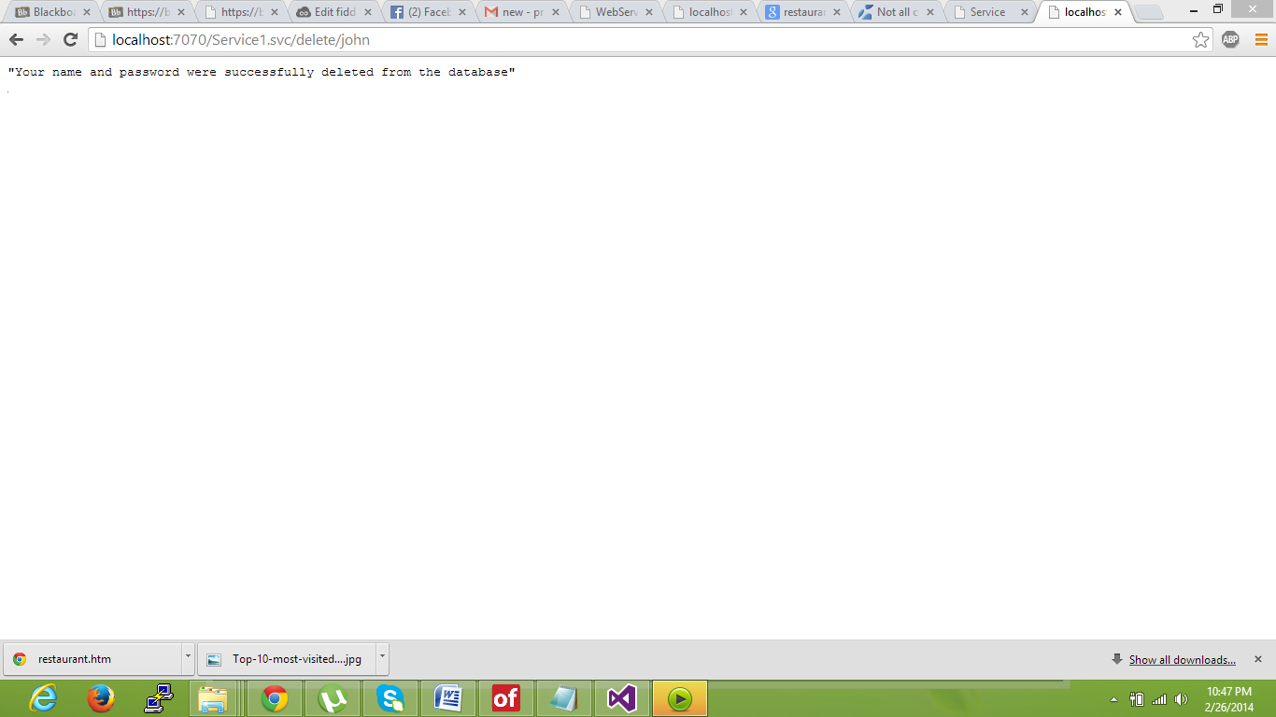

Below screenshot shows that John was completely deleted from database.

