**CS5590BD – BIG DATA ANALYTICS**

**LAB 4 REPORT**

**Name: Prathyusha Dinne (16161128)**

**Android App to insert and save the files:**

Save file is invoked upon successful Hbase retrieval of data. Therefore data files are saved.

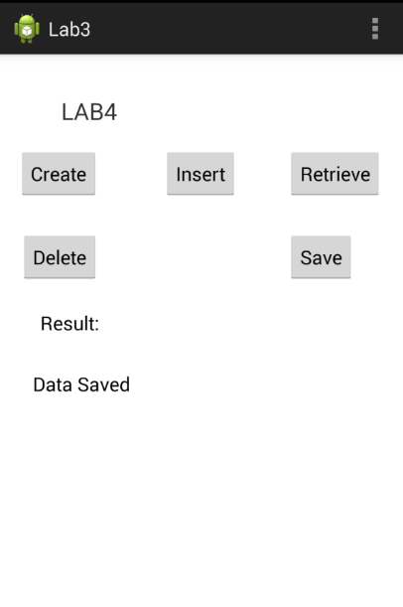

**Input data files:**

Left to Right gesture: Training file – leftToRight.txt , Sequence file – leftToRight.seq

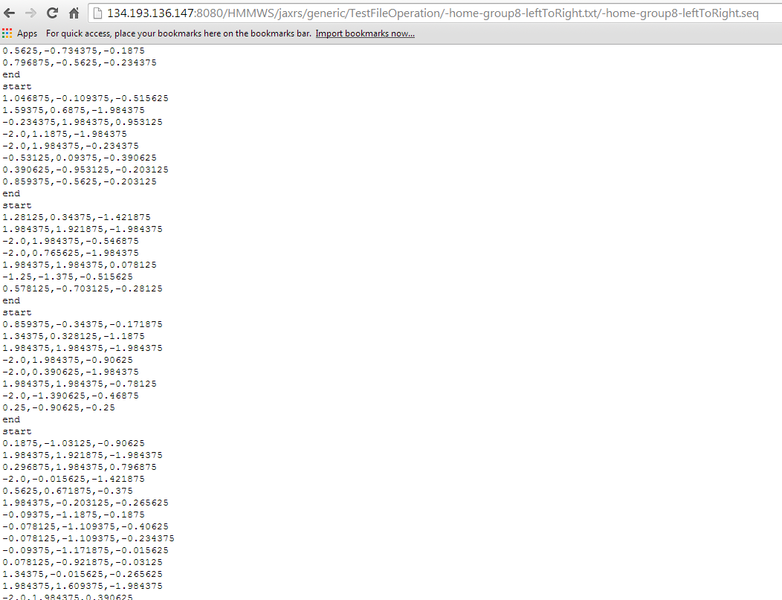

Top to Bottom gesture: Training file – TopToBottom.txt , Sequence file – TopToBottom.seq

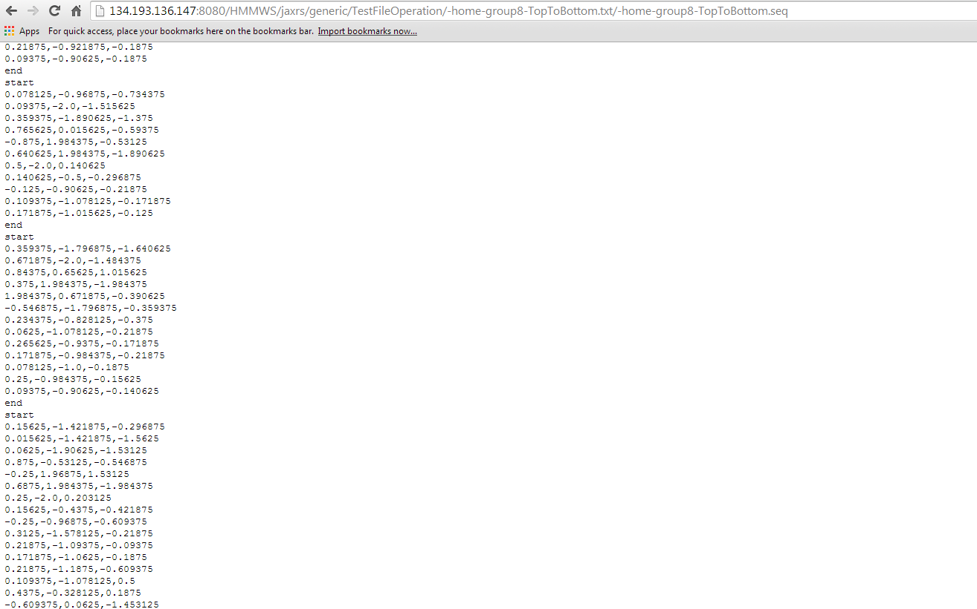

Left to Right gesture: Training file – RightToLeft.txt , Sequence file – RightToLeft.seq

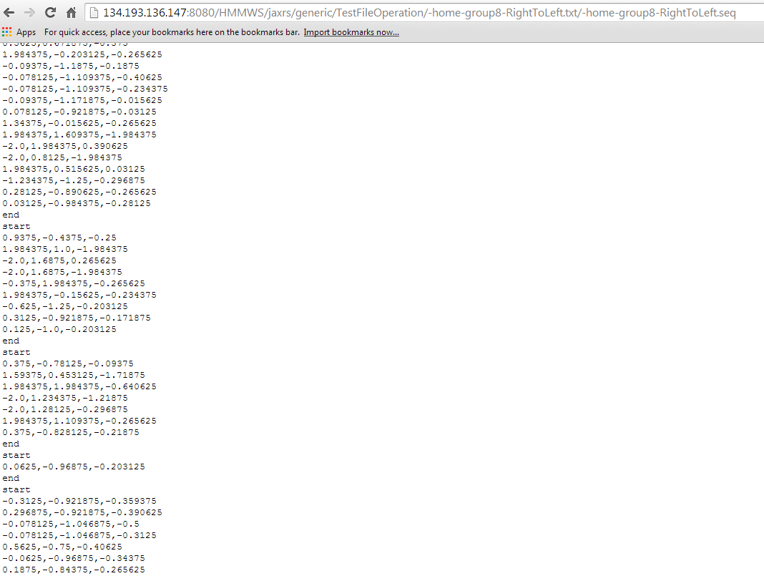

Combination file: It’s a file having all combinations of gestures like left to right, right to left and top to bottom gestures.

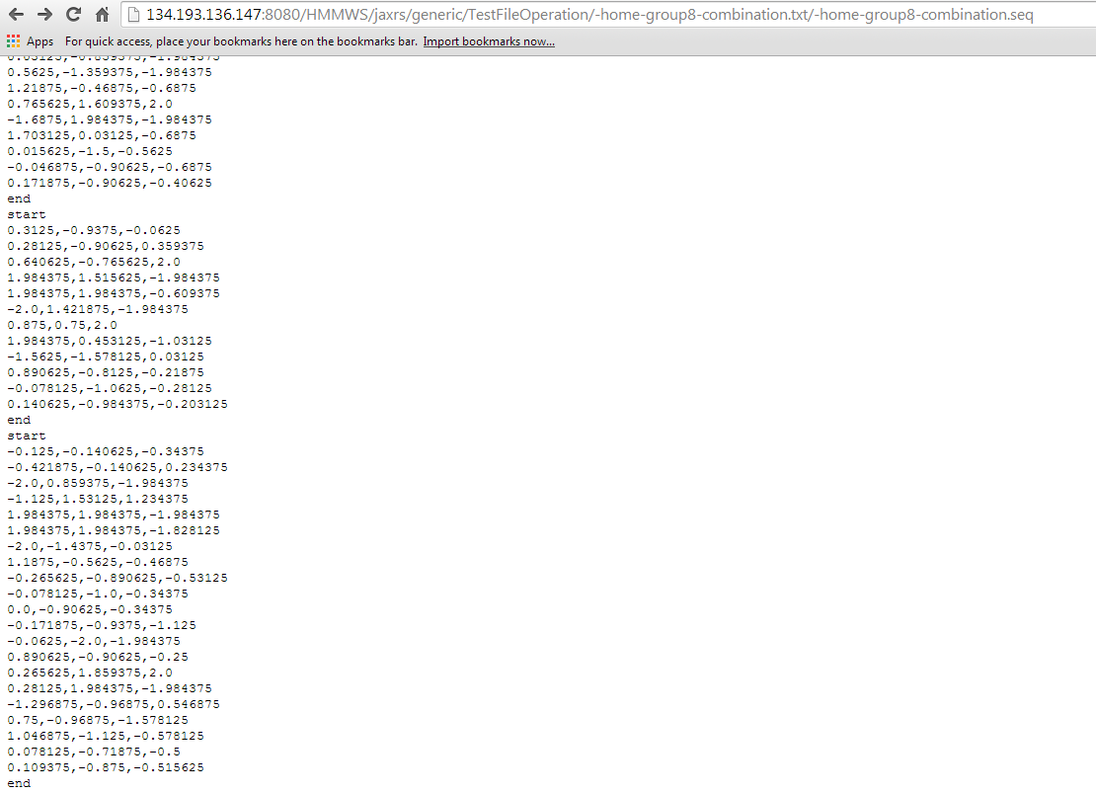

**REST SERVICE:**

URL: http://134.193.136.147:8080/HMMWS/jaxrs/generic/HMMTrainingTest/-home-group8-RightToLeft.seq/-home-group8-LeftToRight.seq/-home-group8-TopToBottom.seq/-home-group8-combination.seq