**CS5590BD BIG DATA ANALYTICS**

**LAB5 REPORT**

**Name:** Prathyusha Dinne(16161128)

Anudeep Vattipalli(16158489)

**Capturing Gestures:**

The gestures were captured in the form of sequence files with the help of traning app.

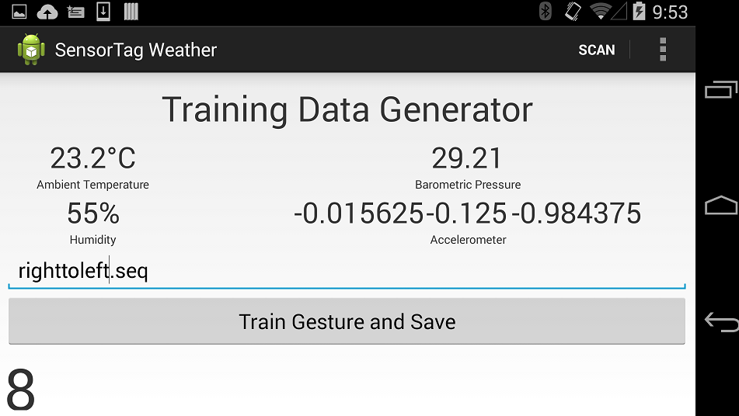

**TestGesture class:**

Three gestures i.e. right to left, left to right and bottom to top are included in the code to sense.

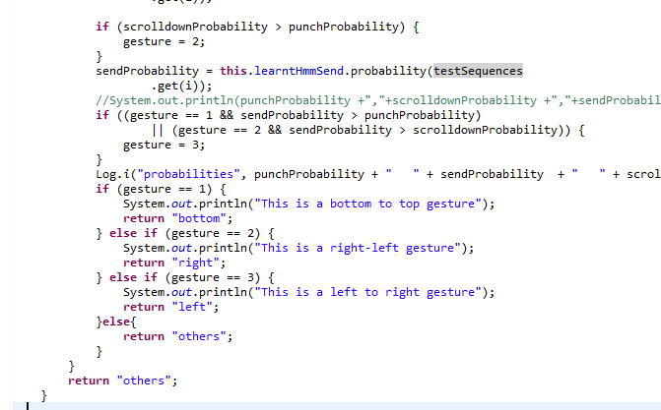

**Connection Service class:**

The patterns were tested with our gestures as below code.

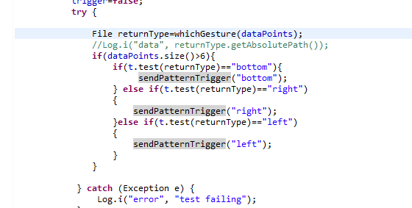

Broadcast signal was send to the game with the help of below code.

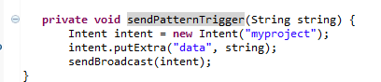

Com.jforeach.mazeman is our project package name.

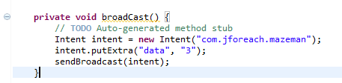

**Game class:**

Broadcast receiver was written in game class of maze game which compares the gestures and calls the methods in game view accordingly.

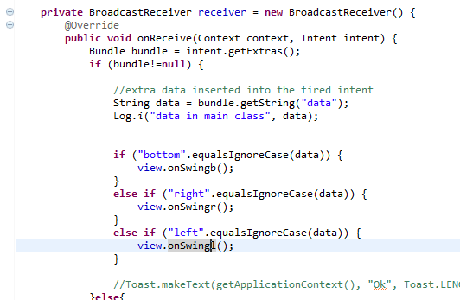

**Gameview class:**

Upon giving right to left, left to right and bottom to top gestures the respective methods are called as below. Invalidate() method is used to redraw the maze.

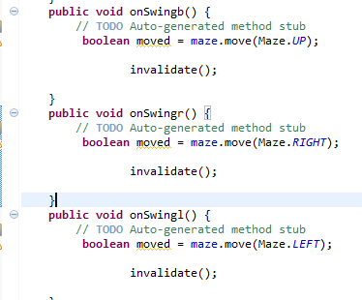

**Maze class:**

The move method is called according to the specified direction.

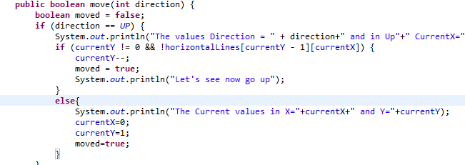

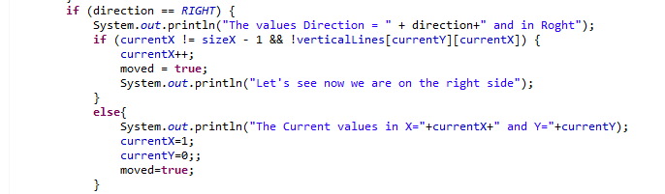

The gestures given by user are also tracked/displayed on the console as shown below.

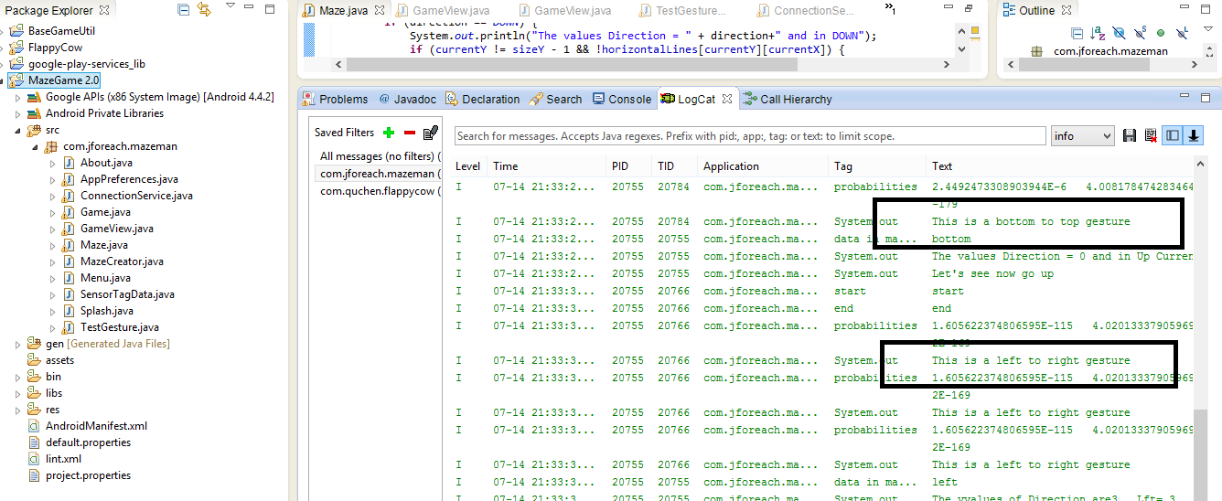

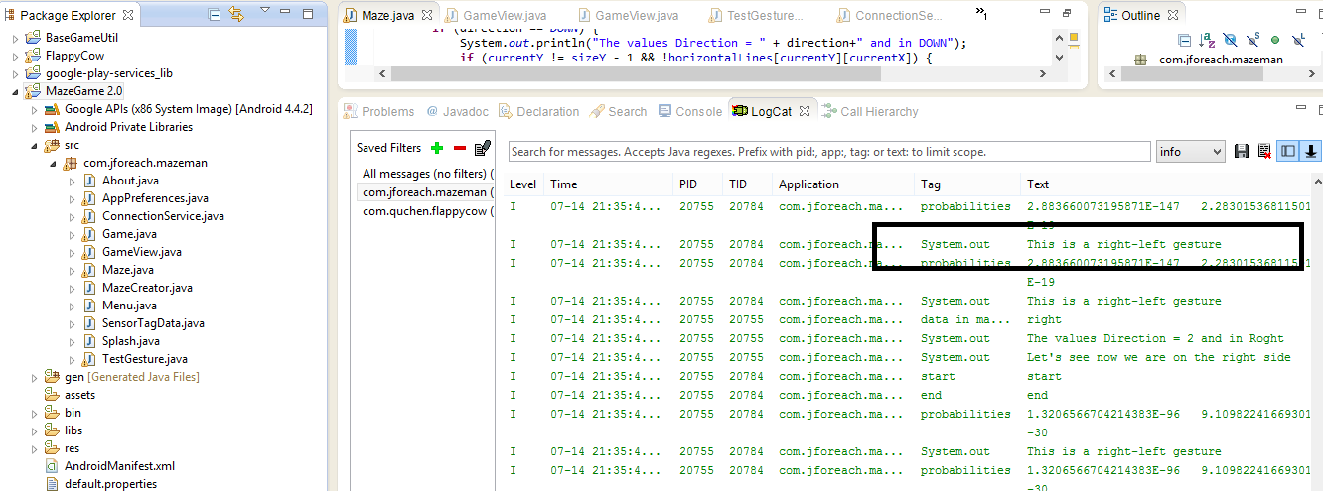

The ball in the game is moved as per the gestures made.

