**CS5590 BD – BIG DATA ANALYTICS**

**LAB6 REPORT (GROUP8)**

When a gesture is recognized, the corresponding variable is incremented to record the number of gestures and the data file is saved in sdcard Data folder as gesture.txt file.

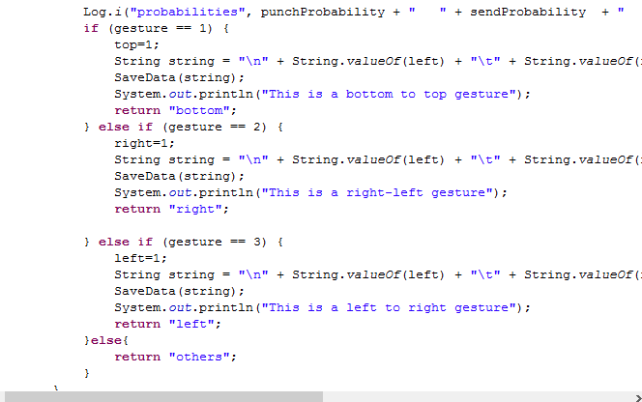

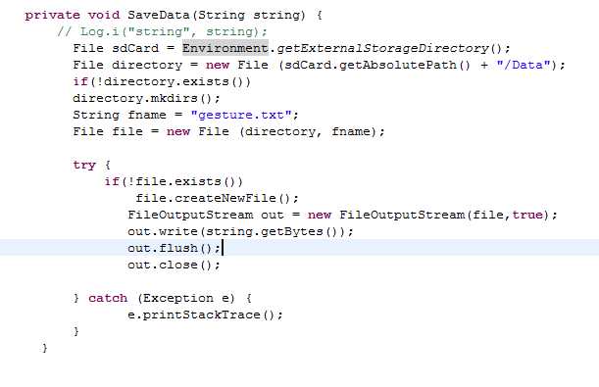

The gesture.txt file looks like below where in first column represents the count of left gesture, second column represents count of right gesture, third column represents count of top gesture and the fourth column represents date.

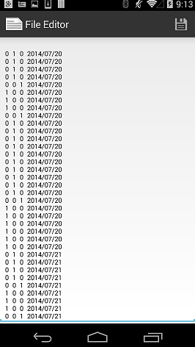

The gestureTable2 is created and gesture.txt file contents are inserted in Hbase table. Then values are retrieved and the repective gesture value are counted and the values are sent to graphical view for statistics.

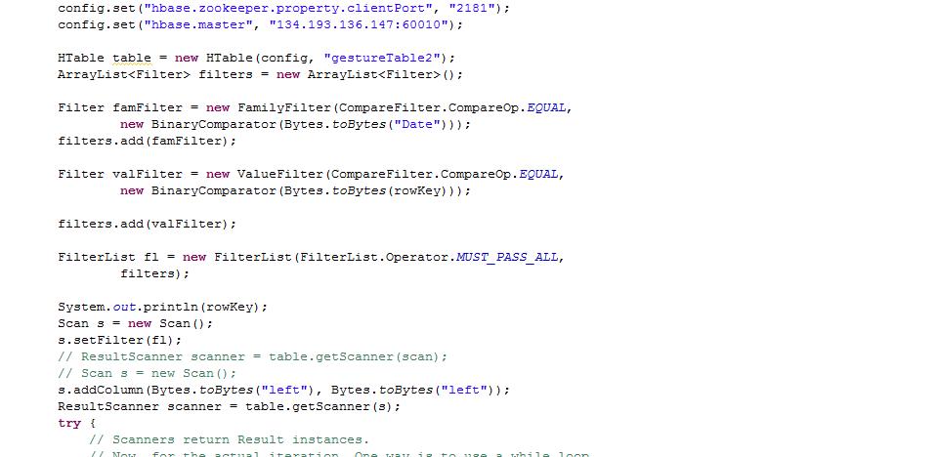

Graph was constructed with the help of below code.

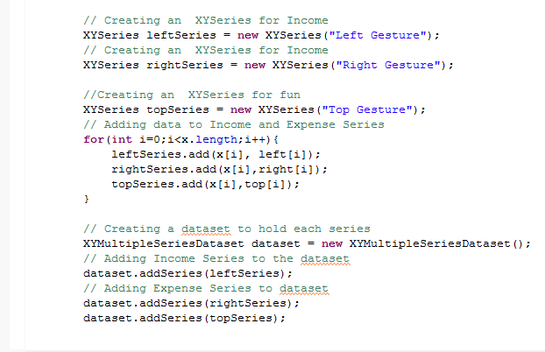

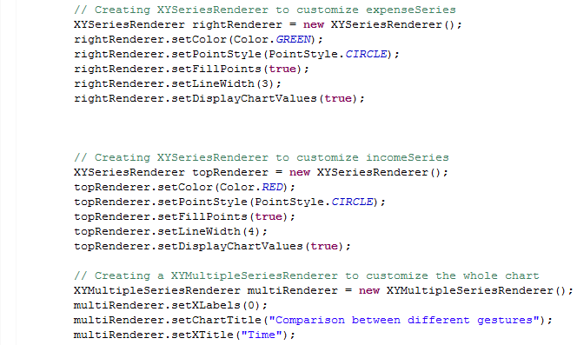

Below graph activity was obtained with the help of readings where red represents top gesture, green represents right gesture and white represents left gesture.

