**CS551 –ADVANCED SOFTWARE ENGINEERING**

**PROJECT PLAN – OCCASIONS ON THE GO**

**Team Members:**

Anudeep Vattipalli (16158489)

Prathyusha Dinne (16161128)

Poojitha Mittapally (16157740)

1. **Introduction:**

***Occasions on the Go*** is an online based application that provides service to the customers in order to plan an event effectively. This application acts as a bridge between the users and the organizers in scheduling and conducting various events. It allows the customers to select any particular service that is available and suits the best for the occasion. The customers will be able to order the services from different vendors in the nearest locations.

1. **Project Goal and Objectives:**

The ultimate goal of the project is to design an online event organizer system through web and mobile app in order to provide customers the best services from different vendors.

There are many vendors available for an event to arrange services like venue, food, decorations, and photography. It is very difficult to access various vendors’ information in order to get the best service of all. Also, identifying the vendors in the nearest locations and getting their reviews is very tough. To overcome these problems, our application provides the customers the option to choose vendors suitable to their requirements in the nearby proximity and place the order well in advance through online.

**Significance:**

The main significant feature of this project is customers need not visit each vendor’s website individually to know their features, deals or reviews. Instead, they can just register and login to our web application and choose the best vendors and their deals in nearby locations. They can also check the vendor’s previous events and their reviews posted on our website. Also, the user interface will be universal for all the vendors so that the customers can easily access this web application. The event organizer system will be a flexible and user friendly application. It gives the customers the choice of opting best vendors from the proximity and allows them to select the services like venue of the event, decoration, arrange the catering facility and photographer.

1. **Project Background and Related Work:**

We find a number of websites having their own online ordering service like <http://www.unionhillinn.com>. In this portal, the users have the facility to search venue, catering by place and prices. Users have the option to choose the best service in the required location and book for the specified time. Currently, we find no such online service providing these services across various vendors. Our project will be solution for this.

1. **Proposed System:**
2. **Requirement Specification:**

**Functional Requirements (Prioritized):**

* Users can register with their details, login and then update their profile if required.
* Vendor Managers can also register with their details, login and update their options.
* Customers can choose the vendors in the near proximity and place the order in advance.
* Navigation to the selected place was provided to the customers.
* Mail sent to vendor manager after order was placed by customer.

**Non Functional Requirements:**

* Our online service will be available on every day i.e., 24*7
* Online web application needs to be User Interface rich with the usage of minimum bandwidth for loading of the page.

**Business Process/Workflow Analysis:**

* Vendor Managers registers, login and will post their offers.
* Users register, login, selects each of the services and would be asked to search for different vendors. Then the vendors in the near proximity will be displayed.
* After choosing a vendor, user will be provided options to “view details” or “place order”
* If customer opts to “view details”, vendor’s past event details will be displayed.
* If customer opts to “place order”, he would be mainly asked for the date and time to book the slot. Also, further details need to be filled in order to complete the ordering procedure.
* Once the order was placed, a mail with order details and user address will be mailed to vendor manager. Also, an order confirmation mail will be send to user for the same.

**Technological Requirements:**

* **ASP.NET:** It is a server side framework designed to build dynamic web applications. This was developed by Microsoft in order to produce dynamic web services.
* **C#:** This is object-oriented language used in building very secure and robust applications.
* **JAVA:** It is a programming language used to create applications on single or distributed systems among clients and servers on a network.
* **SOAP Web Service:**  It is a architectural style that indicates uniform interface in order to enable services to apply best to Web**.**

1. **Framework Specification: Build an overall system model**

* **Methodologies and Algorithms:**

Scrum is one of the important agile methodologies which will be followed in our project. Project requirements can change frequently in order make the web application more creative. Here is where, scrum will be the best methodology to suit for our project. In Agile, project is developed as part of increments wherein each increment is expected to provide a working outcome.

1. **System Specification: Identify Primary Services**

* **Existing Services:**

|  |  |  |  |
| --- | --- | --- | --- |
| **S.no** | **Name** | **Description** | **URL** |
| 1 | Google Maps | To get directions to the vendor from user location | https://maps.googleapis.com/maps/api/directions/output?parameters |
| 2 | Twitter API | To share vendor details/ comments in twitter profile | <https://twitter.com/share> where class=”share-button” and data-lang=”en” |
| 3 | Google Search Engine | To search for vendor by name or location | https://ajax.googleapis.com/ajax/services/searc  h/web?v=1.0&q= |

* **New Services to be built:**

**Login:** To authenticate customer and vendor manager login.

**Update-user:** To update the user profile.

**Update-vendor:** To update the vendor profile, services, offers and prices.

**Retrieve:** Depending on customer search criteria, we get the data.

**Class Diagram:**

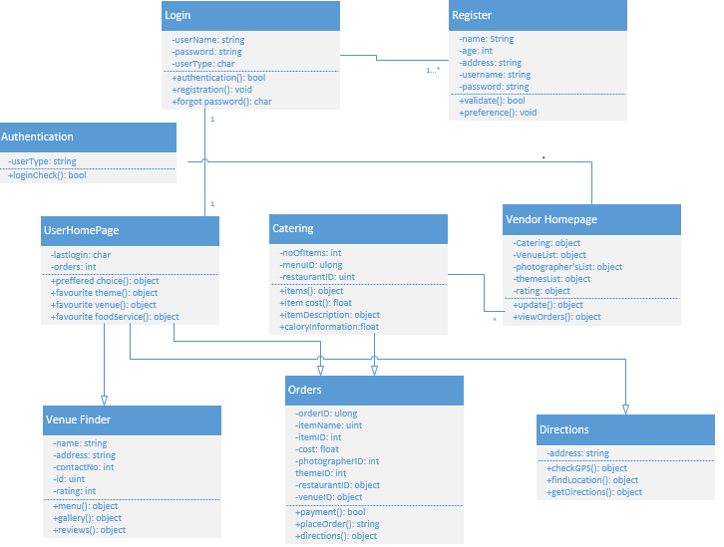

**Sequence Diagram for Customer:**

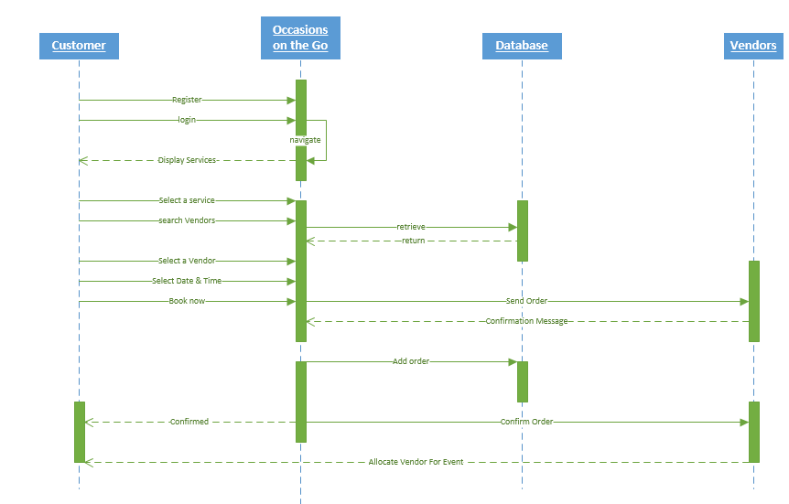

**Sequence Diagram for Vendor:**

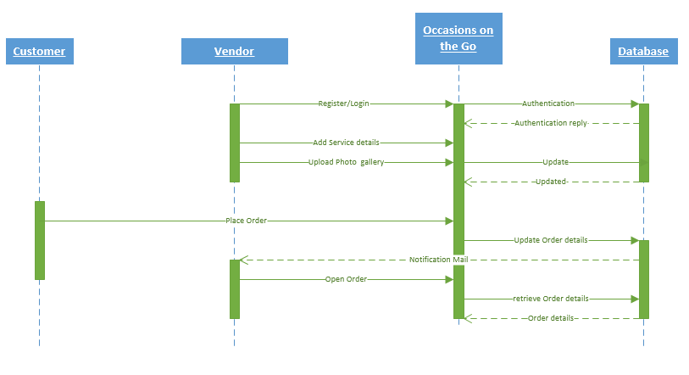

**Activity Diagram:**

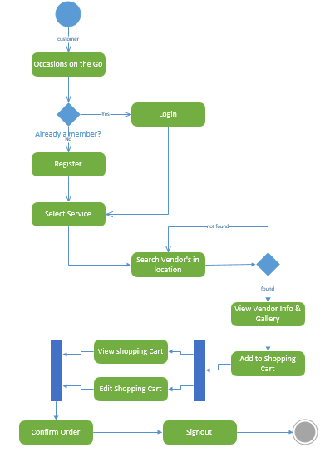

**Service Specification:**

* **Operational Description:**

*Vendor Manager:* Logins to our web application, create new offers/services and updates the existing prices and contact information.

*Customer:* Logins to our web application, searches for different vendors and places the order depending upon the requirement.

* **Input/output:**

Input is the vendor name or location given by user and output will be results searched from the database that matches with the user input.

* **Actors/Objects:**

There are total of three actors in our project. They are Customer/User, Vendor Manager and Administrator.

**Design of Mobile Client:**

* **Features:**
* Allows user and vendors to register, login and view/update their details.
* Users have the option to search for vendors in nearest location and place order depending on their requirement
* A confirmation mail will be sent to both user and vendor after the order is placed.
* **Technologies**: JAVA, C#, ASP.NET, SOAP Web Service

1. **Plan by Services:**

We have planned to implement our project in four increments.

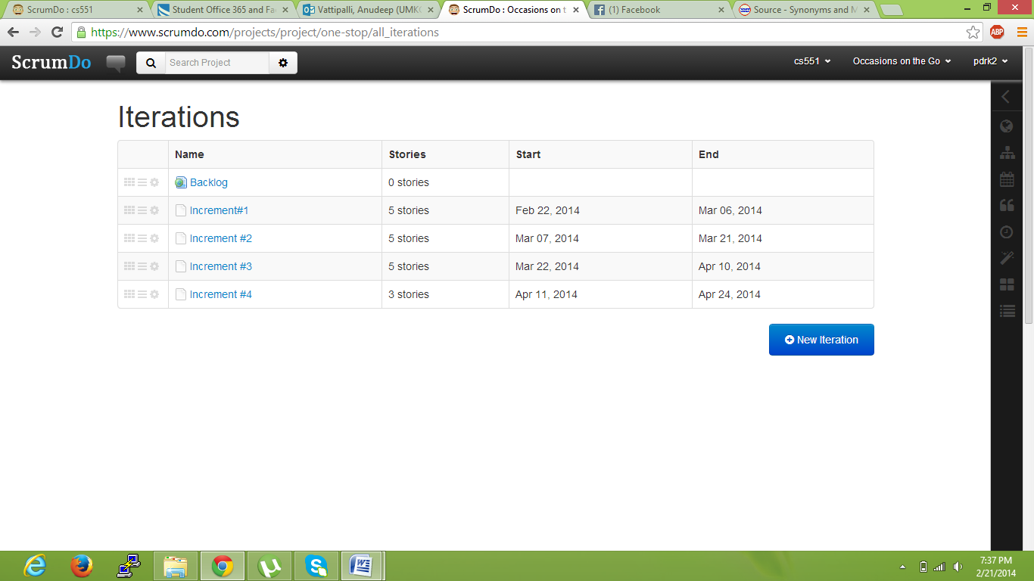

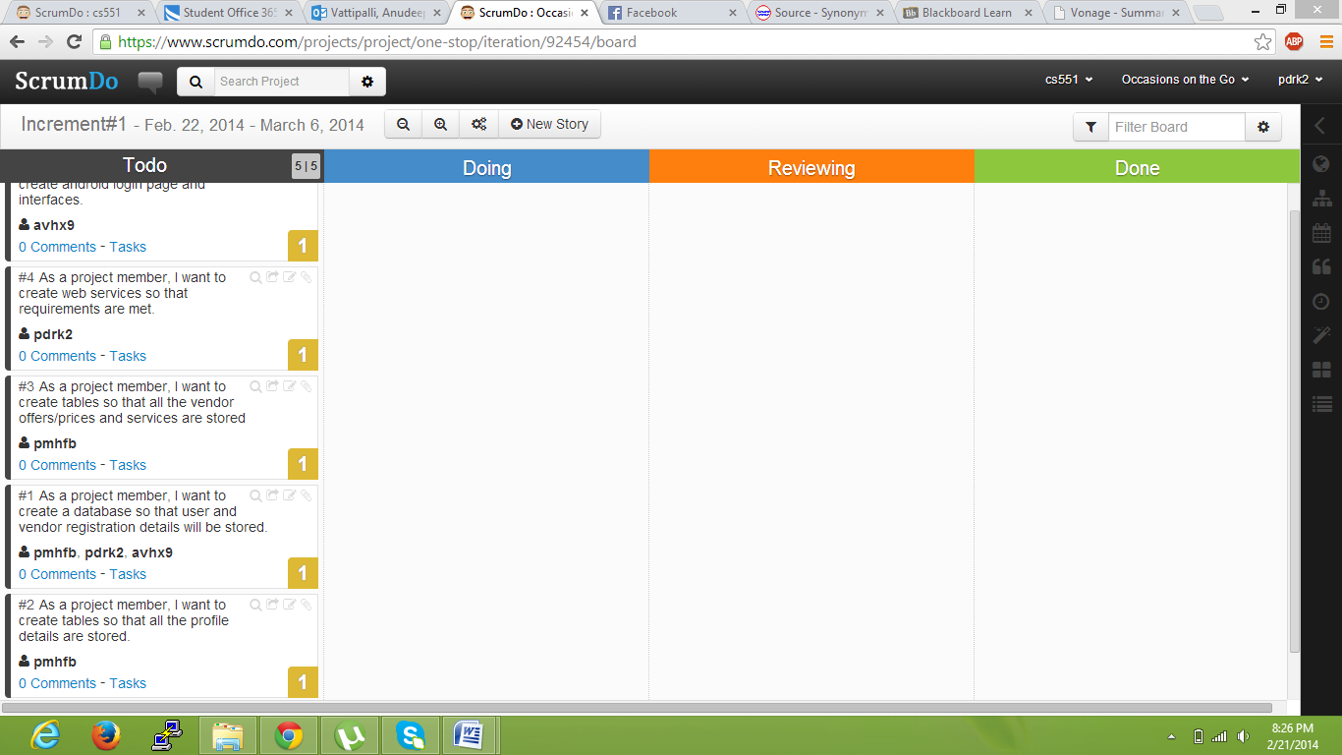

**Responsibilities:**

* **Database:** Poojitha Mittapally
* **UI:** Anudeep Vattipalli
* **Android:** Prathyusha Dinne
* **C#:** Poojitha, Anudeep
* **Testing C#:** Anudeep
* **Testing Android:** Poojitha, Prathyusha

The roles may differ depending on the evolution of the increments and projects.

1. **Risk Management:**

* To process multiple transactions with no interruptions.
* Login authentication both in mobile client and web applications need to be right to avoid third parties accessing this website.
* Mail service need to fast and reliable.
* Vendor’s information need to be up to date in the portal to avoid inconvenience for users.