**CS551- ADVANCED SOFTWARE ENGINEERING - LAB3 ASSIGNMENT**

**Name:** Prathyusha Dinne **Student Id:** 16161128

HTML5 Local Database was implemented in my mobile web client application by adding login and register pages where in new user have to login by providing his details. Existing user can then login to access the services provided by our client web application.

**http://jsfiddle.net/KR5Q5/134/**

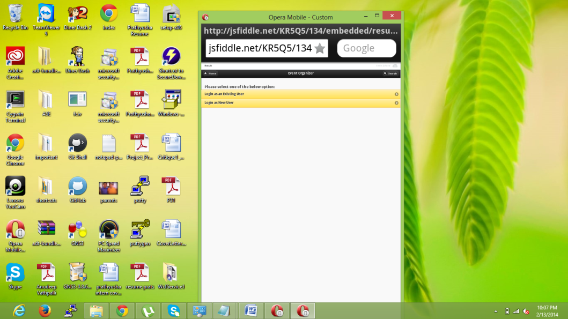

New User registration:

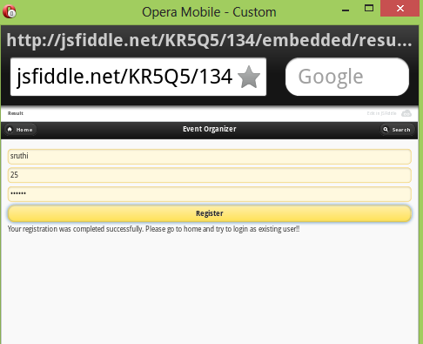

Existing User Login: Error Message pops up when user login name and password does not match with the details stored in database.

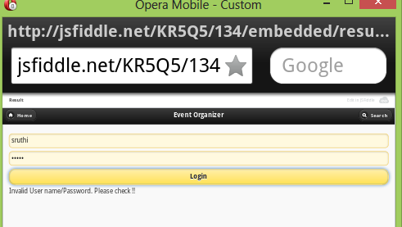

Successful Login of user:

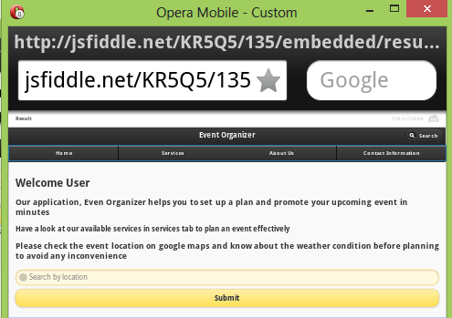

Mashup application :

Google Chart Services- upon button click the sales chart from past 5 years of the vendor was displayed.

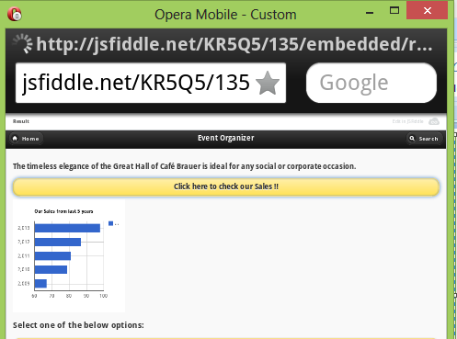

Google Search Engine:

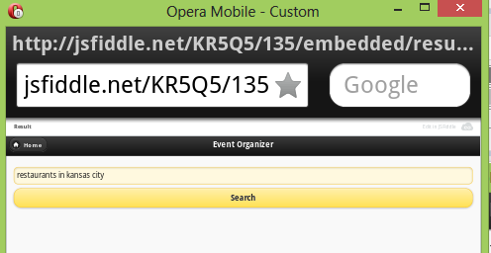

Result of Google Search Engine:

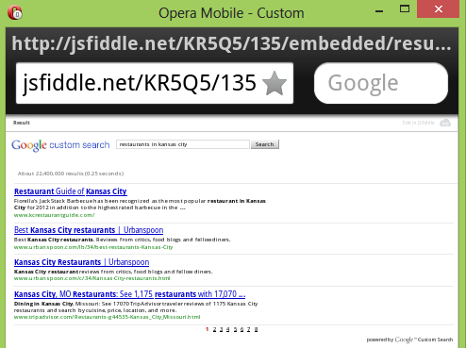

Twitter and Facebook Icons used in Footer:

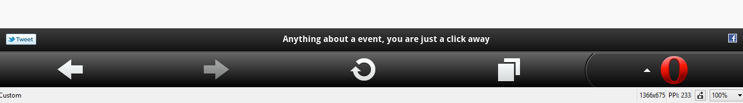

**Rest Web Services:**

