PDS4 Discipline Cartography Data Dictionary User’s Guide *(preliminary)*

October 31, 2019

Trent Hare ([thare@usgs.gov](mailto:thare@usgs.gov))

# Introduction

The Cartography Dictionary contains classes, elements, attributes, and rules describing map projections, including both cartographic, lander, and rings related definitions and descriptions. The PDS Cartography dictionary is based on and utilizes the existing Federal Geographic Data Committee (FGDC) Content Standard for Digital Geospatial Metadata, with modifications and extensions applied by PDS as needed for planetary mapping applications. This dictionary is strongly recommended for any map projected (derived) PDS4 products whether they are an image-based (e.g., Array_2D, Array_3D_Map, etc.) or GIS vector-based (table-based with defined point, line or polygon geometries). The Cartography and Imaging Node at the U.S. Geological Survey and Jet Propulsion Laboratories (JPL) are the stewards of this dictionary. Expect updates at least once or twice per year. Currently, Trent Hare from USGS, oversees updates to the dictionary and any questions can be addressed to him ([thare@usgs.gov](mailto:thare@usgs.gov)).

Fortunately, the creation of the cartography section can generally be fully automated. This does require a known mapping from the application which created the derived product to the PDS4 label. This of course is dependent on whether the software which created the derived product carries the metadata require to transfer the map projection to the PDS4 label. Example software applications which can help to automate the PDS4 label creation from a derive map projected product include, JPL’s VICAR, USGS’s ISIS3, Harris Corp’s ENVI, Esri’s ArcGIS, QGIS, GMT, and many other mapping applications. Thus, stated again, once a data product is map projected within the source software, that defined map projection can be readily transferred into the cartography section for the PDS4 label. It Is recommended that the transfer is automated to reduce label errors. For software which does not retain the metadata for the created derived product, there are alternate methods to define this during conversion, which would be simpler than manually filling out the cartography section in the PDS4 label. Below in the last section of this document, we show a couple examples of how this can be done.

# Overview of the Cartography Discipline Data Dictionary

A map projection is generally a mathematical method used to represent the 3-dimensional surface of the target body on a 2-dimensional plane. This typically requires (1) definition for the shape and size of the body and (2) the ability to transform from geographic/geocentric (longitude and latitude) coordinates to planar/Cartesian coordinates (X, Y or also called eastings, northings) typically in meters. The various map projections allowed in PDS4 have different required parameter needs. For example, the Sinusoidal projection only has one required parameter to define the central meridian, called <cart:longitude_of_central_meridian>. Whereas, the Equirectangular projection (also called Equidistant Cylindrical) requires both the <cart:longitude_of_central_meridian> and the latitude of true scale or <cart:standard_parallel_1>, which defines at what latitude where the scale is not distorted. Unfortunately, it is not uncommon for various applications to support a different number of parameters. Again for Equirectangular, some applications may also require the latitude of projection center or <cart:latitude_of_projection_origin>. For our purposes we have defined this parameter as optional and implies this parameter should default to 0. Although it is optional, it is recommended that this parameter be explicitly set to zero. The equations used for the allowed map projections should be define in the archive’s Software Interface Specification (SIS). For the more typical cartographic projections, it is common to follow the methods (defined equations) as described in the 1987 USGS Professional Paper #1395, *Map projections: A working manual* by John P. Snyder (<https://doi.org/10.3133/pp1395>) or as supported within the open-source PROJ coordinate transformation software library (<https://proj.org/>) as sponsored by the Open Source Geospatial Foundation (OSGeo). Within the cartography XML schema, when available, the page number for the Snyder manual is listed (digital PDF is available from the link above) and the address to the PROJ specific map projection web page is made available.

And while related, landed and rings map projections can be very different. Currently we support seven different lander map projections commonly used in rover missions. Lander projections are commonly found or originate within JPL’s VICAR software. For rings, we currently only support one projection. This projection, called <cart:Ring_Polar>, maps the distance from the center of the body in the X axis and the local time into the Y axis of the resulting Cartesian plane.

For context, the PDS4 cartography data dictionary replaces the original section found in PDS3 archives labeled OBJECT=IMAGE_MAP_PROJECTION. As previously stated, and based on the FGDC standard, the new hierarchical structure in PDS4 allows us to more easily group like sections. For example, to distinguish more typical map projections from landed or ring projections, we have divided available horizontal systems (Cartesian systems) into three categories, see Figure 2. The most used horizontal system will characteristically be <cart:Planar>, where most widely-used cartographic map projections are defined. <cart:Local> allows for landed and rings map projections. And lastly, <cart:Geographic>, not originally allowed in PDS3, simply allows for the most basic of systems using distances provided in angular degrees.

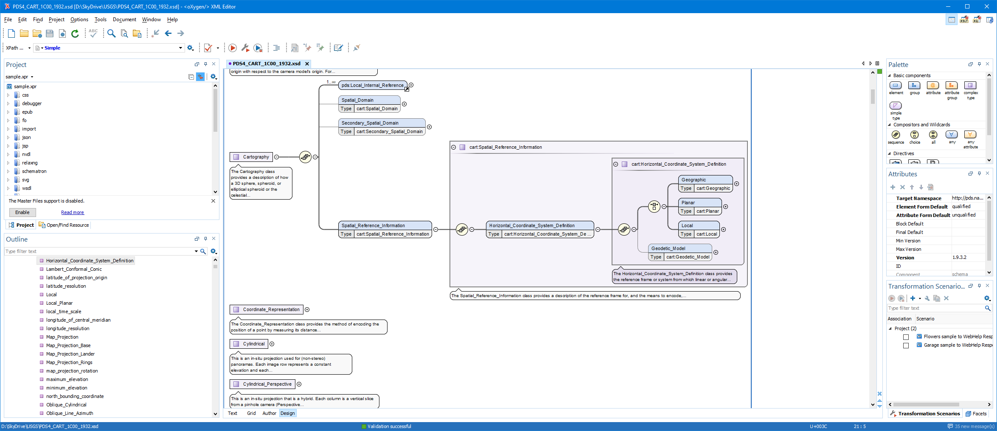

Figure 1. shows the <cart:Horizontal_Coordinate_System_Definition> which requires one and only one type <cart:Geographic>, <cart:Planar>, or <cart:Local>. While <cart:Geodetic_Model>, which defines the size of the target body (e.g. radius of the body), may not always be required if the projection used is for a landed or rings projection.

# How to Include the Cartography Dictionary in a PDS4 Label

If you use the recommended method for defining references for validation (as described in [Schema Referencing in PDS4 Labels](http://sbndev.astro.umd.edu/wiki/Schema_Referencing_in_PDS4_Labels)), the <?xml-model> processing instructions at the top of your label will look like this:

<?xml-model href="https://pds.nasa.gov/pds4/sp/v1/PDS4_CART_1C00_1933.sch" schematypens="http://purl.oclc.org/dsdl/schematron"?>

Similarly, if you're following the recommendations on that page for XSD referencing, then inside the <Product_Observational> tag you will need to add this namespace definition:

xmlns:cart="http://pds.nasa.gov/pds4/cart/v1"

and this pair inside the quotes of your xsi:schemaLocation XML attribute:

http://pds.nasa.gov/pds4/sp/v1 https://pds.nasa.gov/pds4/sp/v1/PDS4_SP_1C00_1100.xsd

Note the cart: prefix is reserved by PDS for classes and attributes from the Cartography Discipline Dictionary. Next is show the initial top part of a PDS4 label with the cartography dictionary defined. For image products, it is common to also include the Display Discipline Dictionary, so it is also shown below.

<?xml version="1.0" encoding="UTF-8"?>

<?xml-model href="https://pds.nasa.gov/datastandards/schema/released/pds/v1/PDS4_PDS_1C00.sch" schematypens="http://purl.oclc.org/dsdl/schematron"?>

<?xml-model href=https://pds.nasa.gov/pds4/disp/v1/PDS4_DISP_1B00.sch

schematypens="http://purl.oclc.org/dsdl/schematron"?>

<?xml-model href=https://pds.nasa.gov/pds4/cart/v1/PDS4_CART_1C00_1933.sch

schematypens="http://purl.oclc.org/dsdl/schematron"?>

<Product_Observational xmlns="http://pds.nasa.gov/pds4/pds/v1"

xmlns:pds="http://pds.nasa.gov/pds4/pds/v1"

xmlns:disp="http://pds.nasa.gov/pds4/disp/v1"

xmlns:cart="http://pds.nasa.gov/pds4/cart/v1"

xmlns:xsi="http://www.w3.org/2001/XMLSchema-instance"

xsi:schemaLocation="

http://pds.nasa.gov/pds4/pds/v1 https://pds.nasa.gov/datastandards/schema/released/pds/v1/PDS4_PDS_1C00.xsd

http://pds.nasa.gov/pds4/disp/v1 https://pds.nasa.gov/pds4/disp/v1/PDS4_DISP_1B00.xsd

http://pds.nasa.gov/pds4/cart/v1 https://pds.nasa.gov/pds4/cart/v1/PDS4_CART_1C00_1933.xsd">

<Identification_Area>

…

# Organization of Classes and Attributes

As of version 1C00_1933, October 2019, for the cartography data dictionary, there are 58 classes and 154 attributes. That is far too many to describe each class and attribute within this document. Looking at the top-level schematic diagram in figure 2, it shows that to begin with the cartography dictionary is simply structured. While deeper into the structure it appears to be much more complicated, but the overall design remains relatively straight forward. The dictionary appears complicated as we currently support twelve cartographic-based map projection, seven lander-based map projections and one rings map projection. Because each of these map projections have often different required parameters, there are many needed attributes, thus the overall construction appears to be complicated.

For example, given a derived global image map, the cartography section needs to (1) when possible, identify the bounding coordinates in degrees, (2) define the horizontal type, size of the target body, and map projection type, (3) define the required attributes for that map projection, and (4) if the product is an image, define the mapping from the top-left pixel to the map projection’s Cartesian plane and the pixel’s cell size in meters.

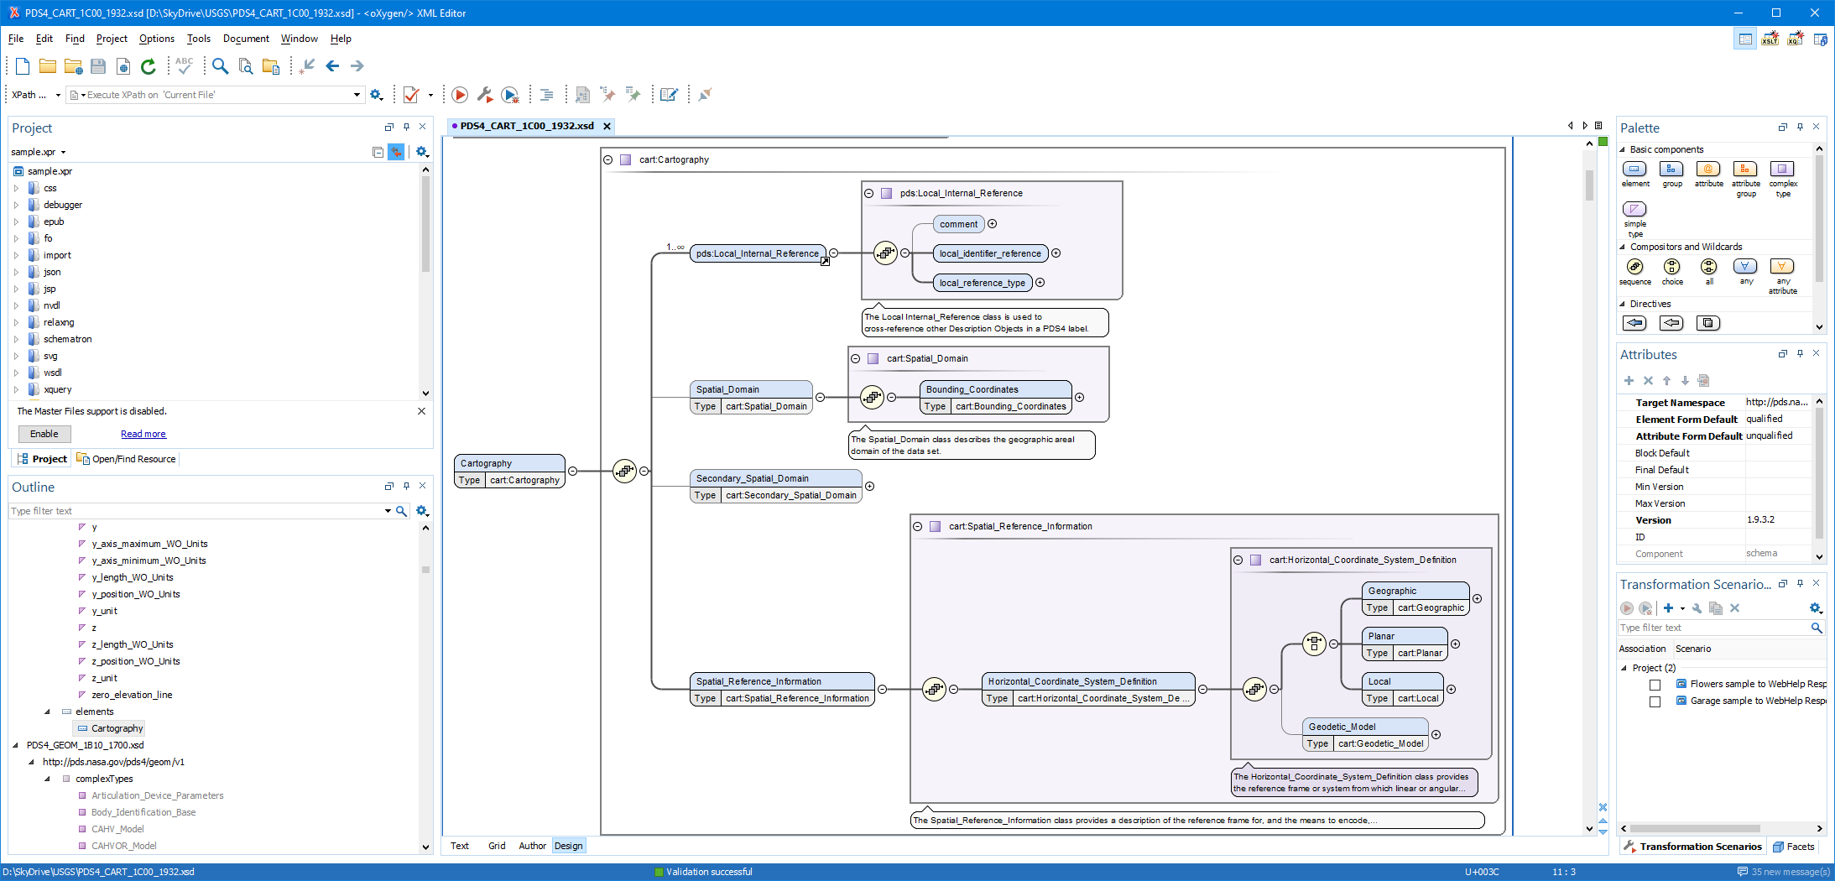

Figure 2. The is the top level of the cartography data dictionary.

## < cart:Spatial_Domain> and < cart:Secondary_Spatial_Domain>

Within Figure 1, <cart:Spatial_Domain> is required and lists the bounding box in degrees (longitude and latitude ranges). While this may become optional, with the introduction of ring map projections, which do not map into a latitude and longitude system, these values can simply be defined with zeros or nil. The <cart:Secondary_Spatial_Domain> was added to assist when a data provider would like to support the bounding degrees in two different systems (e.g. Positive East Longitudes and Positive West Longitudes). Generally Positive East Longitudes are better supported in modern mapping applications, whereas, Positive West Longitudes are needed to support historical uses for example in previous archives or research publications. The IAU allows both systems, but highly recommends using the system historically used in past publications. *(add in more about East/West)*.

## <cart:Spatial_Reference_Information>

Within Figure 1 is <cart:Spatial_Reference_Information> which defines the bulk of the information for the cartography data dictionary. Traversing down the next branch you will only find the horizontal coordinate system definition.

## <cart:Horizontal_Coordinate_System_Definition >

Also within Figure 1 is <cart:Horizontal_Coordinate_System_Definition> which defines the four allowable horizontal system definitions. One branch requires one and only one type of <cart:Geographic>, <cart:Planar>, or <cart:Local>. While the second branch defines <cart:Geodetic_Model>, which defines the size of the target body (via the three radii attributes <a_axis_radius> (also called the semi-major axis), <b_axis_radius>, <c_axis_radius> (also called the polar-radius or semi-minor axis). If the target body is defined as a sphere, which is common for cartographic products defined a triaxial body[1], all three radii values will be the same. Lastly, while <cart:Geodetic_Model> is generally required, it may be considered optional if the projection used is for a landed or rings data product.

## <cart:Geographic>

The <cart:Geographic> class is only intended for image products and provides a location to define the pixel (or cell) size in angular degrees (using the attributes <cart:latitude_resolution> and <cart:longitude_resolution>). This horizontal system is strictly not a map projection although it resembles the same shape as the map projection Equirectangular (or Simple Cylindrical). And although the class is defined as defined as “geographic” it can hold geocentric pixel sizes. The type of system used, geographic or geocentric, is defined within <cart:Geodetic_Model>.

## <cart:Planar>

The <cart:Planar> will characteristically be the most widely-used horizontal type since it defines twelve typical cartographic map projections (including projections like Equirectangular, Sinusoidal, Polar Stereographic, etc.). From the original FGDC specification, Planar is confusingly defined as “The quantities of distances, or distances and angles, which define the position of a point on a reference plane to which the surface of the [target body] has been projected.”[2] In practice, this simply means the resulting transformation from the target body will be to a simple Cartesian coordinate system or “plane” in meters. Other units could be used, but within PDS4, the Cartesian X,Y axes will be in meters.

## <cart:Local>

The <cart:Local> provides a description of any coordinate system not necessarily aligned with the surface of the target body. As such, it provides a location for the seven landed map projections and the one currently supported ring map projection (Ring_Polar).

# Definitions

As stated above, there are 58 classes and 154 attributes within the cartography data dictionary. Here we will only list the critical definitions. Please see the cartography schema for the remainder of the definitions.

5.1 <cart:upperleft_corner_x> and <cart:upperleft_corner_y>

One of the largest causes of issues in PDS3 archives was the not understanding how to define the pixel offsets which registers or spatially locates the image array (plane in pixels) to the Cartesian plane in meters. These new attributes provide the projection offsets in X and Y in meters, relative to the map projection origin, at sample 0.5 and line 0.5 (upper left corner of pixel 1,1 within image array).

(0.5,0.5) - upper left corner (edge) of pixel 1,1

/

#---+---+-> X axis

| * | |

+---+---+

| \

Y axis pixel coordinate (2.5,1.5)

where # is X,Y location in meters relative to map projection origin

and the location for <cart:upperleft_corner_x>, <cart:upperleft_corner_y>.

where * is pixel coordinate (1.0,1.0).

For context, in PDS3, the method to locate the image plane to the Cartesian plane was based in pixel units, called LINE_PROJECTION_OFFSET and SAMPLE_PROJECTION_OFFSET. Due to ambiguities in the standard and confusion over the location of pixel 1,1 (whether it was top left edge or center of the pixel), many PDS3 labels contain half-pixel offset errors. Changing to <cart:upperleft_corner_x>, <cart:upperleft_corner_y> is a more recognized practice among many other spatial formats and should to alleviate most of the uncertainty in defining these values. If the sample and line offsets are correct in the PDS3 labels, the method for conversion to X,Y meters is defined as:

cart:upperleft_corner_x = (SAMPLE_PROJECTION_OFFSET + 0.5) * (MAP_SCALE * 1000) * -1

cart:upperleft_corner_y = ( LINE_PROJECTION_OFFSET + 0.5) * (MAP_SCALE * 1000)

where SAMPLE_PROJECTION_OFFSET, LINE_PROJECTION_OFFSET, and MAP_SCALE (in km) are

from the original IMAGE_MAP_PROJECTION group of the PDS3 label. If MAP_SCALE is

not in km the convert to meters accordingly.

# Examples

## Transverse Mercator example

This example only shows the cartography section from a sample map projected (derived) observational data product. Note the two required sections (1) Spatial_Domain and (2) Spatial_Reference_Information (which includes Horizontal_Coordinate_System_Definition and Geodetic_Model).

…

<cart:Cartography>

<Local_Internal_Reference>

<local_identifier_reference>image</local_identifier_reference>

<local_reference_type>cartography_parameters_to_image_object</local_reference_type>

</Local_Internal_Reference>

<cart:Spatial_Domain>

<cart:Bounding_Coordinates>

<cart:west_bounding_coordinate unit="deg">-117.6411</cart:west_bounding_coordinate>

<cart:east_bounding_coordinate unit="deg">-117.6281</cart:east_bounding_coordinate>

<cart:north_bounding_coordinate unit="deg">33.90241</cart:north_bounding_coordinate>

<cart:south_bounding_coordinate unit="deg">33.89153</cart:south_bounding_coordinate>

</cart:Bounding_Coordinates>

</cart:Spatial_Domain>

<cart:Spatial_Reference_Information>

<cart:Horizontal_Coordinate_System_Definition>

<cart:Planar>

<cart:Map_Projection>

<cart:map_projection_name>Transverse Mercator</cart:map_projection_name>

<cart:Transverse_Mercator>

<cart:scale_factor_at_central_meridian>1.0</cart:scale_factor_at_central_meridian>

<cart:longitude_of_central_meridian unit="deg">-117</cart:longitude_of_central_meridian>

<cart:latitude_of_projection_origin unit="deg">0</cart:latitude_of_projection_origin>

</cart:Transverse_Mercator>

</cart:Map_Projection>

<cart:Planar_Coordinate_Information>

<cart:planar_coordinate_encoding_method>Coordinate Pair</cart:planar_coordinate_encoding_method>

<cart:Coordinate_Representation>

<cart:pixel_resolution_x unit="m/pixel">60</cart:pixel_resolution_x>

<cart:pixel_resolution_y unit="m/pixel">60</cart:pixel_resolution_y>

<cart:pixel_scale_x unit="pixel/deg">1855.345</cart:pixel_scale_x>

<cart:pixel_scale_y unit="pixel/deg">1855.345</cart:pixel_scale_y>

</cart:Coordinate_Representation>

</cart:Planar_Coordinate_Information>

<cart:Geo_Transformation>

<cart:upperleft_corner_x unit="m">-59280.433</cart:upperleft_corner_x>

<cart:upperleft_corner_y unit="m">3751320.543</cart:upperleft_corner_y>

</cart:Geo_Transformation>

</cart:Planar>

<cart:Geodetic_Model>

<cart:latitude_type>Planetocentric</cart:latitude_type>

<cart:spheroid_name>Mars 2000 Sphere</cart:spheroid_name>

<cart:a_axis_radius unit="m">3396190.0</cart:a_axis_radius>

<cart:b_axis_radius unit="m">3396190.0</cart:b_axis_radius>

<cart:c_axis_radius unit="m">3396190.0</cart:c_axis_radius>

<cart:longitude_direction>Positive East</cart:longitude_direction>

</cart:Geodetic_Model>

</cart:Horizontal_Coordinate_System_Definition>

</cart:Spatial_Reference_Information>

</cart:Cartography>

…

* *More coming*

1. Archinal et al (2018). “Report of the IAU Working Group on Cartographic Coordinates and Rotational Elements: 2015,” Celestial Mechanics and Dynamical Astronomy, 130:22, DOI: 10.1007/s10569-017-9805-5.
2. <https://www.fgdc.gov/csdgmgraphical/spref/horiz/planar.htm>